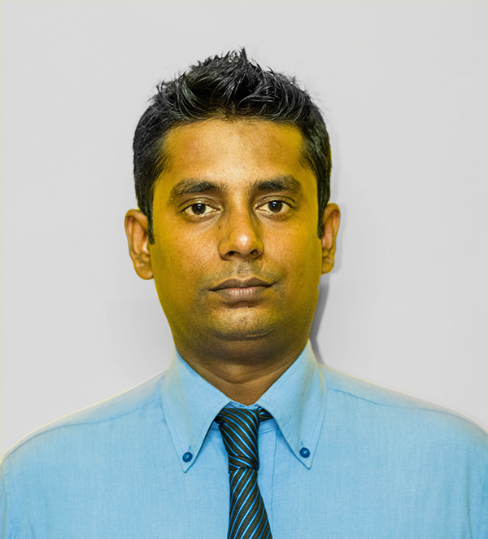
S.T.PREMNATH
98/42, Sri wickrama pura,
Mattakkuliya,
Colombo 15,
Sri Lanka.
Mob: 077 3186867, Tel: 011 2546341
Email: stpremnath@gmail.com

Personal Details

Full Name : Sinnathamby Premnath
Name with initials : S. T. Premnath
NIC No : 810330937 V
Date of Birth : 02nd February 1981
Gender : Male
Civil Status : Single
School Attended : C/Vivekananda College, Colombo 13.

Career Objectives

To become the successful man in whatever I do, I would strive to success by working honestly and sincerely with single-minded devotion and determination; by seeing a leader of men through hard work. I would help the company by my innovation and at the same time ensuring the quality.

Academic Qualification

- MBA at ICBT offered by Cardiff Metropolitan University year 2016.
- GCE Advanced Level
Sat for the G.C.E. (Advanced Level) examination in 2000, obtained the following results:

Chemistry B pass
Biology S pass
Physics S pass
General English 84 Marks

- GCE Ordinary Level
Sat for the G.C.E. (Ordinary Level) examination in 1997, obtained the following results:

MATHS D pass
TAMIL D pass
ENGLISH C pass
SOCIAL STUDIES C pass
RELIGION C pass
SCIENCE C pass
COMMERCE C pass
ARTS S pass

Working Experience

- Worked as a business development Associate for 1 year at Eagle Insurance.
- Worked as a product specialist at KISH International & promoted Amplatzer Occluder Devices for Congenital & Structural Heart diseases from 2004 to 2007.
- Worked as a Product Manager at EMSO from 2007 January to 2010 August and Promoted Biotronik Vascular Interventional Products.
- Worked as an Assistant manager at Medrac (pvt)Ltd from 2010 August to 2011 August and promoting Vitatron Pacemakers, Biosensors Stents and Ashahi Guide wires .
- Worked as a Territory Manager for Pharma Associates and Axia from 2011 August to 2013 July.
- Currently working for Merxo Medics as a business development manager for pharmaceutical and cosmetics department.

Information Technology Skills

- Windows Operating Systems in Windows XP, Windows 2000 & 98.
- Microsoft Office Packages including Word Processing, Power Point presentation, Ms Access, Ms Font page XP.
- Internet Applications.
- E-mail Applications.

Other Activities

- I was a member of School Leo Club and Human Rights Association
- I was participated in inter school athletic meets and played cricket for school house matches
- I won the under 12 Karate District Championships
- I won 1st place in creative writing

Non Related Referees

Dr. Tanya Pereira
Consultant Cardiologist
National Hospital of Sri Lanka
Colombo

Dr. P. P. Sathananthan
Consultant Cardiologist
Karapitiya Teaching Hospital
Galle

Authentication

I do hereby confirm the above information given is true and correct to the best of my knowledge.
I thank you very much, and fervently hope that my CV will meet your requirements and please give the consideration it deserves.

…………………….. ……………………..
S. T. PREMNATH DATE

