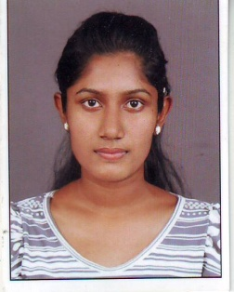**Resume of Lakmali Liyanage**

**E-mail:dulanji1991@gmail.com**

**T.P. 078 4679350/077 5639272**

**PERSONAL DETAILS**

Name in Full :- Kirumbara Liyanage Kavindu Dulanganee Lakmali

Name with Initials :- K.D. Lakmali Liyanage

Postal Address :- No.05, Udawaththa, Kapuduwa, Thihagoda, Matara.

Date of Birth :- 12.11.1991

Age :- 22 years old

Sex :- Female

Civil Status :- Single

Nationality :- Sri Lankan

**SCHOOL EDUCATION**

* ST. Thomas’ Girls’ High School Matara
* G.C.E. (O/L) 2007 (English Medium)

**Subject**  **Grade** **Subject** **Grade**

English A Development Studies C

Sinhala C English Literature S

Maths S Dancing C

Buddhism B Social Studies C

Agriculture S

* G.C.E. (A/L) 2011

**Subject**  **Grade**

Sinhala B

Geography C

Political Science S

General English C

**ACADEMIC QUALIFICATIONS**

* Successfully completed a Computer course at NAITA.
* Completed an English course held at British English Center Matara. (Intermediate level)
* Followed an Dynd’ American English Course at NAITA and got the highest Scores in results.

(Computer Based programme)

**PROFESSIONAL QUALIFICATIONS**

* Followed a certificate in Human resource management at HUMAN RESOURSE MANAGEMENT INSTITIUTE in Nawala, Colombo.
* Now Following a advanced certificate in Human resource management at HUMAN RESOURSE MANAGEMENT INSTITIUTE in Nawala, Colombo.

**WORKING EXPERIENCE**

* Worked as a trainee in National Water Supply and Drainage Board Matara for six months in commercial section.

**NON- RELATED REFEREES**

1. Mr. R.R. Sirilal (Commercial Manager)

National Water supply and drainage board

Paburana,

Matara.

T.P. 077-7392489

1. Mr. Chandika Sarachchandra

State trading General Cooperation,

Railway Station road,

Matara.

T.P. 071-8018000

I hereby certify that the above particulars are true and correct to the best of my knowledge.

……………..….. ……………………………..

Date Signature