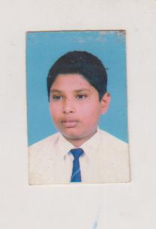**-CURRICULUM VITAE-**

**Ravindu Lavan Basnayake**

**Ishani,**

**Karaghaulpatha,**

**Medawela, Udukinda**

**Profile Summary**

1. Name in Full : Ravindu Lavan Basnayake

2. Address : Ishani, Karaghaulpatha,Medawela,Udukinda

3. Telephone No : Mobile : 078 3579031

4. Date of Birth : 12.19.1995

5. NIC No : 953541734V

6. Nationality : Sri Lankan

7. Religion : Buddhist

8. Gender : male

9. Marital Status : Single

10. Languages : Sinhala English

**Education Qualification**

Ordinary Level 2012

Subject Grade

Science C

Buddhist C

Art C

Geography C

Sinhala C

Maths C

English W

IT S

History W

ADVANCED LEVEL - 2015

Subject Grade

Sinhala - C

Media - C

Geography - C

**REFERENCES**

**Jayasekara Bandara**

**Customer Care Officer**

**People's Bank**

**Keppetipola.**

**072-7081232**

I certified above information is true and correct to the best of my knowledge and belief.

………………..… ………………….

Date Signature