**EDUCATION**

**2005-2008 Jaffna Hindu College**

Advanced level in Maths Stream at 2008

Maths A

Physics A

Chemistry B

Z-score 2.484.

**2009-2014 University of Moratuwa, Faculty of Engineering.**

Bachelor of Science in Material Science and Engineering,

February 2014

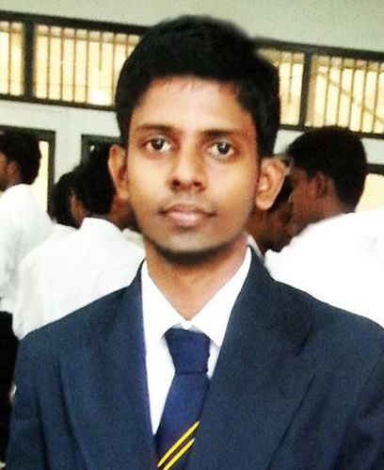

Date of Birth: 03-01-1990

Age: 24 years Old

Gender: Male

Marital status: Unmarried

Religion: Hinduism

Native Place: Jaffna

NIC No: 900034830V

Current Address: 22 2/2

Shakti court,

School Avenue,

Station Road,

Dehiwala

Email Address:

[rajhbrajh@gmail.com](mailto:rajhbrajh@gmail.com)

Contact No: 0771999673

**BALASUBRAMANIAM RAJKUMAR**

**PROFESSIONAL EXPERIENCE**

**May-Nov 2012 Access Engineering Ltd.** (Rehabitation & Improvements of Ambepussa - Trincomalee road)

Road section from 157+000-167+280 & Kantale to Parathuweli

(B 196) road.

Total length: 13.341 km

Construction period: 15 months.

**Post: Training Material Engineer**

**Duties:**

•Testing all construction materials (such as soils, asphalt and concrete). •Management of the laboratory •Field visiting. •Responsibility for quality work •Responsibility for documentary management & maintain the documents

In ISO9001:2008 standards

•Analyzing the result and keeping records & maintaining ISO14001:2004

Environmental management system.

**Experiences:**

My internship has taught me many beneficial things.

To always have an open mind and be willing to work in any type of work environment.

To be willing to adapt to fit in a new work place; and to always be respectful and kind to not only my future supervisors but my coworkers as well.

What I have learned in the span of less than three months will always be big part of me growing up. I’m looking forward to taking what I’ve learned and applying it.

I learned values about the responsibility, sacrifices, and life lessons through my job.



Date of Birth: 03-01-1990

Age: 24 years Old

Gender: Male

Marital status: Unmarried

Religion: Hinduism

Native Place: Jaffna

NIC No: 900034830V

Current Address: 22 2/2

Shakti court,

School Avenue,

Station Road,

Dehiwala

Email Address:

[rajhbrajh@gmail.com](mailto:rajhbrajh@gmail.com)

Contact No: 0771999673

**SOFT SKILL AND COMPETENCIES**

**•** Ability to solve problems **•** Ability to learn in short time period. **•** Ability to work under critical situations **•** Ability to manage with different environments **•** Ability to work with team

**Language skills** *Spoken: English, Sinhala and Tamil

**TECHNICAL SKILLS**

• Laboratory testing of construction materials • Problem solving • Staff management • Project management • Field supervising • Budgeting • Team-Oriented • Meet new challenges

**Software Skills**

* better experience in handling OS( Windows, Linux)
* Microsoft applications: Ms Word, Excel, PowerPoint, Access
* Basic programming Knowledge using C, Visual Basic languages
* Mat lab and solid work software knowledge
* Computer Hardware knowledge & trouble shooting capability.
* very good skills in Auto cad software

**PRESENTATIONS SKIL**

*Presented my final year project

Effect of microstructures and properties of TMT & CTD reinforcement bars on welding.

*Presented Portable Hydraulic jack design

#### MEMBERSHIPS

Memberships/ Honor Societies *Materials Science and Engineering Society (UOM) *Institute of Engineers Sri Lanka - Student member ship (IESL)



Date of Birth: 03-01-1990

Age: 24 years Old

Gender: Male

Marital status: Unmarried

Religion: Hinduism

Native Place: Jaffna

NIC No: 900034830V

Current Address: 22 2/2

Shakti court,

School Avenue,

Station Road,

Dehiwala

Email Address:

[rajhbrajh@gmail.com](mailto:rajhbrajh@gmail.com)

Contact No: 0771999673

#### EXTRA CURRICULAR ACTIVITIES

**Successful cricket player since school days** *Participated in school level competitions

**Photography, Video making and Drawing**

* Take photographs of nature
* Designer and Artist
* Oil painting and sketch drawing
* Photoshop(CS6) software Knowledge

**REFERENCES**

**Prof. Munasinghe R. G. N. De S.**

Professor of Materials Science Engineering

M.Sc. (Berlin), Ph.D. (Berlin), C. Eng., MIE (Sri Lanka)

Email: [nanda@uom.lk](mailto:nanda@uom.lk)

Phone number: 0723477294

**Dr.Amarasinghe S**

Senior Lecturer-Grade II

BSc. (kelaniya), MSc.(Moratuwa),MPhil(CUNY,USA),PhD.(CUNY,USA)

Email: [shantha2u@gmail.com](mailto:shantha2u@gmail.com)

**Mr.MS De Joedth**

Material Engineer (Access Engineering LTD).

Phone number: 0773208731

I hereby certify that the above particular informations are true and accurate according to the best of my Knowledge.

……………………. ……………………..

Date B.Rajkumar