BIO DATA

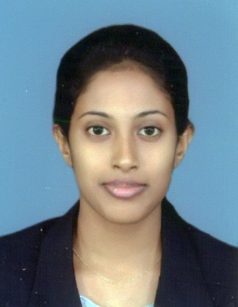

PERSONAL DETAILS

Name in Full : WeerasingheArachchilageAmaliWathsalaWeerasinghe

Name With Initials : W.A.A.W. Weerasinghe

Address : No 473, Danthure

Contact No : 081- 2575197/ 0718039164

E-Mail address : Weerasingheamali@gmail.com

Date of Birth : 27.01.1994

National ID No : 945270357V

Nationality : Sri Lankan

Gender : Female

Civil Status : Single

School Attended : Mahamaya Girls’ College Kandy

COLLEGE LEVEL EDUCATIONAL QUALIFICATIONS

**G.C.E Ordinary Level (Sinhala Medium) 2009**

Subject Grade

Mathematics A

Sinhala Language& lit A

Buddhism A

History A

English A

Drama A

Communication & Media Studies A

Science B

Commerce C

**G.C.E Advanced Level (Sinhala Medium) 2012**

Subject Grade

Business Studies B

Accounting C

Economics C

General English S

Common General Test057

PROFESSIONAL QUALIFICATIONS

**Chartered Accountants CAB1**

SubjectsMarks

Accounting 50

Business English 50

Mathematics & Statistics 58

Management & Business Economics 60

**Passed two subjects of Chartered accounts CAB 2**

Subject Marks

Business English 60

Fundamental of Management

Accounting & Business Finance 54

**AAT foundation level**

SubjectGrade

Basic accounting D

Business Mathematics & Statistics C

Economics A

Business Studies B

**OTHER QUALIFICATIONS**

|  |  |  |
| --- | --- | --- |
| Name of the institute | Qualification obtained | Subjects passed |
| Denuwara Zonal Computer  Resource Centre | Basic knowledge of Computer Skills | I.C.T. |

**WORKING EXPERIENCE**

Now I am working as an Accounts Clerk at Multi Financial Accountancy Accounts office, Heerassagala Road, Kandysince May, 2014.

**Names of Non-related Referees:**

1. Mr. P.G. Nawarathna, 2. Mr. Ravi Giragama

Accountant Branch Manager,

CeylincoInsurance PLC, UB Finance Company Limited,

No.94, No.75,

Kings Street, Yatinuwara Veediya,

Mathale. Kandy .Contact No:

0662223203 Contact No: 0812224405 0714904859 0719679398