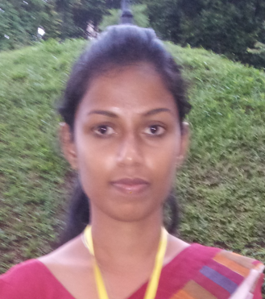

**RATHNAYAKA GEEGANA ARACHCHIGE SUBODHA DARSHANI**

***Contact Details:***

**“Abhaya niwasa”**

**499/D,**

**Urubokka**

**Mobile Phone : 0713800662**

**Email : darshani.subodha90@gmail.com**

**PROFILE**

An aspiring team worker, hard working and dedicated professional who wants to meet the challenges posed in the industry and to contribute towards the growth of the organization along with self-motivation.

**ACADEMIC QUALIFICATION**

I have followed the BA statistics (special) degree of the faculty of Social Sciences and Languages; of University of Sabaragamuwa.

**Major subject – statistics (English medium)**

**Minor subject –economics (English medium)**

**PROFESSIONAL SKILLS**

I have followed chartered Accountancy Course (CAB 1) in Institute of Chartered Accountants of Sri Lanka.

.

**EDUCATIONAL QUALIFICATIONS**

**G.C.E (A/L) (Mr/Urubokka national school) G.C.E (O/L) (Mr/Urubokka National School)**

Subject Grade Subject Grade

Business studies A Mathematics A

Economics B English A

Accounting B Sinhala A

Buddhism A

Agriculture A

Health & Physical Science B

Science B

Social Studies B

Art B

Geography C

**EXTRA CURRICULAR ACTIVITIES**

* I have participated in Sinhala day competitions and obtained certificates divisional and zones.
* I have participated in course for spoken English.
* Member of School Commerce Society.
* I have obtained a certificate from soft skill development programme conducted by John Keels Company Ltd.

**SKILLS AND COMPETENCIES**

* Computer Literacy
* Able to work in Ms-office package.
* Able to work with Internet and E-mail
* I have ability to type English, Sinhala Languages.
* I have ability to speak in English language
* Excellent Interpersonal & Communication skills.

**PERSONAL DETAILS**

* **Date of Birth :** 14.01.1990
* **Sex :** Female
* **NIC number :** 905142763V
* **Nationality :**  Sinhala
* **District :** Matara

REFERENCES

**Neelika Abeykoon**

Assistant Clerk of Regional Educational Director office

Near the Post Office

Urubokka.

Tel: +94 71 98 74098

**Mrs . R.M.L. Rathnayake**

BA Hons, Kelaniya, Sri Lanka   
MPhil (Statistics), Peradeniya, Sri Lanka

Senior Lecturer (Gr. II) in Statistics

Tel: +94(0)45 - 2280048

I hereby certify that the above information is true and correct to the best of my knowledge.

…………………..

Signature

.......................

Date