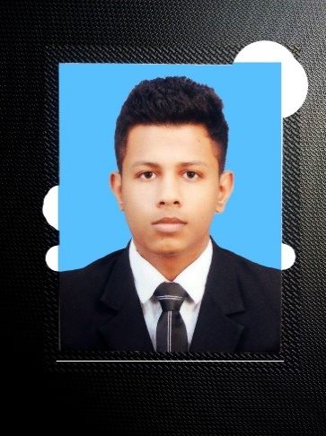Curriculum Vitae.

Mohamed Shameer

Mail : [shameerseven@gmail.com](mailto:shameerseven@gmail.com)

Mobile : (+94) 757 525 032

Personal Details

Name : Mohamed Shameer.

Full Name : Mohamed Iqbal Mohamed Shameer.

Date of birth : 21st May 1994

Marital Status : Single.

Gender : Male.

Permanent Address : 16/1, Nayawala, Mawanella

Nationality : Sri Lankan.

Passport No : -

Bilingual in : English, Tamil & Sinhala.

Educational Qualifications

* G.C.E – Ordinary Level. Passed the G.C.E Ordinary Level Examination in 2010 with the following results.

Result : 3B-5C-S

School : Baduriya Central College.

Year : 1999 - 2010

* G.C.E – Advanced Level. Qualified the G.C.E Advanced Level Examination in 2013 in the Commerce stream, with the following results.

Result : 2C-S

School : Baduriya Central College.

Year : 2011 - 2013

Professional Qualifications

* HND in Network Engineering. Currently following a Higher National Diploma at Pioneer Institute. Colombo - 07 (Advanced Technology Center).
* 1st Semester : Qualified.
* 2nd Semester : Qualified.
* 3rd Semester : Qualified.
* 4rth Semester : Reading…
* Network Administrator. Successfully completed Special Diploma in Networking Administrator at E-Win Networks Kandy…
* Student ID : 3414
* Diploma in Graphic Designing. Successfully completed Diploma in Graphic Designing at British College of Education Kandy…
* Student Registration No : DGD10122665

Other Qualifications

* Diploma in English. Successfully Completed a Diploma in English at IBS Campus Dehiwala.

Software Skills

* Adobe Photoshop
* Coral Draw
* Microsoft Office Packages

Language Skills

* English : Able to Speak, Fluent in Read & Write.
* Tamil : Fluent in Speak, Read & Write.
* Sinhala : Able to Speak.

Extra-Curricular Activities

Special Participations

* Participated in Provincial Software Competition.
* Participated in Esoft Photography Competition.

Other

* Member of Sri Lanka federation on Youth club.
* Member of Board of School Prefect (2006-2010)
* Member of School Art Club.
* Member of School Soccer Team
* Member of School Cricket Team
* Member of School Commerce Club.
* Have participated in School sport meet in Track & Field events.

Expertise Area

* Excellent Communication Skills.
* Excellent Leadership Skills.
* Excellent Public Relationship Skills.
* Ability to Handle Administrative Operations

Declaration

I do here by certify that the above particular are true and accurate to the best of my Knowledge



………………………….

Date Signature