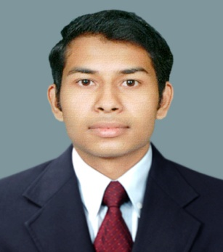**K.M.D.T Dhananjaya**

**No:74,Ampitiya road, Kandy**

**themeera47@gmail.com**

**081-2219836/071-4146044**

PERSONAL INFORMATION

Full name : Korale Mudalige Don Themeera Dhananjaya

Date of birth : 1991 January 10

School : Dharmaraja College

Nationality : Sri Lankan

Marital status : Single

PERSONAL PROFILE

* Have a sound knowledge of civil engineering field
* Excellent team work and leadership
* Computer literacy
* Language skills both Sinhala and English

PROFESSIONAL QUALIFICATION

* Successfully complete NATIONA CERTIFECATE IN INDUSTRIAL TECHNITION CIVIL at Aruppola technical college
* Successfully completed certificate course in computer at Sri Lanka Telecom with 3 month office training
* 3 months training at Business Promoters And Partners in Galigamuwa Awissawella road Project

EDUCATIONAL QUALIFICATION

* NATIONA CERTIFECATE IN INDUSTRIAL TECHNITION (CIVIL)
  + Mechanical engineering : D
  + Engineering surveying : D
  + Geology & soil mechanic : D
  + Structural mechanics : D
  + Computer : D
  + English : M
  + Engineering drawing : M
  + Engineering fundamental : M
  + Water supply and sanitation : M
  + Engineering applications : M
  + Building Constructions : M
  + Mathematics : M
  + Lab work : M
  + Materials in Construction : P
  + Construction Drawing : P
* GCE Advanced level(Combined Math)
  + Physics : S
  + Chemistry : S
  + English : C
* GCE Ordinary level
  + Science : A
  + Social studies : A
  + Buddhism : A
  + Business and accounting : A
  + General English : A
  + Health science : A
  + Dancing : A
  + Mathematics : B
  + Sinhala : C
  + English literature : S

EXTRA ACCTIVITIES

* + Secretary in Aruppola technical college students council
  + Member of school Astronomic society
  + Member of school Buddhist student society

REFERANCE

* Mr. E.M.K.N Jayaweera

“Project Engineer” (Road Development Authority)

102/A/1, Kawdupitiya,

Gampola,

Kandy.

Mobile -0718315103

Email [-emknjayaweera@yahoo.com](mailto:-emknjayaweera@yahoo.com)

* Mr. W.P.S Dharmakeerthi

“Engineer & Lecturer”

College of Technology,

Aruppola,

Kandy.

Mobile-0714847007

Email -sdkeerthi@yahoo.com

I do hereby certify that the above particulars submitted by me are true and correct to the best of my knowledge

………………………….. .……………………………

Date Signature