**Lahiru Deshan Hettiarachchi**

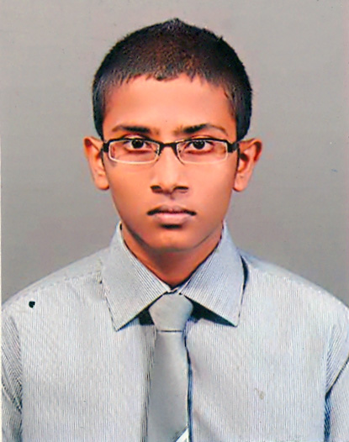

No.70, 1st lane, Rawathawatta, Moratuwa

**PERSANOL**

* Name in Full : Lahiru Deshan Hettiarachchi
* Date of Birth : 19-10-1993
* Address : No.70, 1st lane, Rawathawatta, Moratuwa
* Gender : Male
* Civil Status : Single
* Religion : Buddhist
* Nationality : Sir Lankan
* NIC number : 932932938v
* Telephone : 0755257707,0112641248
* E-mail : deshan1920@yahoo.com
* School Attended : Prince Of Wales’ College,Moratuwa

**EDUCATION**

* **GCE O/L Examination** – **2009**

(Index No: 90325818)

Subject Grade

Buddhism A

Mathematics C

English C

Science C

Sinhala C

Design Tech. C

Art C

Commerce S

History S

* **GCE A/L Examination – 2012**

(Index No: 4252624)

I’m awaiting results & my subjects were,

Accounting Business Studies Economics

* I followed Professional English course conducted by National Youth Services Council Maharagama – Sri Lanka.

I hereby certify that the above particulars are true and correct to the best of my knowledge and are submitted to your kind perusal.

.............................. Date : ............................

L.D.Hettiarachchi