131/65 F,

Jampettah Street,

Colombo-13

Sri Lanka

Dear Sir/Madam,

**APPLICATION: - SEEKING EMPLOYEMENT**

I am Pavithra George would like to seek employment at your company. I kindly request you to consider this application of employment and hope that I would receive a positive reply. Attached along with this application is a Biodata.

I shall be glad to provide you with any further information that you require in connection to this application. I also certify that the details that I have attached in connection with this application are true and correct to the best of my knowledge. I look forward to your fast and positive reply.

Thank You,

Yours Sincerely,

Pavithra George

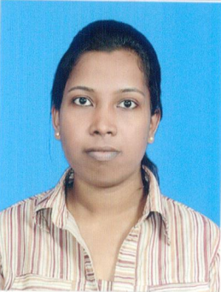**BIODATA:-PAVITHRA GEORGE**

**PERSONAL DETAILS**

* **Full Name :-** Pavithra George
* **Permanent Address :-** No.131/65F, Jampettah Stree**t**, Colombo 13, Sri Lanka.
* **Telephone Number :-** +94770733544
* **Email :**- pavithrageorge1@gmail.com
* **Date Of Birth :-** 18th May 1995
* **Nationality :-** Sri Lankan
* **Schools attended :-** C/St. Anne’s Girl’s Maha Vidyalayam.
* **N**.I.**C** **No** :­­­­- 956392063 v
* **Civil Status** :-Single

**PROFFESIONAL QUALIFICATIONS**

* Successfully completed MS office in 2014

Course : MS Office Application

Institute :I.S.S Campus

Reg. No :NM0922

**EDUCATIONAL QUALIFICATIONS**

* Passed GCE (O level) Examination with 4A’s 3B’s and 2C’s in 2011

Subject Grade

Maths A

Tamil A

Religion A

Health A

Science B

Tamil l.t B

Commerce B

English C

History C

* Passed GCE(A level) Examination under commerce stream in 2014

Subject Grade

Business studies C

Economic C

General English S

**COMMUNICATION**

* Good oral & written communication skills in English and Tamil.

**QUALIFICATIONS IN EXTRA CURRICULAR ACTIVITIES**

* Participated and got places in Essay & Speech Competitions
* Board member of school LEO club
* Secretary of Tamil Union Society
* Act as a Prefect during 2012-2014

**CAREER OBJECTIVE:-**

* I would like to engage myself where my skills would be greatly enhanced for my own professional growth

**NON-RELATED REFREE** **S**

1. Rev. Sister Mary Mable Fernando Pulle,

Principal,

C/St Anne’s Girls Maha Vidyalayam,

Colombo 13.

Tel: 011 2342646

1. Mr. Niroshan Croos,

Finance Executive,

John Keells Holdings,

89, Galle Road,

Colombo 03.

Tel: 075 5272195