Dear Mr. Mohammed,

Herewith I have attached a CV of very close relative and personally I would guarantee the sincerity, honesty and hard work.

He requires a Supervisor post or any other relevant Job, Will be requiring a salary of about Rs. 30 000.

Your effort is highly appreciated.

Thank you

**Suncity Travels & Tours (Pvt) Ltd**

Sharmila Zackie

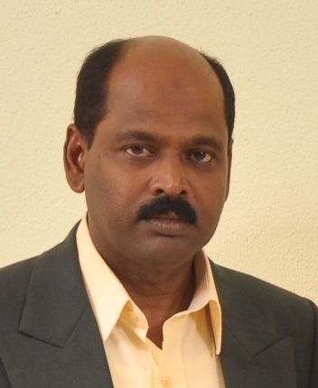

**Application for the post of Cleaning Supervisor or**

**Any Other Suitable Post**

Curriculum Vitae

Name In Full: Mohideen Abdul Cader Mohammed Nowzer

Postal Address: 27/6 palitha place,Dematagoda, Colombo -09

Contact Number : +94725630106 / +94112693401

DateofBirth : 23/10/1961

Age: 53 Years

Status: Married

Religion: Muslim

Nationality: Sri Lankan

Education Qualification: G.C.E [O/L] Examination

Achieve‘s’ grade in commerce/English /Islam and social studies subjects

Language Skills: - Fluency in English-Spoken and Written

- Fluency in Arabic – Spoken

- Fluency in Hindi – Spoken

-Fluency in Tamil –Spoken

- Fluency in Sinhala- Spoken and Written

**Work Experience: 20 Years [Middle East]**

2012/07-upto Date General Supervisor

Stylee Garments Pvt Ltd.

625 Aluthmawatha road,

Modara, Colombo -15 (Sri Lanka)

2011 to 2012 Housekeeping supervisor

Princess Noura University (PNU)

Riyadh-K.S.A

2006 to 2011: Housekeeping Supervisor

Al Dana Tower, [Building]

Qatar Petroleum,

Doha Qatar

2004 to 2005: Cleaning Supervisor at Al Mafraq Hospitals

Abu Dhabi-U.A.E

1996 to 2002: Cleaning Supervisor at Ashok Trader IGC (Pvt)

p.o.Box:1637

Sea Street

Colombo 11, Sri Lanka

1993 to 1995: Floor supervisor

Jw Marriot Hotel,

Dubai –U.A.E

1989 to 1992: Housekeeping Supervisor at General Presidency of youth

Welfare sports Medicine Hospital Project,

Riyadh- K.S.A

1985 to 1989: lead Housekeeper at Nassim Compound,

Gama Service Ltd.

Al Nassim Riyadh – K.S.A

1982 to 1985: Housekeeping in charge at Jeddah International Airport clinic,

Gama Service Ltd

Jeddah-K.S.A

1979 to 1981: Housekeeper at Al –Ibrahim Al- Mohannadi house,

Po Box: 20053

Al Khore

Doha Qatar

I am fully confident that if I am given an opportunity to prove my talent, I will perform all the assigned tasks with utmost diligence and sincerity.

Yours faithfully,

M.A.C.M.NOWZER