**K.A. Lakna Madavi Rathnayaka**

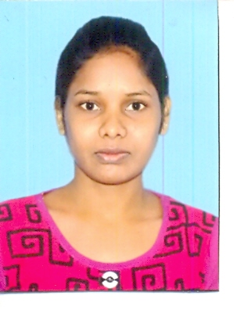

**Pahala Andaluwa,**

**Kolomba Ge Are.**

**Voice – 0719199838**

**Text -** [**kalaknamadavi@gmail.com**](mailto:kalaknamadavi@gmail.com)

**CAREER OBJECTIVE**

**Following a challenging career in an organization where I can contribute to the growth of the organization with my skills & competencies.**

**EDUCATIONAL QUALIFICATIONS**

**(1)Passed G.C.E. Advance Level Examination (2005)**

|  |  |
| --- | --- |
| **Subject** | **Grade** |
| **Economics** | **C** |
| **Business Studies** | **C** |
| **Accounting** | **C** |

**(2)Passed G.C.E. Ordinary Level**

|  |  |
| --- | --- |
| **Subject** | **Grade** |
| **Sinhala** | **B** |
| **Social Studies** | **S** |
| **English** | **S** |
| **Mathematics** | **C** |
| **Buddisum** | **B** |
| **Science** | **C** |
| **Commerce** | **A** |
| **Dancing** | **S** |

**(3) I have completed Degree (ex)**

**B.sc Business Administration (Gen) (ex)**

**Sri Jayawardhanapura University.**

**EXTRA CURRICULAR ACTIVITIES**

1. **Prefect in R/EM/Kolomba Ge Are m.v.**

**PROFESSIONAL QUALIFICATIONS**

**I have followed a computer course (Computer Application Assistant NVQ Level 3) in Tertiary and Vocational Education Commission.**

**PERSONAL DETAILS**

* **Full name : Kadawatha Arachchillage Lakna Madavi Rathnayaka**
* **Name with initials : K.A. Lakna Madavi Rathnayaka**
* **Home Address : Pahala Andaluwa, Kolomba Ge Are.**
* **NIC number : 867830790V**
* **Date of Birth : 09th October 1986**
* **Gender : Female**
* **Civil Status : Single**
* **Nationality : Sri Lankan**
* **School : R/EMB/Kularathna Central College**

**NON RELATED REFREES**

**H. W. Wije Santha Amaradasa Senadheera**

**Grama Niladhari Principle**

**Maduwanwela R/EMB/ Nindagampalassa Vidyalaya**

**Voice-0776438183 Voice- 0724718147**

**I certify that the above details are true and correct.**

**…………………………………………………… ……………………………………………………**

**Date K . A . Lakna Madavi**