**W.B. Jithmi Sandurika Somarathne**

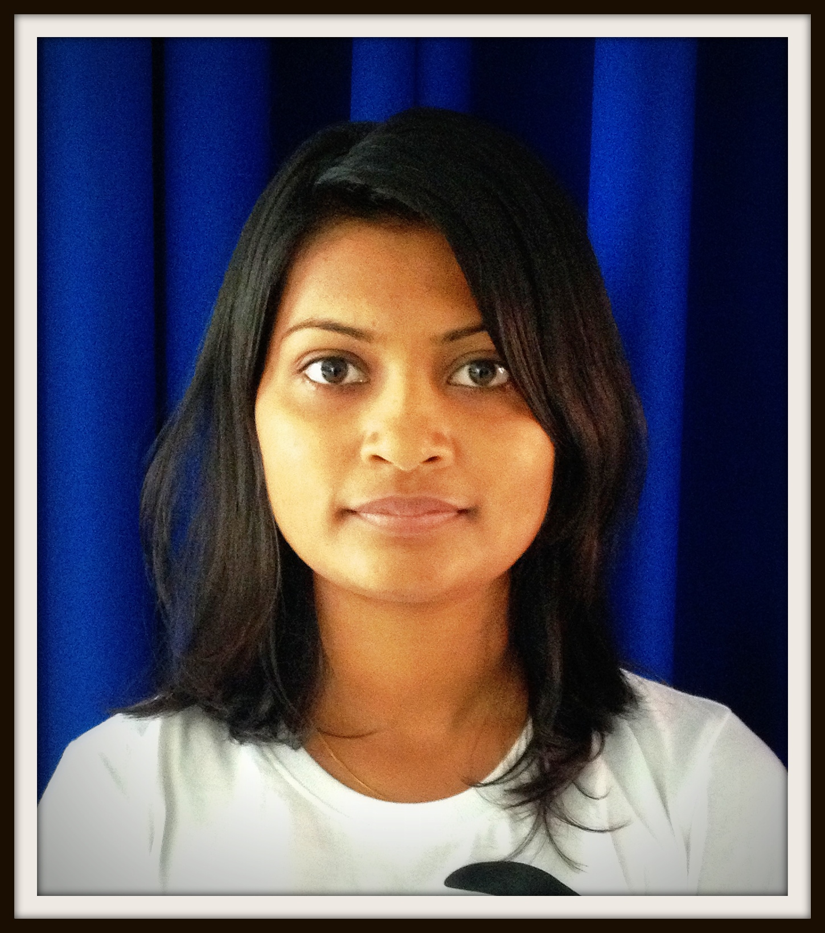

**No:232, Kumarathunga Mw, Matara.**

[**Tel:041**](Tel:041) **22 27 503**

**Mobile:071 37 39 377**

**E mail:** [**jithmisomarathne@gmail.com**](mailto:jithmisomarathne@gmail.com)

Personal Profile

Name with initials: W.B.Jithmi Sandurika Somarathne

Given Name : Watawana Badalge

Date of Birth : 20th December 1991

Age : 22 years

NIC No : 918553169V

Sex : Female

Civil Status : Single

Religion : Buddhism

Personal Dynamics

* Easy to adapt any working environment
* Ability to work under pressure
* Team Player
* Young dynamic innovative thinker

Secondary Education Background

* Sat for the G.C.E. (A/L) in 2011 & got B Pass for General English.
* Sat for the G.C.E. (A/L) in 2010 & got through with one “B” pass, two “C” passes.
* Sat for the G.C.E. (O/L) in 2007 & got through with three “A” passes, three “B” passes, three “C” passes & one “S” pass.

Tertiary Education Background

* Sat for the CBF exam of IBSL in 2012 September & got through Structure of Accounting with “C” pass.
* An English Diploma has been obtained at the MES Campus, Matara, With First Class
* An Information Technology Diploma has been obtained at the ICBT Southern Campus, Matara, with Merit Pass

Working Environment

* I have worked at The Matara District Chamber of Commerce & Industry for 9 months as The Project Co-ordinator.
* Currently working at Wisdom Business Academy as a Junior Executive.

Non Related Referees

1. Name: Charitha Buddhika Rajapaksha

Title : Credit Officer

Address: Union Bank PLC, No: 07, Station Rd, Matara.

T.P.No: 077 70 42 455

1. Name : Suran Patabedige

Title : Manager Operations

Address: Wijeweera Garment (Pvt) Ltd, No:346, Galle Rd, Matara.

T.P.No: 077 90 04 709

I declare that above details are given by me are true and accurate to the best of my knowledge.

……………………….. ………………………

Date Signature