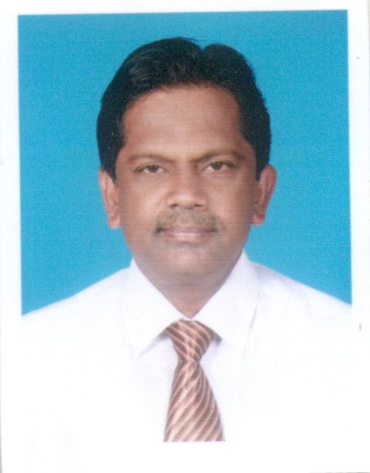

**CURRICULAM VITAE OF**

**I.M.LASANTHA DISSANAYAKE**

**077-3914764**

**E: mail: lasantha_d@yahoo.com**

**Career Objectives:**

To Employment in an interesting and Challenging Position that I can utilize my knowledge, Skills and Training.

Present Employment:

From 2010 to date, the Sri Lanka Volleyball Federation,

Torrington Avenue, Colombo 07, as an Administrative Assistant

Previous Employment:

i. From 1987 to 1995 - Sri Lanka Law College,

Hulftsdorp Street, Colombo 12, Clerical Staff- as a Clerk/Typist

ii. From 1996 to 1997 - at the Sri Lanka Association for The Advancement of Science, Vidya Mawatha, Colombo 07, as Clerical/Technical and Supervisory.

iii. From 1997 to 1999 - National Olympic Committee of

Sri Lanka, Torrington Avenue, Colombo 07,

As an Administrative Assistant/Typist

iv. From 1999 to 2009 - Muslim Commercial Bank, Colombo,

at the International Trade.

Page…2

Personal Profile:

* Highly organized, dedicated with a positive attitudes.
* Work well under pressure, diplomatically and tactfully.
* Ability to communicate well with clients and professionals.
* Problem solver, team player, ability to work independently
* Punctual, realistic, enthusiastic, honest and work flexibility.

Education:

* Up to the G.C.E. (O/L) Examination

Personal Data:

Gender : Male

Date of Birth : 28th December, 1963

Marital Status : Married

Nationality : Sri Lankan

Religion : Roman Catholic

Height & Weight : 5 - 7” & 65kg.

Address : 700/6, Pelengahena, Gonawala, Kelaniya

Contact Nos : 077-3914764

Referees:

Mr.K.R.D.C. Rathnamudali Mr. Ashley de Abrew

Director - Physical Education Dept. Administrative Secretary

University of Moratuwa Sri Lanka Volleyball Federation

Katubedda, Moratuwa 33, Torrington Place, Colombo 07

077-9393088 07777-34589

While thanking for spending your precious time in reading my Curriculum Vitae, I

Assure you that the above mentioned details are true and correct according to my

Knowledge.

**I.M.L. Dissanayake**