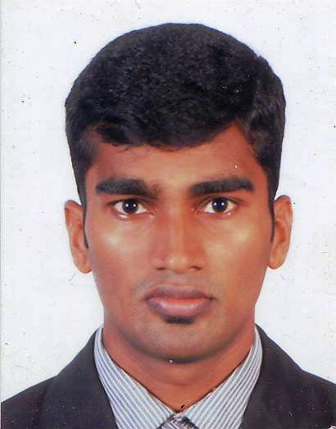Name: Rajhkumar Nishanthan

Address

No,24/2.2/2

Manning Place,

Colombo 06

Contact number: +94775237135

Date of birth:1989.09.28

Nationality :Srilankan

Marital status: single

Language known: Tamil, English and Sinhala can manage.

Mail ID: [nishanthan028@gmail.com](mailto:nishanthan028@gmail.com)

Vision

To be an outstanding of an organization

Objective

I like to be an honorable person for an organization

Personality profile

Excellent interpersonal and communication skills providing the ability to effectively communicate and work together with a wide field of responsibilities, and management levels. Leadership abilities with willingness to take risks while working to advance a team player approach with diverse groups of people.

Working experience

Student manager (Student service unit of people’s Bank) from **02.05.2008 to 31.05.2009**.

One year experience in sales and marketing ( Ceylinco life insurance **2011 to 2012**) Computer trainee one year **2013 to 2014**

occasional qualification

Successfully completed Diploma in Computer Studies. Diploma in Information Technology

Successfully completed Diploma in Computerized Accounting

Successfully completed Special Diploma in Network Administration

Successfully completed Diploma in Marketing Management & Finance

Successfully completed Diploma in Web design and Development

Now follow CCNA courses

Educational qualification

**Passed the G.C.E. Ordinary Level Examinations in 2006 B, 2C, 6S**

**Passed the G.C.E. Advance level in 2009 Commerce Stream**

Accounting S

Business studies S

Economic C

Extracurricular Activities

Student manager of People’s Bank.

Member of Scout {District Commissioner’s Award}

Member of School Prefect