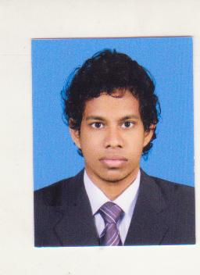**CURRICULUM VITAE**

**WARUSHAHENNEDIGE RALDILU PRAMUDITH SOYSA**

**No.578/9, Galle Road, Panadura.**

**Tel.0382235379 / 0771975078**

**Email. randilu.s@gmail.com**

**PERSONAL DETAILS**

* **Full Name** : Warushahennedige Randilu Pramudith Soysa
* **Date of Birth** : 21st August 1993
* **Sex** : Male
* **Civil Status** : Single
* **Religion** : Buddhist
* **Nationality** : Sri Lankan
* **N.I.C No** : 932340488V
* **School Attended** : D.S.Senanayake College,Colombo 7

**EDUCATIONAL QULIFICATIONS**

* **G.C.E.(A/L) - Examination 2013**

**Medium:**English Medium **Index No**. 7063253

**Subject** **Grade**

Physics A

Combined Mathematics B

Chemistry B

* **G.C.E.(O/L) - Examination 2009**

**Medium:** English Medium **Index No**. 90102550

**Subject** **Grade**

Science A

Sinhala A

Buddhism A

English A

Mathematics A

History A

Commerce A

English Literature A

Information Technology B

**OTHER QUALIFICATIONS**

* I have completed the English language Course at the British Council
* I have completed a Diploma in Computer hardware engineering
* I have completed a Certificate Course in Computer applications

**PROFESSIONAL QUALIFICATIONS**

* I have completed the certificate level and the operational level of CIMA
* I am currently following the management level in CIMA

**EXTRA CURRICULAR ACTIVITIES**

* I have represented the school swimming team and was a member of Sri Lanka Schools’Aquatic Sports Association
* I was a member of the school Junior Prefects Guild
* I was a member of the School Junior Western Band & The Primary Choir

**NON RELATED REFERESS**

Dr. Bandula Abeysinhe, Dr. Deepal Fernando,

Colombo South Hospital, Base Hospital,

Kalubowila. Horana.

Tel : 0718153242 Tel : 0342262001/0773605950

I solemnly state that above particulars given me is true and accurate to the best of my knowledge and in case of me being selected to a selected to a suitable position, I would execute my duties to the maximum satisfaction of the management and my superiors.

………………………………... ……………………

Signature of Applicant Date