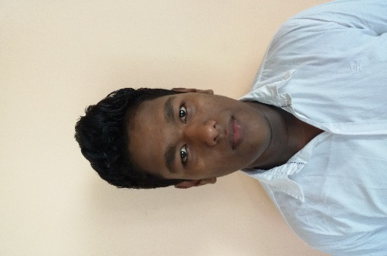 **BIO DATA**

**OBJECTIVES**

* To be a professional and contribute to the organization where I am working to achieve competitive advantages in the industry via integrating knowledge.
* I would like to work in a position that is interesting & challenging which in-turn will empower me to develop my career and to move up the corporate ladder by being a part of an excellent team.

**PERSONAL DETAILS**

**Full Name with Initials :** G.N.D.PERERA

**Names donated by initials :** Gonaduge Nuwan Darshana Perera

**Permanent Address :** No 06 Sooriya purawara

Panapitiya

Waskaduwa

**Date of Birth** **:** 15/02/1995

**Marital Status :** Single

**Nationality :** Sri Lankan

**National Identity Card No :** 950461918v

**Ethnicity** **:** Sinhalees

**Blood Group :** B+

**Mobile Number :** 0766972158

**Schools Attended :** K/kalapugama k.v

Kalutara Vidyalaya National School

**ACADEMIC QUALIFICATIONS**

1. **G.C.E. (Ordinary Level) Examination**

**Index No :** 11046120

**Year :** 2011

**Subject Grade**

Buddhism : A

Science : B

History : : C

Sinhalese : C

Art : C

Mathematics : : C

English : : S

Commerce : S

I.C.T : S

1. **G.C.E (Advanced Level) Examination**

**Index No:**1712314

**Year :**2014

**Subject Grade**

Business Studies : A

Economics : A

Accountancy : C

General English : F

General Test : 58%

1. **General Information Technology Examination**

**Year**  **:** 2013

**Subject** **Grade**

General I.T : B

I do hear by declare that above mentioned information are true and accurate to the best of my knowledge.

……………………… ………………………….

(Date) (Signature)