Cairo University  
Faculty of Computers and Information



**CS251**

**Software Engineering I**

Game4learn

Software Requirements Specifications

*Mostafa Mohamed*

*Mohamed Abdel Baset*

*Mohamed Wahid*

*Medhat Saleh*

November 2016

# Contents

1. Contents…………………………………………………………………………………………………………………………………………………2
2. Team 3
3. Document Purpose and Audience 3
4. Introduction 4

Software Purpose 4

Software Scope 4

Definitions, acronyms, and abbreviations 4

1. Requirements 5

Functional Requirements 5

Non-Functional Requirements 6

1. System Models 7

Use Case Model 7

Use Case Tables 8

1. Ownership Report 13
2. Policy Regarding Plagiarism: 13

# Team

|  |  |  |  |
| --- | --- | --- | --- |
| **ID** | **Name** | **Email** | **Mobile** |
| 20140272 | Mostafa Mohamed Abdel Rahman | mostafa2369@gmail.com | 01144898425 |
| 20140229 | Mohamed Abdel Baset Mostafa | [mohamed.angel17@yahoo.com](mailto:Mohamed.angel17@yahoo.com) | 01147903362 |
| 20140258 | Medhat Saleh Mohamed | Medhattantawy505@gmail.com | 01212506516 |
| 20140243 | Mohamed Wahid Mohamed | matrixh55444@gmail.com | 01112152450 |

# Document Purpose and Audience

**Purpose**: show functional requirements and nonfunctional requirements like performance, usability and the use cases model and project purpose and the scope of project.

**Audiences:** The audience includes the developers, the project manager, the client.

# Introduction

## Software Purpose

Game4learn help students to learn in Simple and fun way. Instead of traditional way, Growing mathematical students skills, enhancing their brain power and fit the alphabetical knowledge and reaching to high learning based on good technique.

## Software Scope

## Game4learn is a web application that works on PC and Smart Phone Platform. That include educational games. Focuses on online learning. The system contains three main category Animals Games, Math Games and Alphabetical Games. Games will be played by one student. Which created by his teacher.

## Definitions, acronyms, and abbreviations

|  |  |
| --- | --- |
| **Feedback** | Student writes his/her imprecisions and opinion, and if there are bugs or a game he wants to play on Game4learn. |
| **Category** | it is including the game from same type like Animals games, Math games and alphabetical games. |

# Requirements

## Functional Requirements

Game4learn student able to:

* Sign up
* Login
* Select category
* Select game
* Search for games
* start game
* Change game
* View Score
* Write feedback
* Update account
* Logout

**Sign up**

student sign up and make account contain name, birth date, gender, country.

**Login**

student enter his/her username and password to access Game4learn.

**Select category**

The student chooses the category of games to view games of same category.

**Select game**

The student selects game.

**Search for games**

The Student search for the games.

**start game**

The Student play game by click on start game.

**Change game**

The Student changes game from the list of games at bottom of page.

**View Score**

Student view his/her Score in any game.

**Write feedback**

The student can write feedback or rate the game.

**Update account**

The Student updates his/her account information.

**Logout**

The Student can logout from account.

## Non-Functional Requirements

|  |  |
| --- | --- |
| **Usability** | **Easy to use Game4learn**: by using search method it is easy to find games, menu in the left that facilitate the movement between pages and a menu of games of same category of the game at the bottom of the page that facilitate the choose of games.  **Playing:** playing games is very easy and simple, by choosing game from the category or search for the game. |
| **Reliability** | Game4learn makes learning and teaching simple and easy and contain various categories and games that makes students learn a lot of subjects of various categories. |
| **Performance** | Game4learn take 2 seconds to access games (according to internet connection) and learn, system is always stable. |
| **Security** | the students accounts are very secure and their information are private and Game4learn have a strong security. |
| **Maintainability** | According to feedback, we maintain games if there is bugs and somethings like that, we update games, improve using Game4learn and if there is any addition the student need to facilitate the use of Game4learn we work on it. |

# 

# System Models

## Use Case Model

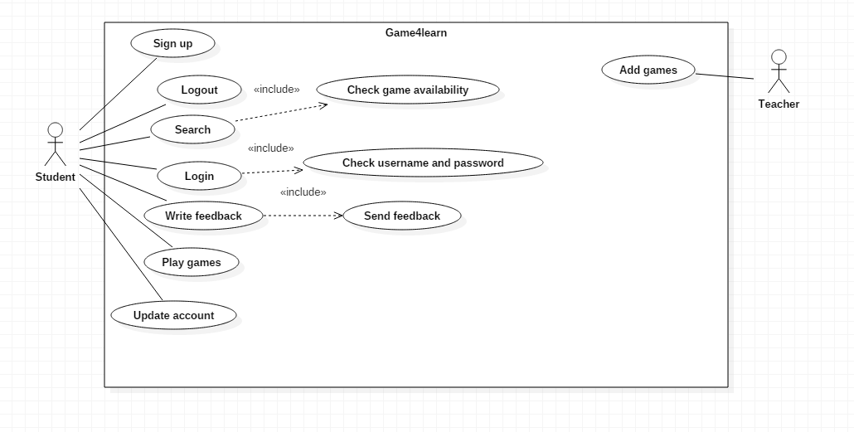

**Student**: person who play games and learn.

**Teacher**: person who add Games and see feedback.

**Developers team:** who maintain Game if there are bugs and improve Game4learn.

## Use Case Tables

|  |  |  |
| --- | --- | --- |
| Use Case Name: | Play Game | |
| Actor: | Student | |
| Pre-conditions: | Login to Game4learn | |
| Post-conditions: | Starting game | |
| Flow of events: | **Student Action** | **System Action** |
| 1- Select game. |  |
|  | 2-open the game and view “start game” button. |
| 3- select start game. |  |
|  | 4- run game. |
| 5- play the game and learn. |  |

|  |  |  |
| --- | --- | --- |
| Use Case Name: | Sign up | |
| Actors: | Student | |
| Pre-conditions: | Enter Game4learn | |
| Post-conditions: | Finish sign up  Login to Game4learn | |
| Flow of events: | **Student Action** | **System Action** |
| 1- Select “Sign up” button. |  |
|  | 2- view sign up page and ask to enter new username. |
| 3- Enter his/her username. |  |
|  | 4- ask for new password. |
| 5-Enter password |  |
|  | 6-ask for Gender |
| 7-Enter his/her Gender. |  |
|  | 8-Make new account and Login into Game4learn |

|  |  |  |
| --- | --- | --- |
| Use Case Name: | Write feedback | |
| Actors: | Student | |
| Pre-conditions: | Student finish playing the game | |
| Post-conditions: | Finish writing feedback  Select submit feedback | |
| Includes: | Send feedback. | |
| Flow of events: | **Student Action** | **System Action** |
| 1- select “Write feedback” button. |  |
|  | 2- view feedback writing box. |
| 3- Write the feedback of the game  Then select “Submit” button. |  |
|  | 4- Accept feedback and send it to developer’s team to see if there is a maintenance and to teachers. |

|  |  |  |
| --- | --- | --- |
| Use Case Name: | Check username and password. | |
| Actors: | Student | |
| Pre-conditions: | Student Enter username and password. | |
| Post-conditions: | System finish checking. | |
| Flow of events: | **Student Action** | **System Action** |
| 1-Enter Game4learn website. |  |
|  | 2-Ask for username. |
| 3- Write his/her username in “username” box. |  |
|  | 4- Ask for password. |
| 5- Write his/her password then press “Login” button. |  |
|  | 6- Check the availability of account and check if password is wrong. |

|  |  |  |
| --- | --- | --- |
| Use Case Name: | Search | |
| Actors: | Student | |
| Pre-conditions: | Login to Game4learn. | |
| Post-conditions: | Find the required game. | |
| Flow of events: | **User Action** | **System Action** |
| 1- select “Search game” button. |  |
|  | 2- view search box. |
| 3- Enter the game name in search box. |  |
|  | 4- search for the game and view it. |
| Exceptions: | **User Action** | **System Action** |
| 1- Enter a game that not found. |  |
|  | 2-View “Game not Found” message. |
| Includes: | Check Game availability. | |
| Notes and Issues: | Student can write a feedback with the game name and description he/she wants then developers team make the game and teacher add this game. | |

# Ownership Report

|  |  |
| --- | --- |
| **Item** | **Owners** |
| Document Purpose and Audience | *Mohamed Wahid* |
| Software Purpose and Scope | *Medhat Saleh* |
| Functional and Non-Functional Requirements | *Mohamed Abdel Baset* |
| Definitions, acronyms, and abbreviations  Use case Model  Use case Tables | *Mostafa Mohamed* |

# Policy Regarding Plagiarism:

1. تشجع الكلية على مناقشة الأفكار و تبادل المعلومات و مناقشات الطلاب حيث يعتبر هذا جوهريا لعملية تعليمية سليمة
2. ساعد زملاءك على قدر ما تستطيع و حل لهم مشاكلهم فى الكود و لكن تبادل الحلول غير مقبول و يعتبر غشا.
3. أى حل يتشابه مع أى حل آخر بدرجة تقطع بأنهما منقولان من نفس المصدر سيعتبر أن صاحبيهما قد قاما بالغش.
4. قد توجد على النت برامج مشابهة لما نكتبه هنا أى نسخ من على النت يعتبر غشا يحاسب عليه صاحبه.
5. إذا لم تكن متأكدا أن فعلا ما يعد غشا فلتسأل المعيد أو أستاذ المادة.
6. فى حالة ثبوت الغش سيأخذ الطالب سالب درجة المسألة ، و فى حالة تكرار الغش سيرسب الطالب فى المقرر.