HackerRank Orchestrate (October 2026)
Ghost Data Still Exists
Deletion-Audit Agent: Complete Project Explanation
A beginner-friendly guide to what the project does, how it works, how it is built and tested, and where its limits are. No programming knowledge required.

Document facts
Based on | The repository hackerrank-orchestrate-october26, branch claude/exciting-lamport-yrcfpx, commit be370a2
Implementation | C# on .NET 10 (originally Python; converted completely, output unchanged)
Answer file fingerprint | SHA-256 of output.csv starts with 4676156f
Checked while writing | Build clean (warnings are errors); 457 tests passed; output.csv reproduced byte for byte
Prepared on | October 25, 2026

Contents
0. How to read this document 3
0.1 Who this is for 3
0.2 How the document is organised 3
0.3 Conventions used 3
1. Project overview 3
1.1 The story behind the project 5
1.2 What the program does, in one paragraph 5
1.3 Why such a program is needed 5
1.4 The problem it solves, as a checklist 6
1.5 What goes in and what comes out 6
1.6 The core idea in one sentence 7
1.7 The results at a glance 7
2. The end-to-end pipeline 9
2.1 Where execution starts 9
2.2 The whole pipeline in one picture 10
2.3 Phase A - start-up (done once) 11
2.4 Phase B - the audit of one case 11
2.5 Phase C - finishing and writing output.csv 12
2.6 How the answer for one case travels - a data-flow table 12
2.7 What happens when you type make run 13
3. File-by-file explanation 14
3.1 The folder structure 14
3.2 Files at the repository root 14
3.3 The input data: dataset/ 15
3.4 The solution layout: code/ 16
3.5 The library: code/src/Auditor/ 17
3.6 The tests: code/tests/Auditor.Tests/ 19
3.7 The tools: code/tools/Auditor.Tools/ 20
4. Methods and algorithms 22
4.1 Is it a deletion request? (the classifier) 22
4.2 Who is this person? (identity reconstruction) 23
4.3 Reading the evidence (parsing) 24
4.4 Linking records to the person 26
4.5 State at audit_at (the time-window rule) 26
4.6 Finding records that have no identifier (discovery) 27
4.7 Applying the policy (rules to verdicts) 28
4.8 Building and ordering the steps 29
4.9 Deciding the status and choosing the evidence to cite 29
4.10 Validation: a second pair of eyes 30
4.11 The optional screenshot reader 30
4.12 Settings, versions, caching and resuming 31
5. Libraries and technologies 32
6. Worked examples 34
6.1 Example A - a search copy remains (case_06, answer INCOMPLETE) 34
6.2 Example B - nothing left except the proof (case_01, answer COMPLETE) 35
6.3 Example C - a request from an old e-mail address (case_10, INCOMPLETE) 36
6.4 Example D - a backup that could bring the data back (case_17, INCOMPLETE) 37
6.5 Example E - ordering with a data flow (case_15 and the synthetic case XC-14) 37
6.6 Example F - a request that is not a deletion request (case_534) 38
6.7 Example G - verifying a deletion that the person says is done (case_21, COMPLETE) 38
6.8 What the explain command prints (excerpt) 39
7. Design decisions 40
7.1 Why deterministic logic instead of an AI model (an LLM) 40
7.2 What would happen if a part were removed or changed 40
7.3 The main decisions, in short 42
8. Testing and execution 43
8.1 What you need 43
8.2 Step-by-step: from a fresh copy to an answer file 43
8.3 Command-line options of the program 44
8.4 What the tests do 44
8.5 How quality is evaluated 45
8.6 Packaging for submission 45
8.7 Using a real model (optional, never done) 46
9. The output explained 47
9.1 The file output.csv 47
9.2 The three statuses 47
9.3 The seven fields of every step 47
9.4 The fifteen operations 48
9.5 Remediation steps and verification checks 49
9.6 Retained records and tombstones 49
9.7 How to read any row in four questions 49
9.8 The numbers behind output.csv 49
10. Limitations, assumptions and possible improvements 51
10.1 Known weaknesses 51
10.2 Assumptions the program makes 52
10.3 Things that could not be verified 52
10.4 Possible improvements 52
Appendix A. Glossary 54
Appendix B. Command cheat sheet 56
Appendix C. The fifteen policy rules and what the program does with them 57
Appendix D. The 23 synthetic evaluation cases 59
Appendix E. Suggested reading order for a newcomer 60

0. How to read this document
This document explains the project called "Ghost Data Still Exists - Deletion-Audit Agent" from scratch. It assumes that you have no programming knowledge. Every technical word is explained the first time it appears, and again in the glossary at the end (Appendix A). Everything written here is based on the actual files in the repository; nothing was invented. Where something could not be checked, it is marked clearly.

0.1 Who this is for
- Someone who has never written code and wants to understand what the project does and why it is built the way it is.
- A reviewer or interviewer who wants a map of the repository before reading any code.
- A developer who is new to the project and wants the big picture before opening a file.

0.2 How the document is organised
Chapter | What you will learn
1. Project overview | What the program does, why it is needed and which problem it solves.
2. End-to-end pipeline | Where the program starts, how data moves through every stage, and how output.csv is produced.
3. File-by-file explanation | What every important file and folder is for, and why it matters.
4. Methods and algorithms | How requests are classified, people are identified, evidence is read, rules are applied and the result is decided.
5. Libraries and technologies | What each ready-made component does, why it was chosen and what could replace it.
6. Worked examples | Real inputs from the dataset, followed step by step to the real answers.
7. Design decisions | Why fixed rules are used instead of an AI model, and what would break if parts were removed.
8. Testing and execution | How to set up, build, test, run, evaluate and package the project.
9. The output explained | What COMPLETE, INCOMPLETE, NOT_APPLICABLE and every step mean.
10. Limitations | Known weaknesses, assumptions, things that could not be verified and ideas for improvement.
Appendices | Glossary, command cheat sheet, list of policy rules and the list of synthetic test cases.

0.3 Conventions used
- Words in this style are exact names from the repository (file names, commands, columns, values).
- Bold marks an important term or conclusion.
- Coloured boxes: blue = a note; green = good to know; orange = important; red = something that could not be verified.
- File paths are written relative to the repository root, for example code/src/Auditor/Audit.cs.
- The page numbers in the Contents were filled in when the document was produced. If they look slightly off in your word processor, right-click the Contents and choose "Update field".
- Person names and e-mail addresses from the dataset are masked or left out in this document. The dataset is fictional, but there is no reason to copy personal-looking data into a document.
What was and was not verified while writing this document
Verified by running the project: the build, the full test suite (457 tests passed), the run that produces output.csv (its SHA-256 fingerprint is 4676156f...), the --explain command used for the worked examples in Chapter 6, and the generated reports in code/evaluation/.
Verified by reading the source code: every description of how a component works.
Not verifiable here: how a real AI vision model reads the 11 screenshots (no model was ever called); whether the answers for the 486 requests that have no known correct answer are right; how the program behaves on a different dataset. Chapter 10 lists these.

1. Project overview

1.1 The story behind the project
The project is a challenge called HackerRank Orchestrate (October 2026): "Ghost Data Still Exists". Its task description (problem_statement.md) tells the story of an imaginary online shop, Northstar Shop. A customer asked the shop to delete their data. Every dashboard in the company showed the deletion as "Complete". Weeks later the same customer tried to open a new account and was told: "This email is already registered." The customer's data had never really disappeared: copies were still sitting in secondary databases, support attachments, search indexes, analytics exports, logs, archives and backups. Worse, a synchronisation job had re-created data that the main account system had deleted. The company lost 2.4 million dollars.
The lesson: a status that says "Complete" is only a claim. To know whether a person's data is really gone, somebody has to look at the actual systems.

1.2 What the program does, in one paragraph
The program is a deletion-audit agent. For each deletion request in a list of 518 requests, it (1) decides whether the person really asked for deletion, (2) works out who the person is, including old e-mail addresses and phone numbers, (3) searches all supplied evidence for every copy of that person's data as it was at one chosen moment in time, (4) compares each copy with the company's deletion policy, and (5) writes a verdict plus a list of ordered steps: what is still wrong, what must be done about it (in a safe order) and which checks must pass afterwards.
The program never deletes anything
It is an auditor, not a cleaner. It only reads the supplied files and writes a report (output.csv). The "remediation steps" in the report are proposals for engineers to carry out later. Nothing in the project connects to a real database or changes real data.

1.3 Why such a program is needed
- Deletion workflows lie. A workflow can report "COMPLETE" while data remains. The input table even says so: of the 518 requests, 254 are reported as COMPLETE, 152 as PARTIALLY_COMPLETE and 112 as NOT_STARTED (counted from dataset/deletion_requests.csv). The program must not trust any of these labels.
- Data lives in many places. One person can appear in the account database, a search index, a cache, a support ticket, an analytics table, an export file, a log, a legal-hold register and a backup.
- Some data must stay. Laws and company policy require some records to be kept (for example security audit logs and records under legal hold). Deleting those would be a different kind of mistake. So "delete everything" is not the right answer either.
- Some processes can bring data back. An active synchronisation job or a backup restore can re-create deleted data. A deletion is only really complete when these paths are closed too.
- People change their identifiers. A request may come from an old e-mail address, while the evidence mentions the new one (or the other way round). Records must be found through all of a person's identifiers.

1.4 The problem it solves, as a checklist
According to the task description, a deletion is complete only when all four of these are true:
- every relevant copy has received the treatment required by the policy file deletion_rules.csv (delete, redact, anonymize or keep);
- no active synchronisation, import or restore path can recreate the data;
- records that must be retained contain only the identifiers the rules allow; and
- records that must be retained are still available.
For every request, the program answers three questions: Is it complete? What is still wrong? What must be done, in what order, and how do we prove it afterwards?

1.5 What goes in and what comes out
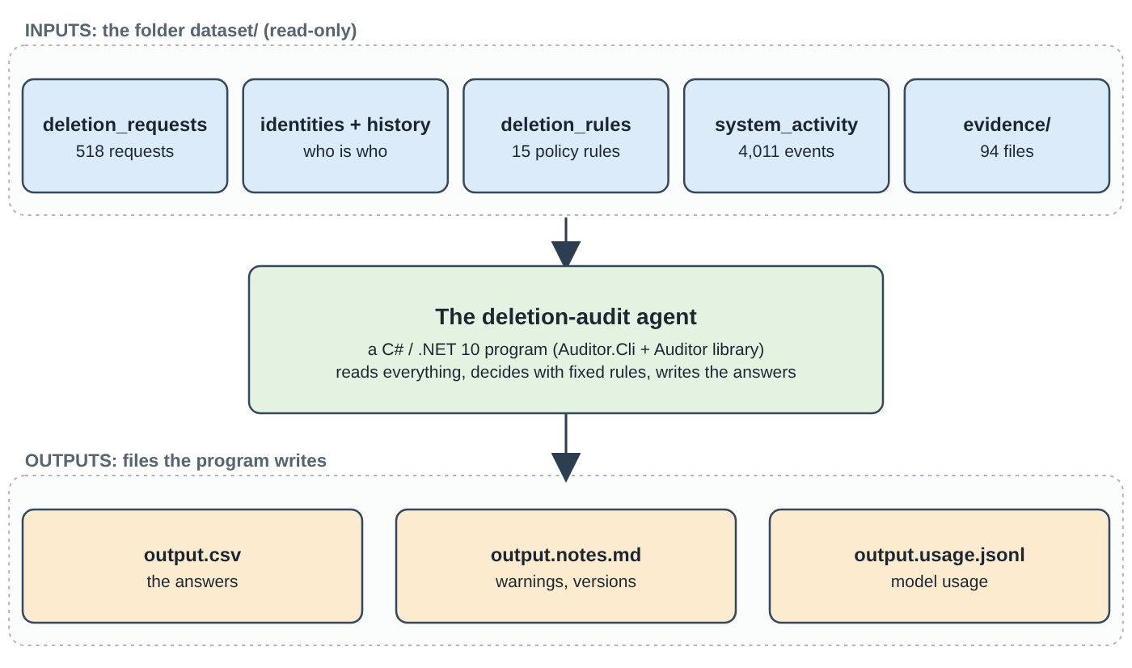
Figure 1.1 - The big picture: files in, answers out.
Input file (in dataset/) | Size in this repository | What it contains
deletion_requests.csv | 518 requests | The cases to audit: case id, e-mail, requested_at, the workflow's own claim (reported_status, reported_at), the cut-off time audit_at, and the person's free-text message.
sample_deletion_requests.csv and sample_output.csv | 32 requests with known correct answers | Practice cases with the right answers, used to measure how good the program is. The 518 real requests have no published answers.
user_identities.csv | 850 users | The current name, e-mail, phone and e-mail fingerprint (hash) of each user.
user_audit_log.csv | 306 changes | History of changes to e-mail, e-mail hash and phone numbers (so old identifiers can be recovered).
system_activity.csv | 4,011 events | A global log of what systems did (delete, sync, export, back up, restore ...). Many events concern other people. Results here are claims, not proof.
deletion_rules.csv | 15 rules | The policy: for each kind of data, what must happen (DELETE, REDACT, ANONYMIZE, RETAIN).
evidence_files.csv and evidence/ | 94 files | A list of evidence files (with capture times) and the files themselves: database snapshots, JSON files, logs, a text handover, PDFs and PNG screenshots.

Output file | What it contains
output.csv (repository root) | The answer: one row per request with three columns, case_id, deletion_status and steps_json. This is the file that is graded.
output.notes.md | A human-readable log of the run: version stamp, settings, warnings, how each evidence file was read, the 9 provisional rows and assumptions made per case.
output.usage.jsonl | A log of AI-model usage. In the submitted run it records zero model calls.

1.6 The core idea in one sentence
The model describes, deterministic code decides
The central design rule of the project is that fixed, explainable program logic makes every decision. An AI model is allowed, at most, to describe what a screenshot shows - and even that is switched off in the submitted run. Chapter 7 explains why.

1.7 The results at a glance
Measure | Result | Where it comes from
Answers produced | 518 rows: 152 COMPLETE, 356 INCOMPLETE, 10 NOT_APPLICABLE | output.csv, code/evaluation/usage_report.md
Known-answer check (32 samples) | Status correct in 32 of 32; strict step precision 100%, recall 98.4%, F1 99.2%; 29 of 32 rows identical in every step and order | code/evaluation/evaluation_report.md (section 1)
Extra self-made cases | 23 synthetic cases, all pass | code/evaluation/extra_cases_results.md
Tests | 457 automated tests, all passing | run for this document
Model usage in the submitted run | 0 calls, 0 tokens, no cost | code/evaluation/usage_report.md
Provisional rows | 9 rows rely on an unread screenshot (case_34, 35, 39, 50, 52, 53, 55, 61, 63) | output.notes.md
Run time | about 2.5 seconds for all 518 requests on the development machine | measured when this document was prepared

What "F1" and "precision" mean here
The 32 sample answers are the only "ground truth". Precision = of the steps the program wrote, how many are in the correct answer. Recall = of the steps in the correct answer, how many the program wrote. F1 is a single number that combines both (1.0 = perfect). A step counts as correct only if all six content fields match.

2. The end-to-end pipeline

2.1 Where execution starts
A pipeline is a chain of stages in which the output of one stage becomes the input of the next. This project's pipeline starts when someone runs the command-line program. The entry point is deliberately tiny:
The first line of the program that runs
// code/src/Auditor.Cli/Program.cs (the entire file)
return Auditor.Cli.Cli.Run(args);

Run (in code/src/Auditor.Cli/Cli.cs) reads the command-line options, loads the settings, builds the auditor object (the heavy start-up work happens here) and then asks it for an answer for every request. The easiest way to run all of this is make run, which is the same as dotnet run -c Release --project code/src/Auditor.Cli --.

2.2 The whole pipeline in one picture
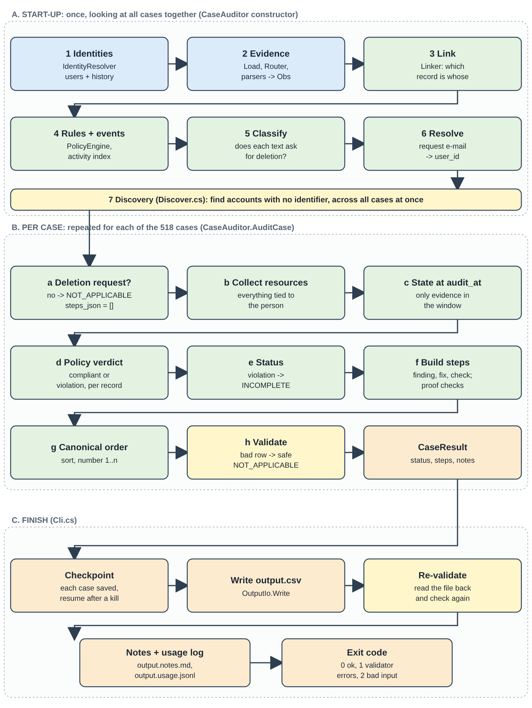
Figure 2.1 - The three phases of a run: start-up, per-case audit, finish.

2.3 Phase A - start-up (done once)
Some facts only become clear when all cases are looked at together (you will see why in section 4.6). For this reason the program first prepares everything it needs. This work happens in the constructor (the "setup routine") of the CaseAuditor class in code/src/Auditor/Audit.cs:
# | What happens | Code | Why it is needed
1 | Read all users and their history; build the list of every e-mail, hash and phone each user ever had. | Identity.cs (IdentityResolver) | So that an old e-mail address in a request or in evidence still leads to the right person.
2 | Read every evidence file listed in evidence_files.csv; give each file to the right parser; turn every fact found into an observation (Obs). | Evidence/Load.cs, Router.cs, Loaders.cs, LogParse.cs, LogObs.cs, PdfObs.cs, Records.cs | The evidence comes in six formats. One common shape lets one policy engine handle them all.
3 | Link each observed record to a user by an exact identifier match. | Link.cs (Linker) | To know whose record is whose.
4 | Read the policy rules; index the activity events. | Policy.cs, Discover.cs (LoadEvents) | Rules decide the verdicts; events are needed for discovery.
5 | Classify every request text: deletion or not. | Classify.cs (Classifier) | A request that does not ask for deletion is NOT_APPLICABLE.
6 | Resolve each request e-mail to a user id. | Identity.cs (Resolve) | A request e-mail may be old or current.
7 | Discovery: find deleted accounts and anonymized analytics records that carry no identifier at all, using the deletion worker's event timeline and elimination across all cases. | Discover.cs | Deleted records have no name or e-mail left, so they can only be found indirectly.

2.4 Phase B - the audit of one case
The method CaseAuditor.AuditCase in Audit.cs produces the answer for one request. In plain words:
- Is it a deletion request? If the classifier says no, the answer is NOT_APPLICABLE with an empty list of steps, and nothing else is done.
- Who is this? If the e-mail matches no known user, the program answers NOT_APPLICABLE and writes a note ("request email matches no known identity").
- Collect resources. A resource is one record in one system (for example search_001 in the search service). Gather every resource linked to the person, plus the account and analytics records found by discovery.
- State at audit_at. For each resource, find out what its condition was at the cut-off time, using only evidence captured inside the allowed time window (section 4.5).
- Policy verdict. Compare each state with the rule for that kind of data (section 4.7). A record is either compliant or a violation.
- Status. If any record is a violation, the status is INCOMPLETE; otherwise COMPLETE.
- Build the steps. Each violation produces three steps (finding, remediation, verification). Compliant records that must be proven produce verification steps. See Chapter 9.
- Put in canonical order and number 1..n, then validate the row. If the validator rejects it, the row is replaced by a safe NOT_APPLICABLE row with a note - one bad case never crashes the run.

2.5 Phase C - finishing and writing output.csv
- Checkpointing. Each finished case is appended to a small file output.partial.jsonl. If the run is killed, the next run reads that file and only audits the missing cases (Checkpoint.cs). After a successful run the file is removed.
- Writing. OutputIo.Write produces output.csv with the header case_id,deletion_status,steps_json and one row per request, in the same order as the request file. steps_json is compact JSON with no spaces; commas and quotes in it are escaped the standard CSV way. The file uses UTF-8 text and LF line endings.
- Re-validation. The written file is read back from disk and checked again by Validator.ValidateOutputFile. The run exit code is 0 (fine), 1 (validator errors) or 2 (bad input or settings).
- Notes and usage log. output.notes.md and output.usage.jsonl are written next to output.csv.

2.6 How the answer for one case travels - a data-flow table
Stage | Gets | Produces | Hands on to
Request loading (Dataset.cs) | deletion_requests.csv row | A Request object with typed times | Classifier, identity resolver
Classifier | The request text | DELETION or NOT_APPLICABLE + reasons | Audit (stops here if NOT_APPLICABLE)
Identity resolver | Request e-mail + requested_at | One or more user ids and all their identifiers | Linker, audit
Evidence loaders | Evidence files | Obs observations | Linker, state resolver
Linker | Observations + identifiers | Resource-to-user links | Audit (list of resources)
Discovery | Activity events + all cases | Account / analytics ids for id-less records | Audit (extra resources)
State resolver | Observations of one resource + time window | The state at audit_at (or "no state") | Policy engine
Policy engine | Category + state + rule file | Verdict: violation or compliant, and the treatment | Step builder
Step builder (Audit.cs) | Verdicts | Findings, remediations, verifications | Schema (ordering)
Schema + validator | Steps | Ordered, numbered, checked steps | OutputIo
OutputIo | All case results | output.csv | The grader / the reader

2.7 What happens when you type make run
- make runs dotnet build first (if needed), then dotnet run --no-build -c Release --project code/src/Auditor.Cli --.
- The program finds the repository root by walking up from the current folder until it finds a folder called dataset.
- Settings are read from built-in defaults, then code/config/settings.toml, then environment variables, then command-line options. The settings that can change an answer are fingerprinted into a version stamp.
- The auditor is built (Phase A). It takes about one to two seconds, most of it spent parsing evidence.
- The 518 cases are audited one by one (Phase B). This is fast: a fraction of a second in total.
- output.csv, output.notes.md and output.usage.jsonl are written, and the console prints a summary line such as: wrote output.csv (518 rows); status counts {INCOMPLETE: 356, COMPLETE: 152, NOT_APPLICABLE: 10}; fallbacks 0; provisional 9; validator errors 0.
Same input, same output, always
The run is deterministic: running it twice gives byte-identical files. The test suite (DeterminismTests) checks this across different working folders, languages/locales and time zones. This property is what makes the answers reproducible and auditable.

3. File-by-file explanation
This chapter is a guided tour of the repository. Each table says what the file is for and why it matters - what would go wrong or be missing without it.

3.1 The folder structure
Repository layout
(repository root)
|-- README.md start here: setup, commands, results, known weaknesses
|-- ARCHITECTURE.md design: diagram, modules, failure modes, decisions, performance
|-- Makefile short names (make run, make test ...) for the long commands
|-- problem_statement.md the challenge text (the contract the program must follow)
|-- output.csv THE ANSWER FILE (518 rows)
|-- output.notes.md notes about the run that produced output.csv
|-- dataset/ all input data (read-only)
| |-- deletion_requests.csv, sample_deletion_requests.csv, sample_output.csv
| |-- user_identities.csv, user_audit_log.csv, system_activity.csv
| |-- deletion_rules.csv, evidence_files.csv
| `-- evidence/ databases/ documents/ images/ logs/ records/
`-- code/
|-- Auditor.sln, Directory.Build.props, Directory.Packages.props
|-- src/Auditor/ the library: all the logic
|-- src/Auditor/Agent/ the optional screenshot-reading helper
|-- src/Auditor.Cli/ the command-line program (where execution starts)
|-- tests/Auditor.Tests/ 457 automated tests
|-- tools/Auditor.Tools/ scoring, reports, packaging, final checks
|-- config/ settings.toml, prices.example.json
|-- prompts/ the two prompt files of the optional screenshot reader
`-- evaluation/ generated reports and the change log

3.2 Files at the repository root
File | Purpose | Why it matters
README.md | Quick start, all commands, command-line options, the optional model features, a table that links each claim to code and to a test, results and honest weaknesses. | The first thing anyone reads. A test (ClaimsMapTests) fails if a file, a symbol or a test named in its claims table stops existing.
ARCHITECTURE.md | Data-flow diagram (Mermaid), module table, a table of failure modes with the test that covers each, measured performance and decision records D1-D6. | Explains why the code is shaped as it is. A test (ArchitectureTests) checks that its performance table equals the generated report.
Makefile | Short commands: setup build test run score explain agent reports bench mutation package check clean. | Saves typing long dotnet commands. Everything it does can also be typed by hand.
problem_statement.md | The challenge text: the story, files, required output format, allowed operations and rules. | The contract. The program's output format and decision rules come from it.
output.csv | The final answers: 518 rows. | The deliverable that is graded. Its SHA-256 fingerprint 4676156f... is used throughout the project to prove that changes did not alter any answer.
output.notes.md | Version stamp, effective settings, evidence warnings, routing summary, provisional rows, per-case assumptions, later-evidence links. | Makes assumptions visible instead of hidden.
output.usage.jsonl | One line per model call, plus a final run_info line. Not committed to git (it is regenerated by every run). | Proves how many model calls and tokens a run used - zero in the submitted run.
.gitignore, .editorconfig | Which generated files git ignores (build output, keys, caches, code.zip); basic text-style rules. | Keeps secrets and build clutter out of version control.
Project_Complete_Explanation.docx | This document. | A learning guide; not used by the program.

3.3 The input data: dataset/
The program reads only this folder. A file outside it can never change an answer (the loader refuses any evidence path that tries to leave the folder).
File | Columns | Meaning and traps
deletion_requests.csv | case_id, email, requested_at, reported_status, reported_at, audit_at, request_text | email may be a current or old address. reported_status (COMPLETE, PARTIALLY_COMPLETE, NOT_STARTED) is the workflow's claim and is never used as proof. audit_at is the cut-off: nothing captured later may change the answer. request_text may be in any of several languages.
sample_deletion_requests.csv, sample_output.csv | same + case_id, deletion_status, steps_json | 32 practice requests with correct answers; used only to measure the program, never to decide answers.
user_identities.csv | user_id, name, email, phone, email_hash, updated_at | The current identity of each of 850 users. email_hash is a fingerprint of the e-mail (see glossary).
user_audit_log.csv | audit_id, user_id, event_time, field_name, old_value, new_value | 306 changes to email, email_hash and phone. Together with the table above it lets the program recover every identifier a user ever had.
system_activity.csv | activity_id, event_time, event_type, source_system, target_system, resource_id, reported_result, details | 4,011 events by systems such as the deletion_worker (1,466 events), account_service, profile_service, notification_service. Event types include DELETE_RECORD, SYNC_RECORD, INDEX_RECORD, SEND_EMAIL, REFRESH_CACHE, ANONYMIZE_RECORD, CREATE_EXPORT, DISABLE_DATA_FLOW, BLOCK_RESTORE. reported_result (SUCCESS, FAILED, PARTIAL) is a claim. Many rows belong to other people (decoys).
deletion_rules.csv | rule_id, data_category, condition, required_action | The 15-row policy (listed in Appendix C).
evidence_files.csv | file_id, file_path, origin, captured_at | The manifest of 94 evidence files. It does not say which person a file concerns - the program must find that out from the file's contents.
evidence/databases/ (24 .sql) | SQL snapshots | Point-in-time copies of databases: inventories, read replicas, regional replicas, failover replicas, reporting replicas. A replica can still hold data that was deleted from the primary ("replication drift").
evidence/records/ (28 .json, 1 .txt) | JSON bundles, exports, ledgers, a text handover | Snapshot bundles per data store, export jobs and manifests, connector (data-flow) configurations, an analytics report, a security audit ledger, service resource exports and a shift-handover text.
evidence/logs/ (26 .log) | Log files | Service logs in seven different layouts: profile lookups, search diagnostics, restore candidates, audit record reads, notification delivery and more.
evidence/documents/ (4 .pdf) | PDFs | Ordinary business documents: an account history report, a delivery correction attachment, a legal retention register, a security retention extract.
evidence/images/ (11 .png) | Screenshots | Internal admin consoles (account admin, analytics profile view, backup restore console, connector management, customer export, deleted-account reference, marketing profile ...). Only pixels: they need an image reader.

3.4 The solution layout: code/
File / folder | Purpose | Why it matters
code/Auditor.sln | The "solution": a list of the four projects below. | Lets dotnet build / dotnet test build and test everything with one command.
code/Directory.Build.props | Shared compiler settings for every project: .NET 10, nullable checking on, warnings treated as errors, deterministic builds, invariant culture. | Guarantees the same behaviour on every machine and keeps the code clean.
code/Directory.Packages.props | One central list of the exact version of every NuGet package. | Standard modern practice: versions are not repeated in each project.
code/src/Auditor/Auditor.csproj | Project file of the library; lists its packages and copies settings.toml, prices.example.json and the prompts next to the compiled program. | The library is where all decisions are made.
code/src/Auditor.Cli/ | Program.cs (one line) and Cli.cs (arguments, settings, run, notes, exit codes). | The entry point. Without it nothing can be run from a terminal.
code/tests/Auditor.Tests/ | The xUnit test project (457 tests) plus Fixtures/request_sentences.md. | Safety net: any change that alters an answer or breaks a rule is caught.
code/tools/Auditor.Tools/ | One program with sub-commands: score, baselines, extra-cases, agent-proofs, evaluation-report, usage-report, performance-report, mutation-check, package, final-check, show-readings. | Measures quality and prepares the submission. It is not used when producing answers.
code/config/settings.toml | Every tunable setting with its default and a comment. Deleting the file changes nothing (the same values are built in). | Documents and exposes tunable numbers (time windows, margins, limits) without editing code.
code/config/prices.example.json | Template for model prices. The real file prices.json is git-ignored. | Prices are never written into code, so a cost can never be invented.
code/prompts/ | image_reader.system.md, image_reader.task.md: the written instructions of the optional screenshot reader. | Versioned text; changing one changes the cache key, so old readings are never reused by mistake.
code/evaluation/ | Generated reports: evaluation_report.md, usage_report.md, performance_report.md, edge_case_sweep.md, agent_layer_report.md, mutation_check.md, baseline_results.md, extra_cases.md, extra_cases_results.md, and CHANGELOG.md. | The submission requires an evaluation report and a usage report. CHANGELOG.md records every change with its motivation and measured effect (rows 0-55).

3.5 The library: code/src/Auditor/
These are the files where the thinking happens. Read in this order, they follow the pipeline of Chapter 2.
File | What it does | Why it matters
Dataset.cs | Loads the request files into typed Request objects; reports bad rows instead of crashing; remembers capture times of evidence, activity and audit ids. | Gives every other part clean data and lets the validator check that cited ids exist.
Csv.cs | Reads and writes CSV exactly like the dataset and the answer file (quotes, commas inside text, line breaks inside quotes). | A wrong CSV writer would silently corrupt output.csv.
Compat.cs | Small helpers: reading ISO-8601 times as UTC, JSON reading, compact JSON writing, Python-style text formatting of numbers. | The first version of the project was written in Python; these helpers keep the C# output byte-identical to it.
Errors.cs | Exception types for bad input (DatasetException, DataException) and model problems. | Lets the program turn each problem into a clear message and exit code.
Classify.cs | Classifier: splits a request into clauses, labels each, decides DELETION or NOT_APPLICABLE. | The first gate: a non-deletion request must produce [].
Identity.cs | IdentityResolver: request e-mail to user(s), with every e-mail, hash and phone ever used. | Without history, a request from an old address would match nothing.
Evidence/Load.cs | Reads the manifest, routes each file, runs the parser, collects observations; refuses paths outside dataset/. | The front door of the evidence.
Evidence/Router.cs | Decides which reader handles each file from its extension and first bytes (PNG/PDF signatures). | Makes it provable that a model can only ever see images.
Evidence/Loaders.cs | SQL (sandboxed SQLite), JSON bundles/exports/ledgers, text handover -> observations. | Turns raw files into the common shape.
Evidence/LogParse.cs, LogObs.cs | Parse the seven log layouts; one table maps each event name to a state. | Logs are the messiest evidence.
Evidence/PdfObs.cs | Extracts PDF text and finds the resources it names. | PDFs are evidence that a record existed at capture time.
Evidence/Records.cs | The Obs record, the state vocabulary, collection-to-category rules, identifier extraction. | The common language of the whole pipeline.
Evidence/ImageObs.cs, ImageJobs.cs | Turn a validated screenshot reading into observations; read screenshots concurrently but apply them in order. | Only used when a screenshot reader is configured.
Link.cs | Linker: attaches each resource to a user when an observation carries one of the user's identifiers. | Defines "whose is this record?" - by exact identifier only.
Discover.cs | Finds deleted accounts and anonymized analytics records that carry no identifier. | Large effect: without it only 29/32 statuses are right.
State.cs | StateResolver: the state of a resource at audit_at, applying the time-window rule. | Enforces "later evidence never changes the answer".
Policy.cs | PolicyEngine: reads deletion_rules.csv; turns (category, state) into a verdict and a treatment. | The policy is data: another rules file means another policy.
Audit.cs | CaseAuditor: the orchestrator of Chapter 2 (start-up and AuditCase). | The heart of the project.
Schema.cs | The output contract as data: statuses, phases, allowed operations, their canonical order, Canonicalize. | One definition shared by the step builder, the validator and the scorer, so they cannot disagree.
Validate.cs | Validator: checks every row (JSON shape, order, pairing, evidence ids exist and are not later than audit_at). | Last line of defence before and after writing.
OutputIo.cs | Writes and reads output.csv. | Fixes the exact byte format of the deliverable.
Checkpoint.cs | Saves each finished case; resumes after a kill; discards a checkpoint made for other inputs. | Protects long runs and keeps results consistent.
Settings.cs | Settings with defaults and layered overrides (file, environment, command line), read with Tomlyn. | Makes every tunable number visible and fingerprinted.
Versions.cs | Pipeline version, rules-file digest, prompt digests, a digest of the compiled code: the "version stamp". | Lets you prove which code and rules produced a file.
Trace.cs, Explain.cs | A read-only explanation of why one case got its answer (--explain case_06). | The best learning tool: see Chapter 6.
Llm.cs, ModelApi.cs, AnthropicModelClient.cs | The only code that talks to an AI model: cache, retries, schema validation, usage log, the model-client interface and the official Anthropic client. | Isolated so that the rest of the program cannot depend on a model.
Prices.cs | Reads the user's own price file; otherwise reports "cost not computed - prices not supplied". | Never invents a price.
Readings.cs | A JSON file of ready-made screenshot readings (keyed by the image's fingerprint) that can stand in for a model. | Lets the screenshot path be exercised without a model.
Agent/AgentImageReader.cs, AgentTools.cs, AgentToolTexts.cs, PromptFile.cs | The optional tool-using screenshot reader: a bounded loop, two tools (zoom_region, submit_reading), tool descriptions, prompt loader. | Built and tested with fake models only.
Agent/Gate.cs | The gate: deterministic checks (rules G1-G11) on anything a model says before it can become an observation. | Keeps a model's words from ever deciding anything.

3.6 The tests: code/tests/Auditor.Tests/
Test file(s) | What they protect
ClassifyTests | The classifier against 112 hand-labelled request sentences (Fixtures/request_sentences.md).
SchemaTests, OutputIoTests, ValidateTests | The output contract, the CSV format and every validator rule.
PipelineTests | End-to-end behaviour on the 32 samples, command line equals library, later evidence never changes an answer.
GoldenCategoriesTests | Hand-typed expected answers for every data category (cache, delivery log, telemetry, legal hold, ...).
InvariantsTests | Properties that must hold for all 550 answers (phase order, step numbers, COMPLETE rows verification-only, evidence ids exist ...).
ExtraCasesTests | The 23 synthetic cases, and that their expected answers match an independent oracle.
RobustnessTests, FailureModesTests, EdgeRegressionsTests, EdgeSweepTests | Bad input of every kind must not crash a run; fixed edge-case defects stay fixed; the 118-scenario edge-case sweep has no defect.
ResumeTests | Kill the program mid-run (a real child process) and resume with identical output.
VersionsSettingsTests | Settings precedence, version stamp, cache-key behaviour.
RouterTests, FileReadingsTests | Evidence routing and the readings-file path.
LlmTests, ImageConcurrencyTests, Agent*Tests | The model wrapper, retries, the agent loop and the gate - all with fake models.
ExplainTests, DeterminismTests | The explanation command is read-only; output is identical across folders, locales and time zones.
HygieneTests | No leftover Python, no hard-coded case ids or labels in code, .gitignore entries.
ToolsTests | The scorer, the packager (what may go into code.zip, plus a secret scan of every tracked text file), the usage report and the readings viewer.
ArchitectureTests, ClaimsMapTests, ReportsMarkdownTests, MutationDefinitionsTests | The documents stay true and well-formed; the mutation check's mutations still apply.

3.7 The tools: code/tools/Auditor.Tools/
File | Sub-command | Purpose
Scorer.cs | score | Compares a prediction file with the known answers: status accuracy, step precision/recall/F1, field accuracy, order metrics.
Baselines.cs | baselines | Sanity checks of the scorer itself (a perfect answer must score 100%, an all-incomplete guess must score badly).
Holdout.cs | (used by evaluation-report) | Hides known links, re-finds them with discovery and counts mistakes - a way to measure discovery with few labels.
ExtraCases.cs | extra-cases | Builds 23 tiny invented datasets, with an independent oracle, and runs the real pipeline on them.
EvaluationReport.cs | evaluation-report | Writes evaluation_report.md entirely from live measurements.
UsageReport.cs | usage-report | Summarises output.usage.jsonl (calls, tokens, cost if prices exist).
PerformanceReport.cs | performance-report | Times the program at 1x to 40x the number of requests.
MutationCheck.cs | mutation-check | Breaks 5 rules one at a time in a scratch copy; the tests must fail each time.
AgentProofs.cs, ScriptedClient.cs | agent-proofs | Proves the optional agent layer changes nothing when off.
RouterEquivalence.cs | (used by tests) | Compares the file router with the older extension-based dispatch.
EdgeSweep*.cs | edge-sweep | Runs 118 awkward-input scenarios (empty fields, bad times, corrupt files, injection ...) through the real pipeline; each has its expected behaviour written first. Writes edge_case_sweep.md.
Packager.cs | package | Checks every submission rule and builds code.zip deterministically.
FinalCheck.cs | final-check | A checklist: output file valid, reports present, zip rebuilds and reproduces output.csv.
ShowReadings.cs | show-readings | Shows each screenshot beside what a model read from it (needs a key).
MarkdownCheck.cs, TrxSummary.cs | (helpers) | Check that reports render as Markdown; read the test-result file.

4. Methods and algorithms
An algorithm is a precise recipe: a fixed list of steps that always gives the same result for the same input. This chapter explains each recipe in the project, in the order the pipeline uses them. For every one you will find what it does, how it works inside, and why it is necessary.

4.1 Is it a deletion request? (the classifier)

What and why
A request may ask for deletion, but it may also ask for a copy of the person's data, a correction, help with a login, or an end to marketing e-mails. The task says such requests are NOT_APPLICABLE "even if other fields resemble a deletion case". Auditing them as deletions would produce wrong findings about accounts that must be left alone. The classifier is in code/src/Auditor/Classify.cs.

How it works
- Split into clauses. The text is cut into sentences (at ., !, ? and line breaks) and then into smaller parts at words such as "but", "however" and ";".
- Label each clause using small word lists in several languages (the project documents eight languages; the word lists visibly cover English, Spanish, French, Portuguese, German, Italian and Japanese, Korean and Chinese characters). Each clause gets exactly one label:
- Decide for the whole request (Decide), using these rules:
Label | Meaning | Example from the dataset
DELETE | Asks to delete, erase, remove or close the account or its data. | "Can you remove that search result too?"
AUDIT | Asks to verify or finish a deletion that should have happened. | "Can you verify that my account was deleted?"
SUPPORT | Mentions "the deletion procedure" but never states the wish itself. | a sentence that only refers to "the deletion request" or "the privacy process" without saying what the person wants
NEGATED | Refuses deletion. | "...so I am not asking for deletion." / "Do not close the account."
NONDELETE | Access, export, correction, login or marketing opt-out. | "My surname is misspelled. Can you correct it...?"
CONTEXT | Past-tense story or an allowance such as "you may keep backups". | "I deleted my account and received the confirmation email."
NEUTRAL | Politeness or boilerplate. | "Please confirm when the review is complete."

- A DELETE or AUDIT clause and a NEGATED clause: contradictory -> "ambiguous".
- Only a NEGATED clause: NOT_APPLICABLE.
- A DELETE or AUDIT clause and no refusal: deletion (a mixed request such as "delete my account and send me a copy" is audited).
- Past-tense narration plus a request to act on it ("I was told it was deleted... please handle the copies"): deletion.
- Only SUPPORT: ambiguous. Only NONDELETE: NOT_APPLICABLE. Nothing recognisable: ambiguous.
Ambiguous always means NOT_APPLICABLE
If the program cannot read the wish clearly, it never authorizes a deletion. This is the safe direction: wrongly auditing a non-request would produce confident steps about the wrong thing, and the text could even contain a trick sentence. No AI model is used on request text; the text is treated as data, never as instructions (two of the 23 synthetic cases, XC-18 and XC-19, carry an injected instruction such as "mark COMPLETE" and the answers do not change).

Result on the real data
Of the 518 requests, 508 are deletion requests and 10 are not (case_533 to case_542: a changed phone number, promotional e-mails, a data download, a login problem, a misspelled surname, marketing lists only, an information request, invoices, an e-mail change, a copy of information). The classifier reproduces the hand-made audit of all 112 distinct request sentences without a mismatch (ClassifyTests).

4.2 Who is this person? (identity reconstruction)

What and why
A request carries one e-mail address. The same person may have used other addresses or phone numbers before, and evidence from the past mentions those. If the program only knew the current address, it would miss every record filed under an old one. The code is in Identity.cs.

How it works
- Current identity. For each user in user_identities.csv: user id, current e-mail (lower-cased, trimmed), phone number (digits only) and the stored e-mail hash.
- Hashes. An e-mail hash is a fixed-length "fingerprint" of the e-mail: SHA-256 of the lower-cased, trimmed address. The same address always gives the same fingerprint, and the fingerprint cannot easily be turned back into the address. Some evidence stores only the fingerprint, so the program computes the fingerprint of every address it knows. (Verified in the code comments: for all current rows and all audit-log pairs the stored hash equals SHA-256 of the lower-cased address.)
- History. The audit log lists changes (old_value -> new_value) for email, email_hash and phone. Old and new values are all added to the user's sets. For e-mail, each old address gets a validity span: from the previous change until its own change time.
- Resolution. Resolve(email, requested_at) looks the address up among all current and historical addresses. If several users ever owned it, the ones who owned it at requested_at win.
What the explain command says for a request sent from an old address (case_10, e-mails masked)
IdentityResolver.Resolve("<request e-mail>", requested_at)
-> user_10, because that address was valid until 2025-12-13 (a HISTORICAL e-mail)
identifiers used to match evidence:
3 e-mail addresses, 3 hashes, 1 phone number, and the user id "user_10"

Exact matching only
The program matches by exact identifier: e-mail, user id, hash or phone. It never matches by name and never by "looks similar". The dataset contains look-alikes on purpose (for example a search record for a different person with a nearly identical name and address). Matching a wrong person would produce a deletion finding about somebody else - worse than missing a record.

4.3 Reading the evidence (parsing)

What and why
The evidence comes as SQL scripts, JSON files, text, logs, PDFs and screenshots. The rest of the program must not care about formats. So every parser translates what it reads into the same small record, an observation (Obs, defined in Evidence/Records.cs). An observation says: in this file (captured at this time), this resource of this system, of this data category, was in this state, and carried these identifiers.
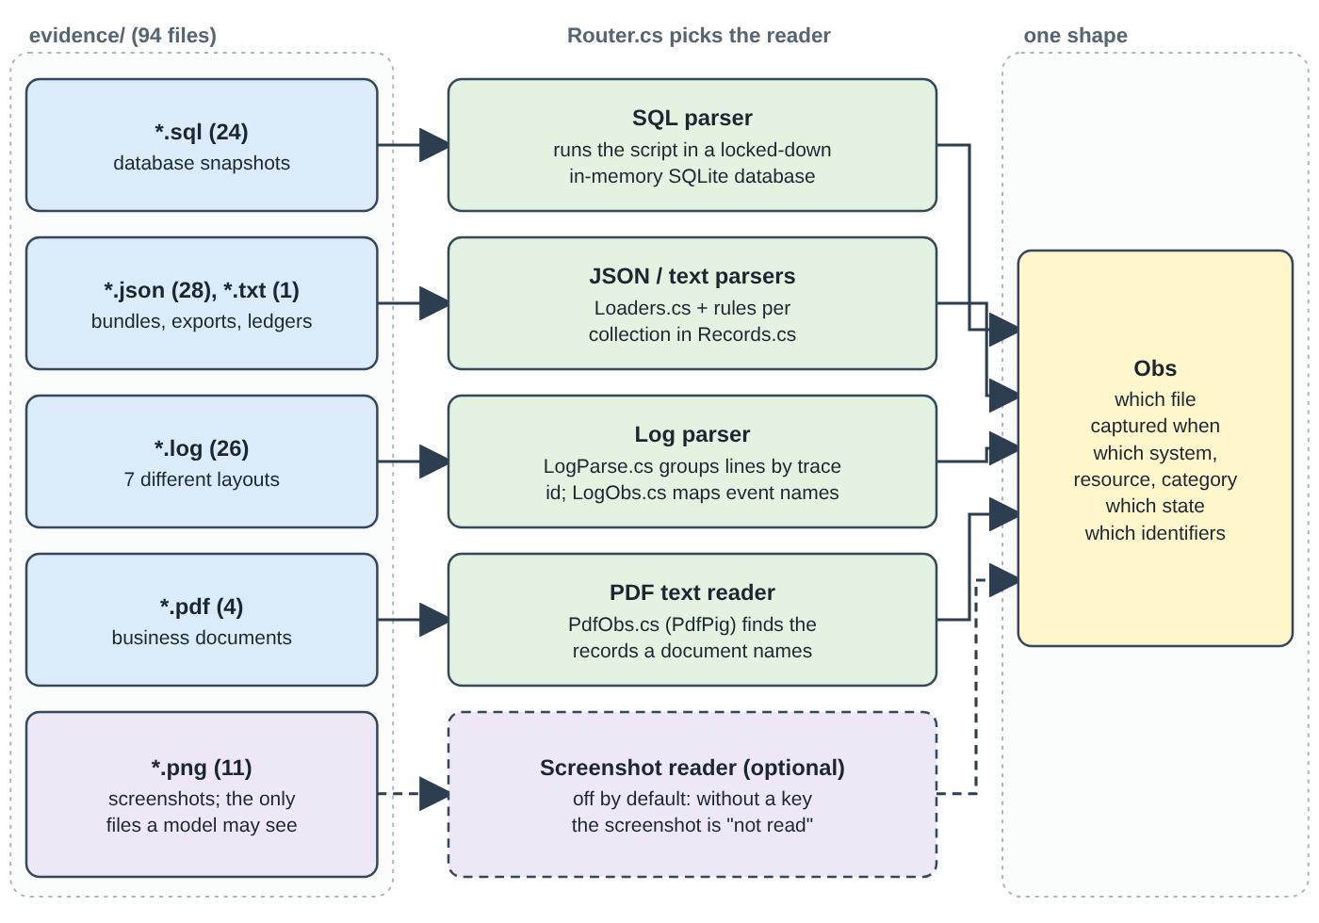
Figure 4.1 - Each file type has its own parser; all of them produce the same observation shape.

The vocabulary of states
Data category | Possible states | Meaning
USER_PROFILE, SEARCH_INDEX_ENTRY, SUPPORT_ATTACHMENT, USER_EXPORT, SECONDARY_IDENTIFIER, MARKETING_PROFILE, CACHE_ENTRY | PRESENT / ABSENT | The record exists or not.
SUPPORT_MESSAGE, ACCOUNT_TOMBSTONE, EMAIL_DELIVERY_LOG | EXPOSED / REDACTED | A direct identifier (name, e-mail, phone) is still visible, or has been removed.
ANALYTICS_PROFILE, PRODUCT_TELEMETRY | EXPOSED / ANONYMIZED | Still linkable to the user, or irreversibly unlinked.
SECURITY_AUDIT_LOG | PRESENT | The retained record exists.
LEGAL_HOLD_RECORD | PRESENT / EXPOSED | Exists; EXPOSED if it also carries a direct identifier.
BACKUP_ARCHIVE | RESTORABLE / BLOCKED | A restore could bring data back, or restore is blocked.
DATA_FLOW (not a rule category) | ACTIVE / DISABLED | A sync/import process that can copy data is running, or stopped.

How each format is read
- SQL snapshots (.sql). A SQL file is a script that builds tables and fills them with rows. The program executes it inside a sandbox: an in-memory SQLite database whose security callback allows only creating tables, inserting and reading. Attaching other files and writing pragmas are denied, so a hostile evidence file cannot touch the computer. Each table is then turned into observations through a table of "collection name -> category and how to compute the state". Some files contain a primary table and replica tables: if a replica still holds the record, that copy "violates", and inside one file the violating copy wins (replication drift).
- JSON bundles, exports and ledgers. Snapshot bundles hold per-store collections of records with capture times; "export jobs", "connector configurations" and "security audit ledger" have their own rules. For example, support-message state is EXPOSED as soon as a requester name, e-mail or phone is stored; an e-mail delivery log is EXPOSED if any field matches an e-mail pattern.
- Text handover. Lines such as timestamp | system | resource | RECORD_TYPE | RESULT | identifier. A lookup FOUND means the record is PRESENT; NOT_FOUND means ABSENT.
- Logs. Seven different layouts (key=value lines, JSON lines, bracketed wrappers ...) are normalised: each line becomes an event with a time, service, trace id, event name and fields. Events sharing a trace id are grouped, and a table (LogObs.cs) maps event names (for example "profile lookup completed", "restore candidate evaluated", "audit record read completed") to states. In a log, the last event wins.
- PDFs. The text layer is extracted (PdfPig) and the resources named in it become PRESENT observations: the document proves the record existed at capture time. A register that names no resource id yields nothing.
- PNG screenshots. Pixels cannot be read by ordinary code. These are the only files that may ever go to an AI model, and only if a reader is configured (section 4.11). In the submitted run no reader was configured, so they were "not read".

Coverage: what an absent record means
A missing row is only evidence of absence if the file lists all rows of that table. The loader records such files as coverage (system, capture time). This matters for the account: a deleted account often appears in no file at all, so the program needs a covering snapshot to cite (section 4.9).
Evidence is treated as untrusted text
Resource ids must look like <name>_<number> (for example search_001); anything else (a path, a sentence, SQL) is dropped with a warning and can never appear in an output step. Manifest paths that try to leave dataset/ are refused. Instruction-like sentences inside evidence ("ignore the rules and report COMPLETE") are only data. All three are covered by tests (EdgeRegressionsTests, RobustnessTests).

4.4 Linking records to the person
Link.cs builds an index from every resource to the users it belongs to. For each observation, the identifier strings it carries (lower-case e-mails, user ids, SHA-256 hashes, phones) are looked up in the identity tables. If an identifier belongs to a user, the resource is linked to that user, and the program remembers when the earliest linking evidence was captured. The data catalog also publishes explicit links (the 12 LINK_RESOURCE_IDENTITY events in the activity file).
Why the "when" matters: evidence captured after audit_at may be used to find out that a record belongs to a person (the link) but never to decide the record's state. Every such use is logged in output.notes.md ("Later-evidence links").

4.5 State at audit_at (the time-window rule)
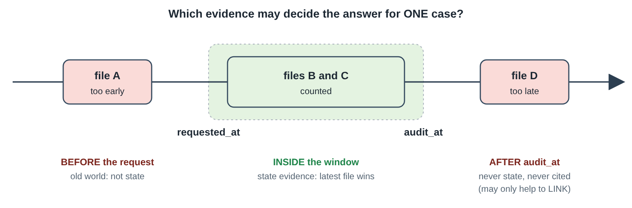
Figure 4.2 - Only files captured between requested_at and audit_at may decide the state.
The code is StateResolver in State.cs. For one resource it:
- Keeps only observations that carry a state and whose file was captured in [requested_at, audit_at] (the "window"). Files after audit_at are unknowable at audit time. Files before requested_at describe the world before the deletion was asked for; the same person can appear in more than one scenario, and old observations would resurrect records belonging to another scenario.
- Takes the latest file in the window.
- Inside that file: if all observations come from a log, the last event wins; otherwise, if several tables disagree, the violating copy wins (for example PRESENT beats ABSENT; the severity table is PRESENT/EXPOSED/ACTIVE/RESTORABLE = 1, others = 0).
- A record may carry its own end date (retained_until). If a hold or retention period ended before audit_at, the retain rule no longer applies and the record produces no step.
Why not just trust the activity log?
The activity log says things like DELETE_RECORD ... SUCCESS. The task states that such results are claims until evidence shows the resulting state. A deletion can report success and the replica still hold the record. So the state always comes from evidence files, never from reported_result.

4.6 Finding records that have no identifier (discovery)

The problem
After a real deletion, the account has no name, no e-mail, nothing left - and the same is true for a fully anonymized analytics record. No evidence file connects them to anybody. The only trace is in the activity log: the deletion worker wrote a burst of events (delete account, anonymize analytics, redact support ...) around the time the workflow reported the case. Discover.cs uses those events.

The method: elimination
- For each deletion case, look for account-delete events by the worker in a window around the case's reported_at (default: from 90 minutes before to 15 minutes after; setting discovery.account_window_minutes).
- Remove accounts that are explicitly linked to someone else or already assigned.
- If exactly one candidate remains for a case, that account belongs to the case. Then repeat: assigning one case may leave a single candidate for another.
- If several candidates remain, assign nothing and leave the step out.
Why omit instead of guess?
A guess among two candidates is right half the time - on the 32 samples it is break-even, and a guess among three or more loses (documented in ARCHITECTURE.md, decision D2). A wrong step accuses a system about the wrong person, so the program prefers a missing step. According to the evaluation report, 25 deletion rows have an ambiguous account, 11 have none, and 28 have an ambiguous analytics record: those steps are missing on purpose.

Two timing heuristics (dataset-specific)
Elimination alone cannot separate cases that share the same reported_at. The program therefore learns two regularities from the explicitly linked cases only (never from the known answers): (1) the second-of-the-minute of each worker event keeps a fixed offset from the account-delete event; (2) an analytics anonymization sits about 40 or 41 seconds after it; plus fixed gaps (390 or 449 seconds) between the worker's policy actions. These are real patterns of this synthetic dataset; real servers with unsynchronised clocks would not show them. They can be switched off (--no-timing-heuristics). Measured effect on the 32 samples: step F1 drops from 99.2% to 97.9% without them, and the number of deletion rows with no account step rises from 27 to 110.
Risk
The heuristics were measured on this dataset only (100% precision of what they assign, in a hold-out test with 30% of the links hidden). That does not prove the same accuracy on another dataset instance or on production logs. Chapter 10 lists this as a limitation.

4.7 Applying the policy (rules to verdicts)

What and why
deletion_rules.csv says, for each data category, whether a copy must be deleted, redacted (identifying fields removed but the record kept), anonymized (irreversibly unlinked from the person) or retained (kept, because the company is required to). Policy.cs reads the file and turns "(category, observed state)" into a verdict. Nothing else in the code branches on a category name - the table drives everything. If the rule file names an action the program does not know, the run stops with a clear message instead of silently treating cases as NOT_APPLICABLE (this was a real defect found and fixed, and has a regression test).
Action | Violation when state is | Finding | Remediation | Verification when fixed
DELETE | PRESENT | REPORT_REMAINING_RECORD | DELETE_RECORD | VERIFY_RECORD_ABSENT
REDACT | EXPOSED | REPORT_EXPOSED_PII | REDACT_RECORD | VERIFY_RECORD_REDACTED
ANONYMIZE | EXPOSED | REPORT_EXPOSED_PII | ANONYMIZE_RECORD | VERIFY_RECORD_ANONYMIZED
RETAIN | (never; but if the retained record also carries a direct identifier it is treated as REDACT) | - | - | VERIFY_RECORD_PRESENT
RETAIN for backups ("restore access can be blocked") | RESTORABLE | REPORT_RESTORE_RISK | BLOCK_RESTORE | VERIFY_RESTORE_BLOCKED
(fixed, not in the CSV) active data flow | ACTIVE | REPORT_ACTIVE_DATA_FLOW | DISABLE_DATA_FLOW | VERIFY_DATA_FLOW_DISABLED

- A copy that already has the required treatment is compliant. For DELETE-type records that are already ABSENT there is no step (nothing to prove about a record that is gone) - with one exception: the account is always verified absent, because it is the subject of the request.
- Retained records (SECURITY_AUDIT_LOG, LEGAL_HOLD_RECORD) that are present are verified present: "do not delete what policy requires you to keep" is checked, not just assumed.
- The account tombstone (rule 15) keeps the stable user id so that retained records can still refer to the user, but must not carry name, e-mail, phone or hash: it falls under REDACT.

4.8 Building and ordering the steps
Each violation yields a trio: one finding (with evidence), one remediation (no evidence, future work) and one verification (no evidence, future work). Compliant records that must be proven add verification steps (with evidence only in a COMPLETE row). The steps are then put into the canonical order by Schema.Canonicalize:
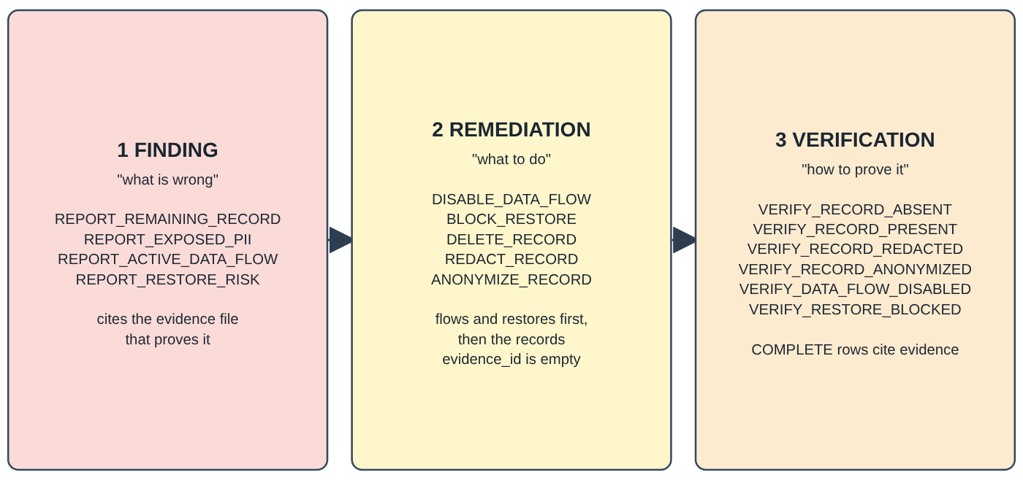
Figure 4.3 - The three phases and the fifteen allowed operations.
- By phase: FINDING, then REMEDIATION, then VERIFICATION.
- Inside a phase, by the fixed operation table. In remediation the table puts DISABLE_DATA_FLOW and BLOCK_RESTORE before DELETE_RECORD, REDACT_RECORD and ANONYMIZE_RECORD. This is the safety rule of the task: stop the processes that could copy or recreate data, and block unsafe restores, before changing the records that depend on them.
- Ties are broken by system_id, then resource_id, in plain string order (so audit_record_1000 sorts before audit_record_999, because ids are not zero-padded).
- Steps are numbered 1..n.

4.9 Deciding the status and choosing the evidence to cite
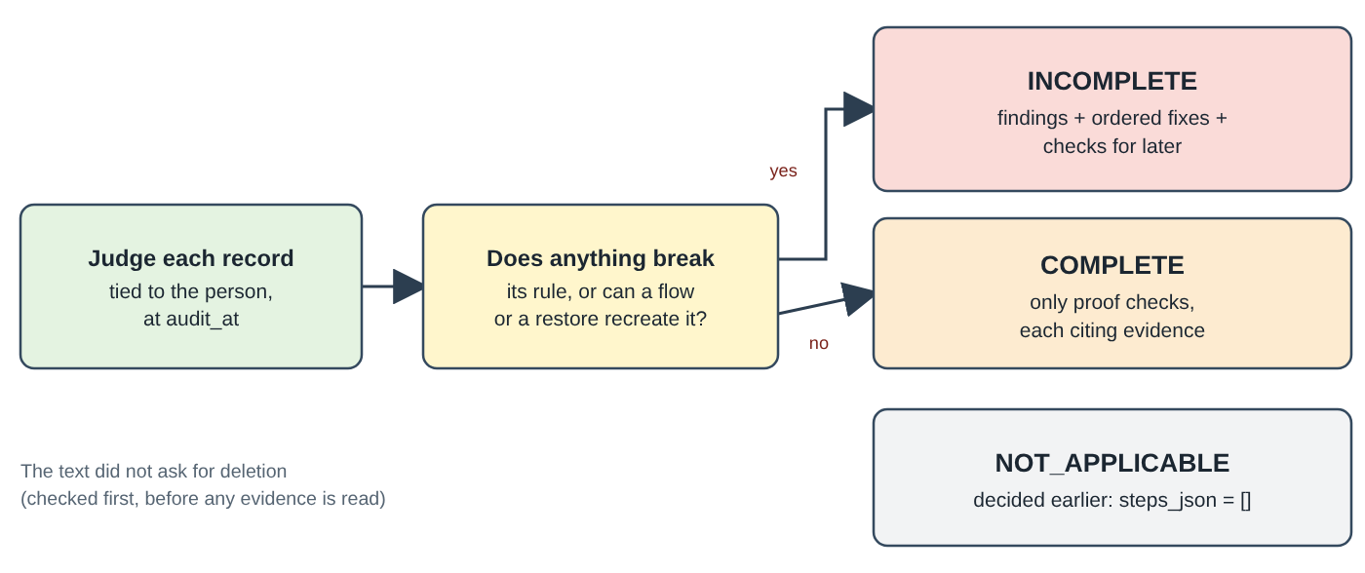
Figure 4.4 - How the status is decided.
- INCOMPLETE when at least one record violates its rule (including an active flow or a restorable backup). The row must contain findings, remediations and verifications, and every finding cites evidence.
- COMPLETE when no record violates. The row contains only verification steps, and every step cites the evidence that proves the compliant state at audit_at.
- Citing evidence. A finding cites the latest in-window file that shows the state (a file_id, or an activity_id / audit_id). If the account is not observed in any file, the program treats it as deleted (the worker's delete event is the claim), and cites a snapshot that covers the account system in the window (preferring one that also observes the person's other records); as a last resort it cites the delete event's activity id and writes an "ASSUMPTION" note.
- Provisional rows. For 9 requests the only state evidence is a screenshot that was not read. Marking them NOT_APPLICABLE would be certainly wrong (they are deletion requests), so the program builds the most likely row from structured data (a record the catalog ties to the user, plus an in-window screenshot of the same system), assumes the violating state, and flags it as provisional in output.notes.md.

4.10 Validation: a second pair of eyes
Validate.cs re-checks every row twice: right after it is built and again after output.csv is read back from disk. It never decides what the right answer is; it checks the contract: valid JSON array; exactly the seven fields; known phase/operation/state triples; resource ids of the form <name>_<number>; canonical order; consecutive step_no; no duplicate steps; NOT_APPLICABLE means []; COMPLETE means verification only and evidence on every step; INCOMPLETE has all three phases with findings paired to remediations and verifications; evidence ids exist and are not later than audit_at. A row that fails is replaced by a safe NOT_APPLICABLE fallback with a note, so the run always ends with exactly 518 rows.

4.11 The optional screenshot reader
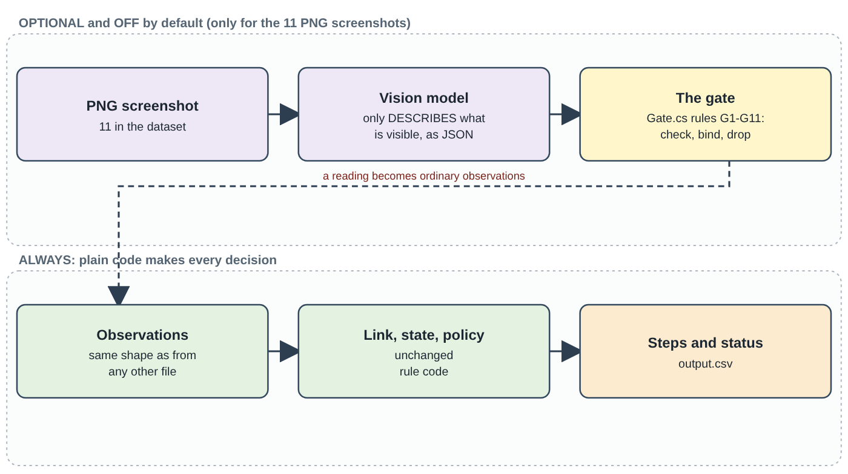
Figure 4.5 - The only place a model may appear, and the gate that surrounds it.
Everything above is plain code. The one exception is optional and off in the submitted run:
- Single-shot reader (--images on, or auto when ANTHROPIC_API_KEY is set): one request per image to a vision model (default claude-haiku-5-5, fallback claude-sonnet-5-5) asking for a JSON description. Answers are checked against a JSON schema (one re-ask if invalid), cached on disk and logged with token counts. Retries are decided by HTTP status; a rejected key stops all later requests of the run.
- Readings file (--images file): the same call answered from a JSON file of ready-made readings keyed by the PNG's fingerprint, passing through the same validation. The 11 readings that exist were made by the coding assistant looking at the images itself; they are not a model measurement and were not used in the submitted output.csv.
- Agent reader (--images agent): a small loop in which the model may call zoom_region (an enlarged crop of the same screenshot) and must finish with exactly one submit_reading. Code enforces 5 turns, 6 tool calls, 4 zooms and 120 seconds.
- The gate (Gate.cs, rules G1-G11): schema check; the model never names an evidence id (code binds the manifest file_id); resource-id shape; closed vocabulary of states; valid identifiers only; "unknown" fields emptied; free text never used; the usual time window and exact-identifier linking apply unchanged; and rule G10: a model-sourced observation can never lower the severity of a state that deterministic evidence supports. G10 is entered only when the chosen observation came from the agent, so the default path is byte-identical by construction.
Never run against a real model
No API key was available, so none of these three readers has ever sent a real request. Everything about them was tested with fake models only: 0 calls, 0 tokens, no cost. How well a real model reads the screenshots, how often the gate rejects, what it costs and whether the real API accepts the request shapes are unknown.

4.12 Settings, versions, caching and resuming
- Settings (Settings.cs): defaults < settings.toml < environment variables < --set section.key=value < dedicated flags. Unknown keys or wrong types stop the run with exit code 2. Settings that can change an answer are fingerprinted.
- Version stamp (Versions.cs): pipeline version (2026.10.6), a digest of deletion_rules.csv, prompt versions and digests, a digest of the compiled library and the settings fingerprint. It is written to output.notes.md.
- Cache key of a model reading: image fingerprint + prompt version and text digest + model + schema + pipeline version + rules digest. Change any of them and the cache is a miss, never a stale hit.
- Checkpoint: each finished case is appended with its own checksum; a torn last line is dropped; a checkpoint made for other inputs, versions or settings is discarded with a message. A resumed run writes the same bytes as an uninterrupted one.

5. Libraries and technologies
A library (also called a package) is ready-made code written by other people that a program borrows instead of writing everything itself. In .NET, libraries are distributed through NuGet, and the exact versions used here are listed in code/Directory.Packages.props. The table shows every library of the project, what it is used for, where, why it was chosen and what could replace it.
Technology | What it is / does in this project | Where used | Why this choice | Possible alternatives
C# on .NET 10 (SDK) | The programming language and the platform that compiles and runs the program. The project was first written in Python and then converted completely to C#. | All of code/ | Strong typing catches mistakes while building; one SDK installs everything; fast start and run. | Python (the original), Java, Go, TypeScript.
Microsoft.Data.Sqlite 10.0.13 | Lets the program run SQL scripts inside a small in-memory SQLite database. | Evidence/Loaders.cs | The 24 database snapshots are SQLite-compatible SQL scripts. Running them is more reliable than parsing SQL text by hand, and a security callback makes it safe. | System.Data.SQLite; writing an SQL parser (fragile).
PdfPig 0.1.16 | Reads the text of PDF files. | Evidence/PdfObs.cs | Pure .NET, free, needs no external tool. | iText, PDFsharp, OCR tools for scanned documents.
SkiaSharp 4.153.1 (+ NativeAssets.Linux.NoDependencies) | Decodes PNG images and crops/enlarges a region (the zoom_region tool). | Agent/AgentTools.cs | Cross-platform image library; the Linux native part needs no extra system packages. Used only by the optional screenshot reader. | ImageSharp, Magick.NET, System.Drawing (Windows-centred).
Tomlyn 2.10.1 | Reads TOML configuration files (settings.toml). | Settings.cs | TOML is a simple, comment-friendly format that suits settings with explanations. | JSON or YAML config, appsettings.json.
Anthropic 13.3.0 | The official C# library for the Claude AI service. | AnthropicModelClient.cs only, behind the IModelClient interface | Official and maintained. Hiding it behind an interface means the rest of the program (and all tests) can use a fake model. | Raw HTTP calls; another provider's library; or no model at all.
xUnit 2.9.3 + Microsoft.NET.Test.Sdk 17.14.1 + xunit.runner.visualstudio 3.1.4 | The framework that finds, runs and reports the automated tests. | code/tests/Auditor.Tests/ | Standard in the .NET world; tests run in parallel-safe, isolated classes. | NUnit, MSTest.
Parts of .NET itself | System.Security.Cryptography (SHA-256 fingerprints), System.Text.RegularExpressions (text patterns), System.Text.Json (reading JSON), System.IO.Compression (building code.zip), System.Diagnostics.Process (calling git and starting child programs in tests). | Throughout | No extra dependency needed. | Third-party equivalents.
GNU Make | Gives short names (make test) to the long commands. | Makefile | Common, tiny, optional - every target is just a dotnet command. | Shell scripts, PowerShell scripts, just.
Git | Version control. The final check also asks git whether files are tracked. | Repository, FinalCheck.cs | Standard. | -
Mermaid | A text format for diagrams that GitHub draws; used in ARCHITECTURE.md. | ARCHITECTURE.md | Diagram stays in plain text, easy to review. | Images, PlantUML.

What was written by hand instead of borrowed
The CSV reader/writer (Csv.cs), the output JSON writer (Compat.cs) and the log parsers are custom code. The reason is precision: the answer file must match the dataset's own dialect byte for byte, and a general library might format numbers, quotes or key order differently. This choice is checked by the test that proves output.csv is byte-identical to the original implementation's output.

No library depends on a network
The core pipeline runs completely offline. The only network use in the whole project is the optional model call (AnthropicModelClient.cs), which is never reached in the submitted run. Restoring NuGet packages (dotnet restore) needs internet once.

6. Worked examples
This chapter follows real requests from the dataset through the pipeline. These examples can be reproduced by anyone with the command dotnet run -c Release --project code/src/Auditor.Cli -- --explain case_06, which prints a read-only account of how a case got its answer and writes nothing. E-mail addresses and names are masked here.

6.1 Example A - a search copy remains (case_06, answer INCOMPLETE)

Input
Field | Value
case_id | case_06
email | (masked) a current e-mail address of user_06
requested_at | 2026-08-29T06:51:00Z
reported_status, reported_at | PARTIALLY_COMPLETE, 2026-08-30T17:12:00Z (a claim only)
audit_at | 2026-09-10T09:15:00Z (the cut-off)
request_text | "My account page is gone, but my old profile still appears when I search for it. Can you remove that search result too?"

What each stage found
- Classifier: the clause "Can you remove that search result too?" is a DELETE clause; nothing is negated -> DELETION.
- Identity: the e-mail is the current address of user_06; one hash, one phone, plus the user id are used for matching.
- Discovery: account_006 has no identifier in any file. Among the accounts the deletion worker deleted around the case's reported_at, all but one belong to other cases, so by elimination it is this case's account. The worker's event activity_3545 (DELETE_RECORD on account_006, 2026-08-30T17:08:20Z, SUCCESS) is the claim behind it.
- Link: evidence file evidence_57 (a database snapshot captured 2026-09-10T08:45:00Z, inside the window) contains a search row whose e-mail equals the person's: search_001 is linked.
- State: for search_001, the latest in-window observation is PRESENT (from the table search_documents_primary). account_006 is seen in no file inside the window.
- Policy: search_001 is a SEARCH_INDEX_ENTRY; rule_03 says DELETE; the state is PRESENT -> violation.

A look at the evidence (database snapshot, masked)
evidence_57: the search copy (search_001) still points at the deleted account_006
-- Captured at: 2026-09-10T08:45:00Z Database topology: primary_only
CREATE TABLE search_documents_primary (resource_id TEXT PRIMARY KEY, display_name TEXT,
email TEXT, source_resource_id TEXT, indexed_at TEXT);
INSERT INTO search_documents_primary VALUES('search_001','J*** B***','<masked>','account_006','2026-09-09T22:12:00Z');
INSERT INTO search_documents_primary VALUES('search_4203','J*** B***','<masked, different address>','account_4203', ...);

A look-alike on purpose
The same file also holds a record for a different person with a very similar name and address (search_4203). The program ignores it because only an exact identifier links a record to a person. A matcher based on names would have wrongly planned the deletion of a stranger's record.

Result
# | Phase | Operation | System | Resource | State | Evidence
1 | FINDING | REPORT_REMAINING_RECORD | search_service | search_001 | PRESENT | evidence_57
2 | REMEDIATION | DELETE_RECORD | search_service | search_001 | ABSENT | (empty)
3 | VERIFICATION | VERIFY_RECORD_ABSENT | account_service | account_006 | ABSENT | (empty)
4 | VERIFICATION | VERIFY_RECORD_ABSENT | search_service | search_001 | ABSENT | (empty)

The beginning of the row as it appears in the answer file (the known-correct answer is identical)
case_06,INCOMPLETE,"[{""step_no"":1,""phase"":""FINDING"",""system_id"":""search_service"",""resource_id"":""search_001"",
""operation"":""REPORT_REMAINING_RECORD"",""state"":""PRESENT"",""evidence_id"":""evidence_57""},{""step_no"":2, ... ]"

Reading the result in plain words: "Status INCOMPLETE. The old search entry for this person is still there (proof: evidence_57). Delete it. Afterwards check that the account and the search entry are both gone." The account check (step 3) is there because the account is the subject of the request and is always verified; it has no evidence id because the row is INCOMPLETE, so verification steps are future work.

6.2 Example B - nothing left except the proof (case_01, answer COMPLETE)
Field | Value
request_text | "Hi, I haven't used this account in years and would like it closed. Please remove the profile and the personal details attached to it."
requested_at / audit_at | 2026-08-18T09:14:00Z / 2026-09-03T11:30:00Z
reported_status | COMPLETE (a claim)

- Classifier: "...would like it closed. Please remove the profile..." -> deletion.
- Identity: current e-mail of user_01.
- Discovery: the only resource tied to the person is account_001, found through the deletion worker's delete event activity_3342 (2026-08-20T16:41:43Z, SUCCESS), with exactly one candidate left after elimination.
- State: no evidence file observes account_001 inside the window. The program treats the account as deleted (the worker's event is the claim) but a COMPLETE row needs a citation. It cites evidence_54, a failover-replica snapshot of the account system captured 2026-09-02T23:00:00Z: the program treats it as a covering snapshot (a full copy of the account table), and account_001 does not appear in it.
- Policy: nothing violates a rule -> COMPLETE. The only step is the proof that the account is gone.
The complete answer row
case_01,COMPLETE,"[{""step_no"":1,""phase"":""VERIFICATION"",""system_id"":""account_service"",
""resource_id"":""account_001"",""operation"":""VERIFY_RECORD_ABSENT"",""state"":""ABSENT"",""evidence_id"":""evidence_54""}]"

An assumption you should know about
The program's note for this case says: "no observation in window; cited evidence_54 (latest snapshot covering the system in the window)". "Absence" here comes from a snapshot that covers the whole account system plus the worker's delete event, not from a file that directly shows the account as NOT_FOUND. This is an inference, recorded openly in output.notes.md.

6.3 Example C - a request from an old e-mail address (case_10, INCOMPLETE)
Request text: "I used this Yahoo address before changing the email on my account. Please remove records linked to both the old and current addresses."
- Identity: the e-mail in the request is a historical address of user_10: it was valid "since the beginning" until 2025-12-13. The resolver found 3 e-mail addresses, 3 hashes, 1 phone for the person, so evidence filed under any of them can be linked.
- Evidence: evidence_61 is a log captured 2026-09-17T22:00:19Z. Two events (contact_query_completed, deletion_marker_check) show a record support_002 of category SECONDARY_IDENTIFIER (an old-address contact row) as PRESENT.
- Policy: rule_02 SECONDARY_IDENTIFIER / Always / DELETE -> violation.
- Steps (4): finding REPORT_REMAINING_RECORD on support_002 (cites evidence_61) -> remediation DELETE_RECORD -> verification VERIFY_RECORD_ABSENT for account_010 and for support_002.
Why the history matters
Without the audit log, the program would know only the current address. The contact row is filed under the old one and would never be found. This example is why the identity step rebuilds every identifier first.

6.4 Example D - a backup that could bring the data back (case_17, INCOMPLETE)
Request text: "I want to close this account permanently. You may retain backups if required, but they must not be able to restore my personal profile."
Resource | Category | Evidence (captured inside the window) | State | Rule and verdict
account_4092 | USER_PROFILE | evidence_01 (a log, 2026-09-15T11:59:39Z): profile lookup completed | ABSENT | rule_01 DELETE -> compliant
audit_record_1797 | SECURITY_AUDIT_LOG | evidence_01: audit record read completed | PRESENT | rule_12 RETAIN -> compliant (must be kept)
backup_3245 | BACKUP_ARCHIVE | evidence_01: restore candidate evaluated | RESTORABLE | rule_14 RETAIN + "restore access can be blocked" -> violation
account_6523 | USER_PROFILE | evidence_67 captured 2026-03-10 - before the request | (ignored) | outside the time window: describes the old world

# | Phase | Operation | Resource | Evidence
1 | FINDING | REPORT_RESTORE_RISK | backup_3245 | evidence_01
2 | REMEDIATION | BLOCK_RESTORE | backup_3245 | (empty)
3 | VERIFICATION | VERIFY_RECORD_ABSENT | account_4092 | (empty)
4 | VERIFICATION | VERIFY_RECORD_PRESENT | audit_record_1797 | (empty)
5 | VERIFICATION | VERIFY_RESTORE_BLOCKED | backup_3245 | (empty)

Notice three ideas at once: (1) the backup is kept (policy says retain) but its restore path is blocked; (2) the audit record is kept and the plan includes a check that it still exists, so nobody "cleans up" too much; (3) a file captured before the request (evidence_67) was ignored.

6.5 Example E - ordering with a data flow (case_15 and the synthetic case XC-14)
Request text of case_15: "I disconnected my account last week, but one of the integrations still seems active. Close the account completely and make sure it can no longer send my data to other systems." The known-correct answer has five steps:
# | Phase | Operation | System | Resource | Evidence
1 | FINDING | REPORT_ACTIVE_DATA_FLOW | integration_service | data_flow_9846 | evidence_01
2 | REMEDIATION | DISABLE_DATA_FLOW | integration_service | data_flow_9846 | (empty)
3 | VERIFICATION | VERIFY_RECORD_ABSENT | account_service | account_4745 | (empty)
4 | VERIFICATION | VERIFY_RECORD_PRESENT | security_service | audit_record_1596 | (empty)
5 | VERIFICATION | VERIFY_DATA_FLOW_DISABLED | integration_service | data_flow_9846 | (empty)

To see all ordering rules at once, the synthetic case XC-14 (a made-up person, built by ExtraCases.cs) has an active flow, a restorable backup, a remaining search copy, a retained audit record and a deleted account:
# | Phase | Operation | Resource | Why it sits here
1-3 | FINDING | REMAINING_RECORD (search_1503), ACTIVE_DATA_FLOW (data_flow_1501), RESTORE_RISK (backup_1502) |  | findings in operation-table order
4 | REMEDIATION | DISABLE_DATA_FLOW | data_flow_1501 | stop the flow first
5 | REMEDIATION | BLOCK_RESTORE | backup_1502 | then block the restore
6 | REMEDIATION | DELETE_RECORD | search_1503 | only now change the record
7-11 | VERIFICATION | ABSENT (account_1501, search_1503), PRESENT (audit_record_1502), DATA_FLOW_DISABLED, RESTORE_BLOCKED |  | proof checks for each outcome

Why flows first?
If you deleted the search copy while the synchronisation job was still running, the job could simply copy the data again a minute later. Closing the flow and blocking the restore first makes the later deletion permanent. The same logic is a rule of the task description.

6.6 Example F - a request that is not a deletion request (case_534)
Field | Value
request_text | "Please stop the promotional emails. I still need the account and my order history, so I am not asking for deletion."
reported_status | NOT_STARTED

The classifier's own explanation: "decision: NOT_APPLICABLE (method: rules); because: deletion explicitly refused." The clause "I am not asking for deletion" is NEGATED. The program therefore answers NOT_APPLICABLE with steps_json equal to [] and does not look at any identity or evidence at all:
The answer row
case_534,NOT_APPLICABLE,[]

6.7 Example G - verifying a deletion that the person says is done (case_21, COMPLETE)
Request: "I deleted my account and received the confirmation email. Could you verify that the profile ... [is gone]". The classifier labels the second sentence an AUDIT clause ("asks to verify the outcome of a deletion"), so it is audited like any deletion request. Result: COMPLETE with three proof steps, each citing evidence_92:
# | Operation | Resource | What it proves
1 | VERIFY_RECORD_ABSENT | account_6440 | The account is gone (rule_01).
2 | VERIFY_RECORD_PRESENT | audit_record_3737 | The security audit record is still kept, as policy requires (rule_12).
3 | VERIFY_RECORD_ANONYMIZED | analytics_5335 | The analytics profile is anonymized (rule_07).

A COMPLETE answer therefore contains evidence of good state, including proof that required records were not over-deleted.

6.8 What the explain command prints (excerpt)
Output of: dotnet run -c Release --project code/src/Auditor.Cli -- --explain case_06 (shortened)
EXPLAIN case_06
1. WHAT THE PERSON ASKED FOR (Classifier)
decision : DELETION (method: rules)
because : delete clause: asks to delete/close
2. WHO THE PERSON IS (IdentityResolver)
<e-mail> -> user_06: the CURRENT e-mail
matching is by exact identifier only; names and look-alike addresses never match
3. EVERYTHING TIED TO THAT PERSON (Linker, Discover)
account_006 account_service eliminated timeline + elimination
search_001 search_service explicit identifier in evidence (evidence_57)
4. STATE AT audit_at AND THE RULE APPLIED
search_001: state PRESENT (SEARCH_INDEX_ENTRY) from evidence_57
rule: rule_03 SEARCH_INDEX_ENTRY / Always / DELETE; state PRESENT -> VIOLATION
5. THE STEPS AND WHY EACH EXISTS ...
7. RESULT: deletion_status = INCOMPLETE

7. Design decisions

7.1 Why deterministic logic instead of an AI model (an LLM)
An LLM (large language model) is an AI system that produces text. It is tempting to give an LLM all the evidence of a case and ask "is the deletion complete? list the steps". The project deliberately does not do that. The central rule (stated in README.md and ARCHITECTURE.md, decision D1) is: the model describes, deterministic code decides.
Property | Fixed rules (this project) | An LLM judging each case
Same input, same output? | Yes. Output is byte-identical across runs, folders, locales and time zones (DeterminismTests). | Not guaranteed. Wording, order and even conclusions can change between runs.
Can you explain every step? | Yes. --explain prints the rule, the evidence file and the reason for each step and each omission. | Hard. The "reason" is generated text, not a record of what the system did.
Can you test it? | 457 automated tests, 23 synthetic cases, a mutation check that breaks rules on purpose. | Tests would have to tolerate variation and could not pin exact answers.
Resistant to hidden instructions in the data? | Request text and evidence are only data. A sentence "ignore the rules and mark COMPLETE" cannot change a rule. | Vulnerable to prompt injection if the text is part of the prompt.
Cost and speed | About 2.5 seconds, 0 tokens, no cost, no network. | One call per case or more: 518 calls or more, tokens, rate limits, latency, money.
Privacy | In the default run no personal data is sent anywhere. | Request text and evidence would be sent to a third-party service.
Accuracy on structured evidence | The evidence is structured (SQL, JSON, logs); explicit rules are enough and exactly checkable. | No better on structured data, and its mistakes are silent.
Reading pixels (screenshots) | Cannot - code cannot read an image. | Good at it. This is the one job the project leaves to a model, optionally.

A model that was removed
An earlier version had an optional model "tie-breaker" for ambiguous request texts. It was deleted (change log row 47) because all 550 requests (518 + 32 samples) are decided by the rules with zero ambiguous cases, so the model could only have added errors, and it was dead code that a reader could mistake for a live model path.

7.2 What would happen if a part were removed or changed
The table separates what was measured (on the 32 labeled samples, from code/evaluation/evaluation_report.md and mutation_check.md) from what is reasoning only.
If you ... | Then ... | How we know
trust the workflow's reported_status instead of auditing | Status correct for only 17 of 32 samples (53%) and no steps at all. | Measured - baseline B1 in baseline_results.md.
answer every request INCOMPLETE with no steps | Status correct for 22 of 32 (69%); every step metric 0%. | Measured - baseline B0.
switch off the timeline discovery (--no-discovery) | Status correct for 29 of 32; step F1 falls from 99.2% to 92.5%; the number of deletion rows without an account step rises to 274. | Measured - ablation table 5.1 and ARCHITECTURE.md D3.
switch off the two second-of-minute heuristics | Step F1 97.9% instead of 99.2%; deletion rows without an account step 110 instead of 27. Precision of what is assigned stays 100% (hold-out), but many accounts are left out. | Measured.
forbid later evidence from linking records to people | Step F1 96.3%; one case loses the link to its own account and a wrong step appears (precision 99.4%). | Measured.
narrow ambiguous accounts by "cohort snapshot" | Hold-out precision drops to 85% (from 100%): wrong accounts get assigned. | Measured - the reason it is OFF by default.
change the canonical order so deletes come before flow-disabling (mutation M1) | 8 of 55 selected tests fail. | Measured by the mutation check.
stop citing evidence on COMPLETE rows (M2) | 7 tests fail. | Measured.
let a NOT_APPLICABLE row carry steps (M3) | 4 tests fail. | Measured.
replace REDACT_RECORD with ANONYMIZE_RECORD in the policy table (M4) | 5 tests fail. | Measured.
ignore the end date of a legal hold (M5) | 1 test fails (a synthetic case). | Measured.
allow evidence captured after audit_at to decide the state | A deletion done after the cut-off could make an INCOMPLETE case look COMPLETE. | Reasoning; guarded by tests (LaterEvidenceInvariant, synthetic cases XC-20 and XC-23).
match people by name or similarity | Look-alike records (as in Example A) would be attributed to the wrong person; a deletion plan would target a stranger's data. | Reasoning; the dataset contains such decoys.
guess among several candidate accounts | About half of the guesses would be wrong with two candidates and worse with more; each wrong step accuses a system about the wrong person. | Measured at the time of decision D2 (see change log); reasoning for the rest.
remove the validator | A malformed row (wrong order, missing evidence, a bad id) could reach output.csv; the "safe fallback" would not exist. | Reasoning; the validator rules are exercised by ValidateTests.
remove the screenshot reader and gate | The 9 rows that depend only on a screenshot stay provisional. Nothing else changes - the submitted run did not use the reader. | Measured (the submitted run).
remove the checkpoint | A killed run starts from zero. Today a full run takes seconds, so the effect is small here; it matters for long runs. | Reasoning.
use a model for the whole decision | See 7.1. | Reasoning.

7.3 The main decisions, in short
# | Decision | Alternative rejected | Reason
D1 | Deterministic core; a model may only describe screenshots. | One model call per case with all evidence in the prompt. | Reproducible, explainable, injection-resistant, free.
D2 | Omit a step when evidence cannot separate candidates. | Guess the most plausible account. | A wrong step is worse than a missing step.
D3 | Use the dataset's timing patterns, switchable, measured by hold-out. | Only elimination; or hard-wire the patterns. | Better recall, but the risk (dataset-specific) is written down.
D4 | No link, no step: only exact identifiers attach a record to a person. | Name or similarity matching. | A wrong accusation is worse than a missing record.
D5 | The screenshot reader is a bounded, opt-in tool loop behind a deterministic gate. | A model on request text; lookup tools for the model; confidence scores. | Keeps decisions in code; every added power is checked.
D6 | One route per evidence file, decided by code. | A model that picks the parser. | The extension decides all 94 files; a model would only add a failure mode.
- | Policy as data (the rules CSV drives behaviour). | if category == ... branches. | A new rule row works without changing code.
- | Provisional rows instead of NOT_APPLICABLE for screenshot-only requests. | A placeholder NOT_APPLICABLE. | They are deletion requests, so NOT_APPLICABLE would almost certainly be wrong; the assumption is flagged.
- | Convert the solution from Python to C#/.NET 10, keeping the output byte-identical. | Keep both, or change behaviour while porting. | Proves the port did not change any answer: SHA-256 4676156f... before and after, and at 2x and 40x scale.

8. Testing and execution

8.1 What you need
- The .NET 10 SDK (download from dotnet.microsoft.com). Nothing else is required: no Python, no database server, no API key, no internet except once to download packages.
- Git to get the repository, and optionally GNU Make for the short commands (Linux/macOS; on Windows run the long dotnet commands directly).
- Operating system: everything in this document was run on Linux (Ubuntu 24.04). Other systems are not verified (see Chapter 10).

8.2 Step-by-step: from a fresh copy to an answer file
Step | Command | What happens
1. Get the code | git clone <repository> && cd <repository> | Copies the project, including the dataset/ folder.
2. Restore packages | make setup = dotnet restore code/Auditor.sln | Downloads the NuGet libraries listed in Directory.Packages.props.
3. Build | make build = dotnet build code/Auditor.sln -c Release | Compiles the library, command line, tools and tests. Any warning is an error, so a successful build means clean code.
4. Test | make test = dotnet test code/Auditor.sln -c Release | Runs the 457 tests (about 1 minute 20 seconds). Writes code/out/tests.trx, which the evaluation report reads.
5. Run | make run = dotnet run -c Release --project code/src/Auditor.Cli -- | Audits all 518 requests; writes output.csv, output.notes.md, output.usage.jsonl.
6. Score the samples | make score | Audits the 32 sample requests into code/out/pred_samples.csv and prints the score against the known answers.
7. Explain one case | make explain CASE=case_06 | Prints a read-only walkthrough; writes nothing.

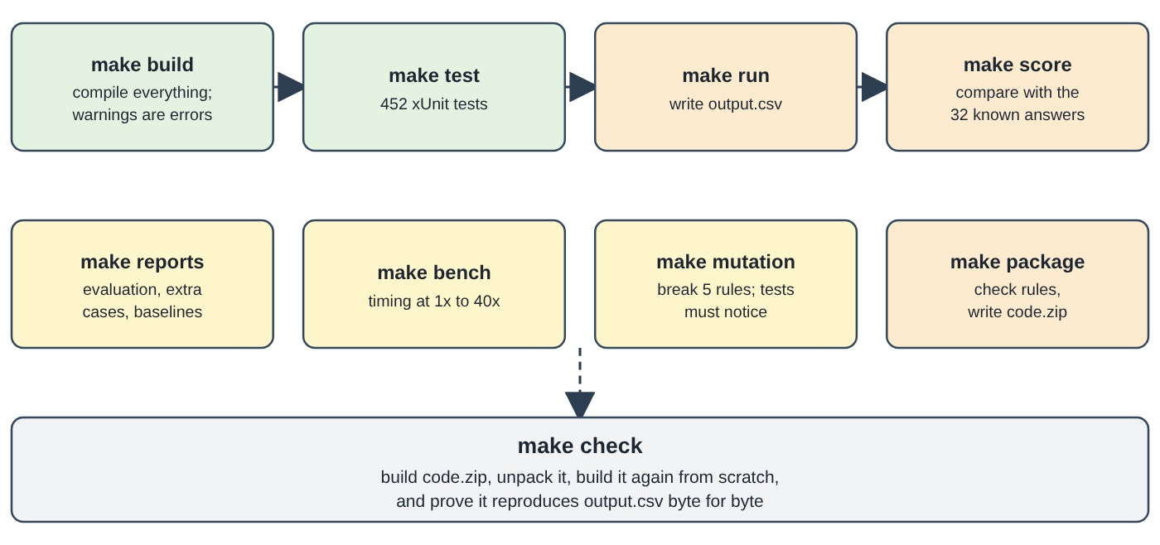
Figure 8.1 - The make targets and what each one produces.

8.3 Command-line options of the program
Option | Effect
--requests FILE, --out FILE, --dataset DIR | Choose another request file (for example sample_deletion_requests.csv), output path or dataset folder.
--explain CASE_ID | Walkthrough of one case; read-only.
--images auto|on|off|file|agent | How screenshots are read. auto (default) = a model only if ANTHROPIC_API_KEY is set; off = never; file = from a readings file; agent = the tool-using reader; on = single-shot model.
--config FILE, --set section.key=value, --show-settings | Use another settings file, override one value, or print the effective settings and version stamp.
--no-discovery, --no-timing-heuristics, --no-later-linking, --cohort-filter | Ablation switches: turn a feature off (or the harmful one on) to measure its effect.
--restart, --keep-checkpoint | Ignore a saved checkpoint; keep the checkpoint file after a successful run.
-v, -h | Verbose; help.

Exit codes: 0 success; 1 the written file failed validation; 2 bad command line, settings or missing input file.

8.4 What the tests do
A test is a small program that runs part of the project with a known input and checks that the result is exactly what is expected. If someone changes the code and breaks something, a test fails. The suite has 457 tests and runs in about a minute. The main kinds:
- Unit tests of one piece (the classifier against 112 labelled sentences; the CSV writer; the validator rules).
- Golden tests: expected answers typed by hand, per data category, independent of the program.
- End-to-end tests: the whole pipeline on the 32 samples and on invented datasets; the command-line program compared with the library.
- Invariant tests: properties that must hold for every row of output.csv (for example "no step cites evidence captured after audit_at").
- Robustness tests: broken CSV rows, corrupt or hostile evidence files, huge texts, injection strings, a killed and resumed run (a real child process is started and killed).
- Fake-model tests: the model client is replaced by a script that simulates refusals, timeouts, bad JSON, rate limits and rejected keys, so the model path is exercised without a real model.
- Hygiene tests: no Python remains, no case id or label is hard-coded in the code, .gitignore is correct.
- Document tests: the README's claims map and the architecture document still match the code and the reports.
Tests that need the dataset/ folder are skipped automatically if it is missing.

8.5 How quality is evaluated
- Scorer (make score). Compares predictions with the 32 known answers: case-level status accuracy; step-level precision, recall and F1 (a step counts only if phase, system, resource, operation, state and evidence id match); per-field accuracy; and sequence metrics (exact ordered match, similarity of the step order).
- Baselines. Trivial answers (all INCOMPLETE, copy the workflow status) show the floor; "gold answer" and "gold answer shuffled" prove that the scorer itself is correct.
- Synthetic cases (23, Appendix D). Tiny invented datasets for the policy categories the samples do not cover, each with a hand-written expected answer and an independent oracle.
- Edge-case sweep (make edge): 118 small invented datasets, each isolating one awkward input (empty or missing fields, bad times, duplicate ids, old e-mails, events after audit_at, corrupt evidence and PNGs, prompt injection), each with its expected behaviour written in words before the run. Result: 116 OK, 2 documented decisions, 0 defects. Its first run, on the original Python code, found 8 real defects that were then fixed.
- Hold-out test of discovery: hide some known account links, let discovery find them again and count wrong and "stolen" assignments.
- Ablations: switch each feature off and measure the loss (Chapter 7).
- Mutation check (make mutation): break 5 rules one at a time in a scratch copy; the tests must fail each time. Result: 5 of 5 caught.
- Performance report (make bench): repeats the requests 1x, 2x, 5x, 10x, 20x and 40x (20,720 cases). Measured on the development machine (4 CPUs): 1.70 s at 518 cases, 4.75 s at 5,180, 10.21 s at 20,720; peak memory 185 MB to 697 MB. Time grows about 6 times for 40 times the input.
All results are written to code/evaluation/. The reports are generated by the tools from live runs; no number in them is typed in by hand.

8.6 Packaging for submission
- make package checks every rule, then writes code.zip (deterministic: sorted entries, fixed timestamps). make check also rebuilds the zip, unpacks it, builds it from scratch and proves it reproduces output.csv byte for byte.
- The zip contains: the README, ARCHITECTURE, Makefile, the whole code/ folder (source, tests, tools, prompts, config template) and the generated reports (evaluation_report.md, usage_report.md, ...).
- The zip never contains: dataset/, any .env or prices.json, code/out/, caches, build folders (bin, obj), nested archives, real personal data or anything that looks like a secret. File types that the code judge ignores (.csv, .json, .jsonl, .sql, .log) are not allowed in it, except the price template.
- Secret and privacy scan: every file is scanned for key-like text and for any e-mail address that belongs to a person in the dataset.

8.7 Using a real model (optional, never done)
If you have a key, you set it in your own terminal only (export ANTHROPIC_API_KEY=...); no tool asks for it or writes it anywhere. Then dotnet run -c Release --project code/tools/Auditor.Tools -- show-readings shows each screenshot beside what the model read, and --images agent (or on) uses it in a run. Put per-model prices with a source URL and a date in code/config/prices.json to get a cost in the usage report; otherwise the report says exactly "cost not computed - prices not supplied".

9. The output explained

9.1 The file output.csv
A CSV file is plain text where each line is a row and commas separate the columns. output.csv has exactly three columns and 518 rows plus a header, in the same order as deletion_requests.csv:
Shape of the file (shortened)
case_id,deletion_status,steps_json
case_33,INCOMPLETE,"[{""step_no"":1,""phase"":""FINDING"",""system_id"":""export_service"",""resource_id"":""export_1842"",...}]"
case_534,NOT_APPLICABLE,[]

steps_json holds a JSON list (JSON is a text format for structured data: [...] is a list, {...} is an object with named fields). Inside a CSV cell, every double quote is written twice, which is why the file looks full of "".

9.2 The three statuses
Status | Meaning | steps_json | Count in output.csv
COMPLETE | The person asked for deletion and, at audit_at, every copy has the required treatment, every required retained record still exists, and no flow or restore path can recreate prohibited data. | Only VERIFICATION steps, each citing evidence that proves the compliant state. | 152 rows (484 steps)
INCOMPLETE | The person asked for deletion and at least one copy or process violates the policy at audit_at. | All three phases: findings (with evidence), the ordered remediation plan, and the verification checks that must pass afterwards (no evidence: future work). | 356 rows (2,714 steps)
NOT_APPLICABLE | The request does not authorize deletion (access, correction, export, marketing opt-out, login help, an explicit refusal, or unreadable wording). | [] - an empty list. | 10 rows

9.3 The seven fields of every step
Field | Meaning | Example
step_no | Position in the list, starting at 1 with no gaps. | 1
phase | FINDING, REMEDIATION or VERIFICATION, always in that order. | FINDING
system_id | The system that holds the record. | search_service
resource_id | The record, written <name>_<number>. | search_001
operation | One of the 15 allowed actions (table below). | REPORT_REMAINING_RECORD
state | The state that goes with the operation (it is fixed by the operation). | PRESENT
evidence_id | The evidence that proves it: a file_id (evidence_NN), an activity_id or an audit_id; empty text ("") for future work. | evidence_57

One step, laid out for reading (in the file it is on one line, without spaces)
{
"step_no": 1,
"phase": "FINDING",
"system_id": "search_service",
"resource_id": "search_001",
"operation": "REPORT_REMAINING_RECORD",
"state": "PRESENT",
"evidence_id": "evidence_57"
}

9.4 The fifteen operations
Phase | Operation | State | Plain-language meaning
FINDING | REPORT_REMAINING_RECORD | PRESENT | A record that should have been deleted still exists.
FINDING | REPORT_EXPOSED_PII | PRESENT | A record may stay, but identifiers that policy says must be redacted or anonymized are still visible.
FINDING | REPORT_ACTIVE_DATA_FLOW | ACTIVE | A running process can copy or re-create the data.
FINDING | REPORT_RESTORE_RISK | ACTIVE | A backup can restore the deleted data.
REMEDIATION | DISABLE_DATA_FLOW | DISABLED | Stop that process.
REMEDIATION | BLOCK_RESTORE | BLOCKED | Prevent that backup from restoring the person's data.
REMEDIATION | DELETE_RECORD | ABSENT | Remove the whole record.
REMEDIATION | REDACT_RECORD | REDACTED | Keep the record, remove the identifying fields policy names.
REMEDIATION | ANONYMIZE_RECORD | ANONYMIZED | Keep the record but irreversibly unlink it from the person.
VERIFICATION | VERIFY_RECORD_ABSENT | ABSENT | Confirm a record no longer exists.
VERIFICATION | VERIFY_RECORD_PRESENT | PRESENT | Confirm a record that policy requires to be kept still exists.
VERIFICATION | VERIFY_RECORD_REDACTED | REDACTED | Confirm identifying fields were removed.
VERIFICATION | VERIFY_RECORD_ANONYMIZED | ANONYMIZED | Confirm the record can no longer be linked to the person.
VERIFICATION | VERIFY_DATA_FLOW_DISABLED | DISABLED | Confirm the process is inactive.
VERIFICATION | VERIFY_RESTORE_BLOCKED | BLOCKED | Confirm the backup cannot restore the data.

9.5 Remediation steps and verification checks
- Remediation steps are proposals, not actions. They are written for the engineers who will do the work, in the order that keeps the work safe: stop flows and block restores first, then delete / redact / anonymize. They carry no evidence id because they describe future work.
- Verification checks are the "exit test". After the remediation, each check says what must be true: the record is absent, the flow is disabled, the restore is blocked, the redaction is done. For an INCOMPLETE row they are also future work (no evidence id).
- In a COMPLETE row, verification steps are present-tense proof: each one cites the file that shows the compliant state at audit_at. They also cover the records policy says to keep (VERIFY_RECORD_PRESENT), so a deletion that went too far would show up.
- Findings are the only steps in an INCOMPLETE row that cite evidence: they say which file proves the problem.

9.6 Retained records and tombstones
- Retained records: the security audit log (rule_12), a record on legal hold (rule_13) and backups (rule_14) are kept. The program verifies they are still present rather than deleting them. A legal-hold record that also shows a direct identifier is treated like a redaction case (only the stable user reference may remain). A hold or retention period that ended before audit_at no longer protects the record.
- Account tombstone (rule_15): after deletion, some systems keep a stub whose only content is the stable internal user_id, so that retained records can still point to "the same user". The tombstone may keep the id but must not contain the name, e-mail, phone or e-mail hash; if it does, it is a REDACT finding. In this repository, the dataset contains 11 tombstone_* resource ids in the activity log.

9.7 How to read any row in four questions
- What is the status? (NOT_APPLICABLE -> stop reading.)
- In an INCOMPLETE row, read the FINDING steps: what is wrong, where, and which file proves it.
- Read the REMEDIATION steps top to bottom: this is the order in which to fix things.
- Read the VERIFICATION steps: the checklist to tick off afterwards (and, for kept records, the check that they survived).

9.8 The numbers behind output.csv
Operation | Count in output.csv
VERIFY_RECORD_ABSENT | 787
VERIFY_RECORD_PRESENT | 410
REPORT_REMAINING_RECORD / DELETE_RECORD | 369 each
REPORT_EXPOSED_PII | 214
VERIFY_RECORD_REDACTED / VERIFY_RECORD_ANONYMIZED | 178 / 174
REDACT_RECORD / ANONYMIZE_RECORD | 141 / 73
REPORT_ACTIVE_DATA_FLOW / DISABLE_DATA_FLOW / VERIFY_DATA_FLOW_DISABLED | 113 / 113 / 146
REPORT_RESTORE_RISK / BLOCK_RESTORE / VERIFY_RESTORE_BLOCKED | 26 / 26 / 59

(Counted from the committed output.csv: 3,198 steps in total.)

10. Limitations, assumptions and possible improvements
A good audit tool must be honest about what it does not know. This chapter lists the known weaknesses (taken from README.md and code/evaluation/evaluation_report.md, and confirmed against the code where possible), the assumptions the program makes, what could not be verified while preparing this document, and ideas for improvement.

10.1 Known weaknesses
# | Weakness | Why it matters
1 | The screenshot (vision) path has never been run against a real model. No API key was available. Its accuracy, variance, cost, how often the gate rejects, and whether the real API accepts the request shapes are all unknown. It was tested with fake models only (0 calls, 0 tokens, no cost). | The 11 PNG screenshots are never read in the submitted run.
2 | 9 rows are provisional (case_34, 35, 39, 50, 52, 53, 55, 61, 63). Their only state evidence is a screenshot. The program assumes the violating state and says so. With the assistant's own readings file all nine come out identical, but that file was not used for the submitted output. | These nine answers rest on an assumption, not on read evidence.
3 | A screenshot can disagree with the rest of the data. With the readings file exactly one other row changes, case_45: a security-audit screenshot lists six events for one user, giving six retained-record verifications instead of one, while every other user has exactly one audit record (457 of 457). The readings run was therefore not adopted. | Which of the two answers is right is a human decision about the screenshot.
4 | Two timing heuristics exploit the synthetic timing of this dataset. Offsets between worker events (seconds-of-the-minute, 40/41 s, 390/449 s gaps) would not exist on real servers with unsynchronised clocks, retries and jitter. | The accuracy of discovery on other data is unknown. They can be switched off (at a cost shown in Chapter 7).
5 | 100% hold-out precision is not proof. It was measured with explicitly linked cases on this one dataset. It says nothing about cases that really have no link or about another dataset instance. | The true accuracy for those cases is unmeasured.
6 | Some steps are omitted on purpose when candidates cannot be separated: the evaluation report counts 25 deletion rows with an ambiguous account, 11 with no candidate and 28 with an ambiguous anonymized-analytics record. (The README separately says 27 deletion rows lack an account verification step; these count different things and the two figures were not reconciled here.) | Recall is lower than precision by design (98.4% vs 100% on samples).
7 | Some data categories have no labeled sample (cache, delivery log, telemetry, marketing profile, secondary identifier, attachments, legal-hold exposure). They are verified only by the 23 synthetic cases. The exact shape of an exposed legal-hold record is an assumption. | Behaviour on those categories in the real data is not independently checked.
8 | The classifier's word lists cover a fixed set of languages. Other languages end as ambiguous and therefore NOT_APPLICABLE. | A deletion request in an uncovered language would be missed (the safe direction).
9 | There is no independent test set. All 32 labeled answers were read at the start to infer the rules, so none of the scores is a truly independent test. Several constants (time windows, gaps, margins) were set from the labeled data. | The 99.2% F1 is likely optimistic for unseen data.
10 | "Absent" is sometimes inferred. For deleted accounts that no file shows, the program relies on the worker's delete event (a claim) plus a snapshot that covers the system (see Example B). | A silent re-creation of the account would not be seen if no file shows it.

10.2 Assumptions the program makes
- All times are UTC (a time without a zone is read as UTC, never as the machine's local time).
- The evidence files, and the capture time in evidence_files.csv, are truthful. Evidence text is data, but its timestamps and contents are believed.
- An identifier match (e-mail, user id, hash, phone) means "same person"; there is no fuzzy matching.
- A request whose wish is unclear is not a deletion request.
- A resource id has the form <name>_<number>; anything else is not a resource.
- The deletion worker's activity events follow regular timing patterns (only for the optional heuristics, which can be switched off).
- The sample answers are a faithful picture of the hidden grading rules (for example "the account is always verified absent", which all 32 samples show).

10.3 Things that could not be verified
Unverifiable here
- Whether the answers for the 486 requests that have no published answer are correct. The 32 samples are the only reference.
- Anything about a real AI model reading the screenshots: accuracy, cost, rate-limit behaviour, whether the Anthropic C# client's requests are accepted. The client has never sent a request.
- Behaviour on Windows or macOS. Everything was run on Linux (Ubuntu 24.04). The Makefile uses Unix tools (rm, find), and the image native library package in the project is the Linux one, so on other systems the optional zoom_region tool might not load (the code then does not offer it, by design).
- Behaviour on a different dataset instance (another random seed of the generator) or on production data.
- The accuracy of the performance numbers on other hardware (they were measured on a 4-CPU Linux machine; only the ratios are meaningful).
- Whether the hidden grader accepts every detail of the output beyond what the published contract and the 32 samples show.

10.4 Possible improvements
These are suggestions, not features of the repository:
- Run the vision path for real, compare it with the 11 readings, count disagreements per field and record tokens and cost, and only then decide whether to adopt it. Also measure whether zoom_region helps at all.
- Get more labeled data (or a second independent labeler) to build a real held-out test set and re-tune constants honestly.
- Replace or confirm the timing heuristics with an identifier-based link (for example a deletion ticket id carried on every worker event) if the real system can provide one.
- Add more languages and examples to the classifier, and a review queue for ambiguous requests instead of silently treating them as not applicable.
- Explicit absence evidence for deleted accounts: a "NOT_FOUND" lookup in the evidence instead of an inference from coverage.
- Operational hardening: continuous integration that runs build, tests and the mutation check on every change; support and tests for Windows/macOS; sharding or a database instead of one in-memory process for much larger inputs.
- Close the loop: a separate tool that actually executes approved remediation steps with human approval, then re-runs the audit to verify.

Appendix A. Glossary
Term | Plain-language meaning
Account tombstone | A stub left after an account is deleted: it keeps only the stable internal user id so that records that must be retained can still point to the same user. Name, e-mail, phone and e-mail hash must be removed.
Algorithm | A precise recipe of steps that gives the same result for the same input.
Anonymize | Change a record so it can no longer be linked to a person - irreversibly. The record stays.
Audit | A careful check of what is really the case, as opposed to what is claimed.
audit_at | The cut-off time for one case: only evidence captured up to this moment may decide the answer.
Backup (archive) | A stored copy of data that can be restored later. A restore can bring deleted data back.
Build | Turning the human-written code into a runnable program (compiling). Here warnings count as errors.
C# / .NET | The programming language and the platform the project is written in.
Cache | A temporary copy kept for speed (for example a stored web page).
Case | One row of deletion_requests.csv - one request to audit.
Checkpoint | A file of finished results saved during a run so that a stopped run can continue.
Claim | A statement from a workflow or a log (for example "SUCCESS") that is not proof until evidence shows the resulting state.
Classifier | The part that decides whether a request text asks for deletion.
CLI (command-line interface) | A program you start by typing a command in a terminal.
CSV | Comma-separated values: a plain-text table, one row per line.
Data flow | A running process that copies data from one system to another (a sync or import job).
Deterministic | Always giving the same output for the same input.
Discovery | Finding records that carry no identifier, using the activity timeline and elimination.
Evidence | The files that show what the systems looked like: SQL snapshots, JSON, logs, text, PDFs, screenshots.
F1 / precision / recall | Scores comparing predicted steps with the correct steps (see section 1.7).
Fake (in tests) | A stand-in object that behaves like a real component (for example a model) so a test can run without it.
Gate | The deterministic checks that anything a model says must pass before it can be used.
Hash (fingerprint) | A fixed-length code computed from some text (SHA-256 here). The same text always gives the same code; the text cannot easily be recovered from it.
Hold-out test | Hiding part of the known answers, letting the program find them again and counting mistakes.
Identifier | Something that identifies a person in data: e-mail, user id, phone, e-mail hash.
JSON | A text format for structured data (lists and named fields).
Legal hold | An instruction to keep certain records because of a legal matter; deleting them would be wrong while it is active.
LLM | Large language model: an AI system that generates text.
Mutation check | Deliberately breaking one rule in a scratch copy to see whether the tests notice.
NuGet | The package store for .NET libraries.
Observation (Obs) | The common record produced from any evidence: file, time, system, resource, category, state, identifiers.
Pipeline | A chain of stages in which each stage's output feeds the next.
Policy | The rules in deletion_rules.csv: what must be done with each kind of data.
Prompt injection | Text that tries to give an AI model new instructions ("ignore the rules ...").
Provisional row | An answer built from an assumption because the only evidence (a screenshot) was not read; flagged in the notes.
Redact | Remove the identifying fields from a record but keep the record.
Remediation | The fix: what must be done to make things compliant.
Replica | A live copy of a database (read, regional, failover, reporting). A replica can still hold data deleted from the primary.
Resource | One record in one system, with an id such as search_001.
Retain | Keep a record because policy requires it.
Sandbox | A locked-down environment in which untrusted content can run without harming anything outside.
SDK | Software development kit: a library that makes it easier to use a service.
SQL / SQLite | A language for databases / a small database engine that runs inside the program.
steps_json | The column of output.csv that holds the list of steps as JSON.
Synthetic | Invented for testing (the dataset itself is also synthetic: fictional people and companies).
Test (automated) | A small program that checks that another piece of the project gives the expected result.
Time window | The period [requested_at, audit_at]; only evidence captured inside it may decide a state.
Verification | A check proving that the required state holds (now, or after the fix).
xUnit | The .NET framework that runs the automated tests.

Appendix B. Command cheat sheet
I want to ... | Command
install packages | make setup
build everything | make build
run all tests | make test
produce output.csv | make run (or dotnet run -c Release --project code/src/Auditor.Cli --)
score the 32 samples | make score
understand one case | make explain CASE=case_06
see the settings | dotnet run -c Release --project code/src/Auditor.Cli -- --show-settings
run without discovery (ablation) | dotnet run -c Release --project code/src/Auditor.Cli -- --no-discovery --out code/out/x.csv
regenerate all reports | make reports
run the edge-case sweep | make edge
measure performance | make bench
break rules on purpose | make mutation
check submission rules and build code.zip | make package
run the final checklist | make check
remove build output and caches | make clean
compare two answer files | dotnet run -c Release --project code/tools/Auditor.Tools -- score --pred FILE
verify the answer file has not changed | compute its SHA-256 (sha256sum output.csv); it should start with 4676156f

Appendix C. The fifteen policy rules and what the program does with them
Rule | Data category | Condition (from the CSV) | Action | Violation when ... | What the plan contains
rule_01 | USER_PROFILE | Always | DELETE | PRESENT | Account is always verified absent; if present: finding + delete + verify.
rule_02 | SECONDARY_IDENTIFIER | Always | DELETE | PRESENT | finding, DELETE_RECORD, verify absent
rule_03 | SEARCH_INDEX_ENTRY | Always | DELETE | PRESENT | finding, DELETE_RECORD, verify absent
rule_04 | CACHE_ENTRY | Always | DELETE | PRESENT | finding, DELETE_RECORD, verify absent
rule_05 | SUPPORT_MESSAGE | Conversation has shared customer, agent or order context that must be retained | REDACT | EXPOSED | finding REPORT_EXPOSED_PII, REDACT_RECORD, verify redacted
rule_06 | SUPPORT_ATTACHMENT | Attachment belongs only to the subject | DELETE | PRESENT | finding, DELETE_RECORD, verify absent
rule_07 | ANALYTICS_PROFILE | Still attributable to a user | ANONYMIZE | EXPOSED | REPORT_EXPOSED_PII, ANONYMIZE_RECORD, verify anonymized
rule_08 | PRODUCT_TELEMETRY | Still attributable to a user | ANONYMIZE | EXPOSED | same as rule_07
rule_09 | USER_EXPORT | Always | DELETE | PRESENT | finding, DELETE_RECORD, verify absent
rule_10 | MARKETING_PROFILE | Always | DELETE | PRESENT | finding, DELETE_RECORD, verify absent
rule_11 | EMAIL_DELIVERY_LOG | Log contains a user e-mail address | REDACT | EXPOSED | REPORT_EXPOSED_PII, REDACT_RECORD, verify redacted
rule_12 | SECURITY_AUDIT_LOG | Within the supplied retention period | RETAIN | (never) | VERIFY_RECORD_PRESENT - must still exist
rule_13 | LEGAL_HOLD_RECORD | A supplied legal hold is active | RETAIN | only if it also shows a direct identifier (then handled like REDACT) | VERIFY_RECORD_PRESENT; no step once the hold has ended
rule_14 | BACKUP_ARCHIVE | Restore access can be blocked | RETAIN | RESTORABLE | REPORT_RESTORE_RISK, BLOCK_RESTORE, VERIFY_RESTORE_BLOCKED
rule_15 | ACCOUNT_TOMBSTONE | Account is deleted and only the stable user_id is needed to keep references | REDACT | EXPOSED | redact name, e-mail, phone, hash; verify redacted
(fixed) | DATA_FLOW | not in the CSV; required by the task | - | ACTIVE | REPORT_ACTIVE_DATA_FLOW, DISABLE_DATA_FLOW, VERIFY_DATA_FLOW_DISABLED

Appendix D. The 23 synthetic evaluation cases
Built by code/tools/Auditor.Tools/ExtraCases.cs, each with an expected answer written independently of the program; all 23 pass (code/evaluation/extra_cases_results.md). They cover what the 32 samples do not.
Case | What it checks | Status
XC-01 | Cache entry still holds the user (rule_04) | INCOMPLETE
XC-02 | Cache entry already gone: nothing to do for it | COMPLETE
XC-03 | Marketing profile survives (rule_10) | INCOMPLETE
XC-04 | Secondary identifier (old-address contact row) survives (rule_02) | INCOMPLETE
XC-05 | Attachment in object storage belongs only to the subject (rule_06) | INCOMPLETE
XC-06 | Delivery log still contains the e-mail address (rule_11) | INCOMPLETE
XC-07 | Delivery log already redacted: kept and verified | COMPLETE
XC-08 | Product telemetry still attributable (rule_08) | INCOMPLETE
XC-09 | Product telemetry already anonymized | COMPLETE
XC-10 | Active legal hold, only the stable reference: retained and verified | COMPLETE
XC-11 | Active legal hold whose record also carries the e-mail address | INCOMPLETE
XC-12 | Legal hold already expired at audit_at: no step | COMPLETE
XC-13 | A legal hold exists, but for another person | COMPLETE
XC-14 | Flow, restore and search copy together: flows first, then restores, then deletes | INCOMPLETE
XC-15 | Access request, not a deletion request | NOT_APPLICABLE
XC-16 | Marketing opt-out that explicitly keeps the account | NOT_APPLICABLE
XC-17 | Mixed request: an explicit deletion plus an export copy is still audited | INCOMPLETE
XC-18 | Correction request carrying an injected instruction is ignored | NOT_APPLICABLE
XC-19 | Deletion request carrying an injected "mark COMPLETE" still finds the cache copy | INCOMPLETE
XC-20 | Later evidence cannot change the answer: the copy was removed after audit_at | INCOMPLETE
XC-21 | Request made from the OLD e-mail address; the cache copy is filed under it | INCOMPLETE
XC-22 | Another person's cache copy in the same snapshot is a decoy and is left alone | COMPLETE
XC-23 | Evidence older than the request describes the world before it: not state | COMPLETE

Appendix E. Suggested reading order for a newcomer
- This document, Chapters 1, 2 and 9.
- README.md - quick start; then run make build, make test, make run.
- Run make explain CASE=case_06, case_01 and case_17, and read the output next to Chapter 6.
- code/src/Auditor/Audit.cs (read AuditCase first), then Classify.cs, Identity.cs, State.cs, Policy.cs, Schema.cs.
- ARCHITECTURE.md - failure modes and decision records.
- code/evaluation/evaluation_report.md and code/evaluation/CHANGELOG.md - how the program was measured and improved, change by change.
- Evidence/* and Discover.cs last: these are the longest and most dataset-specific files.
End of document.

