الاسم : محمد رمضان محمد البيومى عبدربه

رقم الجلوس : 710

سكشن :32

جروب: 6

Topic: programming languages

Application brief:

Programming languages of a high importance

Nowadays due to the demand of its applications, so many job opportunities are available for programmers; therefore we should give attention to it.

List of topics:

1. History of programming languages

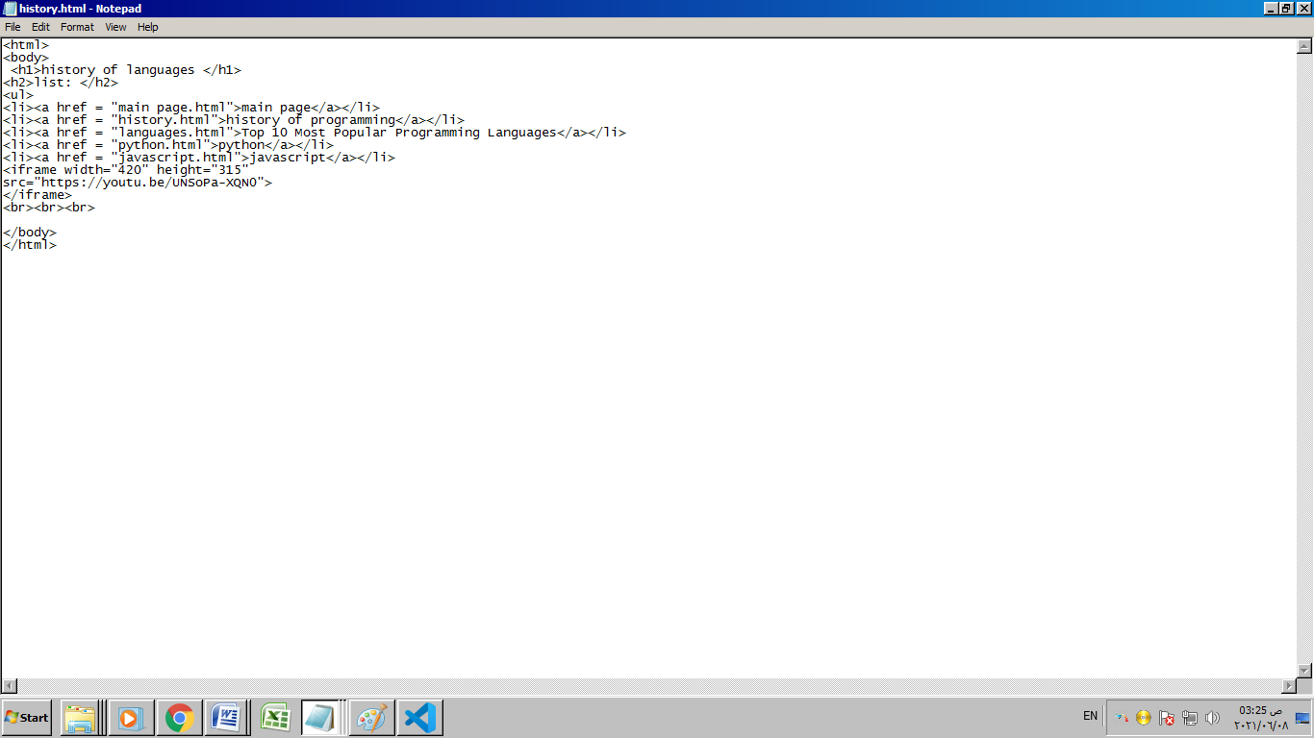

1. Top 10 programming languages

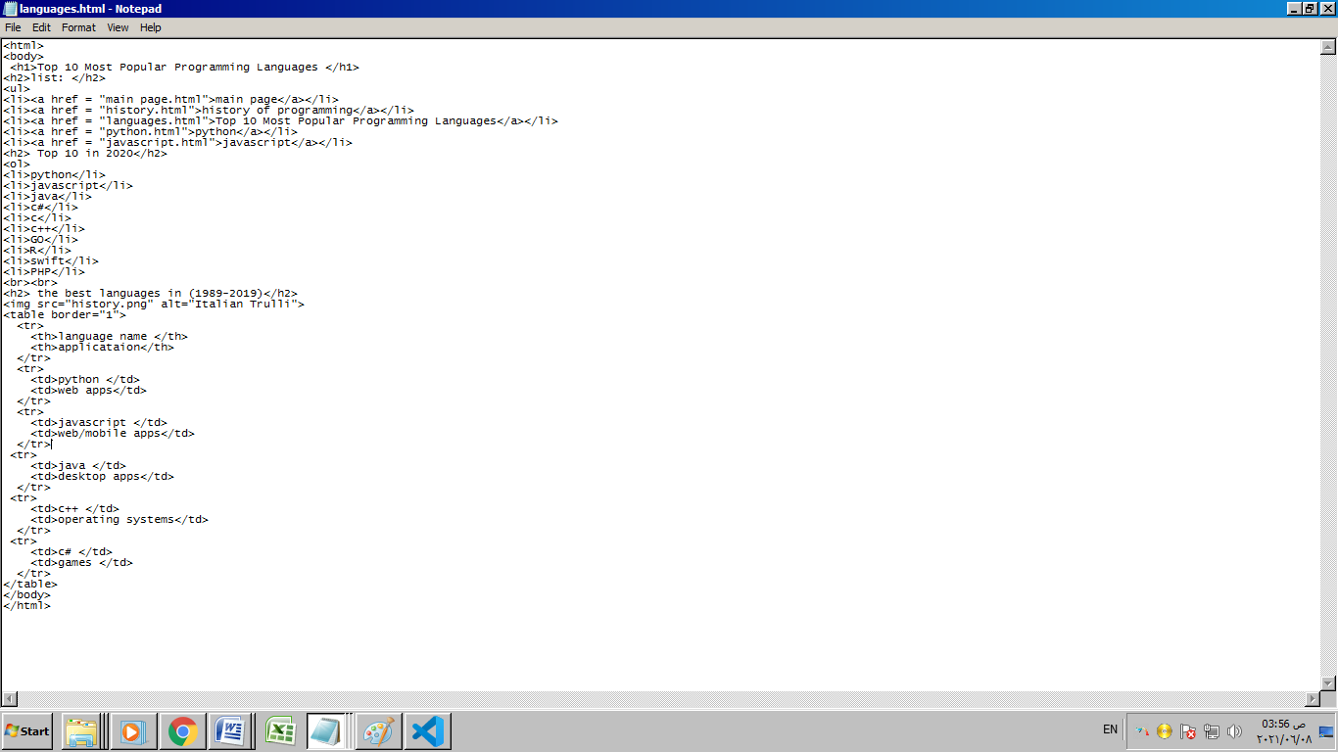

1. Python

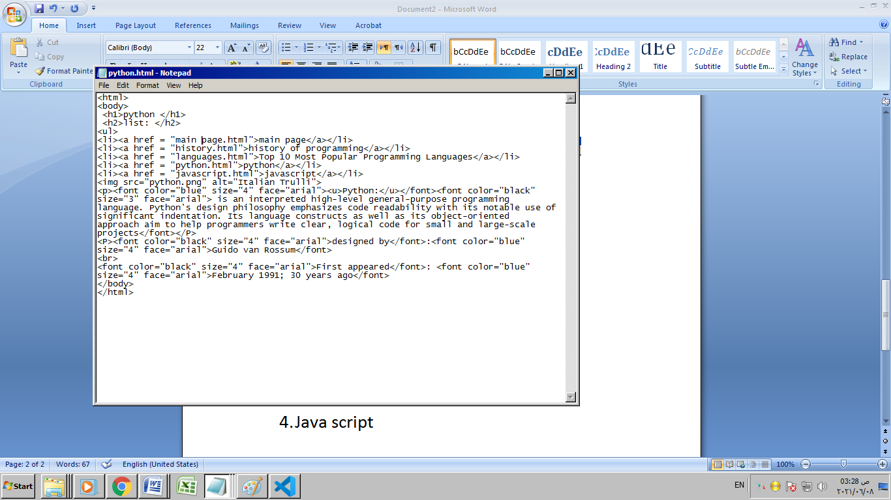

4-Java script