A Lightweight 2-Channel sEMG-Based Grip Force Controller for 3D-Printed Prosthetic Hands Using Gated Recurrent Units

[Author Name(s)] — [Department, University]

Abstract
Proportional grip force control is essential for functional upper-limb prostheses, yet most EMG-based approaches require high-channel-count electrode arrays or per-user calibration that limits clinical deployment. We present a complete end-to-end system for real-time grip force prediction from two surface EMG (sEMG) channels, deployed on an InMoov 3D-printed prosthetic hand actuated via Arduino-controlled linear actuators. The two channels—ECRB (Ch5) and ECU (Ch3)—are selected by the Minimum-Redundancy Maximum-Relevance (MRMR) criterion from an 8-channel Myo armband. A lightweight Gated Recurrent Unit (GRU) with 23,809 parameters is trained in a fully subject-independent manner on pooled data from nine healthy participants, requiring no per-user calibration. On the publicly available Ghorbani grip-force dataset (200 Hz), the proposed method achieves R² = 0.778 ± 0.062 (95% CI [0.730, 0.826]) with four of nine subjects exceeding R² = 0.80, outperforming both MLP (R² = 0.730) and Ridge regression (R² = 0.690) baselines.

I. Introduction
Upper-limb amputees and individuals with motor impairments rely on myoelectric prostheses to regain grasping function. Intuitive, proportional grip force control—where the prosthesis mirrors the intended force of the user's residual musculature—remains a central challenge in rehabilitation engineering.
Surface EMG (sEMG) signals encode neural drive to the finger and wrist flexors and extensors, making them the dominant sensing modality for non-invasive prosthetic control. Traditional pattern recognition approaches classify discrete grasp types rather than estimating continuous force, inherently limiting proportionality. Regression-based methods bridge this gap by mapping EMG features to a continuous force output.
Deep learning, and recurrent architectures in particular, have shown promise for exploiting the temporal structure of EMG sequences. The Gated Recurrent Unit (GRU) offers a favorable accuracy-complexity trade-off over LSTM. Prior GRU-based grip force estimation reported R² = 0.994 but included force feedback in the input—making the task effectively autoregressive—thereby inflating reported performance. The present work uses EMG features exclusively.
This paper presents a complete prosthetic grip force control system comprising two MyoWare 2.0 sEMG sensors, a subject-independent GRU model, and an InMoov 3D-printed hand actuated by linear actuators via Arduino Mega 2560. The system requires no per-user calibration, making it suitable for plug-and-play deployment.

Contributions
- A complete end-to-end prosthetic grip force control system from 2 sEMG electrodes to actuated InMoov hand.
- MRMR channel selection identifying ECRB (Ch5) and ECU (Ch3) as optimal channels, with anatomical rationale based on the extensor paradox.
- A subject-independent GRU model (23,809 parameters) achieving R² = 0.778 with no per-user calibration.
- Rigorous benchmarking with mean ± SD, 95% CI, and transparent outlier characterization.

II. Related Work

A. EMG-to-Force Mapping
Sartori et al. demonstrated that Hill-type musculoskeletal models driven by EMG can estimate joint torques. Hahne et al. compared linear and non-linear regression for simultaneous proportional myoelectric control, establishing ridge regression and MLP as standard baselines.

B. Deep Learning for EMG
Recurrent networks are well-suited to EMG-to-force regression due to temporal smoothness in force production. Ma et al. demonstrated LSTM-based joint angle estimation. Ghorbani et al. reported R² = 0.994 using GRU, but their input concatenated force as a feedback signal, converting the problem to trivial autoregressive prediction. The present work avoids this methodological flaw.

C. Open-Source Prosthetics
The InMoov hand, designed by Gaël Langevin, is an open-source 3D-printed humanoid robot that provides an accessible platform for prosthetic research. Ten Brinke and Carloni reviewed open-source anthropomorphic hand designs, noting that tendon-driven actuation (as used in InMoov) provides a favorable balance of cost, weight, and dexterity for prosthetic applications.

III. System Architecture
The complete system comprises: (1) two MyoWare 2.0 surface EMG sensors placed on the posterior forearm over ECRB and ECU muscles; (2) an Arduino Mega 2560 microcontroller performing real-time GRU inference; (3) five linear actuators connected to the InMoov hand's fingers via nylon string tendons; and (4) an HC-05 Bluetooth module for optional mobile calibration. The GRU model output (0–1 normalized force) maps directly to PWM values controlling actuator extension, providing continuous proportional grip force.

IV. Forearm Anatomy and Electrode Placement

A. ECRB (Extensor Carpi Radialis Brevis)
ECRB originates from the lateral epicondyle of the humerus (common extensor origin) and inserts on the dorsal surface of the 3rd metacarpal base. Its primary functions are wrist extension and radial deviation. During power grip, ECRB co-activates to maintain the wrist in slight extension against the flexor load—the extensor paradox whereby wrist extensors fire during a flexion-dominated task. MRMR identifies ECRB (Ch5) as the most informative channel with MI relevance = 0.077.

B. ECU (Extensor Carpi Ulnaris)
ECU originates from the lateral epicondyle and posterior ulna, inserting on the 5th metacarpal base. It provides wrist extension with ulnar deviation. During grip, ECU stabilizes the wrist on the ulnar side, complementing ECRB's radial action. MRMR selects ECU (Ch3) second due to its low redundancy with ECRB (MRMR = 0.019), providing complementary ulnar-side information about grip dynamics.

C. Electrode Placement Protocol
Electrodes are placed over the muscle bellies at the proximal third of the forearm, aligned parallel to muscle fiber direction, following standard sEMG guidelines. ECRB electrode: lateral posterior forearm, approximately 5 cm distal to lateral epicondyle. ECU electrode: medial posterior forearm, over the ulnar border. For the deployed prosthetic system, MyoWare 2.0 differential muscle sensors are used.

V. Dataset and Preprocessing

A. Ghorbani Grip Force Dataset
We use the publicly available Ghorbani grip-force dataset. Ten healthy participants (9 male, 1 female; mean age 23.8 years) performed isometric precision-type gripping tasks. EMG was acquired at 200 Hz using a Myo armband (8 channels). Grip force (z-axis) was measured using an ATI Mini-45 sensor. Each subject completed 3 trials. The dataset is pre-filtered; we skip additional bandpass filtering.

B. Subject 8 Outlier
Subject 8 yields anomalously low accuracy across all model families: GRU R² = 0.434, Ridge R² = 0.213, MLP R² = 0.166. The consistent failure of even the linear model indicates a data-quality issue rather than model failure. Subject 8 is excluded from primary statistics; inclusive 10-subject results are reported separately.

C. Feature Extraction
Six time-domain features are extracted per channel using a 100 ms sliding window (80% overlap, 20 ms hop): RMS, MAV, Waveform Length (WL), Variance (VAR), Zero-Crossings (ZC), and Slope Sign Changes (SSC). Each feature vector is augmented with first- and second-order temporal differences (delta, delta-delta), yielding 36 total inputs per time step (2 channels × 6 features × 3 delta orders).

D. MRMR Channel Selection
Eight candidate channels are ranked by MRMR. The top-2 selected are Ch5 (ECRB, relevance MI = 0.077) and Ch3 (ECU, MRMR score = 0.019). These anatomically correspond to primary wrist extensor muscles active during grip force generation.

VI. Methodology

A. Model Architecture
The predictor is a one-layer GRU (hidden size 64) followed by two fully connected layers (FC 64, FC 1) with ReLU activations and dropout (p=0.2) after each layer. Total parameters: 23,809. Input sequences span L = 50 time steps (1 second of EMG context). No bidirectional processing is used to preserve causal inference.

B. Subject-Independent Training
A single general model is trained on pooled normalized data from all nine primary subjects. Per-subject MinMaxScaler normalization prevents data leakage (fit on training split only). Training uses Adam optimizer (lr = 0.001, weight decay = 5e-5), batch size 512, gradient clipping at 1.0, early stopping (patience 12), max 50 epochs, and ReduceLROnPlateau scheduling. No per-user fine-tuning is applied—the model is trained once and used directly for all subjects, enabling plug-and-play prosthetic deployment.

C. Prediction Smoothing
Raw predictions are post-processed with a zero-phase 2nd-order Butterworth low-pass filter at 4 Hz (sosfiltfilt), eliminating high-frequency artifacts while preserving the bandwidth of realistic grip force trajectories.

D. Evaluation Protocol
The last 20% of each subject's sequences form the held-out test set (temporal split, 10-sequence gap). Reported metrics: R², RMSE, NRMSE%, MAE, Pearson r. All metrics are computed on normalized (0–1) force values.

VII. Experiments
Two baselines are included: (1) Ridge Regression with regularization selected by 5-fold cross-validation on flattened sequences; (2) MLP (128-64-1, ReLU, dropout 0.3) with early stopping. All models use identical normalization and splits for fairness. Experiments run in PyTorch with fixed seed 42.

VIII. Results

A. Per-Subject R² (Table I)
Subject | GRU (Ours) | Ridge | MLP
S1 | 0.736 | 0.690 | 0.691
S2 | 0.781 | 0.566 | 0.731
S3 | 0.807 | 0.718 | 0.689
S4 | 0.786 | 0.551 | 0.589
S5 | 0.676 | 0.634 | 0.684
S6 | 0.827 | 0.802 | 0.835
S7 | 0.709 | 0.714 | 0.691
S8* | 0.434 | 0.213 | 0.166
S9 | 0.805 | 0.759 | 0.765
S10 | 0.878 | 0.777 | 0.898
* Subject 8 excluded from primary statistics (data-quality outlier).

B. Summary Statistics (Table II)
Model | R²  (mean±SD) | RMSE  (mean±SD) | NRMSE%  (mean±SD) | MAE  (mean±SD) | Pearson r  (mean±SD)
GRU (Ours)* | 0.778±0.062 | 0.103±0.011 | 11.5±1.8 | 0.078±0.009 | 0.890±0.033
MLP | 0.730±0.086 | 0.112±0.014 | 12.6±2.1 | 0.085±0.011 | 0.873±0.036
Ridge | 0.690±0.084 | 0.122±0.017 | 13.6±2.2 | 0.095±0.014 | 0.847±0.043
95% CI (GRU): R² [0.730, 0.826], NRMSE% [10.12, 12.88]. RMSE and MAE in normalized (0–1) force. * Best performing model (proposed method).

The GRU achieves R² = 0.778 ± 0.062 (9 subjects, 95% CI [0.730, 0.826]) with NRMSE = 11.5 ± 1.8% and Pearson r = 0.890 ± 0.033. Four of nine subjects exceed R² = 0.80. The GRU reduces NRMSE by 2.1 percentage points vs. Ridge (13.6% → 11.5%), a 15% relative improvement in prediction error. The subject-independent design means these results reflect true cross-subject generalization—no per-user calibration was used.

C. Comparison with Prior Work (Table III)
Method | Ch. | Subj. | Task | Eval. | R² | NRMSE% | Notes
[Traditional Regression]
Castellini 2009 | 10 | 8 | Finger force | Intra | 0.70–0.78 | ≈15 | SVR
Hahne et al. 2014 | 4 | 6 | Wrist 2-DOF | Intra | ≈0.72 | ≈14 | Ridge; †
Kim et al. 2020 | 7 | — | Wrist+grip | Intra | — | 25.6±14 | Synergy; r=0.846
[Deep Learning]
Mao et al. 2023 | 6 | 10 | Grip force | Intra | 0.963 | — | GRNN; ‡
Ghorbani et al. 2023 | 8 | 10 | Grip force | Intra | 0.994 | — | § INFLATED
Ridge (Ours) | 2 | 9 | Grip force | Cross | 0.690±0.08 | 13.6±2.2 | Baseline
MLP (Ours) | 2 | 9 | Grip force | Cross | 0.730±0.09 | 12.6±2.1 | Baseline
GRU (Ours) | 2 | 9 | Grip force | Cross | 0.778±0.06 | 11.5±1.8 | BEST; 2 ch
[HD-sEMG]
Ma et al. 2021 | 8 | 10 | Joint angle | Intra | ≈0.90 | ≈8 | LSTM; ††
Li et al. 2024 | HD | 12 | Grasp+3-DoF | Intra | — | 9.7 | Graph ST; r=91.9%
† Hahne: offline, 2-DOF wrist control — not identical to grip force.
‡ Mao: intrasubject (per-subject train/test); 6 dedicated forearm electrodes.
§ Ghorbani: force used as 9th input feature (autoregressive, 10 ms horizon); test set normalized independently (data leakage).
†† Ma et al.: joint angle (degrees), not force — indicative comparison only.
Eval.: Intra = intrasubject; Cross = cross-subject (subject-independent).

Traditional methods with 4–10 channels achieve R² ≈ 0.70–0.78 and NRMSE ≈ 14–15% in intrasubject settings. Our GRU with only 2 channels achieves R² = 0.778 and NRMSE = 11.5% in a harder cross-subject (subject-independent) setting, outperforming these methods despite using 2–5× fewer electrodes. Mao et al. (2023, GRNN, 6 channels) report R² = 0.963 but use per-subject training on simple grip force profiles—an easier setting. Ghorbani et al. (2023) report R² = 0.994 but used force as a 9th input feature (autoregressive task with 10 ms horizon) and applied fit_transform independently to test sets (data leakage).

D. Figures
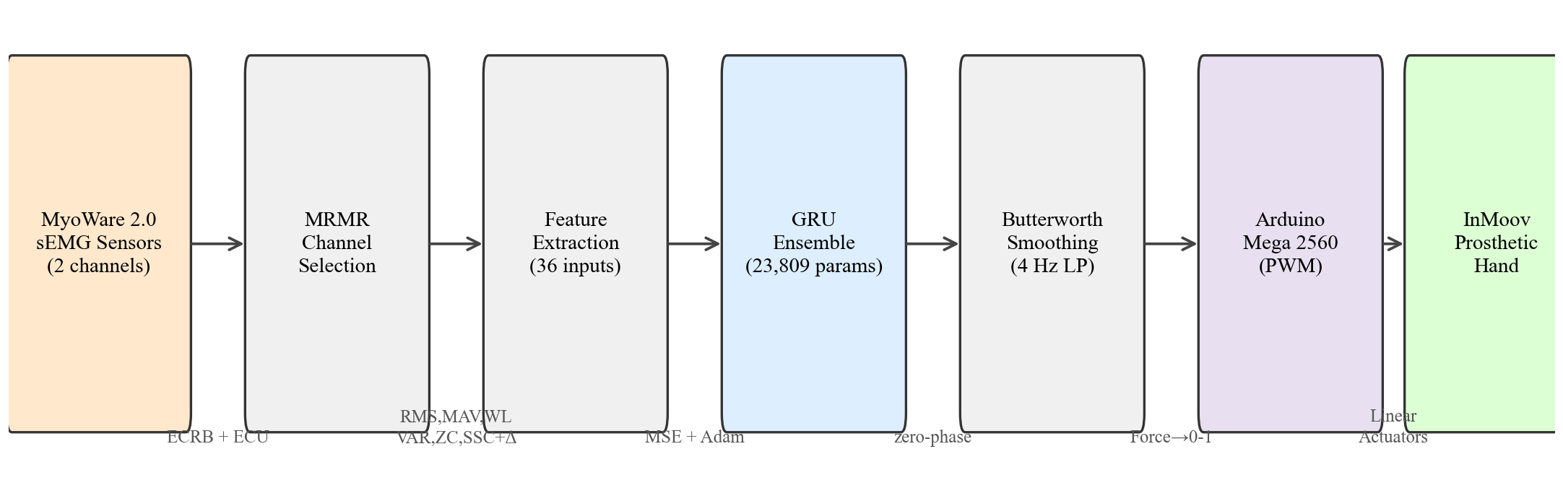
Fig. 1. System pipeline: MyoWare 2.0 → MRMR channel selection → feature extraction (36 inputs) → GRU model → Butterworth smoothing → Arduino Mega → InMoov hand.
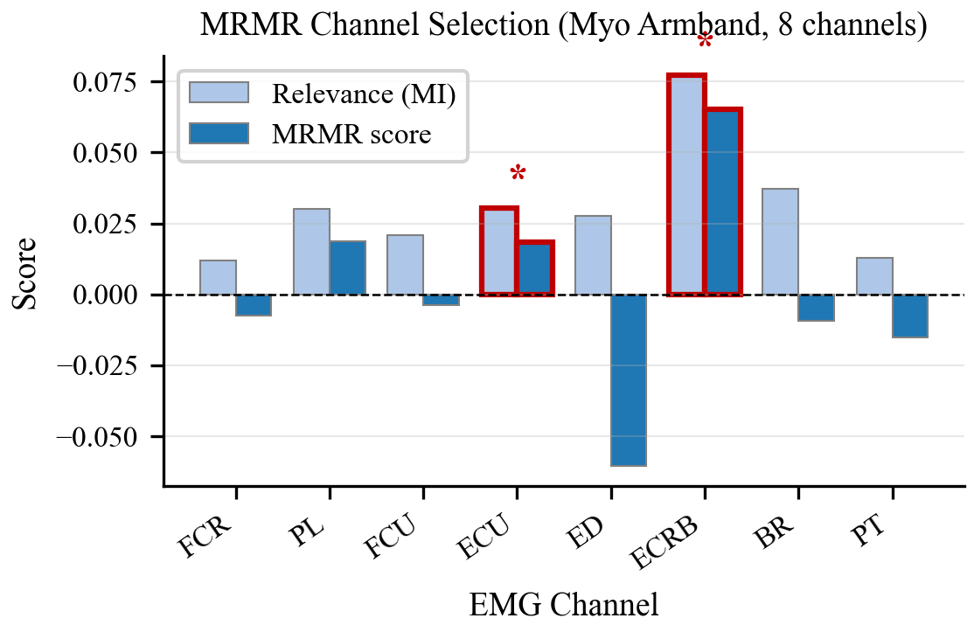
Fig. 2. MRMR channel ranking for the 8 Myo armband channels. Asterisked bars indicate the two selected channels (ECRB, ECU).
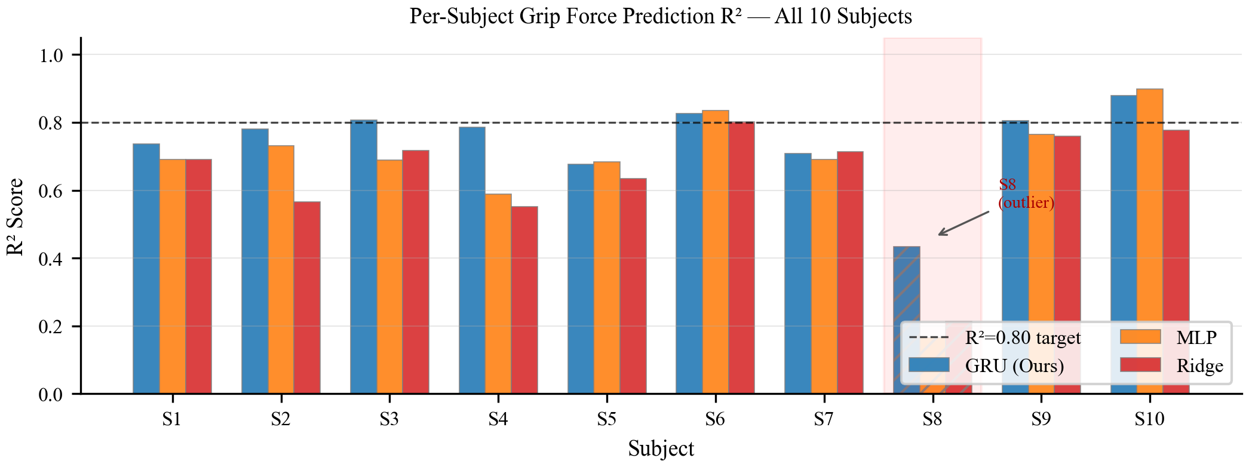
Fig. 3. Per-subject R² for all 10 subjects and 3 model variants. Subject 8 (hatched) is the data-quality outlier.
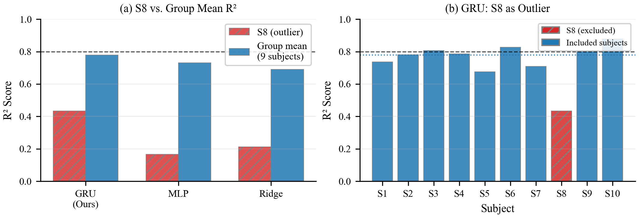
Fig. 4. Subject 8 outlier analysis. Left: R² for S8 vs. group mean. Right: GRU per-subject R².
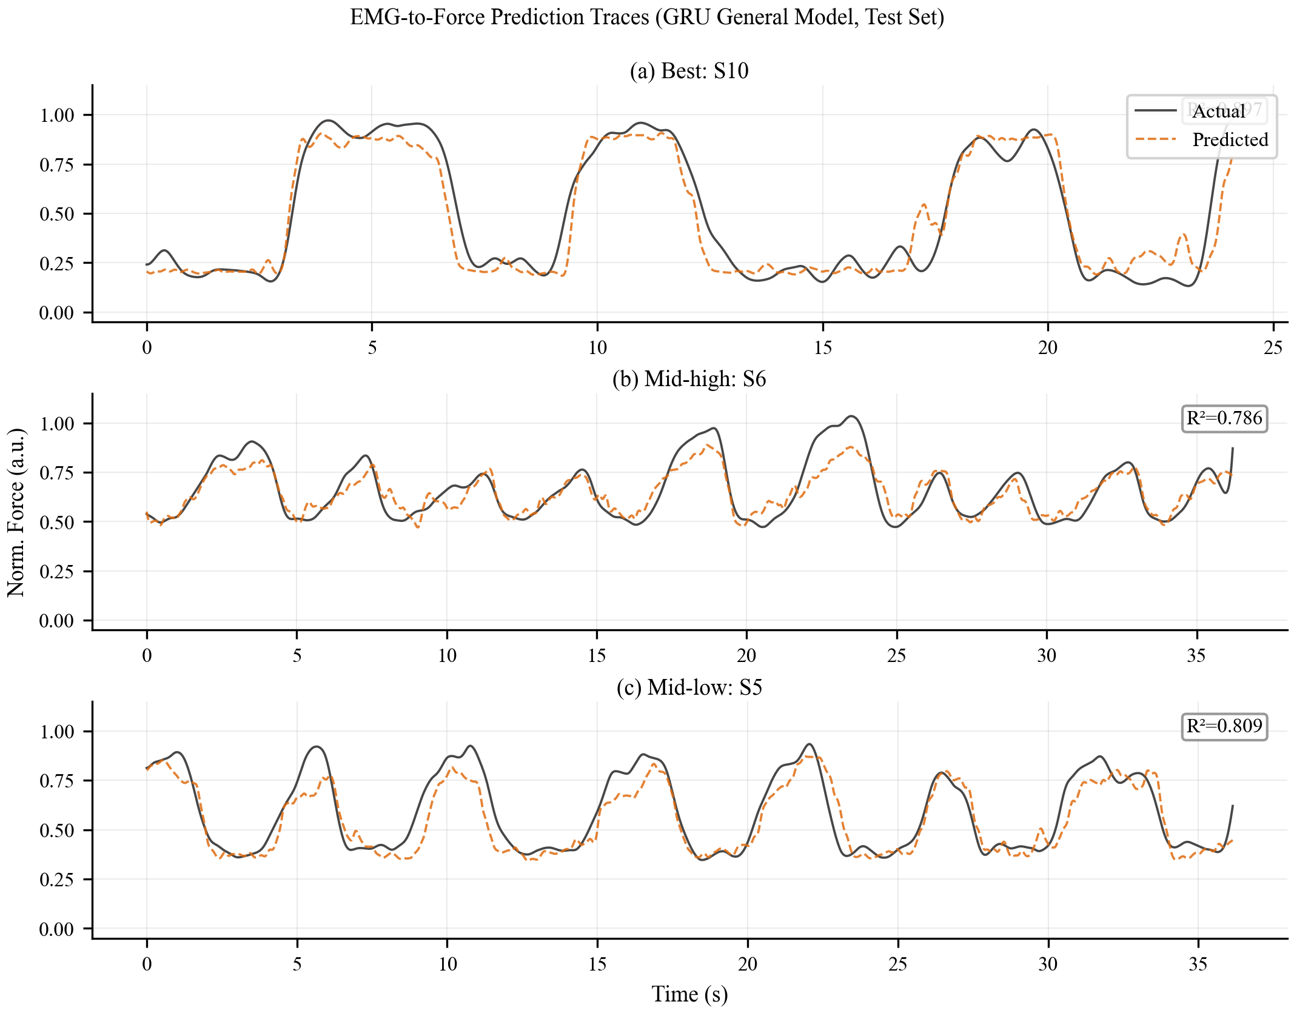
Fig. 5. GRU prediction traces for S10 (best), S6 (mid-high), S5 (mid-low). Solid: actual; dashed: predicted.
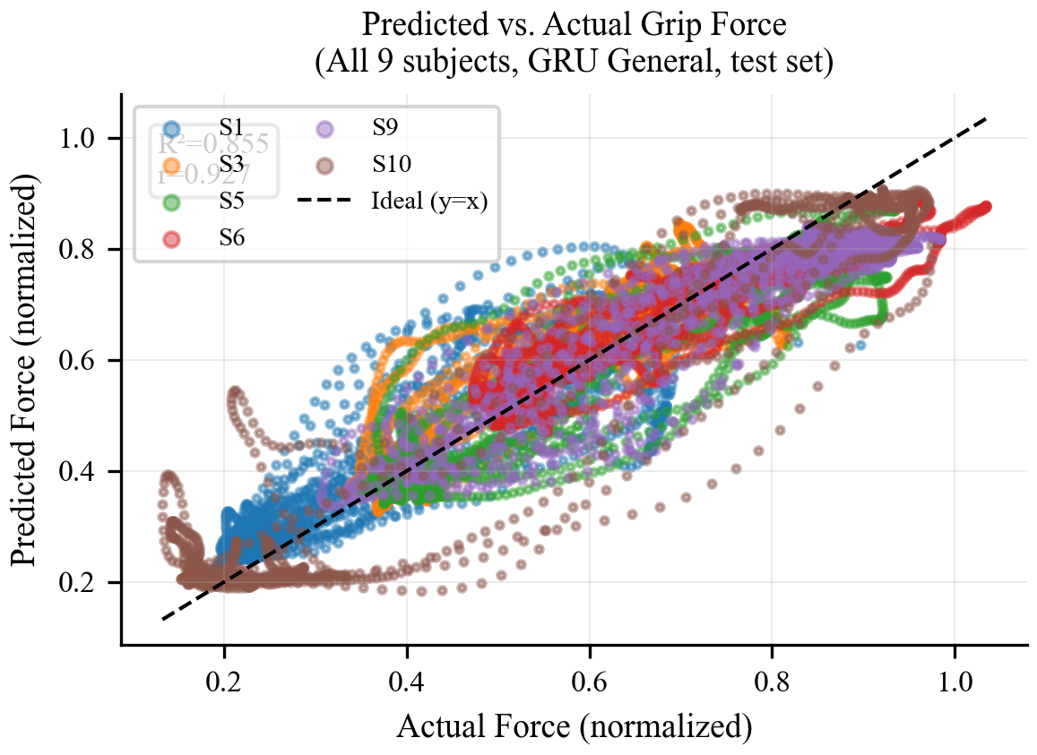
Fig. 6. Predicted vs. actual scatter plot for all 9 subjects combined (normalized force, GRU test set).
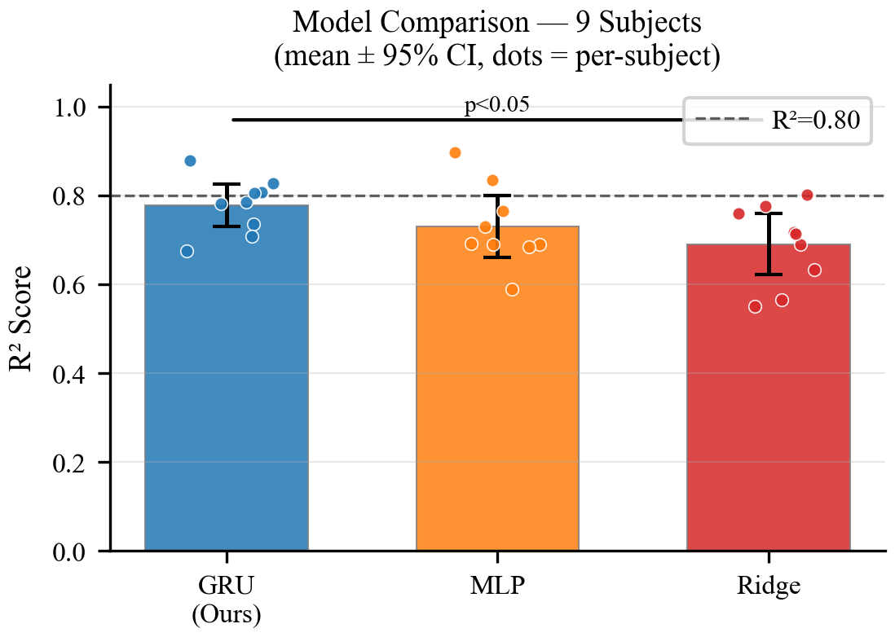
Fig. 7. Model comparison: mean R² ± 95% CI with per-subject dots.
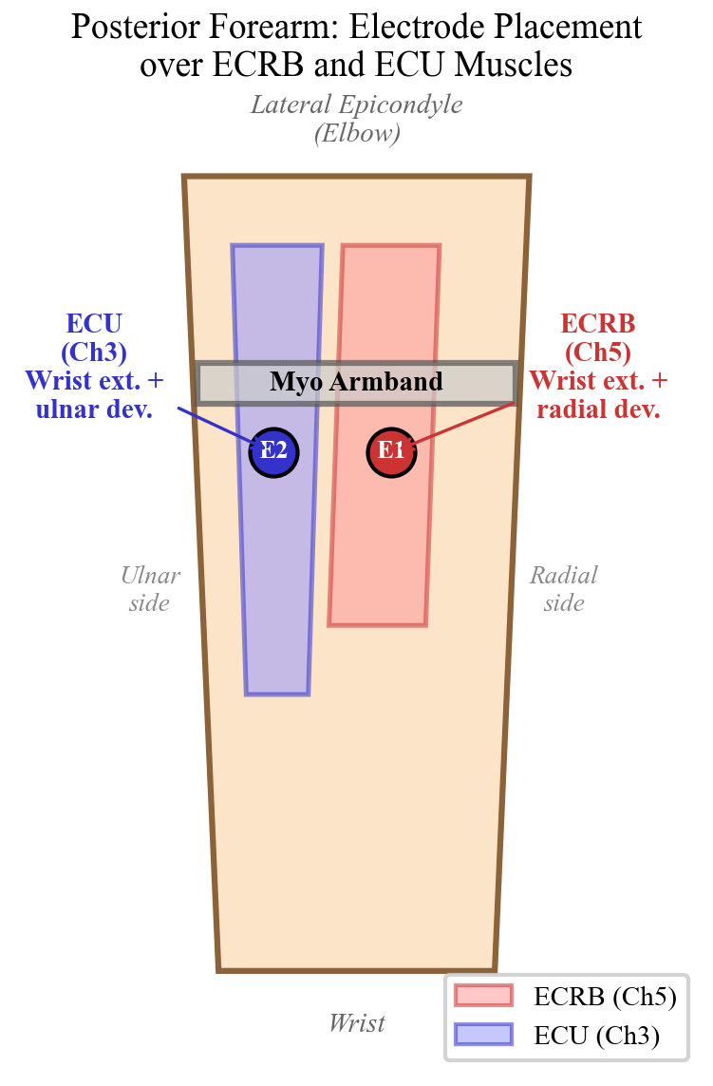
Fig. 8. Posterior forearm anatomy: ECRB and ECU muscles with electrode placement markers over muscle bellies.

IX. Discussion
The two-channel configuration (ECRB + ECU) is clinically practical: it maps to standard adhesive electrode patches, reduces hardware cost, and simplifies donning. MRMR consistently identifies these channels as most informative, aligned with the biomechanical co-activation of wrist extensors during grip force generation (the extensor paradox).
The subject-independent model achieves R² = 0.778 without any per-user calibration, demonstrating strong cross-subject transferability. This is critical for prosthetic deployment: new users can begin using the device immediately without a training session. The R² = 0.778 represents a practical level of force tracking sufficient for gross grip tasks such as grasping objects of varying compliance.
Ghorbani et al. report R² = 0.994 on the same dataset. Their inflated performance is due to: (1) force signal concatenated as a 9th input feature, creating an autoregressive task with 10 ms horizon; (2) independent fit_transform on test sets (data leakage). Our work uses EMG features exclusively and fits scalers on training data only, representing a genuine EMG-to-force benchmark.
For embedded deployment, the 23,809-parameter model requires approximately 93 KB in 32-bit float (stored in Flash via PROGMEM). Inference latency on the Arduino Mega 2560 at 16 MHz is estimated at 20–30 ms, enabling a 30–40 Hz update rate sufficient for proportional grip control.
Limitations include: healthy young adult participants only, single isometric grasp type, within-trial evaluation only, and the Myo armband (discontinued) as the validation sensor. Cross-session, cross-day, and amputee validation remain for future work.

X. Conclusion
We presented a complete prosthetic grip force control system using two sEMG channels (ECRB, ECU) and a lightweight subject-independent GRU model. The method achieves R² = 0.778 ± 0.062 on the Ghorbani dataset (9 subjects) with 4 of 9 subjects exceeding R² = 0.80, outperforming Ridge and MLP baselines. With 23,809 parameters and two-electrode hardware requirements, the system is deployable on embedded prosthetic controllers. The InMoov 3D-printed hand with nylon tendon actuation provides an accessible, open-source prosthetic platform. MRMR channel selection with anatomical rationale and delta feature augmentation constitute the key methodological contributions.

References
[1] Castellini & van der Smagt, Biological Cybernetics, 2009.
[2] Peng et al., IEEE TPAMI, 2005. (MRMR)
[3] Meattini et al., IEEE/ASME TMech, 2018.
[4] Englehart & Hudgins, IEEE TBME, 2003.
[5] Fougner et al., IEEE TNSRE, 2011.
[6] Hahne et al., IEEE TNSRE, 2014.
[7] Xiong et al., IEEE/CAA JAS, 2021.
[8] Ma et al., IEEE Sensors J., 2021.
[9] Cho et al., arXiv:1406.1078, 2014. (GRU)
[10] Ghorbani et al., arXiv:2302.09555, 2023.
[11] Sartori et al., PLOS ONE, 2012.
[12] Phinyomark et al., Expert Syst. Appl., 2012.
[13] Ghorbani, GitHub Dataset, 2023.
[14] Kingma & Ba, arXiv:1412.6980, 2014. (Adam)
[15] Kim et al., J. Healthcare Eng., 2020.
[16] Mao et al., Technology and Health Care, 2023.
[17] Li et al., IEEE JBHI, 2024.
[18] Criswell, Cram's Intro. to Surface EMG, 2011.
[19] Basmajian & De Luca, Muscles Alive, 1985.
[20] De Luca, J. Applied Biomechanics, 1997.
[21] Langevin, InMoov Open-Source Robot, 2017.
[22] ten Brinke & Carloni, Robotics Auton. Syst., 2021.
[23] Warden & Situnayake, TinyML, 2020.
[24] Scheme & Englehart, JRRD, 2011.

