Instructor Performance & Course Quality Evaluation
A Data-Driven Framework for the EduPro Online Learning Platform
Research Paper — Exploratory Data Analysis, Insights & Recommendations
Prepared for: Unified Mentor — EduPro Analytics Initiative
Date: August 2026

1. Executive Overview
EduPro requires a structured, evidence-based framework to evaluate instructor effectiveness and course quality, rather than relying on subjective judgment. This report analyzes 60 instructors, 60 courses, and 10,000 enrollment transactions to answer five core questions: how instructor ratings are distributed, whether experience predicts rating, whether instructor rating predicts course rating, which expertise areas perform best, and whether top-rated instructors drive more enrollment.
The headline finding is counter-intuitive but important: teaching experience correlates moderately with an instructor's own rating, but neither experience nor instructor rating meaningfully predicts the rating of the courses they teach. This suggests course quality on EduPro is driven by factors largely independent of the instructor metrics currently tracked — a critical insight for how the platform should design its quality-improvement strategy.

2. Data & Methodology

2.1 Data Sources
Four tables were provided: Users (3,000 learners), Teachers (60 instructors), Courses (60 courses), and Transactions (10,000 enrollment records linking a UserID, CourseID, and TeacherID). No missing values were found in any of the core analytical fields.

2.2 A Key Data-Structure Finding
Before analysis, the Teacher–Course relationship was validated. Every course in the Transactions table is associated with multiple distinct TeacherIDs (all 60 courses show more than one instructor across enrollment records), and the mapping is many-to-many rather than the one-instructor-per-course structure implied by the business context. This means "which instructor taught a course" cannot be resolved as a fixed 1:1 lookup from Courses alone — it must be read per-transaction.
Implication for this analysis: metrics that combine instructor and course information (e.g., "average course rating taught by an instructor") are computed at the transaction level — averaging the CourseRating of every course an instructor appears against in Transactions — rather than assuming static course ownership. This is methodologically sound but means these instructor-course-linked metrics should be read as directional/associative rather than a precise measure of "courses this person personally designed and delivered." We recommend EduPro capture an explicit primary-instructor field per course in future data collection to sharpen this analysis.

2.3 Analytical Approach
- Data integration: Teachers, Courses, and Transactions joined on TeacherID and CourseID.
- Descriptive statistics and distribution analysis on TeacherRating and CourseRating.
- Pearson correlation analysis for Experience↔Rating and TeacherRating↔CourseRating relationships.
- Group-by aggregation across CourseCategory, CourseLevel, Expertise, and Gender.
- Tier segmentation (Low/Mid/High) of instructors by rating tercile, compared on enrollment volume.

3. Key Performance Indicators
Five KPIs were defined to summarize platform-wide teaching quality:
KPI | Value | Interpretation
Average Teacher Rating | 3.12 / 5.00 | Moderate baseline teaching quality across the platform
Average Course Rating | 3.10 / 5.00 | Course content quality closely tracks instructor rating at the platform level
Rating Consistency Index | 0.47 (0–1 scale) | Based on 1/(1+σ) of course ratings per instructor; moderate consistency, meaning many instructors' courses vary considerably in quality
Experience Impact Score | +0.60 (correlation) | Moderate positive relationship between tenure and an instructor's own rating
Enrollment Influence Ratio | 4.94× | Top-tier rated instructors average ~5x the enrollment of bottom-tier instructors — but see Section 6 caveat

4. Instructor Profile Analysis

4.1 Distribution of Instructor Ratings
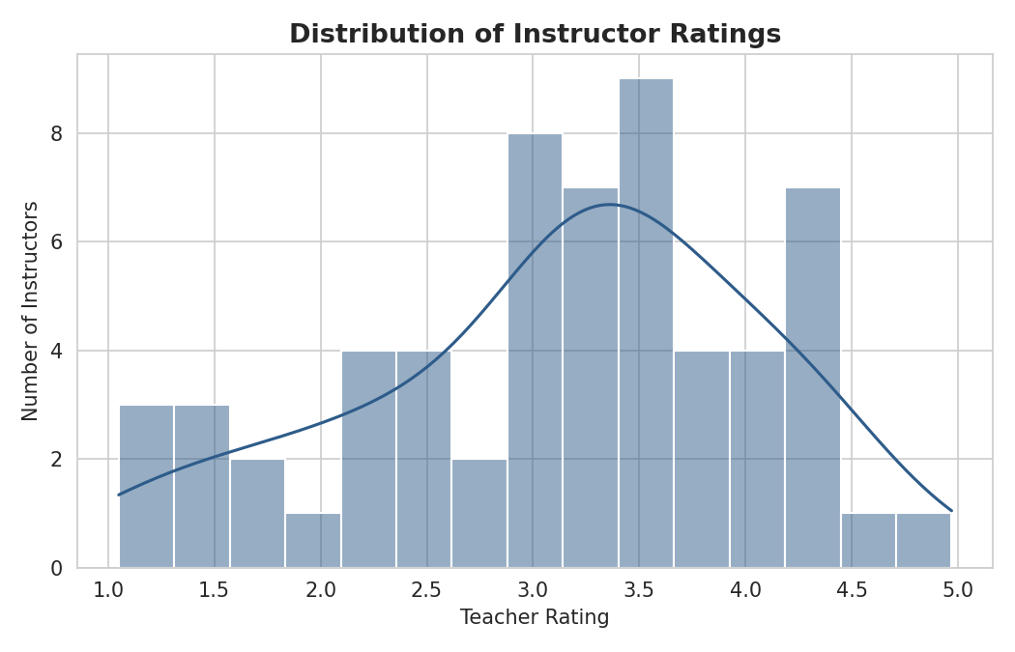
Figure 1. Distribution of instructor ratings (n=60). Mean = 3.13, Median = 3.28, slightly left-skewed (skew = -0.50).
Instructor ratings range from 1.05 to 4.97, with a mean of 3.13 and standard deviation of 0.95. The distribution is roughly symmetric with a mild left skew, meaning a modest cluster of low-performing instructors pulls the average down slightly relative to the median. There is no dominant clustering at either extreme — ratings are broadly spread across the full 1–5 scale, indicating genuine variance in perceived teaching quality rather than rating inflation.

4.2 Top and Bottom Performing Instructors
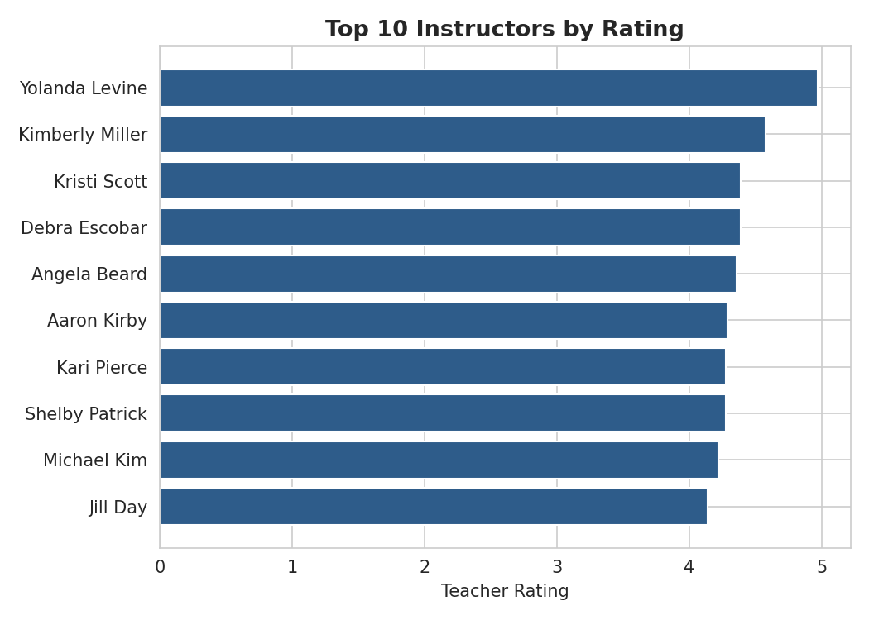
Figure 2. Top 10 instructors by TeacherRating.
Top-rated instructor Yolanda Levine (Machine Learning, rating 4.97) and Kimberly Miller (Cybersecurity, rating 4.58) also carry the platform's two highest enrollment counts (3,061 and 3,025 respectively) — far above the median of ~57. The remaining top-10 instructors have enrollment counts much closer to the platform median, suggesting these two are outliers rather than a consistent "high rating → high enrollment" pattern (explored further in Section 6).
Instructor | Rating | Experience (yrs) | Expertise | Enrollments
Yolanda Levine | 4.97 | 21 | Machine Learning | 3,061
Kimberly Miller | 4.58 | 24 | Cybersecurity | 3,025
Kristi Scott | 4.39 | 9 | Machine Learning | 47
Debra Escobar | 4.39 | 8 | Finance | 117
Angela Beard | 4.36 | 6 | Machine Learning | 49

At the other end, the five lowest-rated instructors (ratings 1.05–1.55) span Project Management, Business, Web Development, Digital Marketing, and Artificial Intelligence — no single expertise area dominates the bottom of the leaderboard, suggesting underperformance is instructor-specific rather than domain-specific.

5. Experience vs. Performance Analysis
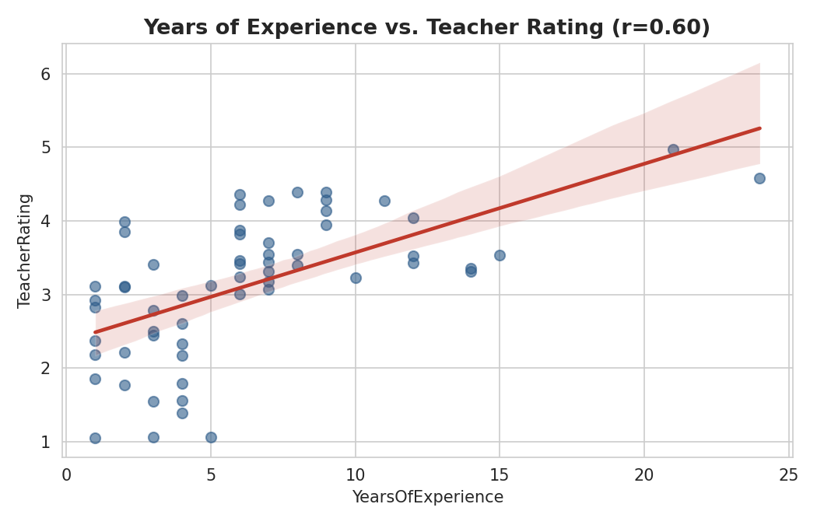
Figure 3. Years of experience vs. instructor rating. Pearson r = 0.60 (p < 0.001).
There is a moderate, statistically significant positive correlation (r = 0.60, p < 0.001) between an instructor's years of experience and their own TeacherRating. This supports the intuitive expectation that tenure builds teaching skill and learner trust — more experienced instructors tend to be rated more favorably by the platform's rating mechanism.
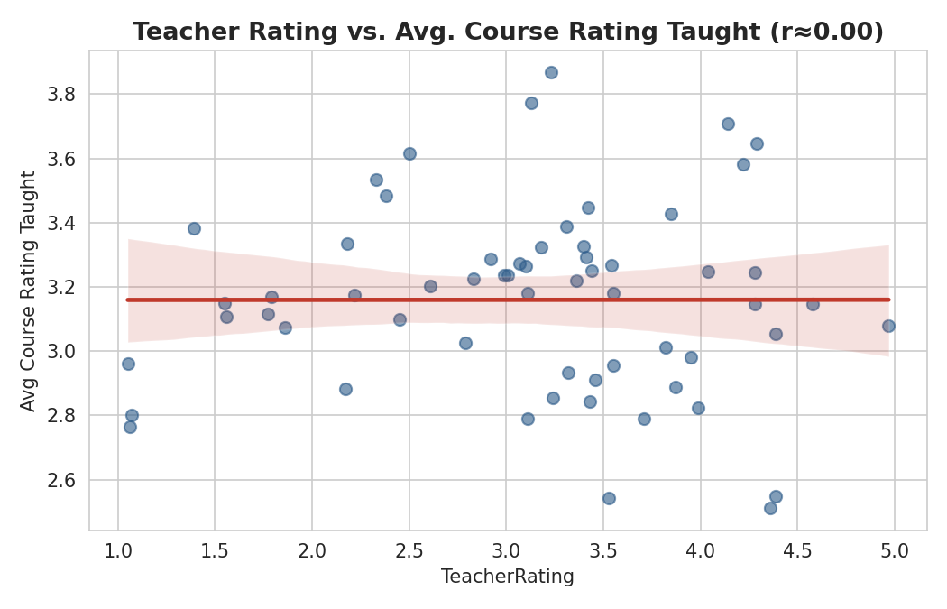
Figure 4. Instructor rating vs. average course rating taught. Pearson r ≈ 0.00 (p = 0.997, not significant).
However, this relationship does not extend to course outcomes. The correlation between YearsOfExperience and the average rating of courses an instructor teaches is negligible and slightly negative (r = -0.06, not significant), and the correlation between TeacherRating itself and course ratings taught is effectively zero (r = 0.00, p = 0.997). In other words, a highly experienced, highly rated instructor is no more likely to be associated with a highly rated course than a novice, lower-rated one.
This is the report's most important and actionable finding: experience and instructor rating are not reliable predictors of course quality on EduPro today. Course quality appears to be driven by other factors — course design, content depth, production quality, pricing, or category-specific dynamics — that are not captured by instructor-level metrics.

6. Course Quality Evaluation

6.1 Course Rating by Category and Level
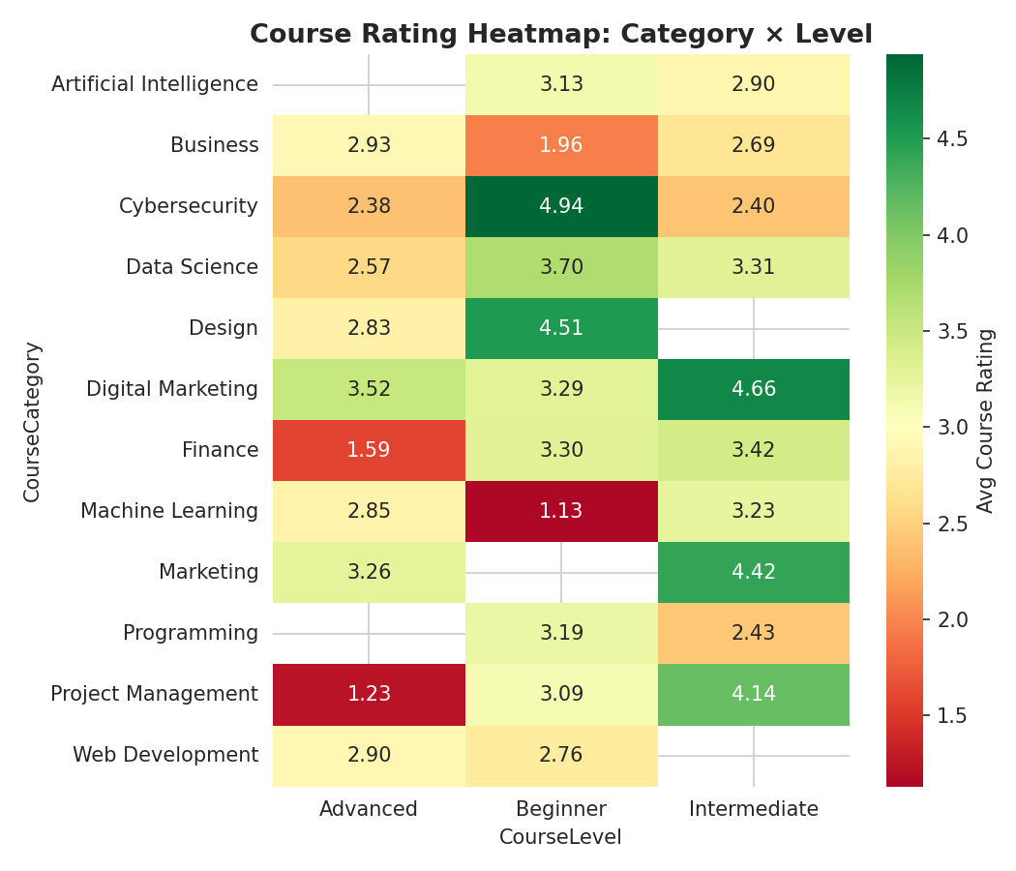
Figure 5. Average course rating by category and level. Green = higher rating, red = lower rating.
Course ratings vary substantially by category and level combination. Marketing and Digital Marketing categories post the platform's highest average ratings (3.72 and 3.66 respectively), while Business and Machine Learning trail (2.69 and 2.66). By level, Intermediate courses rate highest on average (3.32), narrowly ahead of Beginner (3.19), with Advanced courses rating meaningfully lower (2.81) — a pattern worth investigating, as it may indicate advanced content is harder to deliver well or that advanced learners are more critical reviewers.
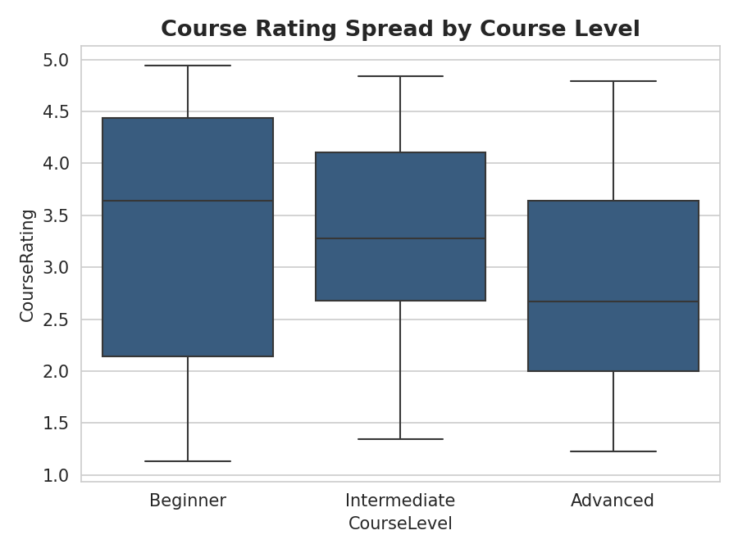
Figure 6. Spread of course ratings by level, showing Advanced courses have both a lower median and wider variance.

6.2 Category Rankings
Category | Avg Rating | Std Dev | Courses
Marketing | 3.72 | 1.20 | 5
Digital Marketing | 3.66 | 1.03 | 5
Data Science | 3.32 | 0.50 | 5
Design | 3.16 | 1.29 | 5
Project Management | 3.14 | 1.71 | 5
Programming | 3.04 | 1.33 | 5
Artificial Intelligence | 3.04 | 1.24 | 5
Finance | 3.01 | 1.10 | 5
Cybersecurity | 2.90 | 1.49 | 5
Web Development | 2.85 | 1.29 | 5
Business | 2.69 | 0.73 | 5
Machine Learning | 2.66 | 1.56 | 5

Data Science shows the tightest rating consistency (std dev 0.50) despite a modest sample, suggesting reliable quality delivery. Project Management and Machine Learning show the widest spread (std dev > 1.5), indicating highly inconsistent learner experience within those categories — some courses excellent, others poor.

7. Instructor Impact on Course Success
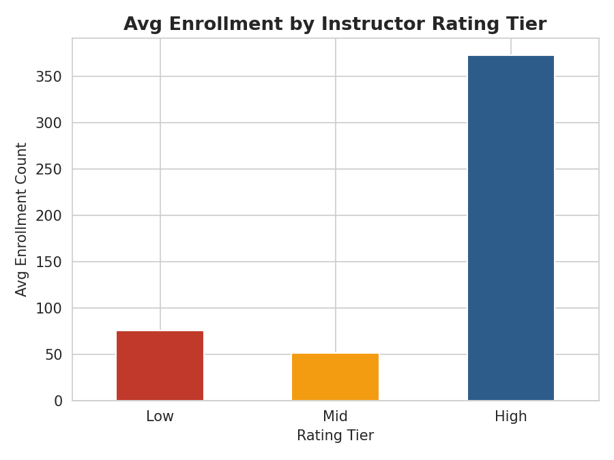
Figure 7. Average enrollment by instructor rating tier (Low / Mid / High, terciles).
Rating Tier | Avg Enrollment | Median Enrollment | Avg Course Rating | Instructors
Low | 75.45 | 61.0 | 3.17 | 20
Mid | 51.60 | 44.0 | 3.20 | 20
High | 372.95 | 62.5 | 3.11 | 20

High-tier instructors show a much higher mean enrollment (372.95) than Low or Mid tiers, producing the 4.94× Enrollment Influence Ratio KPI. However, the median enrollment for High-tier instructors (62.5) is close to the Low tier's median (61.0) — the mean is being pulled upward by the two extreme outliers identified in Section 4.2 (Yolanda Levine and Kimberly Miller, each with 3,000+ enrollments). Excluding those two outliers, enrollment volume is roughly flat across rating tiers, and average course rating is actually marginally lower for the High tier (3.11) than Low or Mid (3.17, 3.20). This reinforces Section 5's conclusion: instructor rating is not a strong, consistent driver of either enrollment or course quality across the general instructor population — the relationship visible in headline averages is concentrated in a small number of high-visibility outliers.

8. Expertise-Based Performance Insights
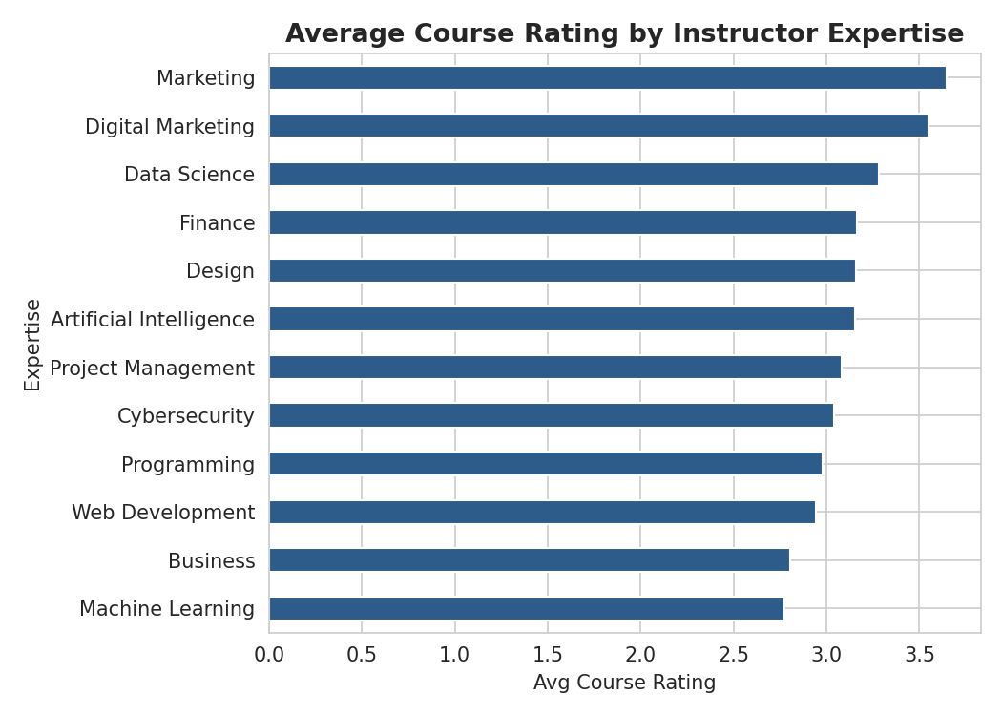
Figure 8. Average course rating by instructor expertise area, sorted descending.
Expertise | Avg Teacher Rating | Avg Course Rating Taught | Instructors
Marketing | 4.29 | 3.65 | 1
Digital Marketing | 3.05 | 3.55 | 11
Data Science | 3.03 | 3.28 | 5
Finance | 3.27 | 3.17 | 6
Artificial Intelligence | 3.17 | 3.16 | 6
Design | 2.29 | 3.16 | 4
Project Management | 2.66 | 3.08 | 5
Cybersecurity | 3.47 | 3.04 | 9
Programming | 3.95 | 2.98 | 1
Web Development | 2.51 | 2.94 | 5
Business | 2.24 | 2.80 | 2
Machine Learning | 4.23 | 2.78 | 5

A striking pattern: Machine Learning instructors have the second-highest average TeacherRating (4.23) of any expertise group, yet the courses they teach have the lowest average course rating (2.78) of all twelve categories. This is the clearest domain-level illustration of the disconnect described in Section 5 — instructor reputation and course outcome quality are decoupled, and Machine Learning is the expertise area where this gap is most acute and most worth investigating (e.g., are ML courses simply harder to teach well regardless of instructor caliber, or is content/curriculum design lagging instructor quality?).
Digital Marketing, by contrast, has the largest instructor pool (11) and a strong average course rating (3.55) despite moderate instructor ratings (3.05) — suggesting quality here may be more a function of course design/category fit than instructor reputation.

9. Gender-Level Comparison
Gender | Advanced | Beginner | Intermediate
Female | 2.80 | 3.10 | 3.33
Male | 2.84 | 3.37 | 3.34

Average course ratings by instructor gender, broken out by course level, show only small differences (≤0.27 rating points) across all three levels, with the largest gap at the Beginner level (Male 3.37 vs. Female 3.10). Given the sample sizes involved at the category level, this gap should be treated as an observation to monitor rather than a strong conclusion, and is not evidence of a systematic quality difference.

10. Key Insights Summary
- Instructor ratings are broadly and genuinely spread from 1.05–4.97 (mean 3.13), not inflated or clustered — the rating system captures real variance.
- Experience moderately predicts an instructor's own rating (r=0.60) but has virtually no relationship with the rating of courses they teach (r=-0.06).
- Instructor rating and course rating are statistically uncorrelated (r≈0.00) — course quality and instructor reputation are currently independent signals on EduPro.
- Machine Learning instructors are rated highly on average but their courses rate the lowest of any category — the platform's sharpest quality/reputation gap.
- Intermediate-level courses outperform Advanced courses in both average rating and consistency; Advanced content shows the widest quality variance.
- The apparent link between instructor rating tier and enrollment volume is driven almost entirely by two outlier instructors; the broader population shows flat enrollment across rating tiers.
- Data Science is the most consistently-delivered category (lowest rating variance); Project Management and Machine Learning are the least consistent.

11. Recommendations
- Decouple instructor evaluation from course evaluation in EduPro's quality dashboards — treat them as two distinct signals rather than assuming one predicts the other.
- Prioritize a course-level quality audit for Machine Learning and Business categories, where ratings lag despite adequate or strong instructor reputations.
- Capture an explicit primary-instructor field per course at the point of course creation, to remove the many-to-many ambiguity in the Transactions table and enable precise instructor-attribution analysis going forward.
- Investigate Advanced-level course design specifically — the consistent rating drop at this level across many categories suggests a structural content or pacing issue rather than instructor quality.
- Avoid using enrollment volume as a proxy for instructor quality in incentive or promotion decisions, since the current correlation is driven by a small number of high-visibility outliers rather than a general pattern.
- Introduce a standardized post-course learner survey capturing content depth, pacing, and production quality separately from instructor delivery, to help isolate which factor is driving the category-level rating gaps identified here.

12. Limitations
- The Transactions table links each enrollment to a TeacherID independent of a fixed course-instructor mapping; course-linked instructor metrics are therefore associative, not a precise record of who designed each course.
- Sample sizes at the Category × Level intersection are small (many combinations have 5 or fewer courses), so category/level findings should be treated as directional.
- No temporal data on rating changes over time was available, so this is a cross-sectional snapshot rather than a trend analysis.

