How AI Is Reshaping the Junior Developer Role
———————————————————————————————————————
Submitted by:
Yousef Mohamed 24-101174
Mohamed Reda Atia 24-101232
Adham Ahmed 24-101016
Taha Ahmed 24-101520

Introduction:
———————————————————————————————————————

The rise of AI tools like Gemini and ChatGPT has changed how we write code. Tasks that used to take junior developers days can now be done with a few prompts in seconds. This makes many of us wonder if there is still a place for entry-level developers in the tech industry. This report looks at the fears and behavioural changes of students at Egypt University of Informatics regarding this shift. We want to understand how students are actually dealing with AI in their studies and career planning. Since we are studying software development right now, this topic is very personal to us and could affect our future career choices.

Research Question:
———————————————————————————————————————
Do computer science students believe that AI tools are making it significantly harder to enter the tech industry as a junior developer, and how is this belief affecting their academic and career decisions?

Hypothesis:
———————————————————————————————————————
The majority of computer science students believe that AI has raised the difficulty and expectations for entry-level developer positions, and as a result, a significant portion are actively changing their academic focus toward more specialized fields such as AI, Cybersecurity, or Cloud computing.

Population of Interest
———————————————————————————————————————
The target population is undergraduate computer science and software engineering students. This group was selected because they are the most directly affected by changes in junior developer hiring , they are the ones entering the job market within the next one to four years, and they are also daily users of AI coding tools in their coursework.

Sampling Method:
———————————————————————————————————————
A convenience sampling approach was used. The survey was distributed digitally via a Google Form link shared through WhatsApp group chats and direct messages to classmates. A total of 23 responses were collected.
Convenience sampling was chosen because it allowed rapid data collection within a defined and accessible population. While it is not a perfect random sample, the fact that all respondents belong to the same academic institution and program makes the sample reasonably representative of the population of interest. The relatively small sample size is acknowledged as a limitation, and results should be interpreted with this in mind rather than generalized to all CS students globally.

Survey Questions:
———————————————————————————————————————
The survey consisted of eight questions grouped into three themes: Job Market Anxiety, Academic Adaptations, and Current Skill Reality. The questions were:

# | Question | Type
1 | Do you believe AI will make it harder to get your first "Junior Developer" job after graduation? | Multiple choice
2 | On a scale of 1 to 5, how worried are you that AI will replace the tasks usually given to interns or junior devs? | Scale 1-5
3 | Are you choosing different electives or specialties specifically because you're afraid standard web/app dev jobs are being automated? | Multiple choice
4 | If a student uses AI to write 80% of their final project but understands how the code works, should they still get an "A"? | Multiple choice
5 | Should our university stop teaching "basic" syntax and focus 100% on "AI Prompting and System Design"? | Multiple choice
6 | Do you think a "Junior Dev" today needs to be much more skilled than a Junior Dev was 5 years ago because of AI? | Multiple choice
7 | When you work on a coding project, how much of the code is "written" by AI vs. you? | Multiple choice
8 | In one sentence: What is the #1 skill a human developer has that AI will never be able to replace? | Open-ended

Survey link: https://forms.gle/NPyKshHjhasqxis78
Number of responses collected: 23

Analysis:
———————————————————————————————————————

To analyze the data, basic descriptive statistics were calculated including the mean, median, and mode where applicable. Visual representations were created for each key question. The worry scale (Q2) is the only fully numerical variable in the dataset; all other questions are categorical.
For the worry scale: Mean = 3.17, Median = 3, Mode = 4. This indicates that students lean toward the worried side, with the most common response being a 4 out of 5.

Chart 1 - Will AI Make It Harder to Get a Junior Dev Job?
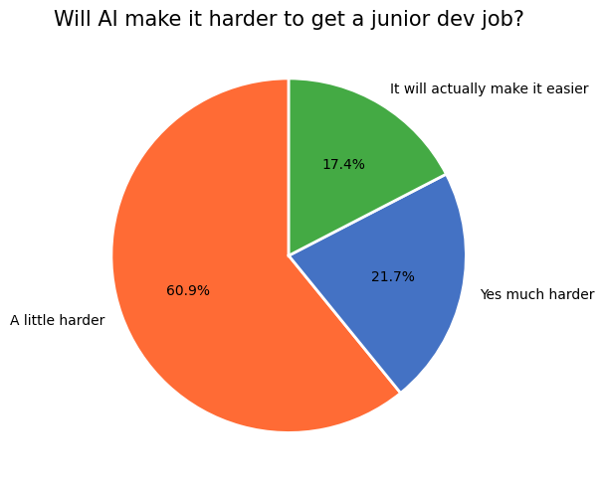
The majority of respondents (60.9%) believe AI will make it "a little harder" to land a first job, while 21.7% feel it will be "much harder". Only 17.4% believe it will actually make things easier. Taken together, 82.6% of us hold the view that AI creates some degree of extra difficulty in breaking into the industry.

Chart 2 - How Worried Are Students About AI Replacing Junior Dev Tasks?
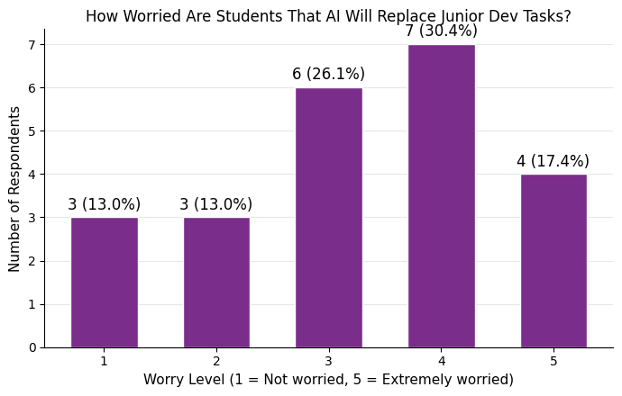
The worry scale shows that most students are concerned, with an average score of 3.17 and a median of 3. The most common response was a 4 (34.8%), followed by 3 (26.1%) and 5 (17.4%). Only 13% of students chose a 1 or 2, meaning very few of us are unbothered by this.

Chart 3 - Are Students Changing Electives Due to Automation Fears?
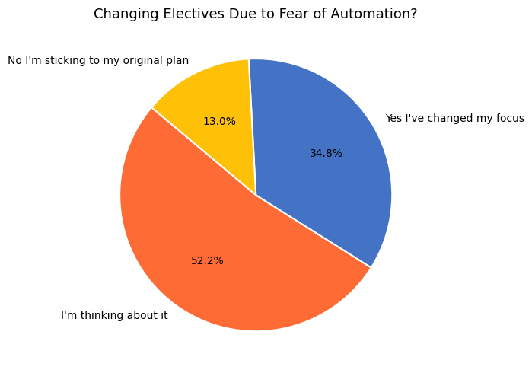

This result is really striking: 87% of students have either already changed their academic focus (26.1%) or are actively thinking about it (60.9%). Only 13% said they are sticking to their original plan. It shows that concerns about AI are actually changing how we pick our classes.

Chart 4 - If AI Writes 80% of Your Project, Do You Deserve an "A"?
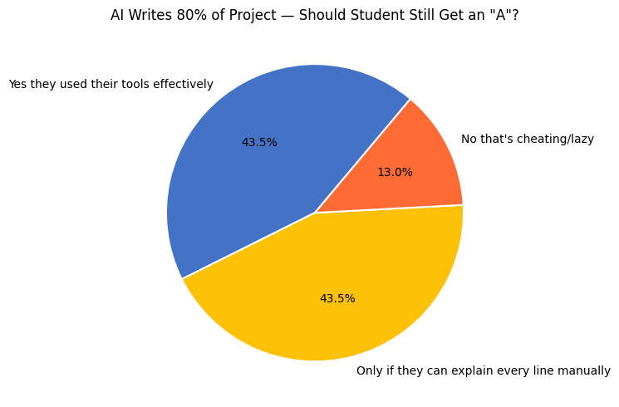

The answers to this hot take question were almost perfectly split. About 43.5% of students think that using AI effectively is a skill that deserves a good grade, while another 43.5% think it’s only okay if the student can explain every single line of code. Only 13% of the group thought it was flat-out cheating.

Chart 5 - Should Universities Stop Teaching Basic Syntax?
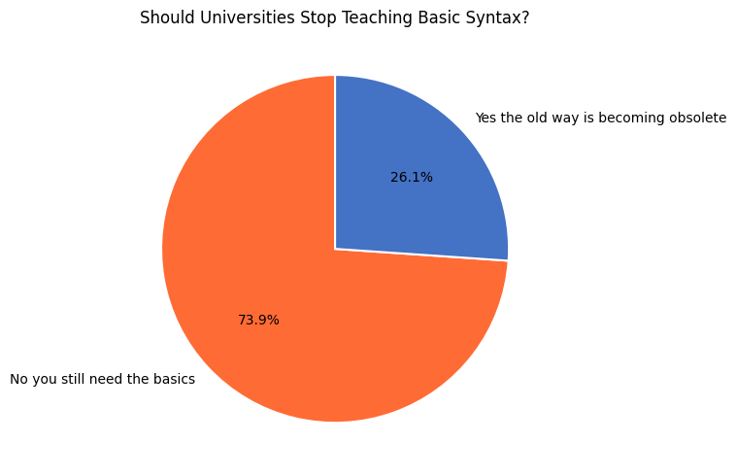

Despite the worries about AI, 73.9% of students believe universities should not stop teaching basic syntax. Most of us feel that foundational knowledge is needed specifically to catch and fix AI mistakes. The 26.1% who wanted to shift toward AI prompting represent a minority view.

Chart 6 - Is the Bar Higher for Junior Devs Today Than 5 Years Ago?
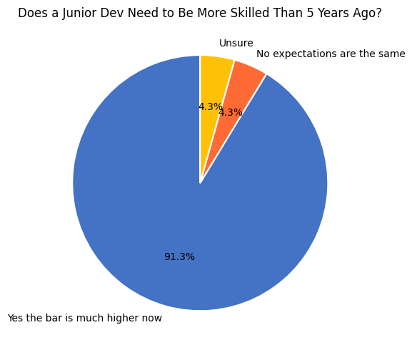
An overwhelming 91.3% of us agreed that a junior developer today needs to be much more skilled than one five years ago because of AI. This was the strongest consensus in the whole survey, showing we feel the baseline for getting hired has definitely been raised.

Chart 7 - How Much of Your Code Is Written by AI?
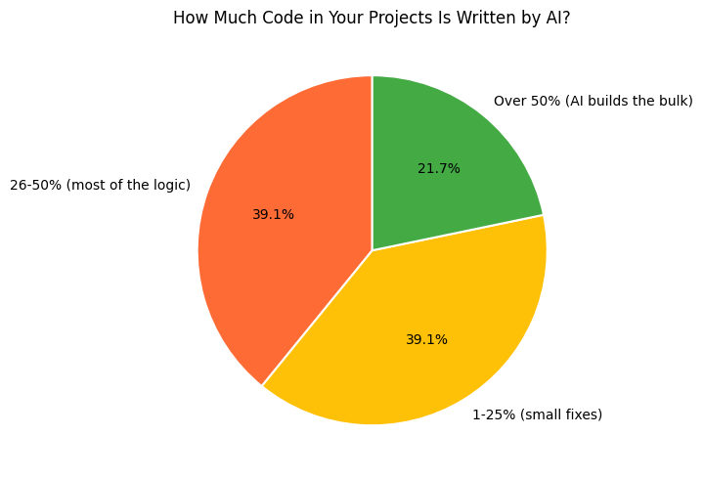
Students are heavy users of AI themselves. 39.1% report that AI writes between 1-25% of their code, while another 39.1% say it handles 26-50%. Another 21.7% say AI builds over 50% of their projects. Interestingly, not one person said they write 100% of their code manually anymore. This shows we are relying on the very tools we are worried about.

Chart 8 - Summary of Key Findings
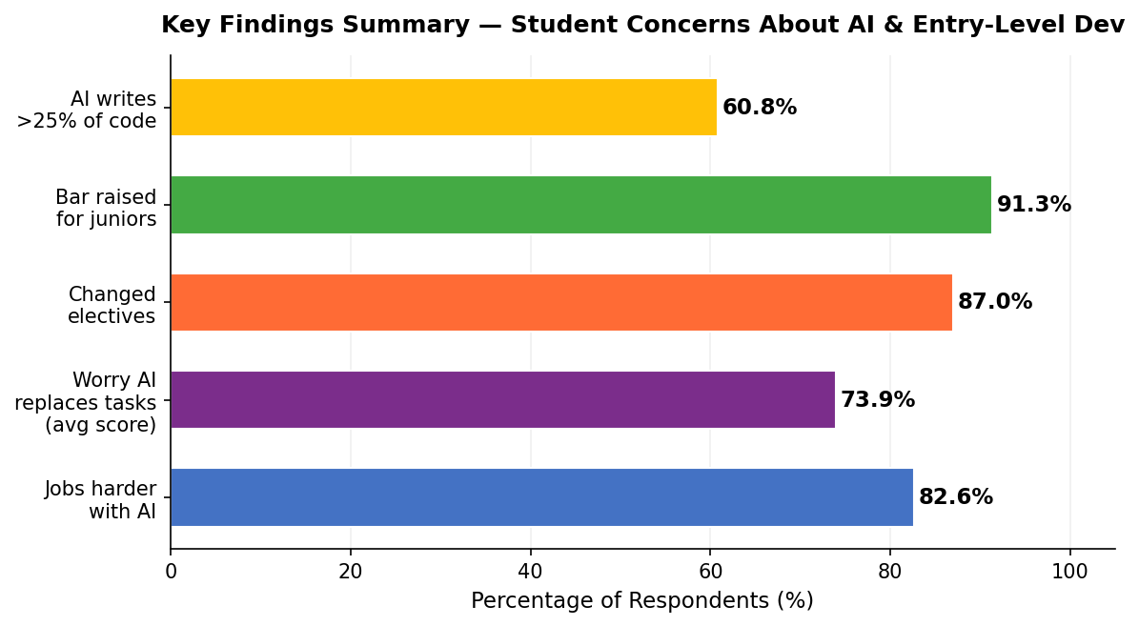
This summary chart shows a consistent trend: across every part of the survey, students are responding to AI with a mix of concern and practical changes. We feel the ground shifting and are adjusting our plans, even while we use the tools ourselves.

Conclusion
———————————————————————————————————————
Our hypothesis was correct: students believe AI has made it harder to start a career and are changing their studies because of it. However, we also found that students are not just giving up. They are adapting by choosing new electives and using AI tools heavily in their own work. The general view is that while AI is a major challenge, learning foundational skills is still the best way to succeed. While this was a small study of only 23 students at one university, it provides a strong signal that our generation feels the industry is changing rapidly and we have to change with it.

