
Cairo University
Faculty of Computers and Information

CS251
Software Engineering I
Project Name
Software Design
Team Names

Month & Year
Contents
Instructions [To be removed] 3
Team 3
Document Purpose and Audience 3
System Models 3
I. System Decomposition 3
II. Class diagrams 6
Important Algorithm 7
III. Sequence diagrams 7
Class - Sequence Usage Table 9
Ownership Report 10
Policy Regarding Plagiarism: 10
References 10
Authors 10

Instructions [To be removed]
- IMPORTANT. Rename this document to CS251-TAName-LeaderID-SDDocument.docx
(e.g. CS251-MohamedSamir-20040752-SDDDocument.docx)
- Remove the following notes and any red notes
- This document is the template document for your Software Design.
- For further guidelines and information, READ project details document (C251-SE2014-Project Description-v2.0).

Team
ID | Name | Email | Mobile
 | 1st name is team leader

Document Purpose and Audience
- Any document should tell the reader 2 things: What is this document? Who is expected to read it?
- Write in simple notes: what this document is.
- List the target audience to read this document (e.g. CEO? Project Manager? Customer...?)

System Models

I. System Decomposition
- Provide and describe a figure that depicts the overall system decomposition.
- Read about “Software Coupling and Cohesion” Concepts. Reflect that in model
- The three following images from web are for purpose of explaining. First one is how model is designed, but there are little connections (so it is not so good).The other two ones have better connection. Consider the 3 to know how a good model should be.
- Remove these images from your report and draw your own system decomposition.
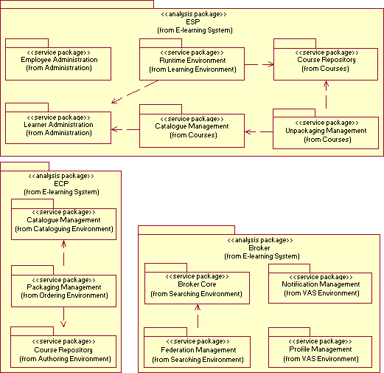
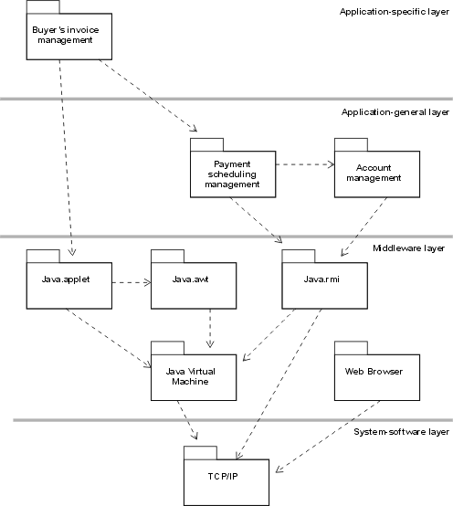
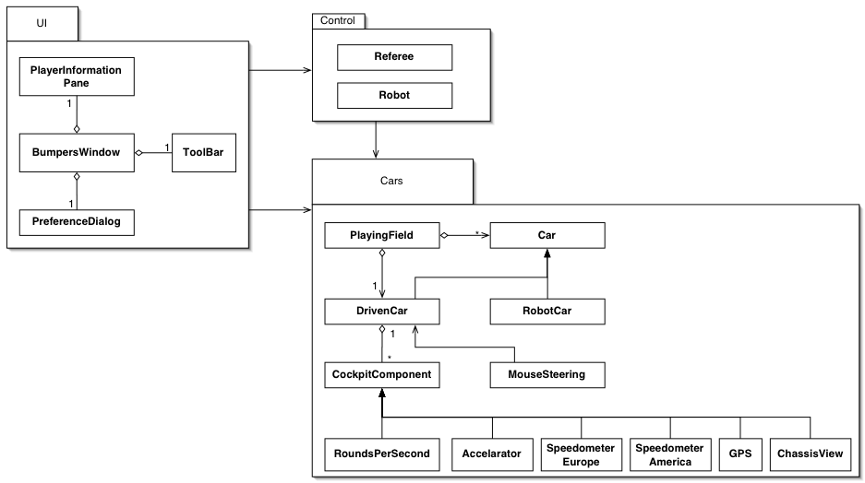

II. Class diagrams
- You should provide your class diagram. In case on diagram is so complex, divide it to several ones of reasonable size or draw separate ones, each for one of the components on the system decomposition diagram.
- Class diagram is a static diagram and should not represent any dynamic flow of events.
- Put stereotypes of the classes to give more information. UML predefines some stereotypes like: <<interface>>, <<type>>, <<implementationClass>>, <<enumeration>>, etc. and you create your own also.
- Put Relationships between classes and the types of the relationships.
- Put multiplicity.
- Put relationship name (e.g. faculty "offer" course).
- Put attributes in the classes.
- Put functions & Put parameters.
- Put data types of each attributes and the parameters.
- Make sure to include all domain (entity), boundary and control classes needed to implement the system.
- Highly perfered: Each class has a corresponding interface
  - Let all objects parameters and returns be of interface type.
  - See Shopping Cart Case Study
- Following is Shopping Cart Component class diagram.
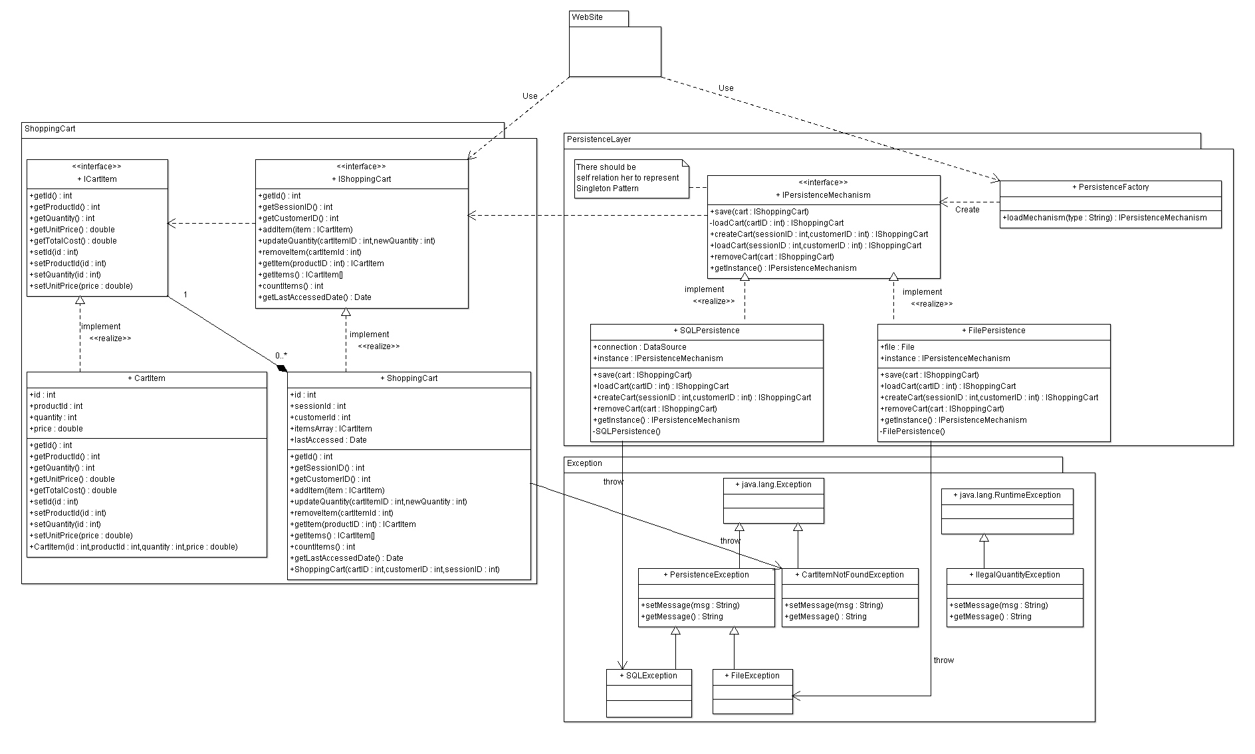

List down your classes and describe them
Class ID | Class Name | Subsystem ID | Description & Responsibility
 | UserView | User | Interface for Services of User component
 | UserController | User | Manages & do requested services by view & save it's effect through entities
 | UserValidationController | User | Controls Validation operations on data entered through view
 | UserEntity | User | Saves user data & manipulate it
 | PremiumUserEntity | User | Saves Premuinm user data & manipulate it
 | PendingRequestEntity | User | Saves friend requsts data & manipulate it so user can check it later
 | FriendRelationEntity | User | Maps friend relationships among users pairs data & manipulate it
 | PostView | Post | Interface for Services of Post component
 | RegularPostController | Post | Manages & do requested services for post by view & save it's effect through post entity
 | PagePostController | Post | Manages & do requested services for Page by view & save it's effect through Page entity
 | GroupPostController | Post | Manages & do requested services for Group by view & save it's effect through Group entity
 | AdPostController | Post | Manages & do requested services for Ad Post by view & save it's effect through Ad Post entity
 | ValidationController | Post | Controls Validation operations for users to do premium users pages admins extra features
 | RegularPostEntity | Post | Saves Regular Post data & manipulate it
 | PagePostEntity | Post | Saves Page Post data & manipulate it
 | GroupPostEntity | Post | Saves Group Post data & manipulate it
 | AdPostEntity | Post | Saves Ad Post data & manipulate it
- In the above table make sure that each class belongs to a subsystem.
- In the above table ALL classes should belong to subsystems. And each subsystem should at least contain one class.

Important Algorithm
- If any method in a class is implementing an algorithm (complex enough), then you should describe it here.

III. Sequence diagrams
- List Sequence diagrams for all requirements. Provide for each Sequence an ID.
- Usually each use case is represented by a sequence diagram or more.
- Overall, all the diagrams should represent all requirements and possible flows.
- Make sure that each object in the sequence diagram has a corresponding class in the class description table above. If not, it will be REJECTED.
- Put actual function calls with proper parameters and return types corresponding to class diagrams.
- Following are couple of examples for small / meduim examples. We expect such diagrams, however there is a missing thing in them. Most of calls don’t have parameters. Please always specify the parameters in the call, matching the class diagram.
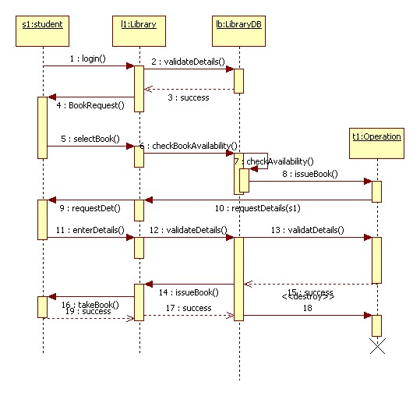
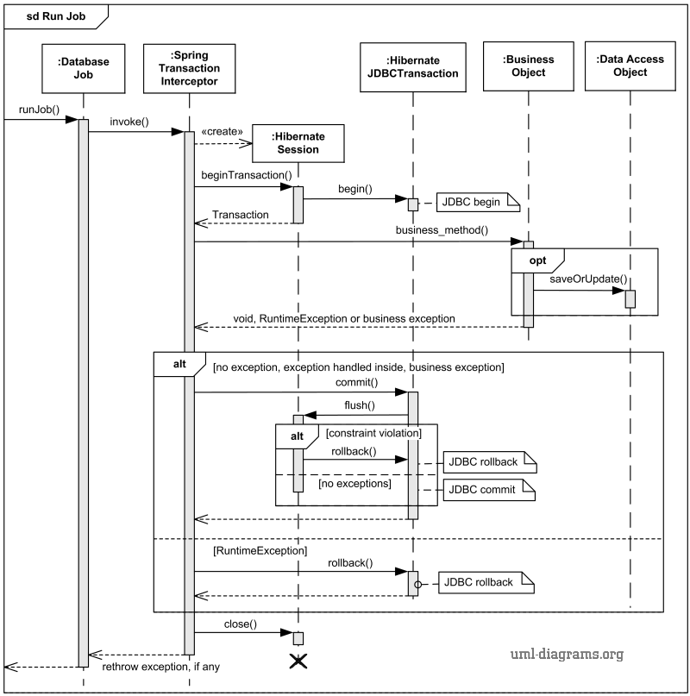

Class - Sequence Usage Table
- In this table, we will list EVERY class in class diagram and which sequences used this class diagram. This helps in avoiding either unused classes or extra classes appears in sequence diagrams. In "Overall used methods" section, put all functions appeared in all sequences. If this table was built in ignorance of actual class / sequence diagrams = REJECTED for whole document.
Class Name | Sequence Diagrams | Overall used methods
E.g. Employee | 1, 3, 5 (means Seq Ids 1, 3, 5 used Employee class) | Save, GetData

Ownership Report
- Remove the following notes and any red notes
- For every item in this document, write the owners. If someone is owner of something, s/he understands it 100.%
- Team leader must verify the table with the team members.
Item | Owners

Policy Regarding Plagiarism:

Students have collective ownership and responsibility of their project. Any violation of academic honesty will have severe consequences and punishment for ALL team members.
- تشجع الكلية على مناقشة الأفكار و تبادل المعلومات و مناقشات الطلاب حيث يعتبر هذا جوهريا لعملية تعليمية سليمة
- ساعد زملاءك على قدر ما تستطيع و حل لهم مشاكلهم فى الكود و لكن تبادل الحلول غير مقبول و يعتبر غشا.
- أى حل يتشابه مع أى حل آخر بدرجة تقطع بأنهما منقولان من نفس المصدر سيعتبر أن صاحبيهما قد قاما بالغش.
- قد توجد على النت برامج مشابهة لما نكتبه هنا أى نسخ من على النت يعتبر غشا يحاسب عليه صاحبه.
- إذا لم تكن متأكدا أن فعلا ما يعد غشا فلتسأل المعيد أو أستاذ المادة.
- فى حالة ثبوت الغش سيأخذ الطالب سالب درجة المسألة ، و فى حالة تكرار الغش سيرسب الطالب فى المقرر.

References
- http://www.mhhe.com/engcs/compsci/pressman/graphics/Pressman5sepa/common/cs1/design.pdf

Authors
- Mostafa Saad and Mohammad El-Ramly

