**Dental Clinic Management System**

**Design Document**

MOHAMED SABAR

# 

# Overview

A Dental clinic management system is used to manage all records of patients, receptionists, and doctors. The Actors are Admin, Receptionists, Doctors, and Nurses.

The system should have the following functionalities:

1- Registering new accounts.

2- Adding, updating, deleting, searching, and viewing a record according to the given authentication.

3- Additional operations such as making an appointment, and managing patients from entering the dental Clinic till discharging them.

Requirements - Functional Requirements

|  |  |  |
| --- | --- | --- |
| **Requirement Identifier** | **Priority (High/**  **Medium/ Low)** | **Description** |
| FR-1 | High | Adding or deleting a patient is enable for the receptionist. |
| FR-2 | High | generates a report for a specific patient is enabled for the receptionist. |
| FR-3 | High | Creating new employee accounts is only available by admin. |
| FR-4 | High | Recording necessary patient information such as full name, phone number, ID number etc. is enabled for the receptionist. |
| FR-5 | High | Scheduling patient’s appointments is enabled for the receptionist. |
| FR-6 | High | Visualizing patients records by the doctors. |
| FR-7 | Medium | Doctors can add instructions for nurses about some patients. |
| FR-8 | Medium | Ordering patient test by doctors. |
| FR-9 | High | Creating employees accounts by the administrator only. |
| FR-10 | High | Managing employees account by the administrator. |
| FR-11 | High | Visualizing patient’s data by nurses. |
| FR-12 | Medium | Ordering medical reports from the receptionist. |

Nonfunctional Requirements:

|  |  |  |
| --- | --- | --- |
| **Requirement Identifier** | **Priority (High/ Medium/ Low)** | **Description** |
| NR-1 | High | Providing high privacy security for patients and employees. |
| NR-2 | Medium | Capacity of the system server can afford up to 50 records at once. |
| NR-3 | Medium | The response time of the system searches and acknowledgments should be approached in a few seconds. |
| NR-4 | High | The system should be protected by an anti-virus. |
| NR-5 | High | The entered data should be accurate and reliable. |
| NR-6 | High | Performing regular backups for the system data. |
| NR-7 | Medium | The system should have a friendly and good-looking UI. |
| NR-8 | High | The system should support working on the latest operating systems environments. |
| NR-9 | High | The system should obey all the governmental requirements and constraints. |
| NR-10 | High | The system should be available 24 hour /7 days with no bandwidth issues. |

Use Cases:

|  |  |
| --- | --- |
| **Use Case Identifier** | UC101 |
| **Use Case Name** | Schedule patient appointment |
| **Participating Actors** | Receptionist and Patient |
| **Flow of events** | Receptionists create a new file for patient.  Collect biodata and personal information from patient. Select an appropriate time for the appointment. |
| **Entry condition** | Receptionist log in to the system. Patient already registered. Receptionist has authority to schedule a new appointment. Having a registered patient. |
| **Exit conditions** | Appointment has been successfully assigned. |

|  |  |
| --- | --- |
| **Use Case Identifier** | UC102 |
| **Use Case Name** | Order patient test |
| **Participating Actors** | Doctor |
| **Flow of events** | Filling laboratory form.  Sending the form to the patient’s file to do the test. |
| **Entry condition** | Doctor log in to the system.  Doctor has authority to order a test. Having a registered patient. |
| **Exit conditions** | Patients did the test successfully. |

|  |  |
| --- | --- |
| **Use Case Identifier** | UC103 |
| **Use Case Name** | Create new account for employee |
| **Participating Actors** | Admin |
| **Flow of events** | admin creates a new employee account  Enters specific information about the employee such as (name, address, government registration number, Tax number, collage degree, phone number, email, experiences). |
| **Entry condition** | Admin log in to the system.  Admin has authority to create an employee. |
| **Exit conditions** | Admin created the employee successfully |

|  |  |
| --- | --- |
| **Use Case Identifier** | UC104 |
| **Use Case Name** | Patient registration |
| **Participating Actors** | Receptionist |
| **Flow of events** | Receptionist creates a new patient account  Enters specific information about the patient such as (name, phone number, social security num ). |
| **Entry condition** | Receptionist log in to the system. Receptionist has authority to create a patient. Patient haven’t registered before. |
| **Exit conditions** | Receptionist created the employee successfully |

|  |  |
| --- | --- |
| **Use Case Identifier** | UC105 |
| **Use Case Name** | View patient records |
| **Participating Actors** | Doctor |
| **Flow of events** | Doctor search about the patient using his ID. |
| **Entry condition** | Doctor log in to the system.  Doctor has authority to create a patient. Having a registered patient. |
| **Exit conditions** | a page of all the records that the patient had done till now shows up. |

|  |  |
| --- | --- |
| **Use Case Identifier** | UC106 |
| **Use Case Name** | File medical report |
| **Participating Actors** | Receptionist |
| **Flow of events** | Receptionist search about the patient using his ID. |
| **Entry condition** | Receptionist log in to the system. Receptionist has authority to create a patient. Having a registered patient. |
| **Exit conditions** | A file of all the important tests that the patient had done till now shows up. |

|  |  |
| --- | --- |
| **Use Case Identifier** | UC107 |
| **Use Case Name** | Discharge patient |
| **Participating Actors** | Doctor |
| **Flow of events** | -Doctor filling the discharge form. |
| **Entry condition** | Doctor log in to the system.  Doctor has authority to discharge patient. Having a registered patient. |
| **Exit conditions** | Patient is discharged. |

|  |  |
| --- | --- |
| **Use Case Identifier** | UC108 |
| **Use Case Name** | Add Patient Progress Note |
| **Participating Actors** | Doctor |
| **Flow of events** | The doctor views the patient record.  The doctor clicks on the add progress note button. The doctor types the new progress note.  The doctor clicks add to save the note. |
| **Entry condition** | Having a registered patient. |
| **Exit conditions** | A progress note has been added to the system. |

|  |  |
| --- | --- |
| **Use Case Identifier** | UC109 |
| **Use Case Name** | Add instruction about patient for nurse |
| **Participating Actors** | Doctor |
| **Flow of events** | The doctor creates a new instruction note.  The doctor clicks on the add instruction note button. The doctor types the new instruction note.  The doctor clicks add to save the note. |
| **Entry condition** | Doctor log in to the system.  Doctor has authority to add instruction to nurses. Having a registered patient. |
| **Exit conditions** | An instruction note has been added to the system. |

# Design Goals

|  |  |  |
| --- | --- | --- |
| **Goal’s Concern**[1] | **Related Requirement Identifier** | **Description** |
| Security | NR-1 | Providing high privacy security for patients and employees. |
| Capacity | NR-2 | Capacity of the system server can afford up to 50 records at once. |
| Availability | NR-10 | The system should be available 24 hour /7 days with no bandwidth issues. |
| High responsivity | NR-3 | The response time of the system searches and acknowledgments should be approached in a few seconds. |
| Adaptability | NR-8 | The system should support working on the latest operating systems environments. |
| Recovery | NR-6 | Performing regular backups for the system data. |
| Usability | NR-7 | The system should have a friendly and good-looking UI. |

# 

# System Models

Use Case Diagrams:

## Class Diagrams :

Sequence Diagrams:

## 

## Activity Diagrams:

## Statechart Diagram :

**ER diagram:**

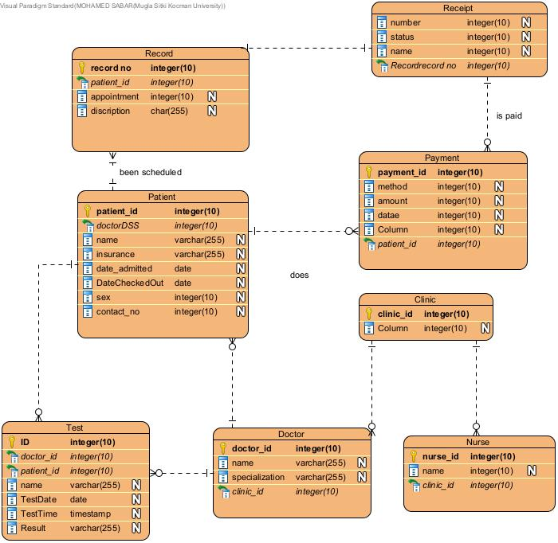

1. .