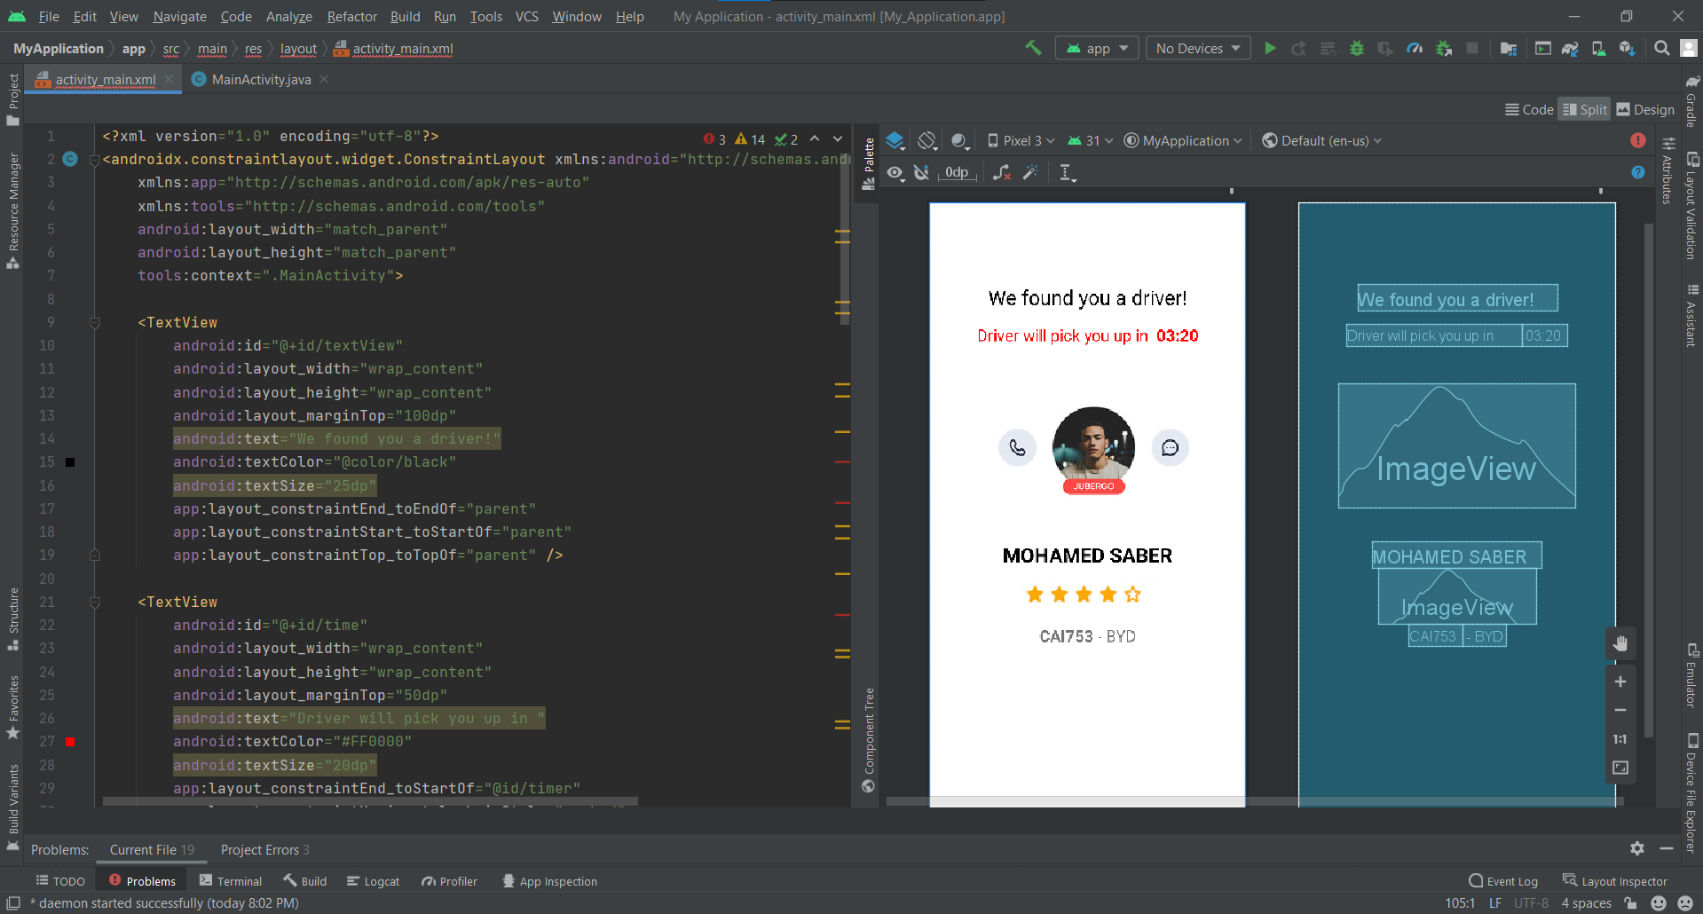

<?xml version="1.0" encoding="utf-8"?>  
<androidx.constraintlayout.widget.ConstraintLayout xmlns:android="http://schemas.android.com/apk/res/android"  
 xmlns:app="http://schemas.android.com/apk/res-auto"  
 xmlns:tools="http://schemas.android.com/tools"  
 android:layout_width="match_parent"  
 android:layout_height="match_parent"  
 tools:context=".MainActivity">  
  
 <TextView  
 android:id="@+id/textView"  
 android:layout_width="wrap_content"  
 android:layout_height="wrap_content"  
 android:layout_marginTop="100dp"  
 android:text="We found you a driver!"  
 android:textColor="@color/black"  
 android:textSize="25dp"  
 app:layout_constraintEnd_toEndOf="parent"  
 app:layout_constraintStart_toStartOf="parent"  
 app:layout_constraintTop_toTopOf="parent" />  
  
 <TextView  
 android:id="@+id/time"  
 android:layout_width="wrap_content"  
 android:layout_height="wrap_content"  
 android:layout_marginTop="50dp"  
 android:text="Driver will pick you up in "  
 android:textColor="#FF0000"  
 android:textSize="20dp"  
 app:layout_constraintEnd_toStartOf="@id/timer"  
 app:layout_constraintHorizontal_chainStyle="packed"  
 app:layout_constraintStart_toStartOf="parent"  
 app:layout_constraintTop_toTopOf="@id/textView" />  
  
  
 <TextView  
 android:id="@+id/timer"  
 android:layout_width="wrap_content"  
 android:layout_height="wrap_content"  
 android:layout_marginTop="50dp"  
 android:text=" 03:20"  
 android:textColor="#FF0000"  
 android:textSize="20dp"  
 android:textStyle="bold"  
 app:layout_constraintEnd_toEndOf="parent"  
 app:layout_constraintStart_toEndOf="@id/time"  
 app:layout_constraintTop_toTopOf="@id/textView" />  
  
 <ImageView  
 android:id="@+id/pic"  
 android:layout_width="293dp"  
 android:layout_height="154dp"  
 android:layout_marginTop="48dp"  
 android:background="@drawable/round"  
 android:src="@drawable/Driver"  
 app:layout_constraintEnd_toEndOf="parent"  
 app:layout_constraintHorizontal_bias="0.498"  
 app:layout_constraintStart_toStartOf="parent"  
 app:layout_constraintTop_toBottomOf="@id/time" />  
  
 <TextView  
 android:id="@+id/fullname"  
 android:layout_width="wrap_content"  
 android:layout_height="wrap_content"  
 android:text="MOHAMED SABER"  
 android:textColor="@color/black"  
 android:textSize="25dp"  
 android:textStyle="bold"  
 app:layout_constraintEnd_toEndOf="parent"  
 app:layout_constraintStart_toStartOf="parent"  
 tools:layout_editor_absoluteY="420dp" />  
  
 <ImageView  
 android:id="@+id/rating"  
 android:layout_width="wrap_content"  
 android:layout_height="70dp"  
 app:layout_constraintEnd_toEndOf="parent"  
 app:layout_constraintStart_toStartOf="parent"  
 app:layout_constraintTop_toBottomOf="@id/fullname"  
 app:srcCompat="@drawable/RATING"  
  
 <TextView  
 android:id="@+id/plates"  
 android:layout_width="wrap_content"  
 android:layout_height="wrap_content"  
 android:text="CAI753"  
 android:textSize="20dp"  
 android:textStyle="bold"  
 app:layout_constraintEnd_toStartOf="@+id/car"  
 app:layout_constraintHorizontal_chainStyle="packed"  
 app:layout_constraintStart_toStartOf="parent"  
 app:layout_constraintTop_toBottomOf="@id/rating" />  
  
 <TextView  
 android:id="@+id/car"  
 android:layout_width="wrap_content"  
 android:layout_height="wrap_content"  
 android:text=" - BYD"  
 android:textSize="20dp"  
 app:layout_constraintEnd_toEndOf="parent"  
 app:layout_constraintStart_toEndOf="@id/plates"  
 app:layout_constraintTop_toBottomOf="@id/rating" />  
  
  
</androidx.constraintlayout.widget.ConstraintLayout>