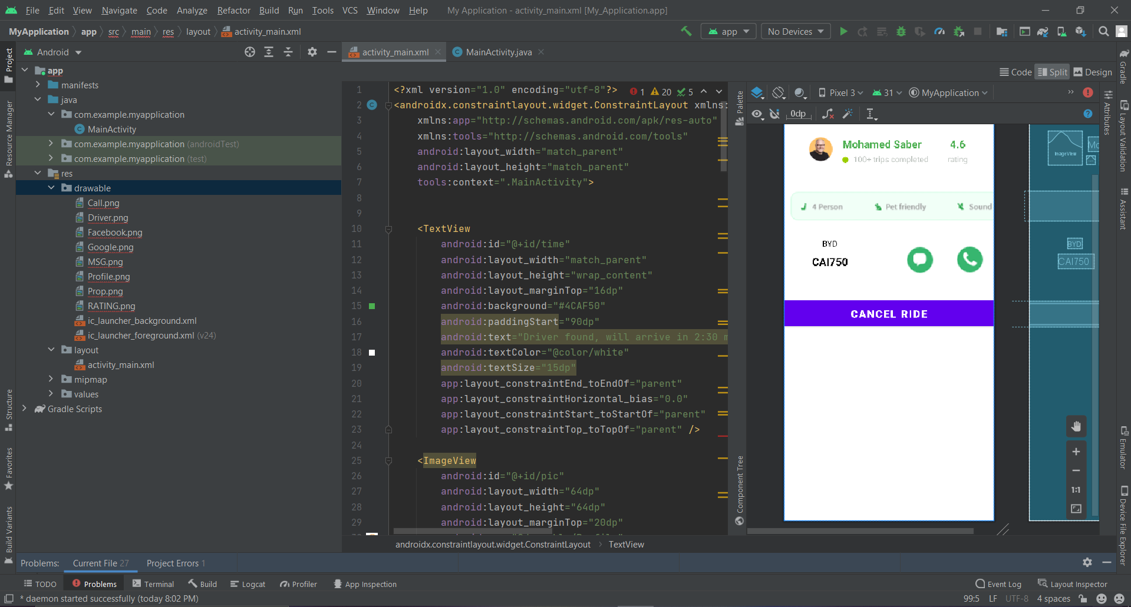

<?xml version="1.0" encoding="utf-8"?>  
<androidx.constraintlayout.widget.ConstraintLayout xmlns:android="http://schemas.android.com/apk/res/android"  
 xmlns:app="http://schemas.android.com/apk/res-auto"  
 xmlns:tools="http://schemas.android.com/tools"  
 android:layout_width="match_parent"  
 android:layout_height="match_parent"  
 tools:context=".MainActivity">  
  
  
 <TextView  
 android:id="@+id/time"  
 android:layout_width="match_parent"  
 android:layout_height="wrap_content"  
 android:layout_marginTop="16dp"  
 android:background="#4CAF50"  
 android:paddingStart="90dp"  
 android:text="Driver found, will arrive in 2:30 min"  
 android:textColor="@color/white"  
 android:textSize="15dp"  
 app:layout_constraintEnd_toEndOf="parent"  
 app:layout_constraintHorizontal_bias="0.0"  
 app:layout_constraintStart_toStartOf="parent"  
 app:layout_constraintTop_toTopOf="parent" />  
  
 <ImageView  
 android:id="@+id/pic"  
 android:layout_width="64dp"  
 android:layout_height="64dp"  
 android:layout_marginTop="20dp"  
 android:src="@drawable/Profile"  
 app:layout_constraintEnd_toEndOf="parent"  
 android:layout_marginEnd="400dp"  
 app:layout_constraintStart_toStartOf="parent"  
 app:layout_constraintTop_toBottomOf="@id/time"  
 app:layout_constraintVertical_bias="0.15" />  
  
 <TextView  
 android:layout_width="wrap_content"  
 android:layout_height="wrap_content"  
 android:id="@+id/name"  
 android:text="Mohamed Saber"  
 android:textColor="#4CAF50"  
 android:textStyle="bold"  
 android:textSize="20dp"  
 app:layout_constraintStart_toEndOf="@id/pic"  
 app:layout_constraintTop_toBottomOf="@id/time"  
 android:layout_marginTop="30dp"  
 android:layout_marginStart="10dp"/>  
  
  
 <TextView  
 android:layout_width="wrap_content"  
 android:layout_height="wrap_content"  
 android:id="@+id/trips"  
 android:text="100+ trips completed"  
 android:textColor="#BFC5C0"  
 android:textSize="15dp"  
 app:layout_constraintStart_toEndOf="@id/pic"  
 app:layout_constraintTop_toBottomOf="@id/name"  
 android:layout_marginTop="5dp"  
 android:layout_marginStart="30dp"/>  
  
 <ImageView  
 android:id="@+id/imageView"  
 android:layout_width="wrap_content"  
 android:layout_height="wrap_content"  
 app:srcCompat="@android:drawable/presence_online"  
 app:layout_constraintStart_toEndOf="@id/pic"  
 app:layout_constraintTop_toBottomOf="@id/name"  
 app:layout_constraintEnd_toStartOf="@id/trips"  
 app:layout_constraintBottom_toBottomOf="@id/trips"  
 android:layout_marginTop="7dp"/>  
  
 <TextView  
 android:layout_width="wrap_content"  
 android:layout_height="wrap_content"  
 android:id="@+id/rating"  
 android:text="4.6"  
 android:textSize="20dp"  
 android:textStyle="bold"  
 android:textColor="#4CAF50"  
 app:layout_constraintTop_toTopOf="@id/name"  
 app:layout_constraintStart_toEndOf="@id/name"  
 app:layout_constraintEnd_toEndOf="parent"/>  
  
  
 <TextView  
 android:layout_width="wrap_content"  
 android:layout_height="wrap_content"  
 android:id="@+id/text2"  
 android:text="rating"  
 android:textSize="15dp"  
 android:textColor="#BFC5C0"  
 app:layout_constraintTop_toTopOf="@id/trips"  
 app:layout_constraintStart_toEndOf="@id/name"  
 app:layout_constraintEnd_toEndOf="parent"/>  
  
  
 <TextView  
 android:id="@+id/car"  
 android:layout_width="401dp"  
 android:layout_height="56dp"  
 android:layout_marginTop="48dp"  
 android:background="#8BC18D"  
 android:drawableStart="@drawable/Prop"  
 android:orientation="horizontal"  
 app:layout_constraintEnd_toEndOf="parent"  
 app:layout_constraintHorizontal_bias="1.0"  
 app:layout_constraintStart_toStartOf="parent"  
 app:layout_constraintTop_toBottomOf="@id/pic" />  
  
 <TextView  
 android:id="@+id/carman"  
 android:layout_width="wrap_content"  
 android:layout_height="wrap_content"  
 android:layout_marginStart="80dp"  
 android:layout_marginTop="32dp"  
 android:text="BYD"  
 android:textColor="@color/black"  
 android:textSize="15dp"  
 app:layout_constraintStart_toStartOf="@id/car"  
 app:layout_constraintTop_toBottomOf="@id/car" />  
  
 <TextView  
 android:layout_width="wrap_content"  
 android:layout_height="wrap_content"  
 android:id="@+id/plates"  
 android:text="CAI750"  
 android:textSize="20dp"  
 android:textColor="@color/black"  
 android:textStyle="bold"  
 app:layout_constraintTop_toBottomOf="@id/carman"  
 app:layout_constraintStart_toStartOf="@id/carman"  
 android:layout_marginTop="10dp"  
 app:layout_constraintEnd_toEndOf="@id/carman"/>  
  
  
 <ImageButton  
 android:id="@+id/chat"  
 android:layout_width="64dp"  
 android:layout_height="64dp"  
 android:layout_marginTop="8dp"  
 android:src="@drawable/MSG"  
 app:layout_constraintTop_toTopOf="@id/carman"  
 tools:layout_editor_absoluteX="219dp" />  
  
 <ImageButton  
 android:id="@+id/phone"  
 android:layout_width="64dp"  
 android:layout_height="64dp"  
 android:layout_marginStart="30dp"  
 android:src="@drawable/Call"  
 app:layout_constraintTop_toTopOf="@id/chat"  
 app:layout_constraintStart_toEndOf="@id/chat"/>  
  
 <Button  
 android:layout_width="500dp"  
 android:layout_height="wrap_content"  
 android:layout_marginTop="60dp"  
 android:background="#4CAF50"  
 android:text="Cancel ride"  
 android:textColor="@color/white"  
 android:textSize="20dp"  
 android:textStyle="bold"  
 app:layout_constraintEnd_toEndOf="parent"  
 app:layout_constraintHorizontal_bias="0.504"  
 app:layout_constraintStart_toStartOf="parent"  
 app:layout_constraintTop_toBottomOf="@id/plates" />  
  
  
</androidx.constraintlayout.widget.ConstraintLayout>