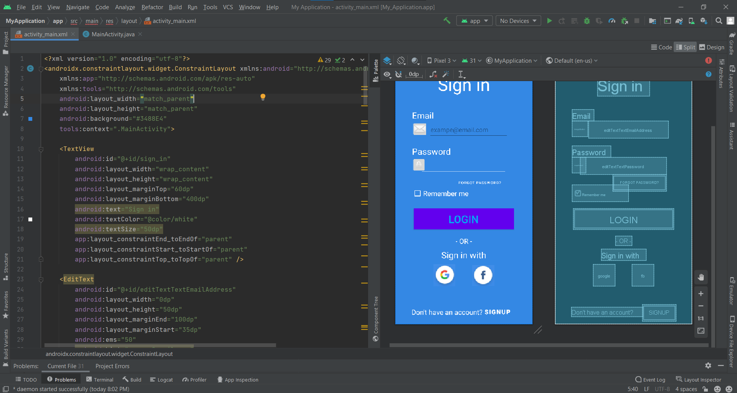

<?xml version="1.0" encoding="utf-8"?>  
<androidx.constraintlayout.widget.ConstraintLayout xmlns:android="http://schemas.android.com/apk/res/android"  
 xmlns:app="http://schemas.android.com/apk/res-auto"  
 xmlns:tools="http://schemas.android.com/tools"  
 android:layout_width="match_parent"  
 android:layout_height="match_parent"  
 android:background="#3488E4"  
 tools:context=".MainActivity">  
  
 <TextView  
 android:id="@+id/sign_in"  
 android:layout_width="wrap_content"  
 android:layout_height="wrap_content"  
 android:layout_marginTop="60dp"  
 android:layout_marginBottom="400dp"  
 android:text="Sign in"  
 android:textColor="@color/white"  
 android:textSize="50dp"  
 app:layout_constraintEnd_toEndOf="parent"  
 app:layout_constraintStart_toStartOf="parent"  
 app:layout_constraintTop_toTopOf="parent" />  
  
 <EditText  
 android:id="@+id/editTextTextEmailAddress"  
 android:layout_width="0dp"  
 android:layout_height="50dp"  
 android:layout_marginEnd="100dp"  
 android:layout_marginStart="35dp"  
 android:ems="50"  
 android:hint="exampe@email.com"  
 app:layout_constraintEnd_toEndOf="parent"  
 app:layout_constraintStart_toEndOf="@id/imageButton"  
 app:layout_constraintTop_toBottomOf="@id/textView2" />  
  
 <TextView  
 android:id="@+id/textView2"  
 android:layout_width="wrap_content"  
 android:layout_height="wrap_content"  
 android:layout_marginTop="40dp"  
 android:layout_marginEnd="425dp"  
 android:text="Email"  
 android:textColor="@color/white"  
 android:textSize="25dp"  
 app:layout_constraintEnd_toEndOf="parent"  
 app:layout_constraintStart_toStartOf="parent"  
 app:layout_constraintTop_toBottomOf="@id/sign_in" />  
  
 <EditText  
 android:id="@+id/editTextTextPassword"  
 android:layout_width="0dp"  
 android:layout_height="50dp"  
 android:layout_marginEnd="20dp"  
 android:backgroundTint="#FFFFFF"  
 android:ems="20"  
 android:inputType="textPassword"  
 app:layout_constraintEnd_toEndOf="@id/editTextTextEmailAddress"  
 app:layout_constraintStart_toEndOf="@id/imageButton2"  
 app:layout_constraintTop_toBottomOf="@id/textView3" />  
  
 <TextView  
 android:id="@+id/textView3"  
 android:layout_width="wrap_content"  
 android:layout_height="wrap_content"  
 android:layout_marginTop="20dp"  
 android:text="Password"  
 android:textColor="@color/white"  
 android:textSize="25dp"  
 app:layout_constraintStart_toStartOf="@id/textView2"  
 app:layout_constraintTop_toBottomOf="@id/editTextTextEmailAddress" />  
  
 <Button  
 android:layout_width="wrap_content"  
 android:layout_height="wrap_content"  
 android:background=""  
 android:text="Forgot password?"  
 android:textColor="@color/white"  
 android:textSize="11dp"  
 app:layout_constraintEnd_toEndOf="@id/editTextTextPassword"  
 app:layout_constraintTop_toBottomOf="@id/editTextTextPassword" />  
  
 <CheckBox  
 android:id="@+id/checkBox"  
 android:layout_width="wrap_content"  
 android:layout_height="wrap_content"  
 android:layout_marginTop="30dp"  
 android:buttonTint="#FFFFFF"  
 android:text="Remember me"  
 android:textColor="@color/white"  
 android:textSize="20dp"  
 app:layout_constraintStart_toStartOf="@id/textView3"  
 app:layout_constraintTop_toBottomOf="@id/editTextTextPassword" />  
  
 <Button  
 android:id="@+id/login"  
 style="@style/Widget.AppCompat.Button.Colored"  
 android:layout_width="0dp"  
 android:layout_height="wrap_content"  
 android:layout_marginTop="20dp"  
 android:background="#FFFFFF"  
 android:text="Login"  
 android:textColor="#03A9F4"  
 android:textSize="30dp"  
 android:layout_marginStart="20dp"  
 app:layout_constraintEnd_toEndOf="@id/editTextTextEmailAddress"  
 app:layout_constraintStart_toStartOf="@id/textView2"  
 app:layout_constraintTop_toBottomOf="@id/checkBox" />  
  
 <TextView  
 android:id="@+id/or"  
 android:layout_width="wrap_content"  
 android:layout_height="wrap_content"  
 android:layout_marginTop="20dp"  
 android:text="- OR -"  
 android:textColor="@color/white"  
 android:textSize="20dp"  
 app:layout_constraintEnd_toEndOf="@id/login"  
 app:layout_constraintStart_toStartOf="@id/login"  
 app:layout_constraintTop_toBottomOf="@id/login" />  
  
 <TextView  
 android:id="@+id/with"  
 android:layout_width="wrap_content"  
 android:layout_height="wrap_content"  
 android:layout_marginTop="10dp"  
 android:text="Sign in with"  
 android:textColor="@color/white"  
 android:textSize="25dp"  
 app:layout_constraintEnd_toEndOf="parent"  
 app:layout_constraintStart_toStartOf="parent"  
 app:layout_constraintTop_toBottomOf="@id/or" />  
  
 <ImageButton  
 android:id="@+id/imageButton"  
 android:layout_width="45dp"  
 android:layout_height="45dp"  
 app:layout_constraintStart_toStartOf="@id/textView2"  
 app:layout_constraintTop_toBottomOf="@id/textView2"  
 app:srcCompat="@android:drawable/ic_dialog_email" />  
  
 <ImageButton  
 android:id="@+id/imageButton2"  
 android:layout_width="40dp"  
 android:layout_height="45dp"  
 app:layout_constraintStart_toStartOf="@id/textView3"  
 app:layout_constraintTop_toBottomOf="@id/textView3"  
 app:srcCompat="@android:drawable/ic_lock_idle_lock" />  
  
 <ImageButton  
 android:id="@+id/google"  
 android:layout_width="64dp"  
 android:layout_height="64dp"  
 android:layout_marginTop="10dp"  
 android:layout_marginEnd="220dp"  
 android:layout_marginBottom="70sp"  
 android:src="@drawable/Google"  
 app:layout_constraintEnd_toEndOf="parent"  
 app:layout_constraintTop_toBottomOf="@+id/with"  
 app:layout_constraintVertical_bias="0.164" />  
  
 <ImageButton  
 android:id="@+id/fb"  
 android:layout_width="64dp"  
 android:layout_height="64dp"  
 android:layout_marginStart="220dp"  
 android:layout_marginTop="10dp"  
 android:src="@drawable/Facebook"  
 app:layout_constraintStart_toStartOf="parent"  
 app:layout_constraintTop_toBottomOf="@+id/with"  
 app:layout_constraintVertical_bias="0.164" />  
  
 <TextView  
 android:id="@+id/dont"  
 android:layout_width="wrap_content"  
 android:layout_height="wrap_content"  
 android:layout_marginTop="60dp"  
 android:text="Don't have an account?"  
 android:textColor="@color/white"  
 android:textSize="20dp"  
 app:layout_constraintEnd_toStartOf="@id/signup"  
 app:layout_constraintHorizontal_chainStyle="packed"  
 app:layout_constraintStart_toStartOf="parent"  
 app:layout_constraintTop_toBottomOf="@id/fb" />  
  
 <Button  
 android:id="@+id/signup"  
 android:layout_width="wrap_content"  
 android:layout_height="wrap_content"  
 android:layout_marginTop="51dp"  
 android:background="00000"  
 android:paddingTop="0dp"  
 android:paddingStart="4dp"  
 android:text="SignUp"  
 android:textColor="@color/white"  
 android:textSize="18dp"  
 android:textStyle="bold"  
 app:layout_constraintEnd_toEndOf="parent"  
 app:layout_constraintStart_toEndOf="@id/dont"  
 app:layout_constraintTop_toBottomOf="@id/fb"/>  
  
</androidx.constraintlayout.widget.ConstraintLayout>