DIGITAL ELECTRONICS HACKATHON
24-Hour Digital Clock Using IC 555 and CD4026
A Project Report on Sequential Digital Logic Design and Hardware Implementation
TEAM NAME: GLITCH MOB

Team Members
Team Member | Unique Role
Pravinkumar V S | Hardware Design & Circuit Implementation Engineer
Mohamed Safi M | System Architect & Digital Logic Designer
Mahitha S | Testing, Verification & Documentation Engineer

Objective
This project sets out to design and build a fully functional 24-hour digital clock using discrete digital electronics — with no microcontroller and no line of firmware code. Every function of the clock, from timekeeping to display to rollover, is realised purely through analog timing and combinational/sequential logic ICs.
The specific objectives of this project are:
- Generate a stable 1 Hz clock pulse using the IC555 timer configured in astable mode.
- Count seconds, minutes, and hours using CD4026 decade counter/7-segment display driver ICs.
- Display the current time on six seven-segment displays in the format HH:MM:SS.
- Implement automatic reset logic so that seconds and minutes roll over at 60, and hours roll over at 24.
- Demonstrate, through a working hardware prototype, core Digital Electronics concepts such as counters, flip-flops, decoders, and combinational reset logic.

Introduction

What Is a Digital Clock?
A digital clock is an electronic system that measures the passage of time by counting a regular, repetitive electrical pulse and presenting the result as numerals rather than as the position of hands on a dial. Unlike an analog clock, which relies on continuously rotating mechanical or electromechanical parts, a digital clock is fundamentally a counting machine: it takes a fixed-frequency pulse train, accumulates pulses in registers, and decodes the accumulated count into a human-readable numeric display. In this project the 'clock' in the electronic sense — the periodic pulse — and the 'clock' in the everyday sense — the timekeeping instrument — are the same word describing two connected ideas: the IC555 produces the electronic clock signal, and the counter chain built on top of it becomes the digital clock instrument.

Why Counters Are Required
A single pulse by itself carries no information about elapsed time; it is the accumulation of pulses that represents seconds, minutes, and hours. Counters are the digital building blocks that perform this accumulation. Each counter stage stores a count value in binary or BCD form and increments that value by one on every active clock edge. When a stage completes a full cycle (for example, reaching 9 in a decade counter), it produces a carry pulse that becomes the clock input to the next, slower-moving stage. Chaining counters this way converts a fast 1 Hz pulse into slower-changing units of tens of seconds, minutes, tens of minutes, hours, and tens of hours — exactly the hierarchy needed to display time in HH:MM:SS form.

Role of Flip-Flops Inside Counters
Internally, every counter IC is built from flip-flops — bistable storage elements that each hold one bit of information and change state only on a defined clock transition. A decade (mod-10) counter such as the CD4026 uses four flip-flops arranged with feedback logic so that the 4-bit binary state cycles through 0–9 and then resets to 0, emitting a carry pulse at the rollover point. The flip-flops give the counter memory: the displayed digit does not disappear or drift between clock pulses, it holds its value until the next valid edge arrives. This is precisely why counters are described as sequential logic circuits — their output depends not only on the present input but also on the stored (remembered) previous state.

Why Decoder / Display Driver ICs Are Used
A binary or BCD count is not directly meaningful to a seven-segment display, which needs seven independent segment-drive signals (a–g) to form each digit shape. A BCD-to-seven-segment decoder bridges this gap by translating the 4-bit count into the correct combination of segment outputs for each digit 0–9. The CD4026 is especially convenient for this project because it integrates the decade counter and the seven-segment decoder/driver in a single package, eliminating the need for a separate 4511 or 7447 decoder chip and simplifying both the wiring and the bill of materials.

12-Hour vs 24-Hour Clocks
A 12-hour clock counts hours from 1 to 12 and repeats twice per day, requiring an AM/PM indicator to remove ambiguity. A 24-hour clock counts hours from 00 to 23 once per day, removing the AM/PM ambiguity entirely at the cost of needing a two-digit hour display that must recognise 24 (rather than 12) as its rollover point. This project implements the 24-hour format because it maps naturally onto a pair of decade-style counters (hour units and hour tens) with a single reset condition — hours = 24 — detected by combinational logic, which is simpler to build with discrete gates than a 12-hour AM/PM scheme.

Importance of Clock Pulse Synchronization
Every counter in the chain must change state in a predictable, glitch-free sequence relative to the others; otherwise, a display could momentarily show an invalid or flickering digit, or a downstream counter could miscount due to a false carry edge. Synchronization is maintained here through ripple-carry propagation: each stage only advances when it legitimately receives a carry pulse from the stage below it, and the reset logic is gated so that all counters return to zero on the same clock edge. Careful attention to pulse edges, debounced manual reset switches, and clean power distribution all contribute to reliable synchronization across the whole clock chain.

Real-World Applications
- Digital wall and desk clocks in homes, offices, and public spaces.
- Timing displays in industrial production lines and process control panels.
- Laboratory instruments requiring a simple, dependable time base.
- Embedded system prototypes used to teach digital design before microcontrollers are introduced.

Components Used
Component | Qty | Function | Why Used
IC555 Timer | 1 | Clock pulse generator | Generates the 1 Hz timing pulse
CD4026BE | 6 | Decade counter + 7-segment driver | Counts and directly drives the displays
7-Segment Display (Common Cathode) | 6 | Output display | Displays HH:MM:SS
NOT Gate IC (CD4069 / 74HC04) | 2 | Logic inverter | Used in reset logic
AND Gate IC (CD4081 / 7408) | 3 | Logic combination | Detects reset conditions
Push Buttons | 2 | Manual reset / start | User control
Resistors | As required | Current limiting | Protect LEDs
Capacitors | As required | Timing & filtering | Stable operation
Power Supply (5 V) | 1 | Power source | Operates the circuit

Components and Their Working

IC555 Timer (Astable Mode)
Purpose: In this project the 555 is configured as a free-running (astable) oscillator that produces a continuous 1 Hz square wave — the master timebase for the entire clock.
Internal working: The 555 contains two voltage comparators referenced to 1/3 and 2/3 of the supply voltage through an internal resistor divider, an SR flip-flop, and a discharge transistor. In astable mode, an external timing resistor–capacitor network charges and discharges between these two thresholds; the comparators toggle the internal flip-flop each time a threshold is crossed, and the flip-flop output (buffered) becomes the square-wave output. The discharge transistor provides a path for the capacitor to discharge through a second resistor, shaping the duty cycle.

Pin Description (8-pin DIP)
Pin | Name | Function
1 | GND | Ground reference
2 | TRIG | Trigger input, starts timing cycle below 1/3 Vcc
3 | OUT | Square-wave output
4 | RESET | Active-low reset, tied high in normal operation
5 | CTRL | Control voltage, bypassed with a capacitor to ground
6 | THR | Threshold input, ends timing cycle above 2/3 Vcc
7 | DISCH | Discharge path for timing capacitor
8 | Vcc | Supply voltage (5–15 V)
Frequency equation for astable mode:
f = 1.44 / [(R1 + 2·R2) · C]
R1, R2, and C are selected so that f = 1 Hz, giving one output pulse per second, which becomes the clock input of the seconds-units counter.
Advantages: simple, inexpensive, stable over a wide supply range, widely available. Limitations: frequency drifts slightly with temperature and component tolerance, so periodic trimming of R/C values may be needed for long-term accuracy. Role in the project: the IC555 is the sole time-base generator — every counted second in the entire clock originates from its output pulse.

CD4026 Decade Counter / Display Driver
Purpose: counts pulses in decade (0–9) fashion and directly drives a common-cathode seven-segment display, removing the need for a separate BCD-to-seven-segment decoder.
Internal working: the CD4026 contains a 5-stage Johnson (divide-by-10) counter, output decoding logic that converts the internal state into seven-segment drive signals, and a display-enable/blanking control. A CLOCK INHIBIT pin can freeze counting, and a CARRY-OUT pin produces one pulse per ten input pulses, which is used to clock the next counter stage.

Key Pins
Pin | Name | Function
1 | CLOCK | Count input
2 | CLOCK INHIBIT | Disables counting when high
3 | DISPLAY ENABLE IN | Enables the segment outputs
5 | CARRY OUT | One pulse per 10 input pulses (drives next stage)
15 | RESET | Active-high, clears the count to 0
8 | GND | Ground
16 | Vdd | Supply voltage
9–13, 15 | Segment Outputs a–g | Drive the display segments directly
Advantages: integrates counting and decoding in one IC, reducing part count and wiring; built-in display blanking simplifies multiplexing if needed. Limitations: limited output drive current, so series resistors are mandatory; being a CMOS part it is sensitive to static discharge. Role in the project: six CD4026 ICs form the six-digit counter chain — one for each of seconds-units, seconds-tens, minutes-units, minutes-tens, hours-units, and hours-tens — and each drives its own seven-segment display directly.

Seven-Segment Display (Common Cathode)
Purpose: converts the electrical segment signals from the CD4026 into a visible digit. Internal working: seven individual LED segments (a–g), plus an optional decimal point, share a common cathode connection to ground; each segment lights when its anode is driven high through a current-limiting resistor. Advantages: intuitive, human-readable, low cost. Limitations: each segment draws current individually, so total display current adds up across six digits; brightness depends on resistor choice. Role in the project: six such displays, one per counter stage, together present the time as HH:MM:SS.

NOT Gate (Inverter)
Purpose: inverts a logic signal, turning a 0 into a 1 and vice versa. Internal working: a CMOS inverter uses a complementary pair of MOSFETs so that exactly one transistor conducts for any input level, giving a clean, fast inversion with low static power draw.
Input | Output
0 | 1
1 | 0
Role in the project: NOT gates invert intermediate AND-gate outputs so that the reset logic produces a clean active-high pulse exactly when a rollover condition (60 or 24) is detected, and so that the momentary reset pulse can be shaped correctly for the counters' active-high RESET pins.

AND Gate
Purpose: produces a high output only when all of its inputs are simultaneously high, making it the natural choice for detecting a specific coincidence of counter bits (for example, both digits of '60' or '24' being reached together). Internal working: a CMOS AND gate is typically built from a NAND gate followed by an inverter, so that current flows to the output only when every input transistor path is satisfied.
A | B | Y = A·B
0 | 0 | 0
0 | 1 | 0
1 | 0 | 0
1 | 1 | 1
Role in the project: AND gates are wired to the relevant BCD output bits of each counter pair so that they output a logic 1 exactly when seconds = 60, minutes = 60, or hours = 24, triggering the reset logic that clears the affected counters.

Push Buttons
Purpose: give the user manual control to reset the clock to 00:00:00 or to start/stop counting. Internal working: a momentary push button is a simple mechanical switch that closes a circuit path while pressed; a pull-up or pull-down resistor keeps the line in a defined logic state when the button is released, and simple RC or software-free debouncing (a small capacitor across the switch) avoids multiple false triggers from contact bounce. Role in the project: one button provides manual reset for testing and demonstration; a second can be used to halt the clock for setting or inspection.

Resistors
Purpose: limit current into the LED segments and set bias points in the timing and gate circuits. Role in the project: series resistors between each CD4026 segment output and its display segment protect the LEDs from excess current; pull-up/pull-down resistors define stable logic levels at unused or switch-connected gate inputs.

Capacitors
Purpose: set the IC555's oscillation timing together with the timing resistors, and filter power-supply noise. Role in the project: the timing capacitor in the 555's RC network directly determines the 1 Hz output frequency; decoupling capacitors placed close to each IC's supply pins suppress switching noise so that counters do not miscount due to supply glitches.

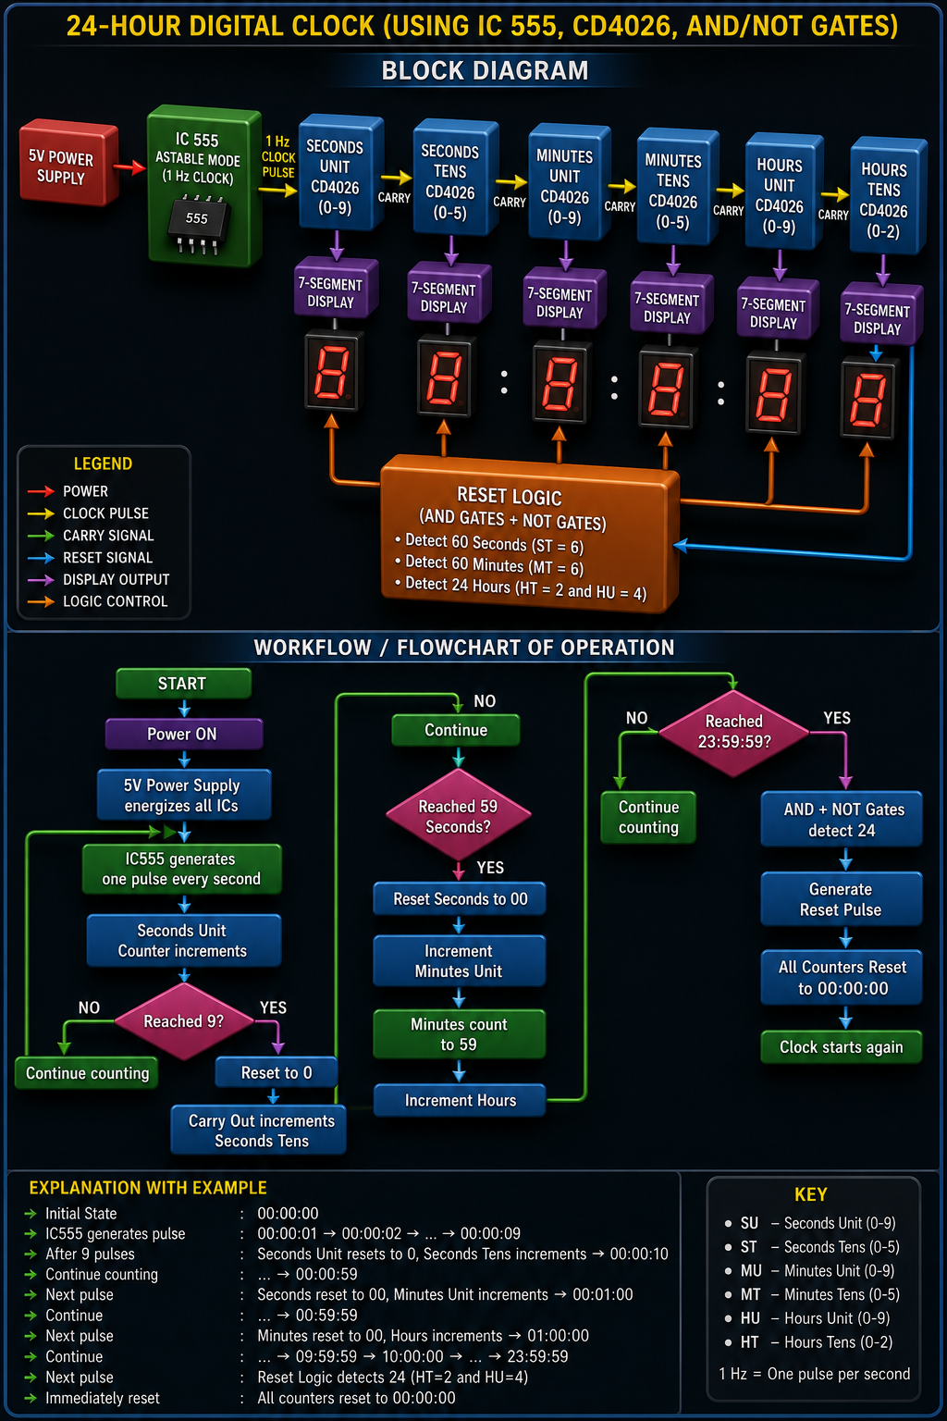

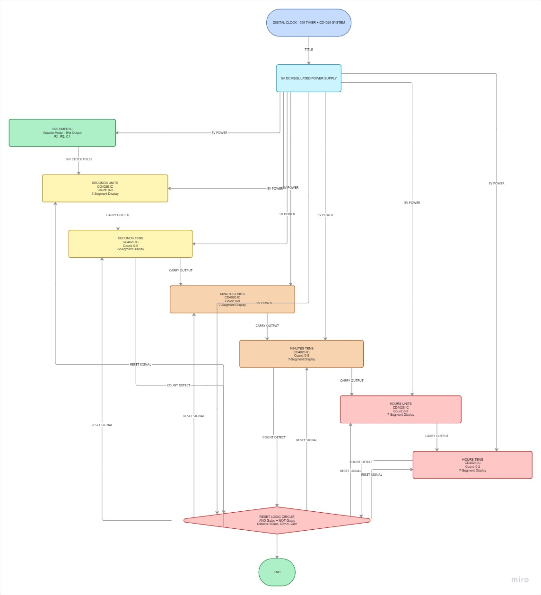

Complete Schematic Diagram 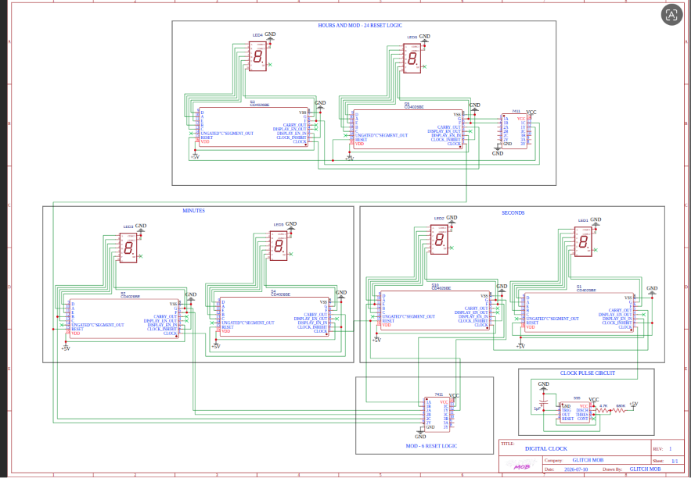

IC555 Timer Circuit
Vcc (Pin 8) and Reset (Pin 4) are tied to +5 V. A timing resistor R1 connects Vcc to the junction of THR (Pin 6) and DISCH (Pin 7); a second resistor R2 connects that junction to TRIG (Pin 2); a timing capacitor C1 connects TRIG/THR junction to ground. A small bypass capacitor (0.01 µF) connects CTRL (Pin 5) to ground to stabilise the internal reference. OUT (Pin 3) feeds the CLOCK input of the seconds-units CD4026.

CD4026 Pin Connections
For each CD4026: Vdd (Pin 16) to +5 V, GND (Pin 8) to ground, CLOCK (Pin 1) to the carry-out of the previous stage (or to the 555 output for the first stage), CLOCK INHIBIT (Pin 2) tied low to enable continuous counting, DISPLAY ENABLE IN (Pin 3) tied high to keep the display always on, RESET (Pin 15) connected to the shared reset-logic output line, and segment outputs (Pins 9, 10, 11, 12, 13, 14 and the appropriate ones per datasheet) each routed through a current-limiting resistor to the corresponding segment of its seven-segment display. CARRY OUT (Pin 5) connects to the CLOCK input of the next counter stage in the chain.

Seven-Segment Display Connections
The common cathode of each display connects to ground; each of the seven segment anodes connects through its own current-limiting resistor to the matching segment output of its CD4026.

Carry-Out Connections
Seconds-units CARRY OUT drives seconds-tens CLOCK; seconds-tens CARRY OUT drives minutes-units CLOCK; minutes-units CARRY OUT drives minutes-tens CLOCK; minutes-tens CARRY OUT drives hours-units CLOCK; hours-units CARRY OUT drives hours-tens CLOCK.

Reset Logic Using AND and NOT Gates
The relevant BCD bits from the seconds-tens and seconds-units counters are combined in an AND gate to detect the count of 60; its output, after inversion where required by gate polarity, drives the RESET pins of both seconds counters. The same arrangement, built from a second AND–NOT pair, detects 60 on the minutes pair, and a third AND–NOT pair detects 24 on the hours pair. All three reset lines can additionally be OR-connected to the manual reset push button so that a user press clears every counter at once.

Power Supply Connections
A regulated 5 V DC supply (for example, a 7805 linear regulator fed from a higher unregulated input, or a stabilised bench supply) powers every IC's Vcc/Vdd pin, with a common ground rail tying all ICs, displays, and switches together. Bulk decoupling capacitors sit across the supply rails, and local 0.1 µF ceramic capacitors are placed at each IC's power pins.
6.7 Manual Reset Switch A push button connects the shared reset line to +5 V when pressed, with a pull-down resistor holding the line low when released, so that pressing the button drives all counter RESET pins high momentarily and returns the display to 00:00:00.

Detailed Working
Starting from the initial state 00:00:00, the IC555 emits one pulse every second, and that single pulse is the only external stimulus the entire system needs — everything else follows automatically from counter and reset logic.

Step-by-step transitions
- 00:00:00 — initial state after power-on or manual reset.
- Each 1 Hz pulse from the IC555 increments the second-units counter: 00:00:01, 00:00:02, 00:00:03 ...
- 00:00:09 — the next pulse resets the seconds-units counter to 0 and sends a carry pulse to the seconds-tens counter: display becomes 00:00:10.
- Counting continues through the tens and units of seconds up to 00:00:59.
- At 00:00:59, the next pulse causes the reset logic to detect 'seconds = 60'; it resets both seconds counters to 0 and sends an effective carry into the minutes-units counter: display becomes 00:01:00.
- This pattern repeats for minutes: counting continues to 00:59:59, at which point the reset logic detects 'minutes = 60', resets both minute counters, and increments the hours-units counter: display becomes 01:00:00.
- Hours count normally through 09:59:59, then 10:00:00, and onward to 23:59:59.
- The next pulse would nominally produce 24:00:00; instead, the reset logic detects 'hours = 24' at that same instant and immediately resets all six counters: display returns to 00:00:00, and the entire 24-hour cycle repeats.
Each transition above is triggered by exactly one edge of the master 1 Hz clock, and every rollover (9→0 within a decade, 59→00 across a units/tens pair, or 23→00 across the full day) is handled by the same two building blocks used throughout the design: ripple carry-out between counter stages, and AND–NOT reset detection at the seconds, minutes, and hours boundaries.
Reset Logic

Seconds Reset (59 -> 00)
Logic equation: Reset_sec = AND(Seconds_tens = 6, Seconds_units = 0), evaluated at the instant the 60th pulse arrives, i.e. Reset_sec = S_t3 AND (NOT S_t2) AND (NOT S_t1) AND S_t0, where the tens digit's BCD pattern for '6' is 0110.
Seconds Tens (BCD) | Seconds Units (BCD) | Reset_sec
0110 (6) | 0000 (0) | 1 (reset fires)
Any other combination | Any | 0

Minutes Reset (59 -> 00)
Identical logic structure to the seconds reset, applied to the minutes-tens and minutes-units counter pair: Reset_min = AND(Minutes_tens = 6, Minutes_units = 0).

Hours Reset (23 -> 00)
Logic equation: Reset_hr = AND(Hours_tens = 2, Hours_units = 4). Because '2' in BCD is 0010 and '4' is 0100, the AND gate inputs are wired to the specific bit lines that are high in each of those patterns, with NOT gates inverting the bit lines that must be low.
Hours Tens (BCD) | Hours Units (BCD) | Reset_hr
0010 (2) | 0100 (4) | 1 (reset fires)
Any other combination | Any | 0
Timing diagram description: the reset pulse for each pair is generated combinationally (it depends only on the present counter state, not on a stored history), so it appears within one propagation delay of the relevant count being reached and disappears as soon as the counters clear on the next clock edge — a narrow, self-terminating pulse rather than a level that could re-trigger a second reset.
Counter Operation

Decade Counting
Each CD4026 counts in decade (mod-10) fashion: its internal Johnson counter cycles through ten unique states corresponding to the digits 0–9 and then returns to 0, rather than continuing into an 11th state.

Carry Generation
A carry pulse is produced once per ten input pulses, coincident with the 9-to-0 rollover of that stage, and is used as the clock input for the next, slower stage.

Ripple Counting
Because each stage is clocked by the carry-out of the stage before it rather than by a common master clock, the counter chain is a ripple (asynchronous) counter: a change at the seconds-units stage may take a small but non-zero time to propagate all the way to the hours-tens stage. For a human-readable clock updating once per second this propagation delay is negligible in practice.

Clock Propagation
The 1 Hz master pulse only ever clocks the very first stage directly; every other stage is clocked indirectly through the carry-out chain described in Chapter 6, so the propagation of time information flows strictly left to right through the six-digit display, low-order to high-order.

Counter Synchronization
Synchronization across the whole clock is maintained by ensuring the reset logic asserts RESET on the affected counter pairs at the same clock edge, so that, for example, both seconds counters clear together rather than one lagging the other and briefly showing an invalid digit pair.

Why CD4026 Simplifies the Design
Because the CD4026 integrates the decade counter, the BCD-to-seven-segment decoding logic, and the display driver stage all in one 16-pin package, it removes the need for a separate 4511-type decoder IC per digit. This roughly halves the IC count and the wiring compared with a design built from bare counters and separate decoders, while still exposing a clean CARRY OUT and RESET pin that make cascading and reset logic straightforward to implement with simple gates.
Role of Logic Gates

NOT Gate

Signal Inversion
The NOT gate is used wherever a counter's BCD bit must be tested for being logic 0 rather than logic 1 — for example, testing that the seconds-units digit is 0 as part of detecting '60' requires inverting that bit before it enters the AND gate.

Reset Pulse Generation
A NOT gate at the output of the detection AND gate can also be used to match the active-high or active-low reset convention required by the CD4026's RESET pin, ensuring the reset pulse arrives with the correct polarity.

AND Gate
AND gates perform the core coincidence detection for every rollover condition in the system:
- Second = 60 → AND of the seconds-tens '6' pattern and seconds-units '0' pattern.
- Minute = 60 → AND of the minutes-tens '6' pattern and minutes-units '0' pattern.
- Hour = 24 → AND of the hours-tens '2' pattern and hours-units '4' pattern.
Condition | Tens Digit Pattern | Units Digit Pattern | Gate Output
Seconds = 60 | 6 (0110) | 0 (0000) | 1
Minutes = 60 | 6 (0110) | 0 (0000) | 1
Hours = 24 | 2 (0010) | 4 (0100) | 1

Complete Workflow
- Power ON — the 5 V supply energises all ICs and displays; counters initialise or are manually reset to 00:00:00.
- IC555 generates a continuous 1 Hz pulse train.
- The seconds-units counter increments on every pulse.
- Its carry-out clocks the seconds-tens counter once per ten seconds.
- The seconds-tens carry-out clocks the minutes-units counter once per minute.
- The minutes-units carry-out clocks the minutes-tens counter once per ten minutes.
- The minutes-tens carry-out clocks the hours-units counter once per hour.
- The hours-units carry-out clocks the hours-tens counter once per ten hours.
- The reset-logic block continuously checks all three digit pairs for their rollover condition.
- If 24 is detected on the hours pair (or 60 on seconds/minutes), the corresponding counters are reset.
- For the full-day rollover, all six counters return to 00:00:00.
- The cycle then repeats indefinitely as long as power is applied.

Breadboard Implementation

Breadboard Layout
The build is laid out left to right in the same order as the signal flow: IC555 timing circuit on the far left, followed by the six CD4026/seven-segment display pairs in sequence (seconds-units, seconds-tens, minutes-units, minutes-tens, hours-units, hours-tens), with the reset-logic gates placed along the bottom edge of the board so their inputs can reach across to the relevant counter output pins with short leads.

IC Placement
Each IC straddles the centre gap of its breadboard section so its two rows of pins land in electrically separate strips, and ICs are spaced so that decoupling capacitors and resistors can sit directly beside their associated pins without overlapping neighbouring components.

Power Rail Distribution
The two outer rail pairs of each breadboard strip are dedicated to +5 V and GND and are linked together across all breadboard sections with heavier jumper wires, so that every IC and display draws from a common, low-impedance supply.

Wiring Strategy
Signal wires are colour-coded by function (for example, one colour for clock/carry lines, another for reset lines, another for segment lines) and kept as short as practical, with carry-out-to-clock-in jumpers run directly between adjacent counter sections to minimise stray coupling.

Noise Reduction Techniques
- A 0.1 µF decoupling capacitor is placed at the supply pins of every IC.
- A single-point ground reference is used to avoid ground loops.
- Long parallel runs of segment wires are avoided, or are kept away from the 555's timing components.
- Unused CMOS gate inputs are tied to a defined logic level rather than left floating.

Step-by-Step Assembly Procedure
1. Build and test the IC555 astable circuit alone; verify a 1 Hz square wave at its output with an oscilloscope or LED blink test.
2. Place the first CD4026 and its seven-segment display; wire CLOCK to the 555 output and verify the display counts 0–9 and rolls over with a carry pulse.
3. Add the remaining five CD4026/display pairs one at a time, verifying each carry-driven stage before adding the next.
4. Wire the AND/NOT reset-logic gates for the seconds pair first, and confirm 59→00 rollover with correct minutes increment.
5. Repeat reset-logic wiring and testing for the minutes pair and then the hours pair. 6. Add the manual reset push button and confirm it clears all six digits simultaneously.
7. Run the assembled clock through at least one full 24-hour cycle (or a scaled-down test at a higher clock frequency) to confirm the 23:59:59 → 00:00:00 rollover.
6. Add the manual reset push button and confirm it clears all six digits simultaneously.
7. Run the assembled clock through at least one full 24-hour cycle (or a scaled-down test at a higher clock frequency) to confirm the 23:59:59 → 00:00:00 rollover.
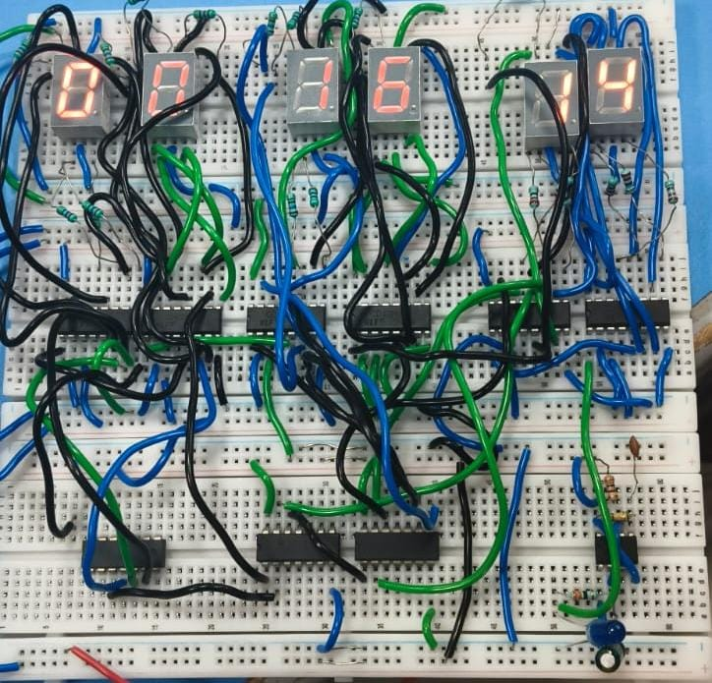

Testing and Verification
Test Case | Expected Output | Actual Output | Observation
IC555 output frequency | 1 Hz square wave | Measured ~1 Hz | Within tolerance
Seconds-units rollover (9→0) | Carry pulse to seconds-tens | Carry pulse observed | Correct
Seconds rollover (59→00) | Minutes-units increments | Minutes increments correctly | Correct
Minutes rollover (59→00) | Hours-units increments | Hours increments correctly | Correct
Hours rollover (23→00) | All digits reset to 0 | All digits reset | Correct
Manual reset button press | Display shows 00:00:00 | Display resets instantly | Correct

Error Analysis
- Digit flicker traced to a missing decoupling capacitor on one CD4026 supply pin, resolved by adding a 0.1 µF capacitor.
- Occasional false reset triggered by switch contact bounce, resolved by adding an RC debounce network across the push button.
- Slight frequency drift in the IC555 output traced to a high-tolerance timing capacitor, resolved by substituting a tighter-tolerance component.

Troubleshooting Steps
- Verify supply voltage at every IC's Vcc/Vdd pin before suspecting logic faults.
- Probe the IC555 output directly to confirm a clean 1 Hz square wave before testing downstream counters.
- Check each CARRY OUT to CLOCK connection with a multimeter continuity test if a stage fails to advance.
- Verify reset-logic gate inputs are wired to the correct BCD bit lines, not simply the adjacent pin.

Applications
- Digital wall clocks for homes and offices.
- Educational laboratories teaching digital logic and counter design.
- Industrial timers for process scheduling.
- Production counters on manufacturing lines.
- Factory monitoring and shift-timing systems.
FUTURE SCOPE
- Adding an alarm function with a settable target time.
- Calendar integration to display date alongside time.
- Battery backup so the clock retains time through a power interruption.
- A dedicated RTC (real-time clock) module for improved long-term accuracy.
- Temperature display alongside the time.
- IoT connectivity to synchronise time over a network.
- Automatic display brightness control based on ambient light.
Learning Outcomes
- Practical understanding of digital logic design principles.
- Hands-on experience with counter operation and cascading.
- Clock generation using the IC555 timer.
- Design and implementation of reset logic using combinational gates.
- Hardware debugging skills using multimeters and oscilloscopes.
- Breadboard prototyping technique and layout planning.
- Team collaboration across hardware, architecture, and testing roles.
- Engineering documentation and technical report writing.
Conclusion
This project successfully demonstrates a fully functional 24-hour digital clock built entirely from discrete digital electronics — an IC555 astable oscillator, six CD4026 decade counter/display driver ICs, and a small set of AND and NOT gates forming the reset logic. Across seconds, minutes, and hours, the design correctly implements decade counting, carry propagation, and rollover detection, culminating in the automatic 23:59:59 → 00:00:00 transition that defines a true 24-hour clock. Beyond the working prototype, the project gave the team, GLITCH MOB, direct practical experience with sequential logic design, combinational reset-condition detection, breadboard prototyping discipline, and structured hardware debugging. The result is a reliable, low-cost, non-programmable timekeeping instrument with clear educational value and a foundation that can be extended toward alarms, calendar features, or RTC-backed accuracy in future iterations.

Appendix

IC555 Pinout
Pin | Name
1 | GND
2 | TRIG
3 | OUT
4 | RESET
5 | CTRL
6 | THR
7 | DISCH
8 | Vcc

CD4026 Pinout (Key Pins)
Pin | Name
1 | CLOCK
2 | CLOCK INHIBIT
3 | DISPLAY ENABLE IN
5 | CARRY OUT
8 | GND
15 | RESET
16 | Vdd

Seven-Segment Connection Table
Segment | CD4026 Output Pin (typical)
a | 11
b | 7
c | 4
d | 2
e | 1
f | 13
g | 3

Reset Logic Truth Tables
See Chapter 8 for the full seconds, minutes, and hours reset truth tables.

Counter Sequence Table (Seconds Digit Pair, Sample)
Pulse Count | Seconds Tens | Seconds Units | Display
0 | 0 | 0 | 00
9 | 0 | 9 | 09
10 | 1 | 0 | 10
59 | 5 | 9 | 59
60 | 0 | 0 | 00 (reset, minute increments)

Breadboard Connection Guide
Refer to Chapter 12 for the complete section-by-section breadboard layout and assembly sequence.

Common Troubleshooting Tips
- No display output: check Vdd/GND at the CD4026 and DISPLAY ENABLE IN polarity.
- Counter stuck at one digit: verify the CLOCK line is actually toggling and CLOCK INHIBIT is held low.
- Random resets: check for switch bounce or a floating reset-logic input.
- Wrong rollover point: re-check which BCD bits are wired into the AND/NOT reset-detection gates.

References
- Texas Instruments / ON Semiconductor, NE555 Precision Timer Datasheet.
- Texas Instruments, CD4026B Decade Counter/Divider Datasheet.
- Fairchild/ON Semiconductor, CD4081B Quad 2-Input AND Gate Datasheet.
- Fairchild/ON Semiconductor, CD4069UB Hex Inverter Datasheet.
- Standard Digital Electronics and Logic Design course reference material.

