PROJECT DESIGN PHASE
Solution Architecture
Date | 30 September 2026
Team ID | SWTID-2026-2273
Project Name | AI StudyBuddy – AI Assistant for Smarter Learning and Study Support
Team Size | 4
Team Leader: KISHORE.T | Team Members: LOGESH.D, MANIKANDAN.M, MOHAMED SAFIR.M

The architecture follows the project documentation: a modular RESTful backend with React frontend, Node.js/Express.js, JWT authentication/RBAC, MongoDB/Mongoose and a dedicated Google Gemini AI service layer.
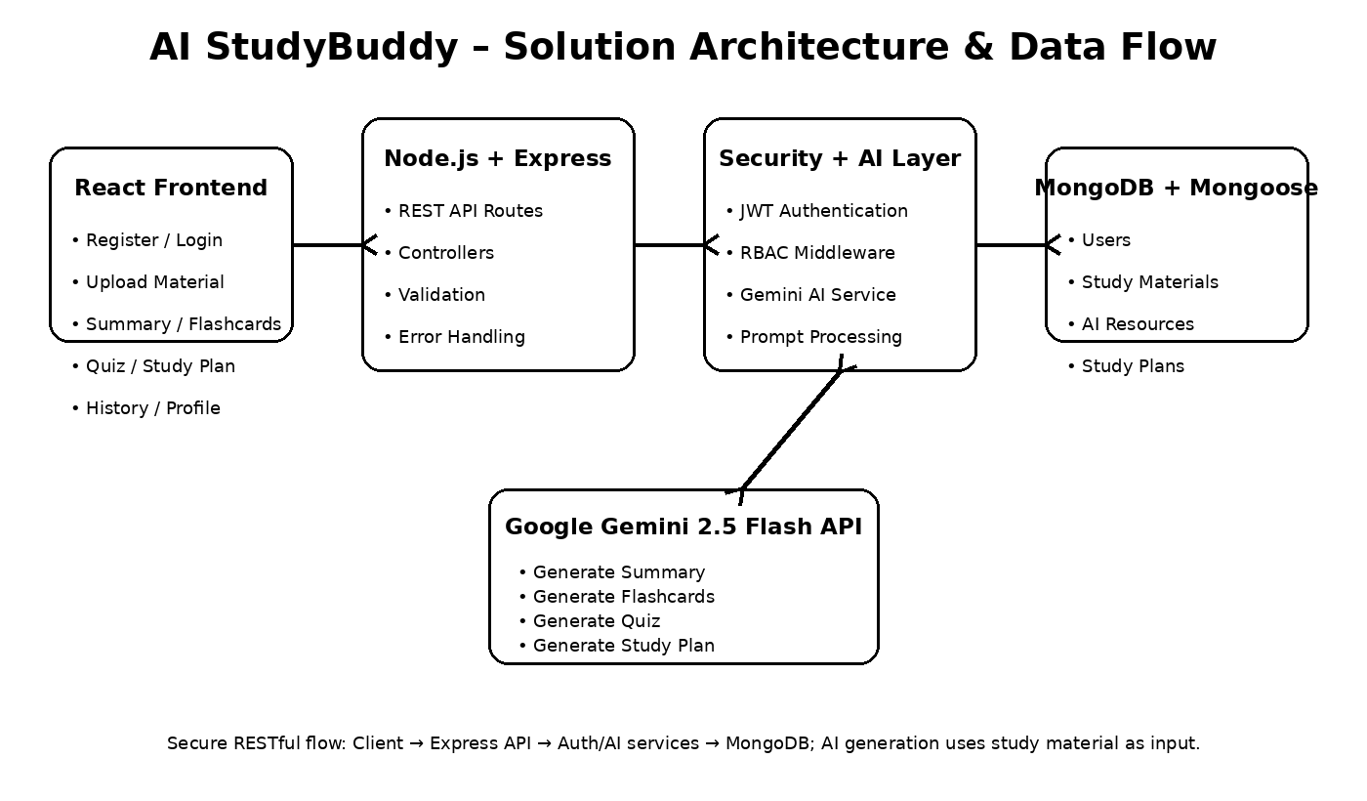
Architecture Components
Component | Technology / Layer | Responsibility
Client Application | React.js | User registration/login, material upload and access to AI learning features through REST APIs.
API Server | Node.js + Express.js | HTTP request handling, routing, middleware, validation and response handling.
Authentication | JWT + bcryptjs + RBAC | Verify user identity, protect private routes, hash passwords and restrict administrator operations.
AI Service Layer | Google Gemini 2.5 Flash API | Generate summaries, flashcards, quizzes and personalized study plans from study content.
Database Layer | MongoDB + Mongoose | Store users, study materials and AI-generated learning resources with schemas and validation.
Upload Middleware | Multer | Validate incoming study-material files before backend processing; documented implementation allows .txt, .md and .pdf within the configured size limit.
API Testing | Postman / Thunder Client | Verify REST API requests, responses and authentication-protected endpoints.
Main Data Flow
- Student registers/logs in; the backend authenticates the request and issues a JWT access token.
- The authenticated student uploads study material through the protected material endpoint.
- The backend validates and stores the material in MongoDB.
- The requested AI feature calls the Gemini service with the relevant study content.
- Gemini returns generated educational content such as a summary, flashcards, quiz or study plan.
- The backend returns the generated resource to the client and stores it for future retrieval.
- Administrators use protected RBAC endpoints for user and system-level management.
Development Phases
- Project setup and environment configuration.
- Backend and REST API implementation.
- MongoDB/Mongoose schema and database configuration.
- JWT authentication and RBAC.
- Gemini AI service integration.
- Study material upload and AI feature endpoints.
- API testing and UAT.
- Future frontend integration and additional AI learning capabilities.

