Project Design Phase-II – Data Flow Diagram & User Stories
AI StudyBuddy – AI Assistant for Smarter Learning and Study Support
Date | 30 September 2026
Team ID | SWTID-2026-2273
Project Name | AI StudyBuddy – AI Assistant for Smarter Learning and Study Support
Team | Leader: KISHORE.T; Members: LOGESH.D, MANIKANDAN.M, MOHAMED SAFIR.M

1. Data Flow Diagram
The DFD represents how information moves through AI StudyBuddy. Students or administrators interact with authentication and study-material services; authenticated material is stored in MongoDB and sent to the Gemini AI service for summaries, flashcards, quizzes and study plans. Generated resources are stored and retrieved through protected APIs.
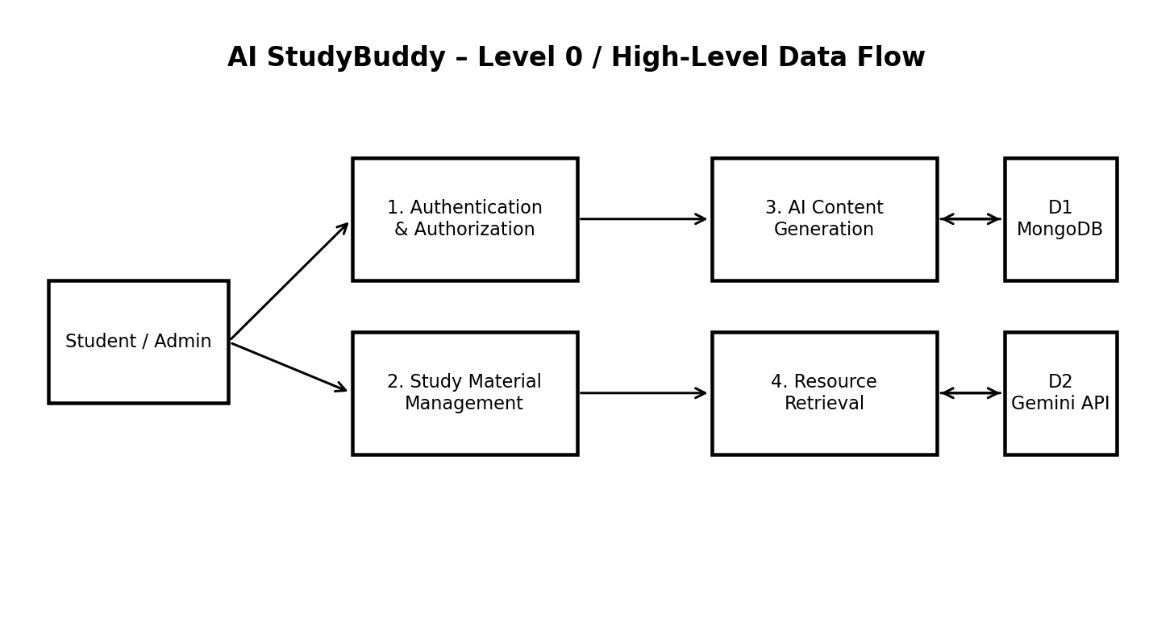

2. DFD Level-1 Process Description
Process | Input | Processing | Output / Storage
1. Authentication & Authorization | Name, email, password, JWT | Register/login, bcrypt password hashing, JWT verification and RBAC | Authenticated session / access decision
2. Study Material Management | Text or permitted file | Validate upload, store metadata/content, associate with user | Study material in MongoDB
3. AI Content Generation | Study material + feature request | Build prompt and call Google Gemini API | Summary / flashcards / quiz / study plan
4. Resource Retrieval | Authenticated user request | Query stored resources and verify ownership | Previously generated learning resources

3. User Stories
User Type | Epic | Story No. | User Story / Task | Acceptance Criteria | Priority | Release
Student | Authentication | USN-01 | As a student, I can register with my name, email and password. | Account is created with unique email and hashed password. | High | Sprint-1
Student | Authentication | USN-02 | As a student, I can log in using email and password. | Valid credentials return a JWT; invalid credentials are rejected. | High | Sprint-1
Student | Study Materials | USN-03 | As a student, I can upload a study material file. | Only permitted file types are accepted and the material is associated with my account. | High | Sprint-2
Student | Study Materials | USN-04 | As a student, I can retrieve my saved study materials. | Only my authorized materials are returned. | High | Sprint-2
Student | AI Summary | USN-05 | As a student, I can generate a concise summary. | A summary is generated from the selected material and returned/stored. | High | Sprint-2
Student | AI Flashcards | USN-06 | As a student, I can generate flashcards. | Question-answer flashcards are generated from the selected material. | High | Sprint-3
Student | AI Quiz | USN-07 | As a student, I can generate a multiple-choice quiz. | Quiz questions and answer choices are returned from the selected material. | High | Sprint-3
Student | AI Study Plan | USN-08 | As a student, I can generate a personalized study plan. | A study schedule is generated using learning goals, available time and exam date. | High | Sprint-3
Student | History | USN-09 | As a student, I can view previously generated resources. | Saved summaries, flashcards, quizzes and study plans can be retrieved. | Medium | Sprint-3
Administrator | Administration | USN-10 | As an administrator, I can manage users and monitor usage. | Admin-only routes are inaccessible to ordinary students. | Medium | Sprint-4

4. Main Data Stores
• Users: account, role and authentication information.
• Study Materials: uploaded material and associated metadata.
• AI-generated resources: summaries, flashcards, quizzes and study plans associated with users/materials.

