Project Design Phase-II – Technology Stack (Architecture & Stack)
AI StudyBuddy – AI Assistant for Smarter Learning and Study Support
Date | 30 September 2026
Team ID | SWTID-2026-2273
Project Name | AI StudyBuddy – AI Assistant for Smarter Learning and Study Support
Team | Leader: KISHORE.T; Members: LOGESH.D, MANIKANDAN.M, MOHAMED SAFIR.M

1. Technical Architecture
The documented architecture separates the React client, Express REST backend, authentication middleware, AI service, and MongoDB data layer. Google Gemini is an external AI interface. The backend follows a modular MVC-style organization with routes, controllers, middleware, models and utility modules.
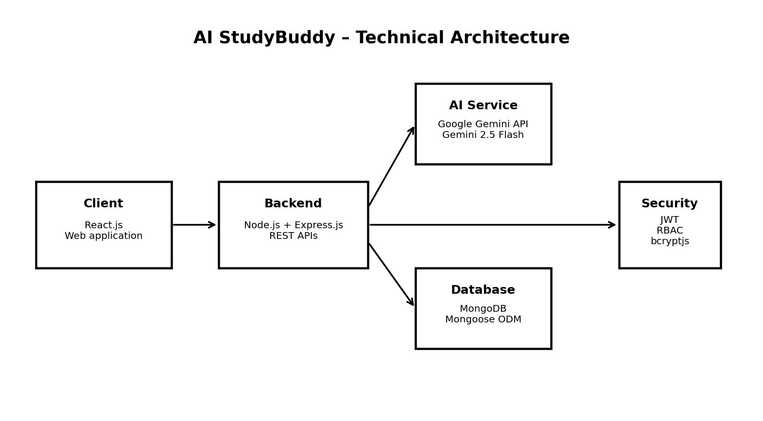

2. Table-1: Components & Technologies
S.No | Component | Description | Technology
1 | User Interface | Student/admin interaction, login, dashboard and AI feature access | React.js
2 | Application Logic-1 | HTTP routing, middleware and REST API processing | Node.js + Express.js
3 | Application Logic-2 | Authentication and authorization | JWT + Express middleware
4 | Application Logic-3 | AI content generation | Google Gemini API / @google/genai
5 | Database | Users, materials and generated learning resources | MongoDB
6 | Data Modeling | Schema validation and database interaction | Mongoose ODM
7 | File Storage / Upload | Incoming study-material handling | Multer + local uploads directory
8 | External API-1 | Generative AI for summaries, flashcards, quizzes and plans | Google Gemini API
9 | External API-2 | Not specified in the project documentation | Not applicable
10 | Machine Learning / AI Model | Educational content generation from user-provided material | Gemini 2.5 Flash
11 | Infrastructure | Development/execution environment | Windows/macOS/Linux; Node.js server; MongoDB

3. Table-2: Application Characteristics
S.No | Characteristic | Description | Technology
1 | Open-Source Frameworks | Express.js, React.js, Mongoose and supporting Node.js packages are used for application development. | Node.js ecosystem
2 | Security Implementations | JWT protected routes, bcrypt password hashing, role-based authorization, environment variables for secrets, CORS configuration and upload validation. | jsonwebtoken, bcryptjs, dotenv, CORS, Multer
3 | Scalable Architecture | Routes, controllers, middleware, models and AI utilities are separated so features can be extended without changing the whole application. | MVC / modular REST architecture
4 | Availability | The server establishes MongoDB connectivity during startup and exposes a health-check endpoint; deployment can later be moved to cloud infrastructure. | Express.js + MongoDB
5 | Performance | Asynchronous Node.js operations, database indexing/validation where required, modular API calls and controlled file-size limits support efficient request processing. | Node.js, Express.js, Mongoose, Gemini API

4. Environment Configuration
The documented project uses environment variables rather than hard-coding secrets:
PORT=5000
MONGO_URI=<MongoDB connection string>
JWT_SECRET=<JWT secret>
GEMINI_API_KEY=<Gemini API key>

5. Technology Flow
• React client sends authenticated HTTP requests to Express REST APIs.
• JWT middleware validates access tokens and RBAC controls administrator-only operations.
• Controllers communicate with Mongoose models for MongoDB data operations.
• AI utility sends suitable prompts to Google Gemini and returns generated educational content.
• Generated summaries, flashcards, quizzes and study plans are stored/retrieved for future use.

