

CITYCOT UNIVERSITY

FACULTY OF COMPUTING AND INFORMATION TECHNOLOGY

PROJECT PROPOSAL

DEVELOPMENT OF A WEB-BASED LAUNDRY MANAGEMENT AND POINT-OF-SALE SYSTEM FOR LAUNDRY BUSINESSES IN BOSASO

Group Names and IDs

2026

1. PROJECT IDENTIFICATION
Project Title: | Development of a Web-Based Laundry Management and Point-of-Sale System for Laundry Businesses in Bosaso
Area of Specialization: | Software
Proposed Supervisor:
Supervisor Contact:

2. PROJECT OVERVIEW

2.1 Introduction / Background
Laundry and dry-cleaning shops are a common small business in Bosaso and other Somali towns. They serve households, students, office workers, hotels and restaurants, and a busy shop receives many orders every day. Each order contains several garments, and each garment may need a different service such as washing, ironing or dry cleaning, with its own price and delivery date. Managing this volume of small, detailed transactions accurately is the central challenge of the business.
Around the world, service businesses of this kind have moved from paper records to computerised information systems. Point-of-sale (POS) and web-based management systems are now used to register orders, print receipts, follow each order until delivery and produce financial reports. Published studies on laundry businesses describe the same pattern: manual recording leads to mixed-up clothing, delayed collection and records that are hard to retrieve, and web-based systems built with PHP and MySQL are proposed to solve these problems (Adekola et al., 2021; Nasution et al., 2026). More recent work extends this to order management on mobile devices (Masitoh & Astrianty, 2024). Modern open-source frameworks such as Laravel have made it realistic to build this kind of system at low cost.
The topic is especially relevant in Somalia today. Mobile money is now widely used by small and medium enterprises and has been shown to influence their performance (Mohamed, 2023), and laundry customers in Bosaso commonly pay through services such as Sahal, eDahab, Premier Wallet, MyCash and T-Plus. However, most local laundries still record orders and payments by hand, and the commercial laundry software available online is generally designed for foreign markets: it is sold as a monthly subscription, assumes card or cash payments, and does not fit local payment channels or languages. This project therefore proposes a web-based laundry management and point-of-sale system designed for the way laundry shops in Bosaso actually work.

2.2 Problem Statement
Most small and medium laundry shops in Bosaso still manage their work with paper receipt books and handwritten ledgers. This manual system causes the following specific problems:
- Lost and mixed-up garments: The paper ticket is the only link between a customer and their clothes. When a ticket is lost or the handwriting is unclear, garments are mixed up or delivered late, and staff cannot quickly see which orders are pending, in process, ready or already delivered.
- Slow and inaccurate billing: Prices depend on the garment and the service type, and discounts or extra services are calculated by hand. This slows down the counter at busy times and leads to pricing mistakes.
- Payments that are hard to reconcile: Customers pay through several mobile money services, often in part payments. Payments are confirmed by checking messages on a phone and are not linked to the order, so unpaid balances and customer debts are easily forgotten.
- No control of supplies: Detergent, softener, hangers and packaging are bought and used without any record. The owner does not know the current stock, how much is consumed each day, or how much is owed to suppliers.
- No management reports: To know the sales, expenses or profit of a day or a month, the owner must add up the ledger by hand, so decisions are based on estimates instead of accurate figures.
- Slow answers to customers and weak accountability: When a customer calls or visits to ask whether their clothes are ready, staff must search through the paper tickets to answer, and there is no record of which staff member created an order or received a payment.
The size of these problems (for example, the time needed to register an order and the number of misplaced items or unrecorded payments per month) will be measured during the Analysis phase through interviews and observation at selected laundry shops in Bosaso, and will be used as the baseline for evaluating the proposed system.

2.3 Project Aim & Objectives
- Aim: To design and develop a web-based laundry management and point-of-sale system that automates order processing, payment tracking, inventory control and reporting for small and medium laundry businesses in Bosaso.
- Specific Objectives:
1. To analyse the current manual workflow of laundry shops in Bosaso and identify the functional and non-functional requirements of the proposed system.
2. To design a responsive, web-based point-of-sale interface for registering customers, creating orders by garment and service type, and printing invoices and garment job cards.
3. To implement a secure MySQL database with role-based access control for storing customer, order, payment, expense and inventory records.
4. To implement order status tracking (Pending, Processing, Ready to Deliver, Delivered and Returned) so that the state of every order can be seen at any time on an order status screen.
5. To develop a payment module that records full and partial payments made through local mobile money services and keeps a ledger for each customer.
6. To develop inventory and expense modules that record suppliers, purchases, daily usage of supplies and operating expenses.
7. To generate daily, sales, order, expense and stock reports that can be printed or exported to PDF and Excel.
8. To evaluate the functionality and usability of the system through functional testing and user acceptance testing with laundry staff.

3. PROPOSED METHODOLOGY

3.1 Development Framework
The project will follow the Agile methodology using the Scrum framework (Schwaber & Sutherland, 2020). Development will be organised into short sprints of about two weeks. Each sprint will start with planning from a prioritised product backlog, produce a working increment of the system, and end with a review with the supervisor and, where possible, a laundry owner.
Agile was chosen for three reasons. First, laundry owners and staff are not technical users, so their requirements will become clearer when they see and try working screens; an iterative model allows these changes at low cost, unlike a plan-driven waterfall model in which requirements are fixed at the start (Sommerville, 2016). Second, the system is naturally modular (orders, customers, payments, inventory and reports), so it can be built and tested one module at a time. Third, the official FYP Calendar already divides development into three phases, which map directly onto groups of sprints.
Requirements will be gathered through interviews with laundry owners and staff, observation of daily work and review of existing receipt books. The design will be documented with Use-Case, Entity-Relationship and activity diagrams before coding starts. The database will be designed as a normalised relational schema (Elmasri & Navathe, 2016), and access to system functions will follow the role-based access control model (Sandhu et al., 1996). Every sprint will include testing of the new features, and the completed system will go through functional testing and user acceptance testing. Git will be used for version control and team collaboration.

3.2 Tools and Technologies
- Frontend: HTML5, Tailwind CSS and JavaScript, using Laravel Blade templates with Livewire 3 and Alpine.js for responsive, interactive screens, and JsBarcode for printing barcodes on job cards.
- Backend: PHP 8.2 with the Laravel 11 framework (MVC architecture and Eloquent ORM), with DomPDF and Laravel Excel for PDF and Excel reports.
- Database: MySQL 8 relational database, managed through Laravel migrations and seeders.
- Simulation: Not applicable, because this is a software project. Instead, draw.io will be used for UML and ER diagrams, and PHPUnit and browser developer tools will be used for testing.
- Hardware: Development laptops (Intel Core i5 or equivalent, 8 GB RAM, 256 GB SSD). For use in a laundry shop: any computer or tablet with a web browser, a thermal receipt printer or A4 printer, and an internet or local network connection.
- Other Tools: Visual Studio Code, Git and GitHub, Composer, Node.js with Vite, and a local PHP and MySQL server for development.

3.3 Proposed System Architecture
The proposed system will use a three-tier web architecture, shown in Figure 1, which separates the user interface, the application logic and the data. In the presentation layer, the owner, cashier and laundry staff will use the system through a web browser on a PC or tablet at the counter and will print invoices, job cards, receipts and reports on a receipt or A4 printer. The application layer will be a Laravel 11 application on a web server: each request will pass through routing and middleware (login, roles and permissions) to the Livewire component of the module concerned, which holds the business logic, while the Eloquent ORM maps application objects to database tables. The data layer will be a MySQL database holding all records, together with file storage for the logo, uploads and generated PDF and Excel files. The browser and the server will communicate over HTTP/HTTPS, and the application and the database through SQL.
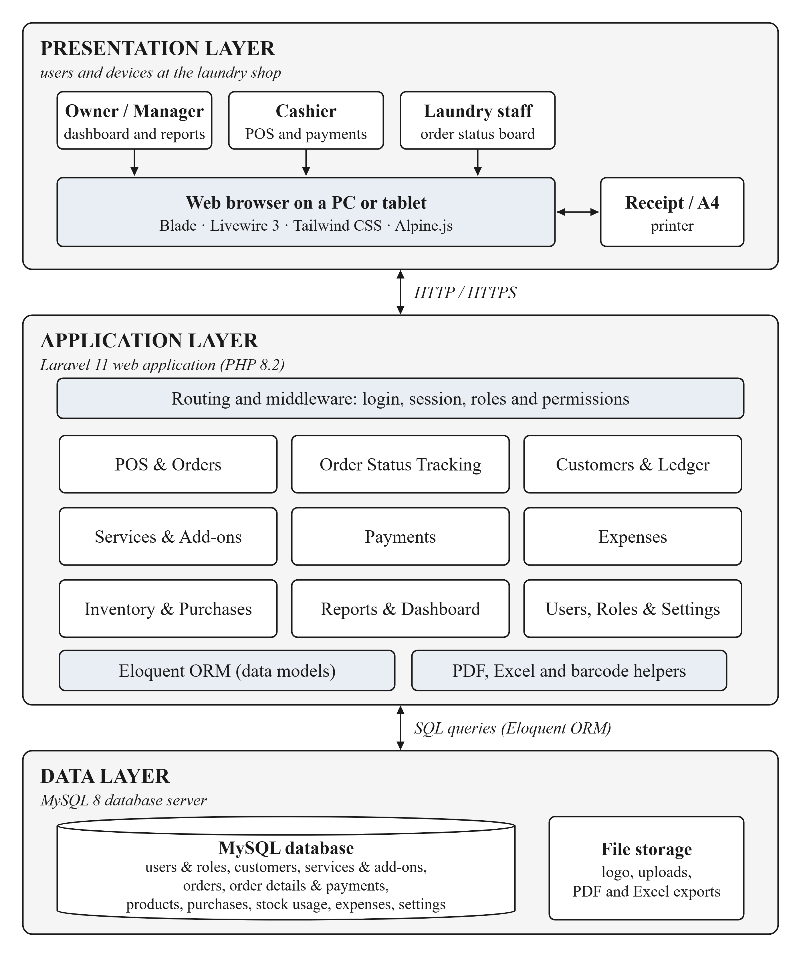
Figure 1: Three-tier architecture of the proposed laundry management system

3.4 System Workflow (Flowchart)
Figure 2 shows how the system will work from beginning to end by following one order through the laundry. After a staff member logs in, the cashier finds or registers the customer and creates the order in the POS screen by selecting the service type, garments, add-ons and quantities; the system calculates the total and the delivery date is set. The order is saved as Pending, the invoice and garment job cards are printed, and any payment made now is recorded in the customer ledger. The status is changed to Processing while the garments are washed and ironed (with the consumables used recorded as stock usage) and to Ready to Deliver when the work is finished. On collection, any remaining balance is collected, the garments are handed over and the order is marked Delivered (or Returned if rejected). Finally, the owner reviews the reports on the dashboard.
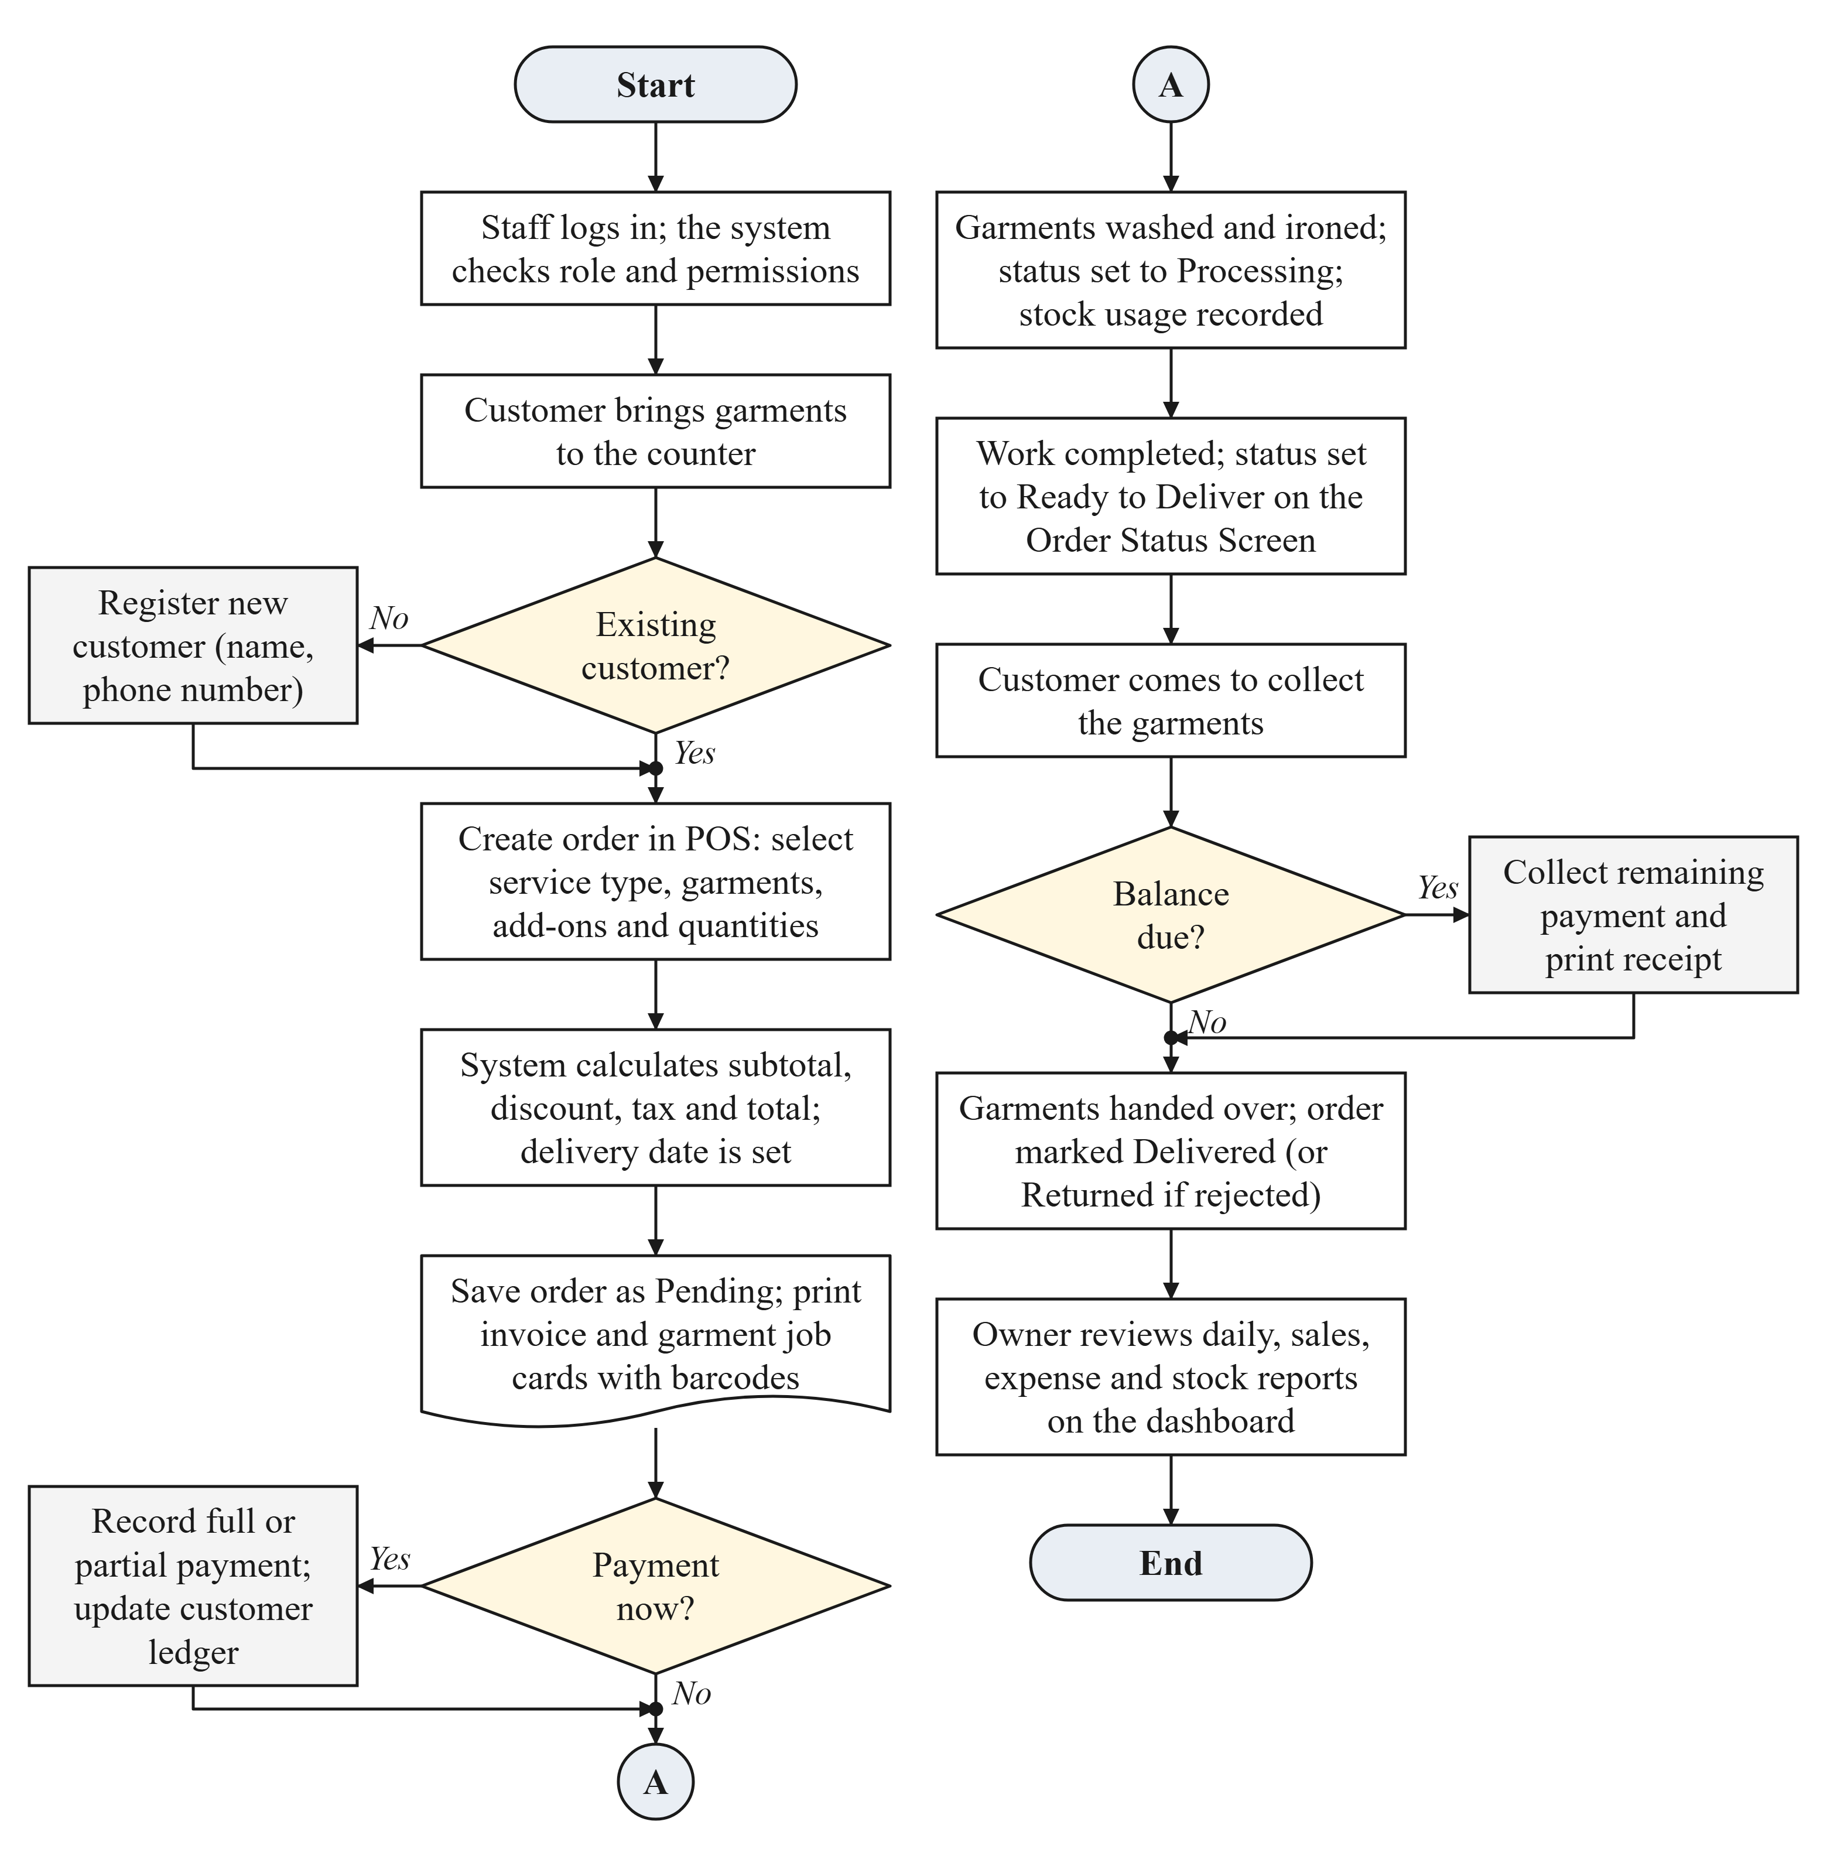
Figure 2: Flowchart of the proposed system from order registration to delivery and reporting

4. FEASIBILITY ANALYSIS
- Technical Feasibility: The project is technically feasible. The team members have studied web development, database systems and software engineering in their degree courses. The remaining tools, mainly the Laravel and Livewire frameworks, are well documented (Laravel, 2024) and will be learned during the Design phase and Development Phase I. All the tools are free and run on the team’s existing laptops. The main technical risk is the team’s limited experience with Livewire and with receipt printing; this will be reduced by building a small prototype of the POS screen and its printed invoice early in Development Phase I.
- Economic Feasibility: The project has a low cost. All the development software (PHP, Laravel, MySQL, Visual Studio Code and Git) is free and open source, so no software licences are required, and the team will use laptops they already own. The estimated costs are: web hosting and a domain name for the demonstration (about $30–50), an 80 mm thermal receipt printer for the demonstration (about $40–60), and internet, printing and binding of the project book (about $30–50). The total estimated budget is about $100–160, which the team can cover.
- Operational Feasibility: The end users are laundry owners, cashiers and laundry staff who have basic computer or smartphone skills. The system will run in a normal web browser with no installation, and the POS screen will use large buttons and garment icons so that an order can be registered in a few clicks. Role-based access will show each user only the functions they need, and the interface will support more than one language so that it can be translated into Somali. A short training session and a user manual will be provided, and the system can be hosted online or on a computer inside the shop where the internet connection is unreliable.

5. PROJECT TIMELINE (Gantt Chart)
The project work is divided into the phases below. The schedule follows the official FYP Calendar, and the task details have been adjusted to this software project.
Phase | Task Description | Timeline (per FYP Calendar)
Proposal Preparation | Background, problem statement, aim & objectives, methodology, feasibility & initial references for the laundry management system | July 2026
Proposal Defense | Present the proposal, receive feedback, revise and obtain approval | July 2026
Analysis | Interviews and observation at laundry shops, review of existing receipt books and related literature, and specification of functional and non-functional requirements | July 2026
Design | System architecture, Use-Case, ER and activity diagrams, database schema design and interface mock-ups of the POS, order and dashboard screens | August 2026
Development Phase I | Set up the Laravel and MySQL development environment and Git repository; build the database migrations, login, roles and permissions, and the base layout (dashboard and navigation) | August 2026
Development Phase II | Implement the core modules: services and pricing, customer management, POS order entry, order status tracking, invoices and job cards, and payment recording | August 2026
Development Phase III | Complete and integrate the remaining modules: inventory, purchases and stock usage, expenses, reports (PDF and Excel) and language settings; refine the interface | September 2026
Testing | Functional and integration testing, debugging, and user acceptance testing with laundry staff | September 2026
Documentation Phase I | Write Introduction, Literature Review and Methodology (Draft Book Part I) | October 2026
Documentation Phase II | Design & Implementation chapters, results, conclusion (Full Project Book) | November 2026
Finalization | Improve functionality from testing feedback, prepare slides and finalize the demo | November 2026
Pre-Defense | Internal presentation, supervisor evaluation and corrections | December 2026
Final Submission | Submit source code, final book and slides | 01 December 2026

6. EXPECTED OUTCOMES
At the end of the project, the following outcomes are expected:
- A functional web application: a responsive laundry management and point-of-sale system with modules for services and pricing, customers, orders and order tracking, payments, expenses, inventory and purchases, reports, and user and role management.
- A structured database: a MySQL database that keeps all the customer, order, payment and stock records of the laundry in one secure place.
- Printed and digital outputs: invoices, garment job cards, payment receipts and management reports in print, PDF and Excel form.
- Project documentation: the final project book, a user manual, the source code and the presentation slides.
- Benefits for the laundry business: faster order registration, fewer lost or delayed garments, accurate records of payments and customer balances, better control of supplies, and up-to-date reports for decision making. These benefits will be assessed against the baseline measured in the Analysis phase.

7. REFERENCES (Initial)
Adekola, O. D., Maitanmi, S. O., Akande, O., Somefun, O., Ajayi, W., Omotunde, A., Ayo-Fanibe, F. S., & Adeoye, I. T. (2021). Online laundry management system. International Journal of Computer (IJC), 41(1), 25–35. https://doi.org/10.53896/ijc.v41i1.1895
Elmasri, R., & Navathe, S. B. (2016). Fundamentals of database systems (7th ed.). Pearson.
Laravel. (2024). Laravel 11.x documentation. https://laravel.com/docs/11.x
Masitoh, P., & Astrianty, L. E. (2024). Implementation of a mobile-based laundry order management system at Barack Laundry in Sleman. Journal of Computer Science and Technology Studies, 6(5), 38–49. https://doi.org/10.32996/jcsts.2024.6.5.4
Mohamed, A. A. (2023). The influence of the mobile money payment on the performance of small and medium enterprises in Somalia. Technological Forecasting and Social Change, 196, Article 122821. https://doi.org/10.1016/j.techfore.2023.122821
Nasution, A. B., Fadillah, K., & Abdi, K. (2026). Analysis and design of web-based laundry management information system at ELS Laundry using the RAD method. Journal of Artificial Intelligence and Engineering Applications (JAIEA), 5(2), 3387–3392. https://doi.org/10.59934/jaiea.v5i2.2200
Sandhu, R. S., Coyne, E. J., Feinstein, H. L., & Youman, C. E. (1996). Role-based access control models. Computer, 29(2), 38–47. https://doi.org/10.1109/2.485845
Schwaber, K., & Sutherland, J. (2020). The Scrum guide: The definitive guide to Scrum: The rules of the game. https://scrumguides.org/scrum-guide.html
Sommerville, I. (2016). Software engineering (10th ed.). Pearson.

8. SIGN-OFF
- Student Signature: ____________________ Date: __________
- Supervisor Recommendation: [ ] Approved [ ] Revise & Resubmit
- Faculty Dean Signature: ____________________

