

***Artificial Intelligence* *Report***

***Name:*** *Mohamed Saied Mahmoud Mohamed Nasrelden.*

***B.N:*** *716*

***Date:*** *26/5/2020*

***Topic:*** *Artificial intelligence.*

***Github URL:***

***Application Brief:***

Artificial intelligence is one of the most important topics that currently occupy the world, where all countries of the world (I mean developed countries) are heading to use artificial intelligence in many fields, due to its various and important applications as it is used in [Marketing](https://www.edureka.co/blog/artificial-intelligence-applications/#AI%20in%20Marketing), [Banking](https://www.edureka.co/blog/artificial-intelligence-applications/#AI%20in%20Banking), [Agriculture](https://www.edureka.co/blog/artificial-intelligence-applications/#AI%20in%20Agriculture), [HealthCare](https://www.edureka.co/blog/artificial-intelligence-applications/#AI%20in%20HealthCare), [Gaming](https://www.edureka.co/blog/artificial-intelligence-applications/#AI%20In%20Gaming), [Space Exploration](https://www.edureka.co/blog/artificial-intelligence-applications/#AI%20In%20Space%20Exploration), [Autonomous Vehicles](https://www.edureka.co/blog/artificial-intelligence-applications/#AI%20In%20Autonomous%20Vehicles), [Chatbots](https://www.edureka.co/blog/artificial-intelligence-applications/#AI%20In%20Chatbots) and [Artificial Creativity](https://www.edureka.co/blog/artificial-intelligence-applications/#AI%20In%20Artificial%20Creativity). And this is what has inspired and prompted many countries to pay attention to artificial intelligence and try to develop it.

# *Screenshots:*

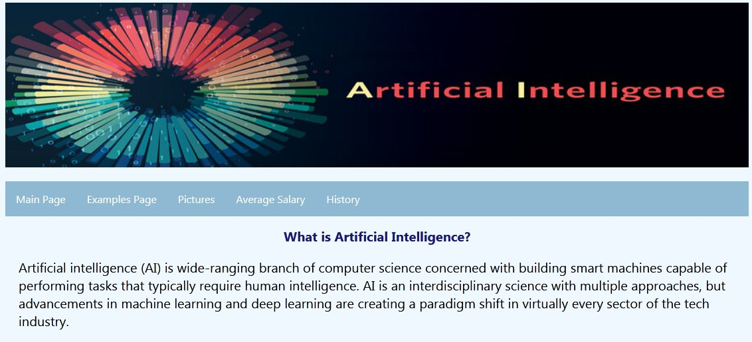

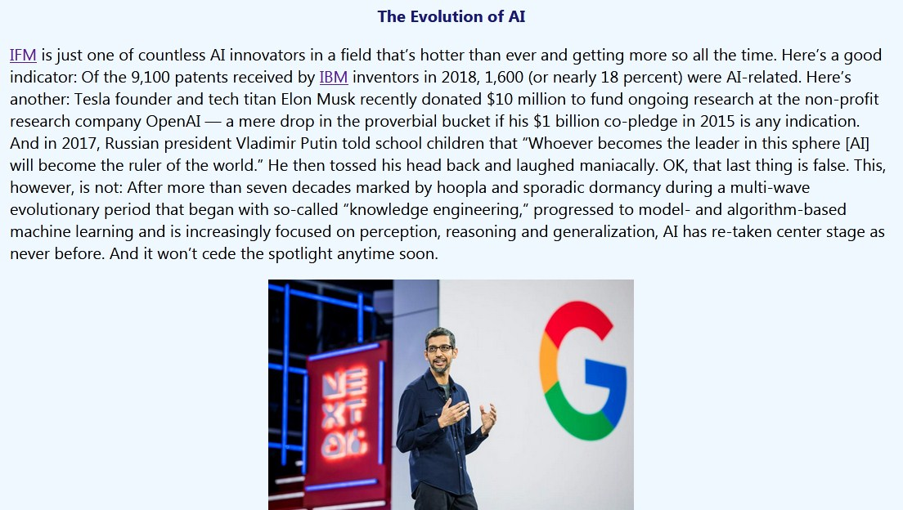

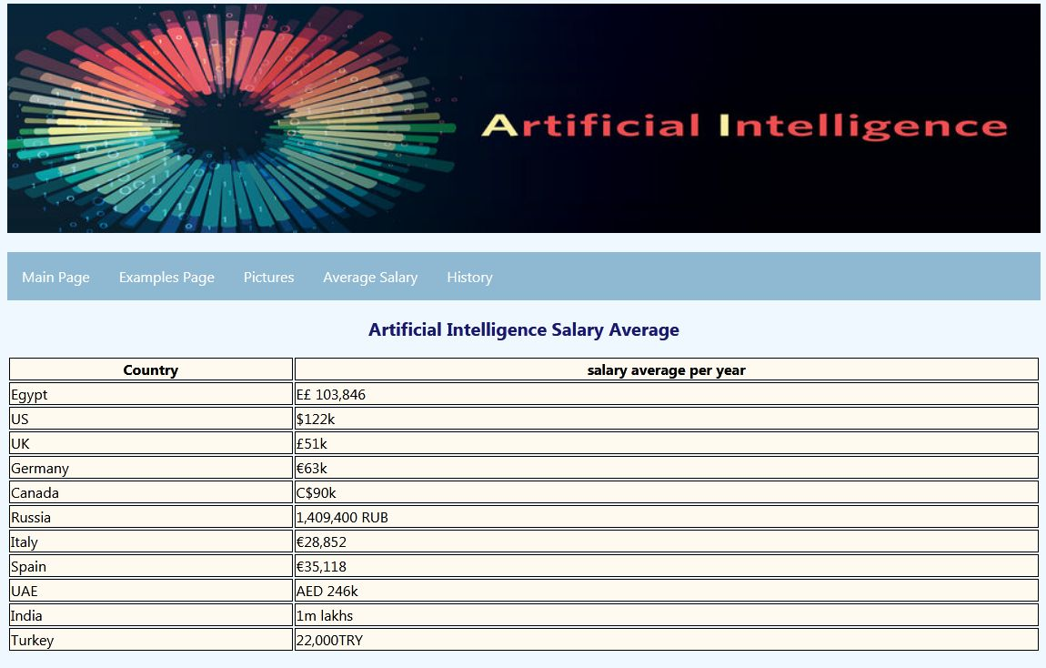

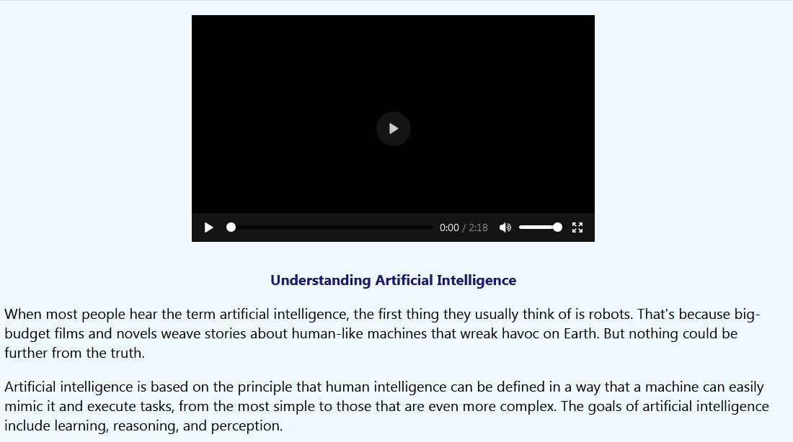

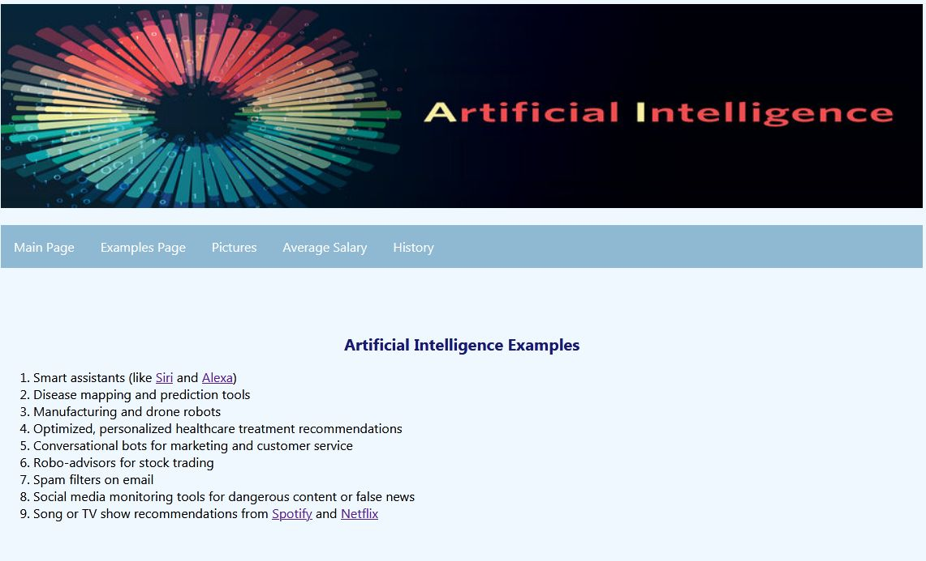

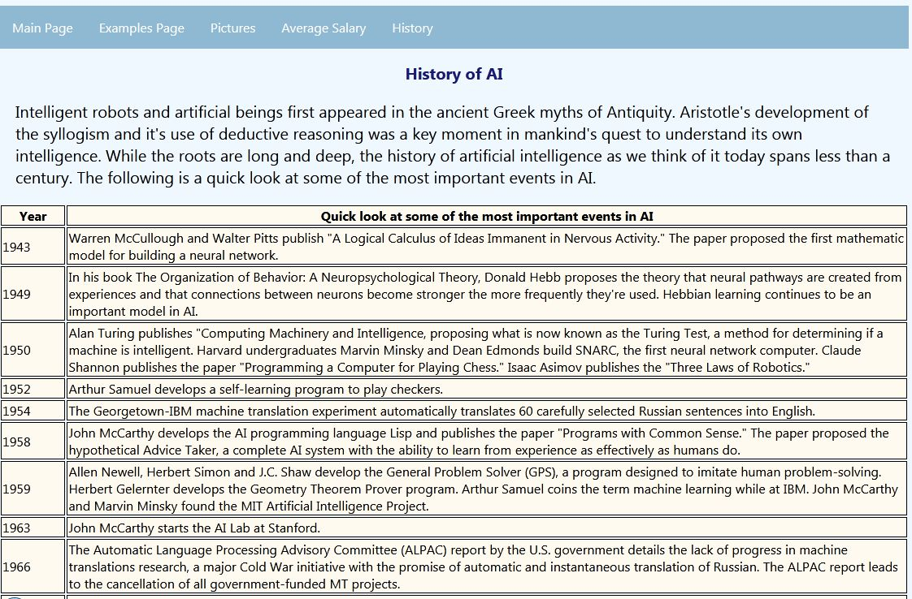

***Screenshots of source code:***



