SIMATS ENGINEERING
CSA15 – CLOUD COMPUTING AND BIG DATA ANALYTICS
ASSIGNMENT 3 – CO3
DESIGN A CLOUD-BASED COLLABORATIVE SOLUTION
OBE-Based Evidence Principle

CO3: Implement cloud-based solutions using cloud storage, web APIs, and platform services for real-world applications.
Table 1: Student and assignment details
Field | Details | Field | Details
Student name | Mohamed Saif A | Reg no | 192521171
Department / Section | Information technology | Academic year / Semester | 2025
Faculty name | DR Latha R | Nature of assignment | individual
Duration | 1 week | Total marks | 50
Submission date |  | Evaluation date

Table 2: Index of tasks and marks
Task | Title | Marks
Q1 | Accessing Cloud Services through Different Methods | 6
Q2 | Cloud Platforms and Web Applications | 7
Q3 | Web APIs for Cloud Access | 7
Q4 | Cloud Security and Network Access | 7
Q5 | Collaboration Using Cloud-Based Services | 6
Q6 | Integrated Cloud Access and Collaboration Mini Investigation | 7
Q7 | Day-4 Design Challenge: Cloud-Based Collaborative Solution | 10
 | Total | 50

IMPLEMENTATION ENVIRONMENT AND EVIDENCE NOTE
Every programming task in this assignment was implemented in Python 3.12 using only the standard library, and each program was executed to obtain the outputs shown. The cloud-side services (file service, web application, REST API, collaboration service, portal and event service) are hosted on the local loopback address 127.0.0.1 so that the experiments are repeatable without an account or Internet connection. They use the same HTTP request/response behaviour, status codes, token-based security and JSON data formats as public cloud services; only the hosting location differs. Timings reported are therefore local measurements and are not representative of real Internet latency.
Table 3: Execution environment
Item | Details
Language / version | Python 3.12 (standard library only)
Modules used | http.server, urllib, threading, json, hmac, hashlib, ssl, time
Operating system | Ubuntu Linux (command-line terminal)
Cloud services emulated | File storage (CloudDrive), web application (CloudNotes), REST API, shared document service, assignment portal, event service
Source code | Full listing given with each task; files q1_access_methods.py to q7_validation.py

Original screenshots of real cloud products (Google Drive, Google Docs and similar) cannot be generated from program execution. Positions for these are marked with highlighted placeholder boxes and must be replaced with the students’ own screenshots before submission.

Q1 – ACCESSING CLOUD SERVICES THROUGH DIFFERENT METHODS (6 MARKS)

1.1 Shared Group Work
Cloud services are delivered over a network and are consumed through a client. Three principal methods were studied: browser-based (cloud console) access, mobile application access and API access. A fourth method, the desktop synchronisation client, is also noted. All of them depend on Internet or network connectivity, because the data and computing resources reside in the provider’s data centre and not on the user’s device.
The selected service for demonstration is a cloud file-storage service (modelled on Google Drive and named CloudDrive in the programs). It was chosen because it is familiar to students, can be reached through all three methods, and requires authentication.
Table 4: Classification of cloud access methods
Method | Client software | Interface / protocol | Typical user | Example
Browser / cloud console | Web browser | HTTPS with HTML pages | End users, administrators | Google Drive website, AWS Management Console
Mobile application | Android / iOS app | HTTPS with REST/JSON | Users on the move | Google Drive mobile app
API / CLI / SDK | Script, command line, library | HTTPS REST with JSON | Developers, automated systems | AWS CLI, Python scripts
Desktop sync client | Installed desktop program | HTTPS with background sync | Office users | Drive for desktop, OneDrive client

1.2 Student A – Access Method Design
A cloud service is reached by the path Client → Network → Cloud Service, as shown in Figure 1. The client sends a request, the network carries it, the cloud service authenticates it and returns a response.
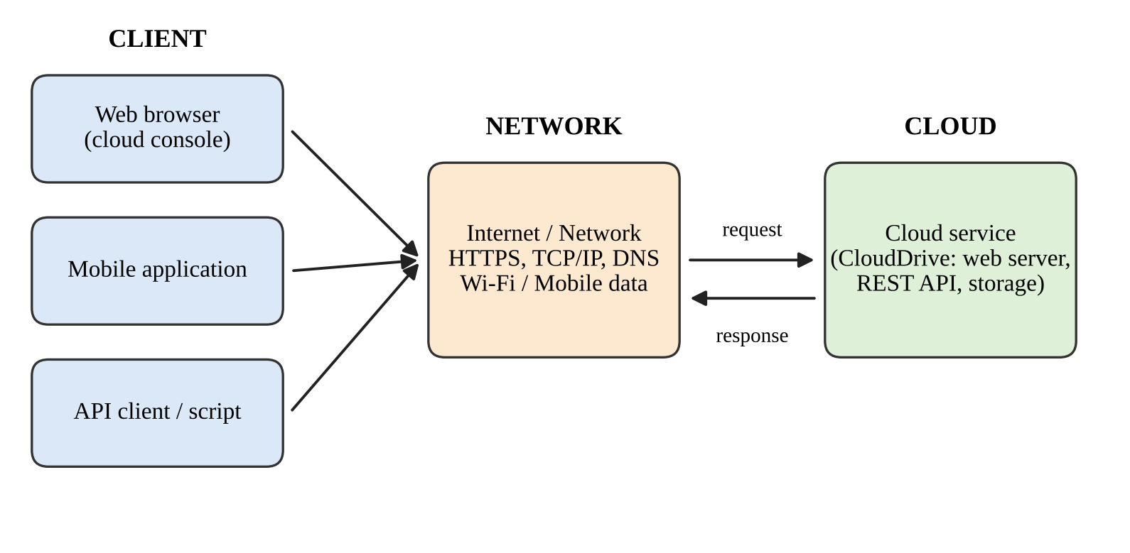
Figure 1: Client–Network–Cloud architecture showing three access methods

How a user accesses the selected service
- The user opens a client (browser, mobile app or script) and enters the service address or opens the installed app.
- The domain name is resolved by DNS and a secure HTTPS connection is established with the cloud service.
- The user authenticates with a username and password, a token or an API key.
- The cloud service checks permissions and returns the requested file list, page or data.
- The client displays the result, or the program processes the returned data.
Table 5: Hardware and software requirements
Access method | Hardware | Software | Network
Browser | PC, laptop or tablet | Modern web browser | Broadband or Wi-Fi
Mobile application | Smartphone | Provider’s app, mobile operating system | Wi-Fi or mobile data
API / script | Any computer | Python or another language, HTTP library, API key | Internet connection

Role of the client: it creates requests, presents the interface, stores credentials or tokens temporarily and displays results. Role of the network: it carries requests and responses between client and cloud, and its bandwidth, latency and reliability decide how responsive the service feels. Secure protocols (HTTPS/TLS) protect the data in transit.
Most suitable method: for the selected file-storage application, the browser-based method is the most suitable for general users because it needs no installation, works on any operating system and always shows the latest version of the files. API access is the best choice when files must be processed automatically, and the mobile app is best for quick access away from a computer.

1.3 Student B – Practical Evidence
A program (Listing 1) starts a local CloudDrive service and then accesses it by three methods: a browser-style request returning an HTML page, a mobile-application request (identified by its user-agent string) and an API request using an API key. Two further tests check a wrong key and the behaviour when the service becomes unreachable.
Listing 1: Python program accessing CloudDrive by three methods (q1_access_methods.py)
"""Q1 - Accessing a cloud service (CloudDrive) through three methods."""
import json, time, threading, urllib.request, urllib.error
from http.server import BaseHTTPRequestHandler, ThreadingHTTPServer

FILES = [{"id": 1, "name": "report.docx", "size_kb": 120},
{"id": 2, "name": "slides.pptx", "size_kb": 860}]
API_KEY = "demo-key-123"

class CloudDrive(BaseHTTPRequestHandler):
def log_message(self, *a): pass
def _send(self, code, ctype, body):
data = body.encode()
self.send_response(code)
self.send_header("Content-Type", ctype)
self.send_header("Content-Length", str(len(data)))
self.end_headers(); self.wfile.write(data)
def do_GET(self):
if self.path == "/": # browser / console access
rows = "".join(f"<li>{f['name']}</li>" for f in FILES)
self._send(200, "text/html", f"<html><body><h1>CloudDrive</h1><ul>{rows}</ul></body></html>")
elif self.path == "/api/v1/files": # mobile app / API access
if self.headers.get("X-API-Key") != API_KEY:
self._send(401, "application/json", json.dumps({"error": "invalid key"}))
else:
self._send(200, "application/json", json.dumps(FILES))
else:
self._send(404, "application/json", json.dumps({"error": "not found"}))

srv = ThreadingHTTPServer(("127.0.0.1", 8081), CloudDrive)
threading.Thread(target=srv.serve_forever, daemon=True).start()

def access(method, url, headers):
t0 = time.perf_counter()
try:
req = urllib.request.Request(url, headers=headers)
with urllib.request.urlopen(req, timeout=2) as r:
body = r.read(); status, ctype = r.status, r.headers["Content-Type"]
except urllib.error.HTTPError as e:
body, status, ctype = e.read(), e.code, e.headers["Content-Type"]
except Exception as e:
ms = (time.perf_counter() - t0) * 1000
print(f"{method:<22}{'FAILED':<8}{type(e).__name__:<24}{ms:>7.1f} ms")
return
ms = (time.perf_counter() - t0) * 1000
print(f"{method:<22}{status:<8}{ctype:<24}{ms:>7.1f} ms {len(body)} bytes")

print(f"{'Access method':<22}{'Status':<8}{'Content-Type':<24}{'Time':>10} Size")
print("-" * 78)
base = "http://127.0.0.1:8081"
access("1. Browser (console)", base + "/", {"User-Agent": "Mozilla/5.0 (Windows NT 10.0)"})
access("2. Mobile application", base + "/api/v1/files",
{"User-Agent": "CloudDriveApp/1.0 (Android 14)", "X-API-Key": API_KEY})
access("3. API / script", base + "/api/v1/files",
{"User-Agent": "python-urllib", "X-API-Key": API_KEY})
print("\nTest: wrong credentials and loss of connectivity")
access("API with wrong key", base + "/api/v1/files", {"X-API-Key": "bad-key"})
srv.shutdown(); srv.server_close() # cloud service goes offline
access("API after outage", base + "/api/v1/files", {"X-API-Key": API_KEY})

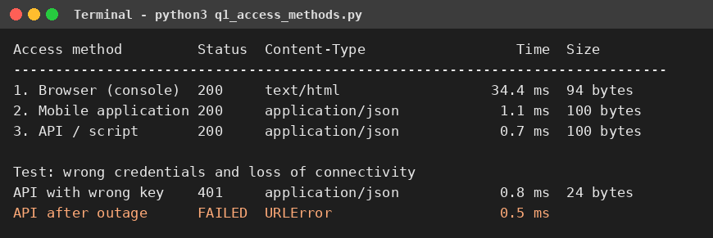
Figure 2: Output of the access-method program
Table 6: Observations from the access test
Test | Result | Observation
Browser (console) | HTTP 200, text/html, 34.4 ms | Returns a complete page for human reading; the first request is slower because the connection is being set up.
Mobile application | HTTP 200, application/json, 1.1 ms | Returns compact data for the app to format; smaller response than a page.
API / script | HTTP 200, application/json, 0.7 ms | Same data as the mobile method; ideal for automation.
Wrong API key | HTTP 401 | Access is refused; authentication is required for every method.
Service unreachable | URLError (no response) | The client cannot reach the cloud, so no data is available.

[ Insert original screenshot 1 here ] | [ Insert original screenshot 2 here ]
Figure 3: Original screenshots of accessing Google Drive through a web browser and through the mobile app. (Student B to attach real screenshots.)
Usability and accessibility: the browser and mobile methods present information for people, whereas the API method presents data for programs; all three methods reached the same file list, which shows that one cloud service can be offered through several interfaces.
Limitation encountered: when the service was made unreachable, the client failed immediately with a connection error and no files could be listed. Effect on cloud usage: because the data is not stored locally, a network or service outage stops the user from working, so important files may need offline copies, and applications should handle connection failures with retries and clear messages.

1.4 Cross-Verification
Student A can explain Student B’s demonstration: the three requests in Listing 1 correspond to the three client types in Figure 1, and the failed request shows the dependence on the network. Student B can explain Student A’s architecture: requests travel from the client across the network to the cloud service and responses return along the same path.

Q2 – CLOUD PLATFORMS AND WEB APPLICATIONS (7 MARKS)

2.1 Shared Group Work
Two cloud platforms were selected: Google Cloud (with Google Workspace) and Microsoft Azure (with Microsoft 365). Both provide infrastructure and platform services for developers and ready-made web applications for end users.
Table 7: Comparison of the two selected cloud platforms
Aspect | Google Cloud / Google Workspace | Microsoft Azure / Microsoft 365
Web applications for users | Gmail, Google Drive, Google Docs, Sheets, Meet | Outlook, OneDrive, Word, Excel and Teams on the web
Compute services | Compute Engine, App Engine, Cloud Run | Virtual Machines, App Service, Azure Functions
Storage services | Cloud Storage, Persistent Disk | Blob Storage, Azure Files
Database services | Cloud SQL, Firestore, BigQuery | Azure SQL Database, Cosmos DB
Identity and access | Cloud IAM, Google account sign-in | Microsoft Entra ID (Azure Active Directory)
Management interface | Google Cloud Console, gcloud CLI, APIs | Azure Portal, Azure CLI, APIs
User interaction | Browser or mobile app over HTTPS | Browser or mobile app over HTTPS

Users interact with these applications through a browser or mobile app; behind the interface, the application servers, storage, databases and identity services of the platform process each request.

2.2 Student A – Platform Analysis
Google Cloud was analysed. Its major components are compute (virtual machines and application platforms), storage (object and block storage), databases, networking (load balancing, virtual private network, DNS), identity and access management, and the management console and APIs. Web applications are supported because the platform hosts the application code on managed servers, scales servers automatically with demand, stores data in durable storage and secures access through identity services.
Table 8: Mapping of a user request to cloud services
Step | User / system action | Cloud component involved
1 | User opens the web application address | DNS and load balancer
2 | Request reaches the application | Web server / App Engine or Cloud Run
3 | User identity is verified | Identity and access management
4 | Application reads or writes data | Cloud Storage or database service
5 | Response is sent back to the browser | Web server and network

Role of the Internet: it connects the user’s device to the cloud data centre. Role of the server/cloud infrastructure: it supplies the compute, storage and network resources, and keeps the service available. Role of the application: it contains the logic that interprets the request, applies rules and produces the response.
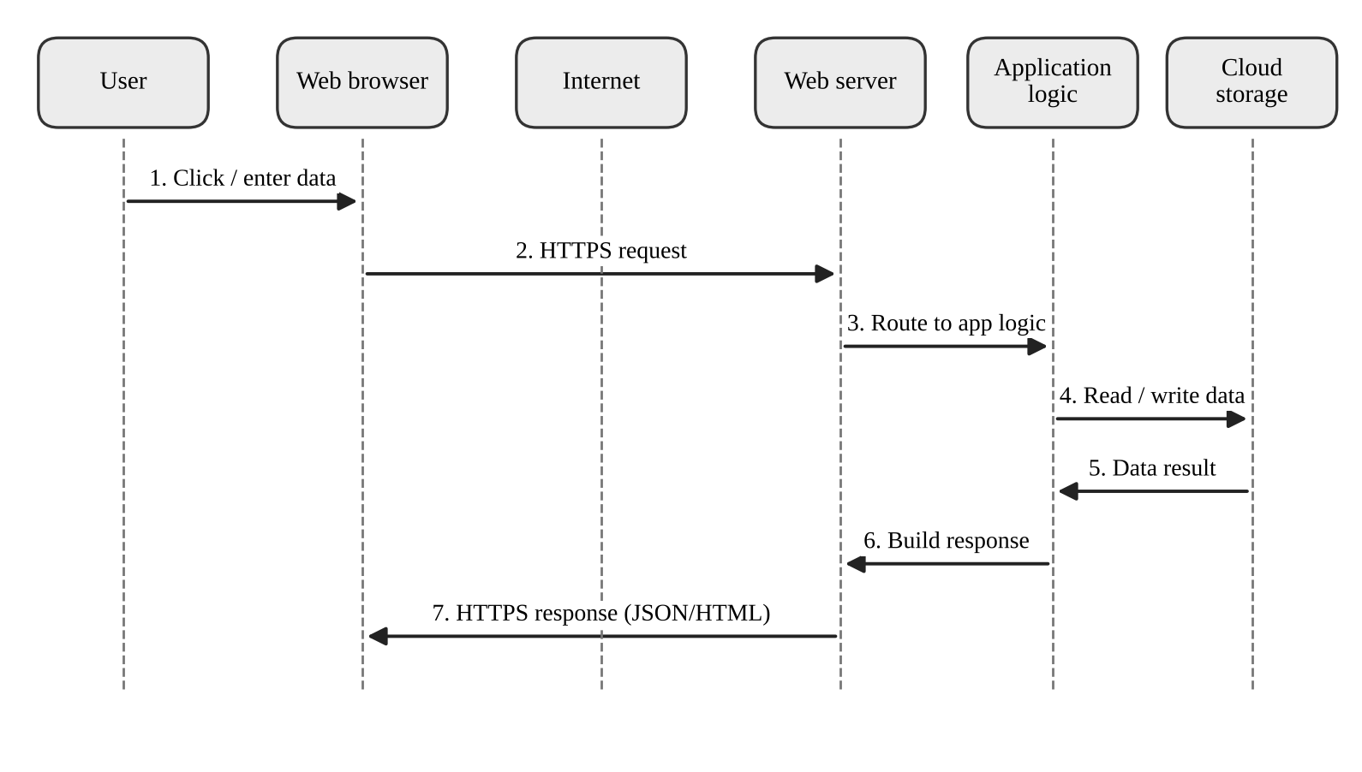
Figure 4: Interaction diagram of a user request to a cloud web application

2.3 Student B – Application Investigation
The real-world cloud application selected is Google Docs, a browser-based word processor. Its major functions are creating a document, editing text, saving automatically, sharing with other people, viewing version history and opening the same document from another device. To demonstrate the same behaviour in a repeatable way, a small cloud web application named CloudNotes was implemented (Listing 2). It records which layers each request passes through and compares the cloud application with a locally installed one.
Listing 2: CloudNotes web application and request-path demonstration (q2_webapp.py)
"""Q2 - Cloud-hosted web application (CloudNotes): request path and cloud vs local."""
import json, threading, urllib.request
from http.server import BaseHTTPRequestHandler, ThreadingHTTPServer

CLOUD_DB = {} # stands in for cloud storage service
TRACE = [] # layers touched by the last request

class CloudNotes(BaseHTTPRequestHandler):
def log_message(self, *a): pass
def reply(self, code, obj):
data = json.dumps(obj).encode()
self.send_response(code); self.send_header("Content-Type", "application/json")
self.send_header("Content-Length", str(len(data))); self.end_headers()
self.wfile.write(data)
def body(self):
return json.loads(self.rfile.read(int(self.headers["Content-Length"])))
def do_GET(self):
TRACE[:] = ["Web server", "App logic", "Storage(read)"]
if self.path == "/app":
TRACE[:] = ["Web server"]
return self.reply(200, {"page": "CloudNotes UI"})
self.reply(200, list(CLOUD_DB.values()))
def do_POST(self):
TRACE[:] = ["Web server", "App logic", "Storage(write)"]
n = self.body(); n["id"] = len(CLOUD_DB) + 1; CLOUD_DB[n["id"]] = n
self.reply(201, n)
def do_PUT(self):
TRACE[:] = ["Web server", "App logic", "Storage(update)"]
nid = int(self.path.rsplit("/", 1)[1]); CLOUD_DB[nid].update(self.body())
self.reply(200, CLOUD_DB[nid])

srv = ThreadingHTTPServer(("127.0.0.1", 8082), CloudNotes)
threading.Thread(target=srv.serve_forever, daemon=True).start()
URL = "http://127.0.0.1:8082"

def call(step, device, action, method, path, data=None):
req = urllib.request.Request(URL + path, method=method,
data=json.dumps(data).encode() if data else None,
headers={"Content-Type": "application/json"})
with urllib.request.urlopen(req) as r:
out = json.loads(r.read())
print(f"Step {step}: [{device}] {action}")
print(f" {method} {path} -> HTTP {r.status}")
print(" Path: Browser > Internet > " + " > ".join(TRACE))
return out

print("=== PART A: user-action sequence on the cloud web application ===")
call(1, "Laptop", "Open application", "GET", "/app")
call(2, "Laptop", "Create note", "POST", "/notes", {"text": "Cloud assignment draft"})
call(3, "Laptop", "Edit note", "PUT", "/notes/1", {"text": "Cloud assignment draft v2"})
notes = call(4, "Phone", "Open notes from another device", "GET", "/notes")
print(" Phone sees:", notes)

print("\n=== PART B: cloud application vs locally installed application ===")
local_store = {"Laptop": [], "Phone": []} # each device has its own data
local_store["Laptop"].append("Cloud assignment draft v2")
print("Local application -> Laptop notes:", local_store["Laptop"])
print("Local application -> Phone notes:", local_store["Phone"], "(data not available)")
print("Cloud application -> Laptop notes:", [n["text"] for n in CLOUD_DB.values()])
print("Cloud application -> Phone notes:", [n["text"] for n in notes])
srv.shutdown()

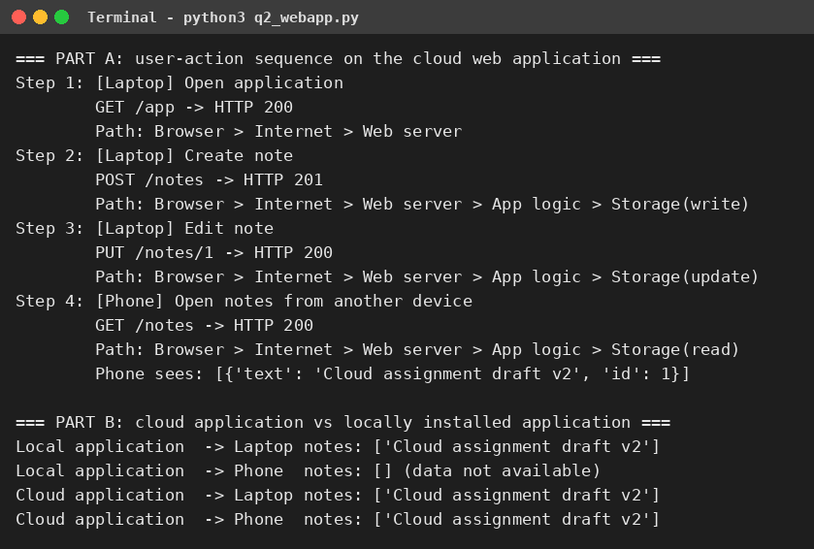
Figure 5: Output of the CloudNotes demonstration
Table 9: Sequence of user actions and where cloud access is involved
Step | User action | Cloud access involved
1 | Open the application on the laptop | Browser requests the page from the web server over the Internet
2 | Create a note | POST request; application logic writes to cloud storage
3 | Edit the note | PUT request; the stored note is updated in the cloud
4 | Open the notes on a phone | GET request; the same data is read from cloud storage

[ Insert original screenshot 1 here ] | [ Insert original screenshot 2 here ] | [ Insert original screenshot 3 here ]
Figure 6: Original screenshots of the Google Docs demonstration (create, edit and share a document, open on another device). (Student B to attach real screenshots.)
Benefits of the cloud-based application: access from any device with a browser, automatic saving, no installation or manual updates, data kept safe in the provider’s data centre, easy sharing and real-time collaboration, and the ability to scale to many users.

2.4 Joint Evaluation
If the same application were installed and operated only on a local computer, what limitations might users experience compared with accessing it through the cloud?
Part B of Listing 2 shows the difference: the local application kept its data on one device, so the phone saw an empty list, whereas the cloud application returned the same note to both devices.
Table 10: Local application compared with cloud application
Aspect | Locally installed application | Cloud-based application
Data availability | Only on the computer where it is stored | Available from any device with Internet access
Installation and updates | Manual installation on each computer | No installation; updated centrally by the provider
Collaboration | Files must be copied and merged manually | Several users work on one shared copy
Backup and reliability | Lost if the computer fails | Replicated in data centres
Scalability | Limited by the computer’s hardware | Resources increase with demand
Offline use | Works without a network | Needs connectivity unless offline mode is provided

Q3 – WEB APIs FOR CLOUD ACCESS (7 MARKS)

3.1 Shared Group Work
A Web API (Application Programming Interface) is a set of rules that lets one program communicate with another over the web. Cloud providers expose their services as REST APIs: a client sends an HTTP request to a URL (endpoint), and the cloud returns an HTTP response, normally with data in JSON format. Because the exchange is standardised, any language or device that can send HTTP requests can use the cloud service without a human interface.
The selected API is the CloudDrive REST API, a file-metadata service that lists files, returns one file and requires a bearer token. It was hosted locally for repeatable testing. A client for a public API (JSONPlaceholder) is also provided in Listing 4 for use when Internet access is available.

3.2 Student A – API Design and Understanding
Purpose of the API: to let applications list and retrieve file information stored in the cloud, and to do so securely using a token, so that any program can use the service automatically.
Table 11: Request components
Component | Example | Purpose
Method | GET | Action requested (GET reads data)
Endpoint (URL path) | /api/v1/files/3 | Identifies the resource
Query parameter | ?owner=saif | Filters the result
Header | Authorization: Bearer abc123 | Carries the credential

Table 12: Response components
Component | Example | Purpose
Status code | 200, 401, 404 | Tells whether the request succeeded
Header | Content-Type: application/json | Describes the data format
Body | {"id": 3, "name": "data.csv", ...} | Carries the requested data or error message

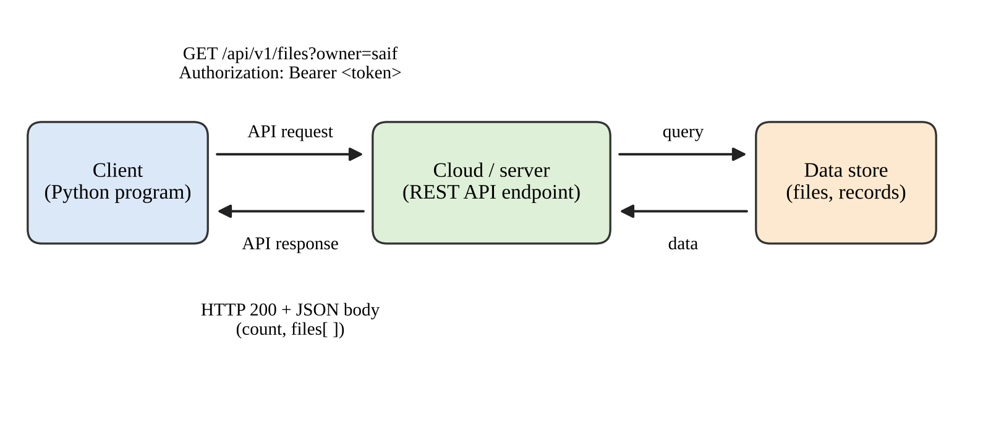
Figure 7: Flow diagram of Web API communication with the cloud
Role of each part: the client is the program that needs data; the API request states what is wanted and proves who is asking; the cloud/server authenticates the request, runs the operation and reads the data store; the API response returns the result or an error code. APIs enable programmatic cloud access because they allow programs, not only people, to create, read, update and delete cloud resources, which makes automation, integration and mobile apps possible.

3.3 Student B – Implementation and Evidence
Listing 3 starts the local API and a Python client. The client sends four requests (two valid inputs and two error tests) and then makes 100 automatic calls to test many clients.
Listing 3: Python REST API server and client (q3_api_client.py)
"""Q3 - Web API for cloud access: REST server (cloud side) + Python client."""
import json, time, threading, urllib.request, urllib.error
from http.server import BaseHTTPRequestHandler, ThreadingHTTPServer
from urllib.parse import urlparse, parse_qs

FILES = [{"id": 1, "name": "report.docx", "owner": "saif", "size_kb": 120},
{"id": 2, "name": "slides.pptx", "owner": "saif", "size_kb": 860},
{"id": 3, "name": "data.csv", "owner": "partner", "size_kb": 45}]
TOKEN = "Bearer abc123"

class API(BaseHTTPRequestHandler):
def log_message(self, *a): pass
def send_json(self, code, obj):
d = json.dumps(obj).encode()
self.send_response(code); self.send_header("Content-Type", "application/json")
self.send_header("Content-Length", str(len(d))); self.end_headers(); self.wfile.write(d)
def do_GET(self):
if self.headers.get("Authorization") != TOKEN:
return self.send_json(401, {"error": "unauthorised"})
u = urlparse(self.path)
if u.path == "/api/v1/files":
owner = parse_qs(u.query).get("owner", [None])[0]
res = [f for f in FILES if owner is None or f["owner"] == owner]
return self.send_json(200, {"count": len(res), "files": res})
if u.path.startswith("/api/v1/files/"):
fid = int(u.path.rsplit("/", 1)[1])
for f in FILES:
if f["id"] == fid: return self.send_json(200, f)
self.send_json(404, {"error": "resource not found"})

srv = ThreadingHTTPServer(("127.0.0.1", 8083), API)
threading.Thread(target=srv.serve_forever, daemon=True).start()

def request(label, path, token=TOKEN):
url = "http://127.0.0.1:8083" + path
print(f"--- {label}")
print(f"REQUEST : GET {path}\n Authorization: {token}")
t0 = time.perf_counter()
try:
with urllib.request.urlopen(urllib.request.Request(url, headers={"Authorization": token})) as r:
status, body = r.status, json.loads(r.read())
except urllib.error.HTTPError as e:
status, body = e.code, json.loads(e.read())
print(f"RESPONSE: HTTP {status} ({(time.perf_counter()-t0)*1000:.1f} ms)")
for line in json.dumps(body, indent=2).splitlines():
print(" " + line)
return status, body

request("Request 1: list files owned by 'saif'", "/api/v1/files?owner=saif")
request("Request 2: get file with id 3", "/api/v1/files/3")
request("Request 3 (error test): missing resource", "/api/v1/files/99")
request("Request 4 (error test): invalid token", "/api/v1/files", token="Bearer wrong")

# Many clients calling the API automatically
def worker(results, i):
results[i] = request_quiet()
def request_quiet():
req = urllib.request.Request("http://127.0.0.1:8083/api/v1/files", headers={"Authorization": TOKEN})
with urllib.request.urlopen(req) as r: return r.status
results = [None] * 100
t0 = time.perf_counter()
ths = [threading.Thread(target=worker, args=(results, i)) for i in range(100)]
[t.start() for t in ths]; [t.join() for t in ths]
print(f"\n100 automatic client calls: {results.count(200)} succeeded "
f"in {(time.perf_counter()-t0)*1000:.0f} ms")
srv.shutdown()

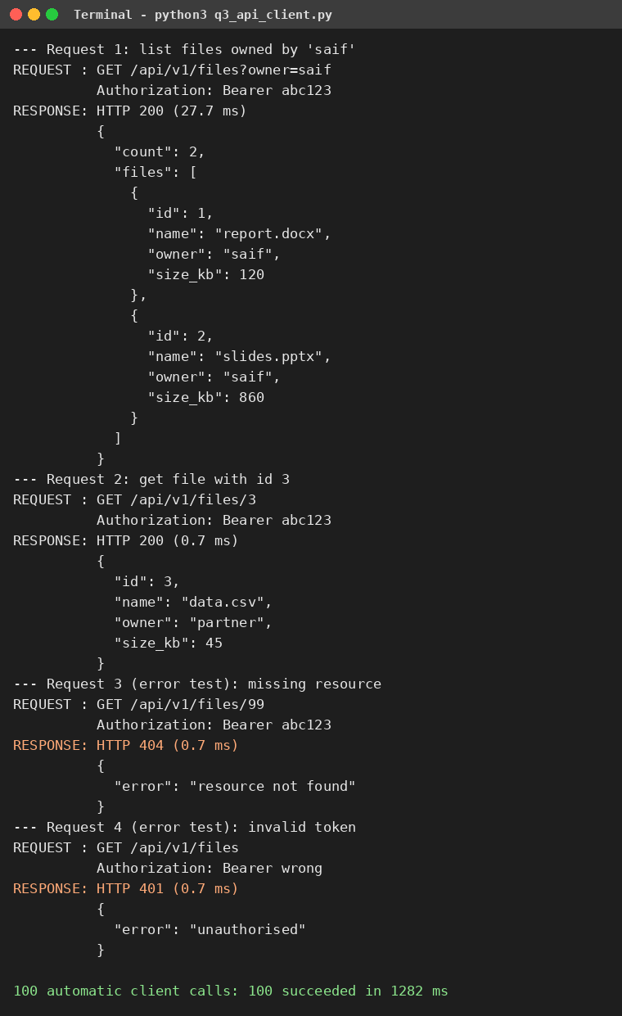
Figure 8: Execution output of the Web API client (requests and responses)
Table 13: Analysis of requests and responses
Request | Input | Response | Analysis
1 | GET /api/v1/files?owner=saif | HTTP 200, count 2 (27.7 ms) | Query filter returned only the two files owned by saif; first call includes connection set-up.
2 | GET /api/v1/files/3 | HTTP 200, data.csv (0.7 ms) | Single resource returned by its identifier.
3 | GET /api/v1/files/99 | HTTP 404 (0.7 ms) | Missing resource produced a clear error instead of a crash.
4 | Wrong token | HTTP 401 (0.7 ms) | Access was refused because authentication failed.
5 | 100 simultaneous calls | 100 succeeded in 1282 ms | The service handled many automatic clients without failure.

The results show that the API returns structured data, uses standard status codes for success and failure, and enforces authentication. The program is short, so an application can use the cloud without any manual steps.
Listing 4: Optional client for a public API (q3_public_api_client.py; to be executed with Internet access)
"""Q3 (optional) - Client for a public web API (JSONPlaceholder test service)."""
import json, urllib.request

BASE = "https://jsonplaceholder.typicode.com"

def get(path):
with urllib.request.urlopen(BASE + path, timeout=10) as r:
return r.status, json.loads(r.read())

for path in ("/posts/1", "/users/2"):
status, body = get(path)
print("GET", path, "->", status)
print(json.dumps(body, indent=2)[:300])

Listing 4 was not executed in the offline environment used to prepare this document; students should run it when connected and attach the original output as additional evidence.

3.4 Joint Analysis
Why is API-based access useful when a large number of users/applications need to communicate with a cloud service automatically?
- Automation: programs call the service without human interaction, as the 100 automatic calls showed.
- Standardisation: one set of HTTP methods, status codes and JSON works with every language and device.
- Scalability: the cloud can add servers behind one endpoint, so thousands of clients use the same API.
- Security and control: each call carries a token, so access, rate limits and usage can be controlled and audited.
- Integration: mobile apps, websites and other services can share the same cloud data and logic.

Q4 – CLOUD SECURITY AND NETWORK ACCESS (7 MARKS)

4.1 Shared Group Work
Cloud services are reached through the Internet, so they are exposed to threats that do not exist for an isolated local program. The group studied the main security issues, the difference between authentication and authorization, secure network communication and the threats that occur during access. A secure scenario was prepared: a student uses a college cloud portal from a public Wi-Fi network to open shared project files.

4.2 Student B – Security Design
Table 14: Security considerations for cloud access
No. | Consideration | Description
1 | Authentication | Verify who the user is, using passwords, multi-factor authentication or tokens.
2 | Authorization | Allow only the actions permitted to the user’s role (least privilege).
3 | Secure communication | Encrypt data in transit using TLS/HTTPS so it cannot be read or altered.
4 | Data protection | Encrypt stored data, take backups and control sharing.
5 | Monitoring and logging | Record access events to detect misuse and support investigation.
6 | Availability protection | Use rate limiting and redundancy against denial-of-service attacks.

Table 15: Authentication compared with authorization
Aspect | Authentication | Authorization
Question answered | Who are you? | What are you allowed to do?
When it occurs | First, at login or token issue | After authentication, on every request
Example | Correct password and valid token | A viewer may read but not delete a file
Failure result | HTTP 401 Unauthorised | HTTP 403 Forbidden

Importance of secure communication: data crosses many networks between the user and the cloud. Without encryption, an attacker on the same Wi-Fi can read passwords and files or change them in transit. TLS provides encryption, integrity and server identity verification through certificates.
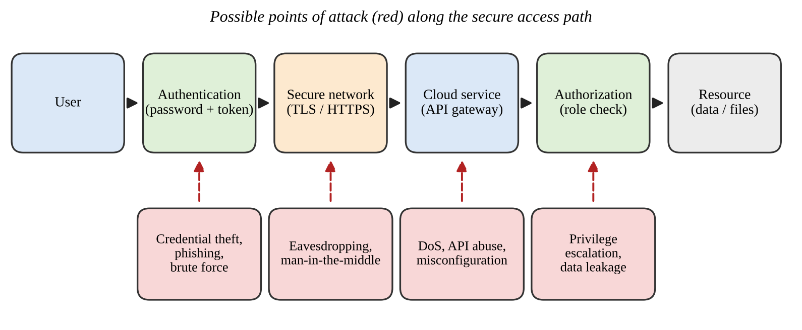
Figure 9: Secure access flow with possible points of attack
Table 16: Threats, points of attack and mitigation
Attack point | Threat | Impact | Mitigation
Authentication | Phishing, stolen or guessed password | Account takeover | Multi-factor authentication, strong password policy, hashed passwords, lockout
Network | Eavesdropping, man-in-the-middle | Data theft or alteration | TLS/HTTPS, certificate validation, avoid public Wi-Fi without VPN
Cloud service | DoS, API abuse, misconfiguration | Service unavailable, exposure | Rate limiting, firewalls, secure configuration, monitoring
Authorization | Privilege escalation, excessive sharing | Data leakage | Role-based access, least privilege, regular permission review

4.3 Student A – Security Investigation
The investigated scenario is token-based authentication with role-based authorization over TLS. Listing 5 demonstrates credential storage, login, a signed token, six authorization tests and a TLS connection with certificate checking.
Listing 5: Security investigation program (q4_security.py)
"""Q4 - Cloud security: password hashing, token authentication, authorization, TLS."""
import hashlib, hmac, base64, json, time, os, ssl, socket, threading, subprocess

SECRET = b"server-side-secret-key"
USERS = {"saif": ("admin", "S@if#2026"), "partner": ("editor", "P@rtner#1"), "guest": ("viewer", "Gu3st!")}
PERMS = {"admin": {"read", "write", "delete"}, "editor": {"read", "write"}, "viewer": {"read"}}

def b64(b): return base64.urlsafe_b64encode(b).rstrip(b"=").decode()
def unb64(s): return base64.urlsafe_b64decode(s + "=" * (-len(s) % 4))

# ---------- A. Credential storage ----------
print("A. CREDENTIAL STORAGE")
pw = USERS["saif"][1]; salt = os.urandom(8)
h = hashlib.pbkdf2_hmac("sha256", pw.encode(), salt, 100_000)
print(" Insecure store (plain text):", pw)
print(" Secure store (PBKDF2-SHA256):", salt.hex() + "$" + h.hex()[:24] + "...")

# ---------- B. Authentication: signed token ----------
def login(user, password):
role, real = USERS.get(user, (None, None))
if real is None or not hmac.compare_digest(real, password): return None
payload = b64(json.dumps({"sub": user, "role": role, "exp": time.time() + 60}).encode())
return payload + "." + b64(hmac.new(SECRET, payload.encode(), hashlib.sha256).digest())

def verify(token):
try:
payload, sig = token.split(".")
good = b64(hmac.new(SECRET, payload.encode(), hashlib.sha256).digest())
if not hmac.compare_digest(sig, good): return None, "invalid signature"
claims = json.loads(unb64(payload))
if claims["exp"] < time.time(): return None, "token expired"
return claims, "ok"
except Exception: return None, "malformed token"

def access(token, action): # authorization check
claims, why = verify(token) if token else (None, "no token")
if claims is None: return f"401 Unauthorised ({why})"
if action not in PERMS[claims["role"]]:
return f"403 Forbidden ({claims['sub']}/{claims['role']} cannot {action})"
return f"200 Allowed ({claims['sub']}/{claims['role']} may {action})"

print("\nB. AUTHENTICATION")
print(" Login saif / wrong password :", login("saif", "wrong"))
tok = login("saif", "S@if#2026"); print(" Login saif / correct password: token issued (%d chars)" % len(tok))

print("\nC. AUTHORIZATION TESTS (request, outcome)")
guest = login("guest", "Gu3st!"); partner = login("partner", "P@rtner#1")
tampered = partner[:-3] + ("AAA" if not partner.endswith("AAA") else "BBB")
payload = b64(json.dumps({"sub": "saif", "role": "viewer", "exp": time.time() - 5}).encode())
expired = payload + "." + b64(hmac.new(SECRET, payload.encode(), hashlib.sha256).digest())
tests = [("admin delete", tok, "delete"), ("editor write ", partner, "write"),
("viewer delete", guest, "delete"), ("no token read ", None, "read"),
("tampered token", tampered, "write"), ("expired token ", expired, "read")]
for name, t, act in tests: print(f" {name} -> {access(t, act)}")

# ---------- D. Secure communication (TLS) ----------
print("\nD. SECURE COMMUNICATION (TLS)")
subprocess.run("openssl req -x509 -newkey rsa:2048 -nodes -keyout k.pem -out c.pem -days 1 "
"-subj /CN=localhost -addext subjectAltName=DNS:localhost",
shell=True, capture_output=True)
sctx = ssl.SSLContext(ssl.PROTOCOL_TLS_SERVER); sctx.load_cert_chain("c.pem", "k.pem")
ls = socket.socket(); ls.bind(("127.0.0.1", 8443)); ls.listen(5)
def serve():
for _ in range(2):
try:
c, _ = ls.accept()
with sctx.wrap_socket(c, server_side=True) as s: s.sendall(s.recv(100)[::-1])
except Exception: pass
threading.Thread(target=serve, daemon=True).start()
try:
with socket.create_connection(("127.0.0.1", 8443)) as raw:
ssl.create_default_context().wrap_socket(raw, server_hostname="localhost")
except ssl.SSLCertVerificationError as e:
print(" Untrusted certificate -> connection refused:", e.verify_message)
cctx = ssl.create_default_context(cafile="c.pem")
with socket.create_connection(("127.0.0.1", 8443)) as raw:
with cctx.wrap_socket(raw, server_hostname="localhost") as s:
print(" Trusted certificate -> connected:", s.version(), "|", s.cipher()[0])
s.sendall(b"secret-data"); print(" Encrypted round trip -> reply:", s.recv(100).decode())
print(" Client verify mode:", cctx.verify_mode.name, "| hostname check:", cctx.check_hostname)

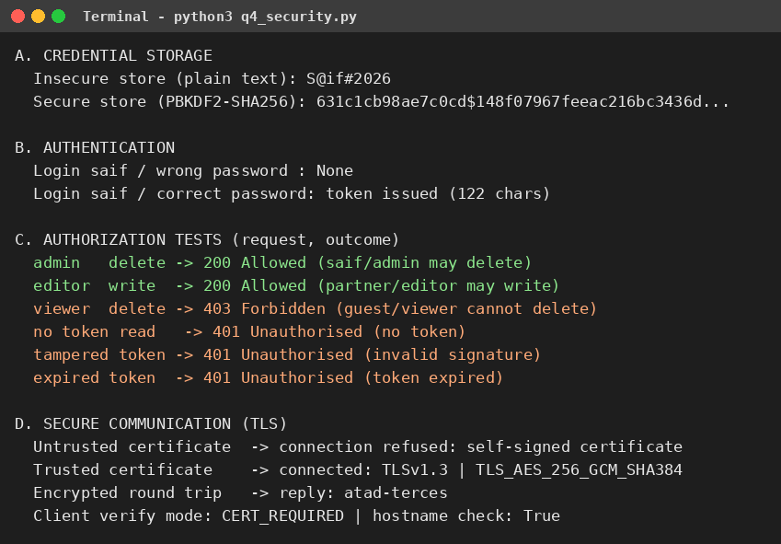
Figure 10: Execution output of the security investigation program
Table 17: Secure and insecure access compared
Situation | Insecure practice | Secure practice (observed)
Password storage | Plain text shown as S@if#2026 | Salted PBKDF2 hash; original password cannot be read
Login | Any password accepted | Wrong password returned no token
Token handling | Unsigned or never expiring | Signed token; tampered token rejected (401) and expired token rejected (401)
Permissions | Everyone can delete | Viewer delete refused (403); admin delete allowed (200)
Network | Plain HTTP, no certificate check | TLS 1.3; untrusted self-signed certificate refused, trusted certificate accepted

Observations: a user who was authenticated but lacked permission received 403, showing that authentication and authorization are separate checks; tampering with the token was detected through the signature; and the TLS client refused an untrusted certificate. Effect of poor security practices: weak passwords, unencrypted connections or excessive permissions can lead to stolen accounts, leaked or altered data, loss of privacy, financial loss and loss of trust in the cloud service.

4.4 Joint Evaluation
If cloud access is available from anywhere through the Internet, what additional security measures are necessary compared with a local application?
- Strong authentication, preferably multi-factor, because anyone on the Internet can attempt to log in.
- Encryption of all traffic with TLS and validation of certificates.
- Fine-grained role-based authorization and least-privilege sharing.
- Encryption of stored data and secure key management.
- Rate limiting, firewalls and DoS protection for public endpoints.
- Logging, monitoring and alerts for unusual access.
- Backups, patching and secure configuration, because misconfiguration is a common cause of exposure.

Q5 – COLLABORATION USING CLOUD-BASED SERVICES (6 MARKS)

5.1 Shared Group Work
The collaboration service selected is Google Docs with Google Drive. A shared document titled “CO3 Project Report” was created, sharing permissions were assigned to each participant, collaborative editing was performed and the process was recorded. The same rules (owner, editor, viewer, version history and conflict detection) were reproduced in a program (Listing 6) so that the behaviour can be shown with repeatable output.
Table 18: Sharing permissions configured
Participant | Role | Permitted actions
Student A | Owner | Read, edit, share, change permissions, delete
Student B | Editor | Read and edit; cannot change sharing
Faculty | Viewer | Read only

[ Insert original screenshot here ]
Figure 11: Original screenshot of the share dialog showing the three users and their permission settings. (Attach real screenshot.)

5.2 Student A – Collaboration Design
Collaboration requirements: several authors must edit one report at the same time; the faculty must be able to review it without changing it; changes must be visible immediately; earlier versions must be recoverable; and unauthorised people must not see the document.
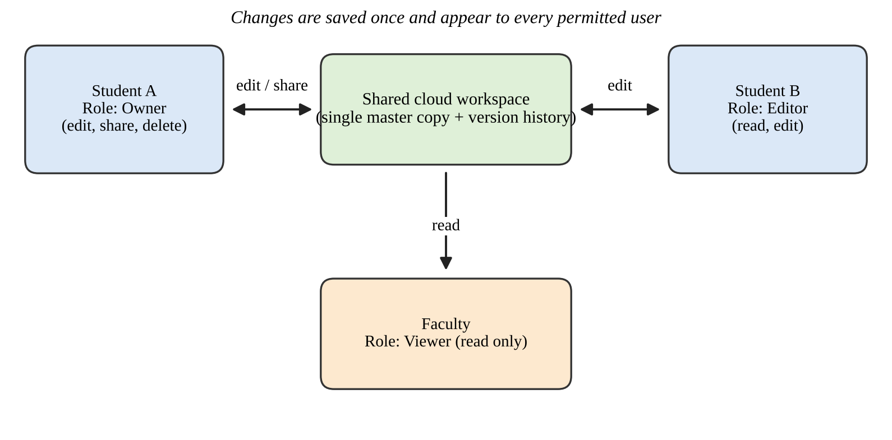
Figure 12: Cloud collaboration workflow with user roles
Table 19: Collaboration concepts
Concept | Explanation | Use in this design
Sharing | The owner grants access to named users or a link | Student B and Faculty were added by name
Concurrent access | Several users open the same document at once | Both students edit sections together
Version control | Every saved change is recorded as a version | History v1 to v5 lists who changed what
Permission management | Roles decide what each user can do | Owner, editor and viewer roles

Justification of permissions: the owner needs full control to manage the document; the second student needs edit rights to contribute; the faculty needs only view access, which protects the work from accidental changes while allowing evaluation. This follows the principle of least privilege.

5.3 Student B – Collaborative Implementation
Listing 6: Shared-workspace simulation with permissions and version history (q5_collaboration.py)
"""Q5 - Cloud collaboration: shared document, permissions, concurrent edits, versions."""
from datetime import datetime

class SharedDoc:
def __init__(self, title, owner, text):
self.title, self.text, self.version = title, text, 1
self.perms = {owner: "owner"}
self.history = [(1, owner, "created document")]
def share(self, by, user, role):
if self.perms.get(by) != "owner": return f"DENIED {by} cannot change sharing"
self.perms[user] = role; return f"OK {user} given '{role}' access"
def revoke(self, by, user):
if self.perms.get(by) != "owner": return "DENIED"
self.perms.pop(user, None); return f"OK access of {user} removed"
def read(self, user):
return self.text if user in self.perms else None
def edit(self, user, base_version, new_text, note):
if self.perms.get(user) not in ("owner", "editor"):
return f"DENIED {user} has '{self.perms.get(user, 'no')}' access - edit refused"
if base_version != self.version:
return f"CONFLICT {user} edited v{base_version} but latest is v{self.version}"
self.text, self.version = new_text, self.version + 1
self.history.append((self.version, user, note))
return f"OK {user} saved -> v{self.version}"

print("=== 1. Create shared workspace and set permissions ===")
doc = SharedDoc("CO3 Project Report", "StudentA", "Title: Cloud Collaboration")
print(doc.share("StudentA", "StudentB", "editor"))
print(doc.share("StudentA", "Faculty", "viewer"))
print(doc.share("StudentB", "Stranger", "editor"))
print("Permissions:", doc.perms)

print("\n=== 2. Collaborative activities ===")
print(doc.edit("StudentA", 1, "Title: Cloud Collaboration\nSection 1: Access methods", "added Section 1"))
print(doc.edit("StudentB", 2, doc.text + "\nSection 2: Security", "added Section 2"))
print("Faculty reads :", len(doc.read("Faculty").splitlines()), "lines (latest version v3)")
print(doc.edit("Faculty", 3, "Faculty overwrite", "attempt"))
print("Stranger reads :", doc.read("Stranger"))

print("\n=== 3. Concurrent editing issue and resolution ===")
a_base = b_base = doc.version # both open the same version
print(doc.edit("StudentA", a_base, doc.text + "\nConclusion (A)", "added conclusion"))
print(doc.edit("StudentB", b_base, doc.text + "\nReferences (B)", "added references"))
print("Resolution: StudentB reloads latest version and re-applies the change")
print(doc.edit("StudentB", doc.version, doc.text + "\nReferences (B)", "added references"))

print("\n=== 4. Revoke access ===")
print(doc.revoke("StudentA", "Faculty"))
print("Faculty reads :", doc.read("Faculty"))

print("\n=== 5. Version history (single shared copy) ===")
for v, who, note in doc.history: print(f" v{v} {who:<9} {note}")
print("\nFinal document:\n" + doc.text)

print("\n=== 6. Same work by e-mailing copies ===")
copies = {"StudentA": doc.text, "StudentB": doc.text}
copies["StudentA"] += "\nConclusion (A)"; copies["StudentB"] += "\nReferences (B)"
print("Copies identical?", copies["StudentA"] == copies["StudentB"],
"-> two diverging files must be merged manually")

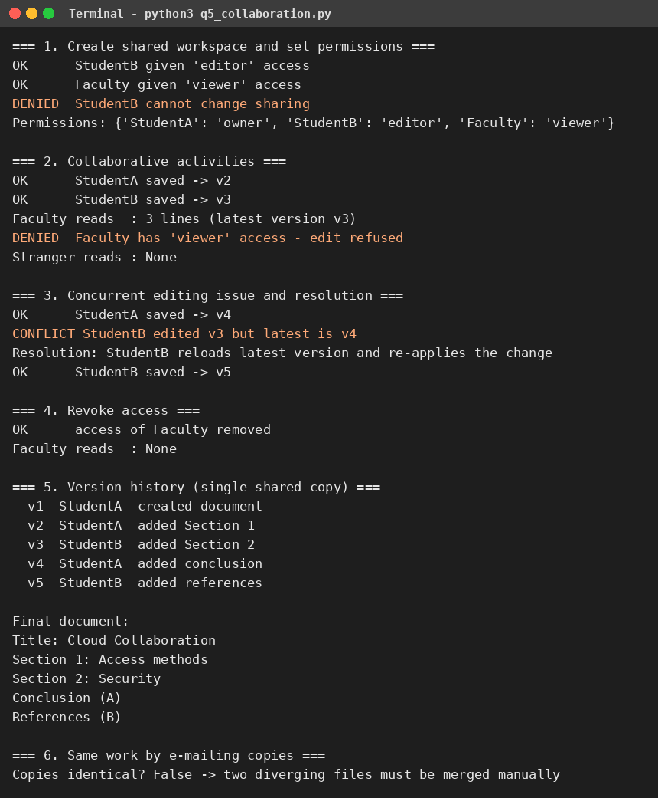
Figure 13: Execution output of the collaboration program
Collaborative activities performed: (1) Student A added Section 1 and Student B added Section 2 to the shared document, creating versions v2 and v3; (2) Student A added a conclusion and Student B added references, creating versions v4 and v5. Each contribution is recorded with the author’s name in the version history.
[ Insert original screenshot here ]
Figure 14: Original screenshot of the shared document being edited by two users at the same time. (Attach real screenshot.)
[ Insert original screenshot here ]
Figure 15: Original screenshot of the version history showing the contributions of each user. (Attach real screenshot.)
Observation of changes: after Student B saved Section 2, the faculty member read three lines, which is the latest version; a viewer’s edit attempt was denied; a stranger without access received nothing; and after access was revoked the faculty member could no longer read the document.
Collaboration issue and solution: when both students edited version v3 at the same time, Student A’s save succeeded (v4) and Student B’s save was reported as a conflict because it was based on an older version. The solution used was for Student B to reload the latest version and re-apply the change (v5). Real services reduce the problem by merging non-overlapping edits automatically and by showing each user’s cursor.

5.4 Cross-Understanding
How does cloud collaboration reduce the need to exchange multiple copies of the same file? (Student B)
In cloud collaboration there is one master copy in the cloud and users receive access to it instead of separate files. Section 6 of the program output shows what happens with e-mailed copies: the two copies diverged and had to be merged manually. With a shared copy, every change is saved once, appears to all permitted users and is recorded in the version history, so there is no confusion about which file is the latest.
What problems can occur if incorrect sharing permissions are given? (Student A)
- Giving edit rights to everyone allows accidental or malicious changes and deletion of content.
- Public or “anyone with the link” sharing can expose private data to unauthorised people.
- Giving viewers the ability to re-share leads to uncontrolled spreading of the document.
- Too few permissions block legitimate users and delay the work.
- Without owner-only control of sharing, a stranger could be invited, as the denied request in Listing 6 shows.

Q6 – INTEGRATED CLOUD ACCESS AND COLLABORATION MINI INVESTIGATION (7 MARKS)
Selected scenario: Cloud-Based Assignment Submission and Evaluation (scenario 4 of the suggested list).

6.1 Student A – System Design
Problem: assignments are often submitted by e-mail or on paper, which causes lost files, unclear deadlines, late-submission disputes and slow, unrecorded evaluation. A cloud portal is needed in which students submit work, faculty review it and both see the result.
Table 20: Users and their needs
User | Needs
Student | Submit assignment before the deadline, view only own submission, see marks and comments
Faculty | View all submissions, record marks and comments, identify late submissions

Table 21: Cloud access methods and services
Item | Choice | Reason
Access methods | Web browser (main), mobile app, REST API | Students use phones and laptops; API allows integration with other systems
Cloud services | Web application hosting, REST API, file storage, database, identity service | Handles submissions, records and login
Network | Internet with HTTPS | Secure access from campus and home
Collaboration | Shared submission records visible to faculty and the owning student | Both sides work on the same cloud data

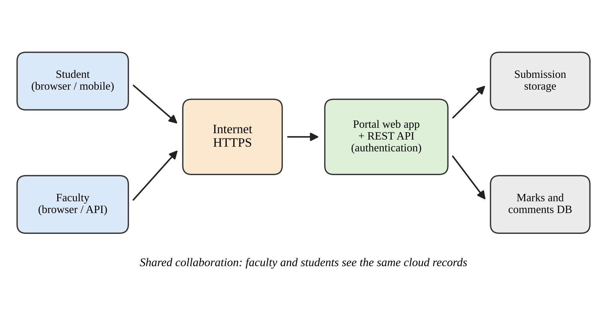
Figure 16: Architecture of the cloud-based assignment submission and evaluation portal
How users access the system: students and faculty log in through a browser or mobile app; each request carries a token, travels over HTTPS to the portal and REST API, and is checked for identity and role. How users collaborate: a student’s submission is stored in the shared cloud database; the faculty member opens it, records marks and comments, and the student sees the result on the same record without any file being sent.

6.2 Student B – Evidence and Evaluation
A working prototype of the portal was implemented (Listing 7). It provides login by token, submission with automatic late detection, role-based viewing and faculty evaluation. Two user scenarios and three access-control checks were executed.
Listing 7: Prototype of the assignment portal with two user scenarios (q6_assignment_portal.py)
"""Q6 - Prototype: cloud-based assignment submission and evaluation portal."""
import json, threading, urllib.request, urllib.error
from datetime import datetime
from http.server import BaseHTTPRequestHandler, ThreadingHTTPServer

TOKENS = {"tok-stu1": ("Student1", "student"), "tok-stu2": ("Student2", "student"),
"tok-fac": ("Faculty", "faculty")}
DEADLINE = datetime(2026, 11, 10)
SUBS = {} # shared cloud database

class Portal(BaseHTTPRequestHandler):
def log_message(self, *a): pass
def out(self, code, obj):
d = json.dumps(obj).encode()
self.send_response(code); self.send_header("Content-Type", "application/json")
self.send_header("Content-Length", str(len(d))); self.end_headers(); self.wfile.write(d)
def user(self): return TOKENS.get(self.headers.get("Authorization", ""))
def do_POST(self):
u = self.user()
if not u: return self.out(401, {"error": "login required"})
data = json.loads(self.rfile.read(int(self.headers["Content-Length"])) or b"{}")
if self.path == "/api/submissions" and u[1] == "student":
sid = len(SUBS) + 1
late = datetime.fromisoformat(data["date"]) > DEADLINE
SUBS[sid] = {"id": sid, "student": u[0], "file": data["file"], "late": late, "marks": None}
return self.out(201, SUBS[sid])
if self.path.endswith("/evaluation") and u[1] == "faculty":
sid = int(self.path.split("/")[3]); SUBS[sid].update(marks=data["marks"], comment=data["comment"])
return self.out(200, SUBS[sid])
self.out(403, {"error": "role not permitted"})
def do_GET(self):
u = self.user()
if not u: return self.out(401, {"error": "login required"})
vis = [s for s in SUBS.values() if u[1] == "faculty" or s["student"] == u[0]]
if self.path == "/api/submissions": return self.out(200, vis)
sid = int(self.path.rsplit("/", 1)[1])
self.out(200 if SUBS[sid] in vis else 403, SUBS[sid] if SUBS[sid] in vis else {"error": "not your submission"})

srv = ThreadingHTTPServer(("127.0.0.1", 8086), Portal)
threading.Thread(target=srv.serve_forever, daemon=True).start()

def summary(b):
if isinstance(b, list): return f"{len(b)} rec: " + ", ".join(f"#{s['id']}({s['student']})" for s in b)
if "error" in b: return b["error"]
return f"#{b['id']} late={b['late']} marks={b['marks']}"

def call(who, method, path, data=None):
tok = {"Student1": "tok-stu1", "Student2": "tok-stu2", "Faculty": "tok-fac", "None": ""}[who]
req = urllib.request.Request("http://127.0.0.1:8086" + path, method=method, headers={
"Authorization": tok, "Content-Type": "application/json"},
data=json.dumps(data).encode() if data is not None else None)
try:
with urllib.request.urlopen(req) as r: code, body = r.status, json.loads(r.read())
except urllib.error.HTTPError as e: code, body = e.code, json.loads(e.read())
print(f" {who:<8} {method:<4} {path:<29} -> {code} {summary(body)}")
return code, body

print("USER SCENARIO 1 - Student submits and tracks result")
call("Student1", "POST", "/api/submissions", {"file": "co3_report.pdf", "date": "2026-11-08"})
call("Student2", "POST", "/api/submissions", {"file": "co3_final.pdf", "date": "2026-11-11"})
call("Student1", "GET", "/api/submissions")
print("\nUSER SCENARIO 2 - Faculty reviews and evaluates")
call("Faculty", "GET", "/api/submissions")
call("Faculty", "POST", "/api/submissions/1/evaluation", {"marks": 46, "comment": "Good"})
call("Student1", "GET", "/api/submissions/1")
print("\nACCESS-CONTROL CHECKS")
call("Student1", "GET", "/api/submissions/2")
call("Student1", "POST", "/api/submissions/1/evaluation", {"marks": 50, "comment": "self"})
call("None", "GET", "/api/submissions")
srv.shutdown()

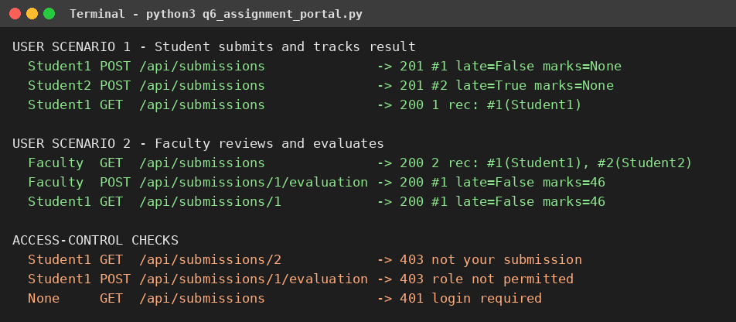
Figure 17: Execution output of the assignment portal prototype
Table 22: User scenarios and test results
Scenario | Steps | Expected result | Observed result | Result
1 – Student | Student1 submits on 8 Nov; Student2 submits on 11 Nov; Student1 lists submissions | Both accepted; second marked late; Student1 sees only own record | 201 created, late=False; 201 created, late=True; 1 record returned | Pass
2 – Faculty | Faculty lists all; adds marks 46 to submission 1; Student1 reads submission 1 | Faculty sees 2 records; marks visible to the student | 2 records; marks=46 shown to Student1 | Pass
Access check | Student1 reads Student2’s work; Student1 evaluates; no login | 403, 403, 401 | 403 not your submission; 403 role not permitted; 401 login required | Pass

[ Insert original screenshot here ]
Figure 18: Original screenshot of the prototype or mock-up screen used in the demonstration (optional). (Attach real screenshot if a user interface is built.)
Analysis of results: access by token worked for both roles, the collaboration mechanism (shared records with different views and rights) worked, late submissions were detected automatically and unauthorised actions were blocked.
- Limitations: data is held in memory and is lost when the program stops; there is no file upload, user interface, password login or notification; the service runs on one computer; and the deadline is fixed in the code.
- Improvements: use a cloud database and object storage, add a web and mobile interface, use institutional single sign-on with multi-factor authentication, send e-mail notifications, keep an audit log, and add resubmission with version history.

6.3 Joint Evaluation
How does combining cloud access and cloud collaboration improve the efficiency of the proposed system?
Cloud access lets students submit from any device and place at any time, and lets faculty review from anywhere, so no one needs to be physically present. Cloud collaboration keeps a single shared record for each submission, so marks and comments appear immediately to the right person and no copies are exchanged. Together they remove manual forwarding, reduce lost or duplicate files, make deadlines and late submissions transparent, shorten the evaluation cycle and keep a verifiable record, which makes the process faster, more reliable and easier to audit.

Q7 – DAY-4 DESIGN CHALLENGE: CLOUD-BASED COLLABORATIVE SOLUTION (10 MARKS)

7.1 Stage 1 – Independent Design Proposals
Each student prepared a proposal before discussing it with the partner. Both original proposals are retained below as evidence.
Table 23: Independent proposals of Student A and Student B
Element | Student A proposal | Student B proposal
Problem definition | Campus events are announced and registered through notice boards and messaging groups, causing missed information and unclear attendance | Urgent campus notices are spread through scattered groups, so some students do not receive them in time
Target users | Event organisers, students, administrator | Administrator, department staff, students
Cloud access method | Web browser and mobile app | Mobile app with push notification, plus web browser
Required cloud services | Web hosting, REST API, database, identity service | Notification service, REST API, database, identity service
Collaboration mechanism | Organisers co-edit a shared event plan; administrator approves | Staff co-edit a draft notice; administrator publishes
Basic architecture | Users → browser/app → Internet → web app and API → database | Staff → app/browser → Internet → notification service and API → students’ devices

7.2 Stage 2 – Design Comparison Record
Table 24: Design comparison record
Aspect | Observation from comparison | Decision
Where the designs agree | Both use browser and mobile access, a REST API, a database, identity login and an approval step by the administrator | Retain as the common core
Where they differ | A focuses on event registration; B focuses on instant notification | Combine into one platform: events plus notices
Strengths and weaknesses | A: clear workflow but no alerts. B: fast alerts but no registration or planning workspace | Add alerts to A’s workflow
Security concerns | Both need protection against unauthorised posting and fake notices | Token login and role-based authorization
Accessibility | Students use phones mainly; some use shared computers | Responsive web application plus mobile access
Collaboration requirements | Several organisers must edit the same plan without overwriting each other | Version check on every edit
Missing components | Capacity limits, duplicate prevention, offline behaviour, load handling | Add and test each of them
Ideas retained | A’s shared plan and registration; B’s approval-before-publish and notification idea | Final design in Stage 3

7.3 Stage 3 – Joint Final Design: CampusConnect
Table 25: Final design of CampusConnect
Design item | Decision
Problem | Campus events are planned, approved, published and registered through disconnected channels
Users | Organisers, students, administrator
Cloud access method | Web browser (main) and mobile app; REST API for integration
Network requirements | Internet connection; HTTPS; retry when the connection fails
Cloud service / platform | Public cloud web hosting with managed database and identity service
Web application / API requirement | Web application for users; REST API with endpoints for events, plan editing, approval and registration
Collaboration mechanism | Shared event plan edited by several organisers with version checking
Authentication / security | Token-based login, role-based authorization, TLS, duplicate and capacity checks
Data / resource sharing | Event plans shared among organisers; approved events visible to students; registrations stored centrally
Complete workflow | Create event → co-edit plan → administrator approves → event is published → students register → organisers see attendance

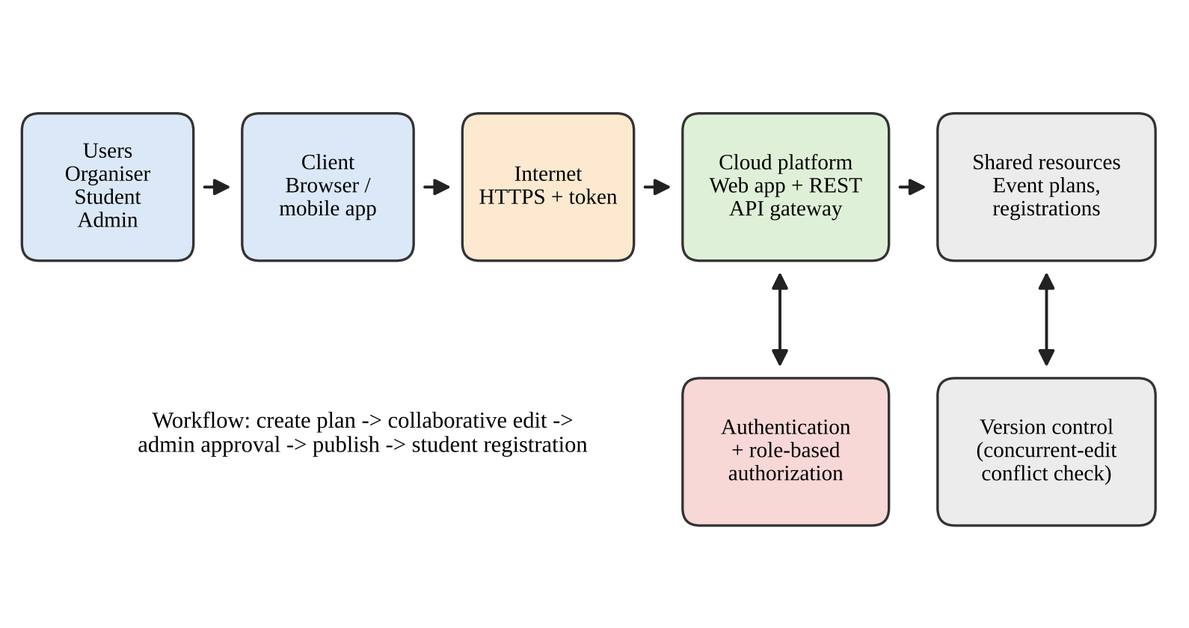
Figure 19: Final architecture of the CampusConnect cloud-based collaborative solution
Architecture: Users → Client → Internet/Network → Cloud Platform → Application/API → Shared Resources, with an authentication and authorization layer and a version-control check protecting the shared resources.

7.4 Stage 4 – Validation

Student A – Technical validation
- Access method: the browser is the main method because students and organisers need no installation and the interface works on any device; the mobile app adds quick access and alerts.
- Platform selection: a public cloud platform provides managed hosting, database and identity services, so the team can concentrate on the application and the service scales with demand.
- Architecture: requests travel over HTTPS to the API, where the token is verified and the role is checked before the shared event data is read or changed.
- API use: the REST API exposes events, plan editing, approval and registration, so the browser, mobile app and other systems all use the same rules.
- Suitability: the design meets the problem because it centralises information, controls who can create, approve and register, and prevents conflicting edits.

Student B – Experimental validation
Eleven test cases covering different users and access conditions were designed, together with a concurrency test with 200 simultaneous registrations (Listing 8). Expected and observed behaviour were compared.
Listing 8: Validation program for CampusConnect with test cases (q7_validation.py)
"""Q7 - CampusConnect (cloud event coordination): server + experimental validation."""
import json, threading, time, urllib.request, urllib.error
from http.server import BaseHTTPRequestHandler, ThreadingHTTPServer

TOKENS = {"t-org": ("Organiser", "organiser"), "t-adm": ("Admin", "admin"),
"t-s1": ("Stu1", "student"), "t-s2": ("Stu2", "student")}
EVENTS, LOCK, CAPACITY = {}, threading.Lock(), 120

class App(BaseHTTPRequestHandler):
def log_message(self, *a): pass
def out(self, code, obj):
d = json.dumps(obj).encode(); self.send_response(code)
self.send_header("Content-Length", str(len(d))); self.end_headers(); self.wfile.write(d)
def handle_req(self, method):
user = TOKENS.get(self.headers.get("Authorization", ""))
n = int(self.headers.get("Content-Length", 0)); data = json.loads(self.rfile.read(n) or b"{}")
if not user: return self.out(401, {"error": "login required"})
name, role = user; p = self.path.strip("/").split("/")
with LOCK:
if method == "POST" and p == ["events"]: # create event plan
if role != "organiser": return self.out(403, {})
eid = len(EVENTS) + 1
EVENTS[eid] = {"id": eid, "title": data["title"], "plan": "", "ver": 1,
"approved": False, "regs": []}
return self.out(201, EVENTS[eid])
ev = EVENTS.get(int(p[1])) if len(p) > 1 else None
if ev is None: return self.out(404, {})
if method == "PUT" and p[2] == "plan": # collaborative edit
if role != "organiser": return self.out(403, {})
if data["base"] != ev["ver"]: return self.out(409, {"latest": ev["ver"]})
ev["plan"], ev["ver"] = data["text"], ev["ver"] + 1
return self.out(200, {"ver": ev["ver"]})
if method == "POST" and p[2] == "approve":
if role != "admin": return self.out(403, {})
ev["approved"] = True; return self.out(200, {"approved": True})
if method == "POST" and p[2] == "register":
if role != "student": return self.out(403, {})
if not ev["approved"]: return self.out(409, {"error": "not approved"})
if name in ev["regs"]: return self.out(409, {"error": "duplicate"})
if len(ev["regs"]) >= CAPACITY: return self.out(409, {"error": "full"})
ev["regs"].append(name); return self.out(201, {"seat": len(ev["regs"])})
if method == "GET" and len(p) == 2:
return self.out(200 if ev["approved"] or role != "student" else 403, {"title": ev["title"]})
self.out(400, {})
do_GET = lambda s: s.handle_req("GET")
do_POST = lambda s: s.handle_req("POST")
do_PUT = lambda s: s.handle_req("PUT")

ThreadingHTTPServer.request_queue_size = 256 # larger connection backlog
srv = ThreadingHTTPServer(("127.0.0.1", 8087), App)
threading.Thread(target=srv.serve_forever, daemon=True).start()

def call(tok, method, path, data=None, port=8087):
req = urllib.request.Request(f"http://127.0.0.1:{port}{path}", method=method, data=json.dumps(data or {}).encode(),
headers={"Authorization": tok})
try:
with urllib.request.urlopen(req, timeout=1) as r: return r.status
except urllib.error.HTTPError as e: return e.code
except Exception: return "NET-ERR"

cases = [("TC1 Organiser creates event", ("t-org", "POST", "/events", {"title": "TechFest"}), 201),
("TC2 Student creates event", ("t-s1", "POST", "/events", {"title": "X"}), 403),
("TC3 No login reads event", ("", "GET", "/events/1"), 401),
("TC4 Student reads unapproved", ("t-s1", "GET", "/events/1"), 403),
("TC5 Register before approval", ("t-s1", "POST", "/events/1/register"), 409),
("TC6 Admin approves event", ("t-adm", "POST", "/events/1/approve"), 200),
("TC7 Student registers", ("t-s1", "POST", "/events/1/register"), 201),
("TC8 Duplicate registration", ("t-s1", "POST", "/events/1/register"), 409),
("TC9 Organiser edits plan v1", ("t-org", "PUT", "/events/1/plan", {"base": 1, "text": "A"}), 200),
("TC10 Stale concurrent edit", ("t-org", "PUT", "/events/1/plan", {"base": 1, "text": "B"}), 409),
("TC11 Service unreachable", ("t-s2", "GET", "/events/1", None, 9999), "NET-ERR")]
print(f"{'Test case':<31}{'Expected':>9}{'Observed':>10} Result")
print("-" * 60)
passed = 0
for name, args, exp in cases:
got = call(*args); ok = got == exp; passed += ok
print(f"{name:<31}{exp:>9}{got:>10} {'PASS' if ok else 'FAIL'}")
print(f"\nFunctional tests passed: {passed}/{len(cases)}")

print("\nSCALABILITY TEST: 200 students register concurrently (capacity 120)")
for i in range(200): TOKENS[f"t-load{i}"] = (f"Load{i}", "student")
codes = []
def reg(i): codes.append(call(f"t-load{i}", "POST", "/events/1/register"))
t0 = time.perf_counter()
ths = [threading.Thread(target=reg, args=(i,)) for i in range(200)]
[t.start() for t in ths]; [t.join() for t in ths]
print(f"Accepted: {codes.count(201)} | Rejected (full): {codes.count(409)} | "
f"Network errors: {codes.count('NET-ERR')} | Time: {(time.perf_counter()-t0)*1000:.0f} ms")
print("Total registrations stored:", len(EVENTS[1]['regs']), "(never exceeds capacity)")
srv.shutdown()

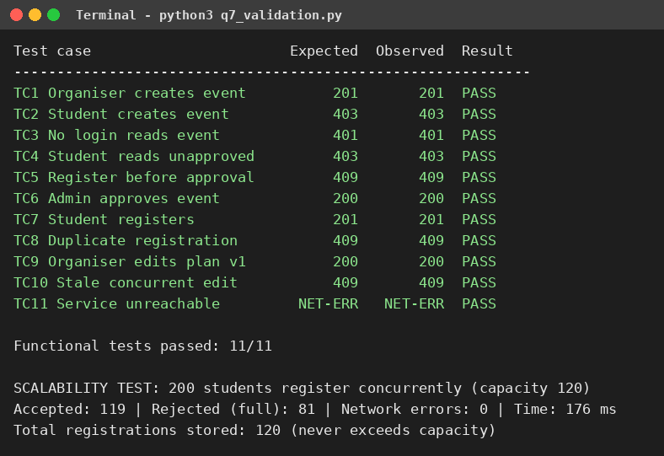
Figure 20: Execution output of the CampusConnect validation program
Table 26: Test cases: expected and observed behaviour
Test case | User / condition | Expected | Observed
TC1 | Organiser creates an event | 201 Created | 201 – pass
TC2 | Student tries to create an event | 403 Forbidden | 403 – pass
TC3 | No login reads an event | 401 Unauthorised | 401 – pass
TC4 | Student reads an unapproved event | 403 Forbidden | 403 – pass
TC5 | Registration before approval | 409 Conflict | 409 – pass
TC6 | Administrator approves the event | 200 OK | 200 – pass
TC7 | Student registers | 201 Created | 201 – pass
TC8 | Same student registers again | 409 Conflict | 409 – pass
TC9 | Organiser edits plan (version 1) | 200 OK | 200 – pass
TC10 | Second edit based on old version | 409 Conflict | 409 – pass
TC11 | Service unreachable | Network error | Network error – pass

All 11 functional tests matched the expected behaviour. In the load test with a capacity of 120 seats, the service accepted 119 further registrations (the 120th seat had been taken in TC7) and rejected 81 as full, and the stored total never exceeded 120. In an earlier trial with the default connection queue, some simultaneous requests failed with network errors; increasing the server’s connection queue to 256 allowed all 200 requests to receive a response. This shows that capacity planning is needed for peak load.
[ Insert original screenshot 1 here ] | [ Insert original screenshot 2 here ]
Figure 21: Original screenshots of the CampusConnect demonstration with different users (optional, if a web interface is built). (Attach real screenshots.)

7.5 Stage 5 – Cross-Defence
What experimental evidence supports the group’s cloud design? (answered by Student A)
The test results show that each design decision works: role checks blocked a student from creating events (403) and an anonymous user from reading (401); approval was enforced before registration (409); duplicate registrations and over-capacity registrations were refused; the version check rejected a stale edit (409), which protects collaborative editing; the client detected an unreachable service; and 200 concurrent users were handled without exceeding capacity.
Why was the selected cloud access and collaboration approach chosen? (answered by Student B)
Browser and mobile access were chosen because the users are students and staff who use different devices and need no installation. The shared event plan with version checking was chosen because several organisers edit the same plan and conflicting changes must be detected. An approval step was added because published information must be trusted. A cloud platform was chosen because it scales for peak registration times and is available from anywhere.

7.6 Stage 6 – Joint Evaluation
Table 27: Joint evaluation of the proposed solution
Criterion | Evaluation
Benefits | One trusted source of event information, automatic registration records, less manual coordination, access from any device
Access-related limitations | Requires Internet connectivity; the unreachable-service test showed that no action is possible offline unless offline queuing is added
Collaboration benefits | Organisers work on one plan with version checking, so edits are not silently overwritten
Security risks | Stolen tokens or passwords, fake notices, excessive permissions; reduced by multi-factor authentication, TLS and role-based authorization
Scalability considerations | Load test handled 200 concurrent users; real events need autoscaling servers, a managed database and queue handling
Possible improvements | Push notifications, offline mode, automatic merge of edits, audit logs, single sign-on, analytics on attendance
Situations where the approach may not be appropriate | Areas with unreliable networks, highly confidential data with legal restrictions on storage location, or very small groups that gain nothing from the added complexity and cost

7.7 Final Question
What characteristics should a system designer consider before selecting cloud-based access and collaboration for a real-world application?
- Users and devices: who will use the system, with which devices and skills.
- Connectivity: availability and quality of the network, and the need for offline use.
- Security and privacy: sensitivity of the data, authentication needs, encryption and legal or regulatory limits on where data may be stored.
- Availability and reliability: acceptable downtime, backup and recovery requirements.
- Scalability and performance: expected number of users, peak loads and response-time needs.
- Collaboration needs: concurrent editing, permissions, version history and conflict handling.
- Integration: availability of APIs for connecting other systems.
- Cost and vendor dependence: pricing model, long-term cost and the difficulty of moving to another provider.
- Maintenance and support: who administers the system and updates it.

EVIDENCE SUMMARY
Table 28: Evidence summary
Task | Evidence included in this document | To be attached by the students
Q1 | Architecture diagram, access program, executed output, observations | Screenshots of Google Drive access by browser and mobile app
Q2 | Platform comparison, interaction diagram, web application program and output | Screenshots of the Google Docs demonstration
Q3 | API flow, program, four requests and responses, analysis | Optional output of the public API client
Q4 | Secure-access flow, threat table, security program and output | None
Q5 | Roles, workflow, program and output | Screenshots of sharing settings, two-user editing and version history
Q6 | Scenario, architecture, prototype program, two user scenarios and results | Optional screenshot of a mock-up
Q7 | Two proposals, comparison, final design, test cases and output | Replace Stage 1 with the students’ own original proposals if different; optional screenshots

CONTRIBUTION RECORD
Each pair includes the following table at the end of the submission. It reflects the work completed by each student.
Table 29: Contribution record
Question | Student A – Primary contribution | Student B – Primary contribution | Joint work
Q1 | Access methods, architecture diagram, requirements, justification | Practical access program, screenshots, observations, limitation | Service selection, cross-verification
Q2 | Platform components, request mapping, interaction diagram | Web application demonstration, user-action sequence, benefits | Platform comparison, local-versus-cloud evaluation
Q3 | API purpose, request/response components, flow diagram | Python implementation, two or more requests, execution evidence, analysis | API selection, analysis of API-based access
Q4 | Security investigation, authentication demonstration, secure and insecure comparison | Security considerations, secure access flow, attack points and measures | Secure scenario, additional measures
Q5 | Collaboration design, workflow, permission justification | Shared workspace activities, contribution evidence, issue and solution | Workspace creation, permission settings, cross-understanding
Q6 | Problem, users, services, architecture, access and collaboration | Prototype, user-scenario tests, results, limitations | Scenario selection, efficiency evaluation
Q7 | Own proposal, technical validation, cross-defence answer | Own proposal, test cases, experimental validation, cross-defence answer | Comparison record, final design, joint evaluation

The contribution record reflects the primary responsibilities assigned in the assignment. Primary contribution does not mean exclusive responsibility, and both students are accountable for the complete assignment.

CONCLUSION
The assignment demonstrated how cloud services are accessed through browsers, mobile applications and APIs; how cloud platforms and web applications use shared infrastructure; how Web APIs allow programs to communicate with the cloud; how authentication, authorization and TLS secure cloud access; and how shared workspaces with permissions and version control support collaboration. The integrated portal and the CampusConnect design combined these ideas, and the executed outputs showed correct behaviour in both normal and failure conditions. The main limitations are dependence on network connectivity and the need for careful security, permission and capacity planning.

REFERENCES
- P. Mell and T. Grance, “The NIST Definition of Cloud Computing,” NIST Special Publication 800-145, 2011.
- R. Fielding, M. Nottingham and J. Reschke, “HTTP Semantics,” RFC 9110, IETF, 2022.
- E. Rescorla, “The Transport Layer Security (TLS) Protocol Version 1.3,” RFC 8446, IETF, 2018.
- M. Jones, J. Bradley and N. Sakimura, “JSON Web Token (JWT),” RFC 7519, IETF, 2015.
- OWASP Foundation, “OWASP API Security Top 10.”
- Python Software Foundation, “Python 3 Standard Library Documentation: http.server, urllib, ssl, hmac.”

