

**Faculty of engineering - Shoubra Benha University**

# Research Article / Research Project / Literature Review

in fulfillment of the requirements of

|  |  |
| --- | --- |
| **Department** | Engineering Mathematics and Physics |
| **Division** | -------------------- |
| **Academic Year** | 2019-2020 Prepartory |
| **Course name** | Computer |
| **Course code** | ECE001 |

**Title: -**

**Internet of Things**

By:

|  |  |  |  |
| --- | --- | --- | --- |
|  | Name | Edu mail | B.N |
| 1 | محمد صلاح محمد يوسف | muhammed195822@feng.bu.edu.eg | 736 |

## Approved by:

|  |  |
| --- | --- |
| Examiners committee | Signature |
| Dr.Ahmed Bayoumi |  |
| Dr.Shady Elmashad |  |
| Dr.Abdelhamid Attaby |  |
|  |  |
|  |  |

Project link : <https://github.com/mohamedsalah01/html-project>

Website link : <https://mohamedsalah01.github.io/html-project/>

# Abstract

Since the coining of the term in 1999, the internet of things (IoT) has transformed from a mere vision to a palpable reality. This can be attributed to the extensive use of the Internet Protocol (IP), the rise of ubiquitous computing, and the continued advancement of data analytics, among other drivers of development. By 2020, it is estimated that there will be [20.4 billion](https://www.gartner.com/newsroom/id/3598917) devices connected to the IoT. Despite its continuing expansion, however, the IoT remains to some degree an obscure concept, something that’s often referred to in abstract terms even as it provides manifest benefits.

# Table of contents

|  |  |
| --- | --- |
| **Subject / section** | **Page** |
| Introduction | 4 |
| Literature Review | 5 |
| Results and discussion | 8 |
| Conclusions | 10 |
|  |  |
|  |  |

**Introduction**

IoT brings the power of the internet, data processing and analytics to the real world of physical objects. For consumers, this means interacting with the global information network without the intermediary of a keyboard and screen; many of their everyday objects and appliances can take instructions from that network with minimal human intervention. The IoT can be described as an extension of the internet and other network connections to different sensors and devices — or “things” — affording even simple objects, such as lightbulbs, locks, and vents,  a higher degree of computing and analytical capabilities. Interoperability is one of the key aspects of the IoT that contribute to its growing popularity. Connected or “smart” devices — as “things” in the IoT are often called — have the ability to gather and share data from their environments with other devices and networks. Through the analysis and processing of the data, devices can perform their functions with little or no need for human interaction.

Given the ever-increasing number of connected devices, the IoT continues its path of evolution, adding different layers to the data that is already being shared and processed, and giving rise to sophisticated algorithms that result in improved levels of automation. And because of the variety of “things” that can be connected to it, the IoT has enabled diverse applications for individual users and entire industries alike.

# Literature Review

In this section I will preview the HTML website created about IOT.

1. IOT page :

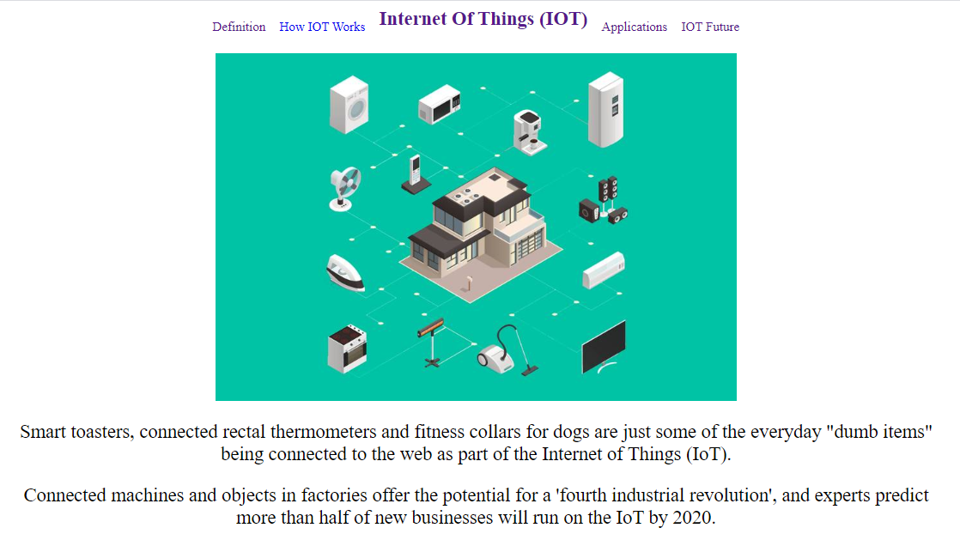

Source code :

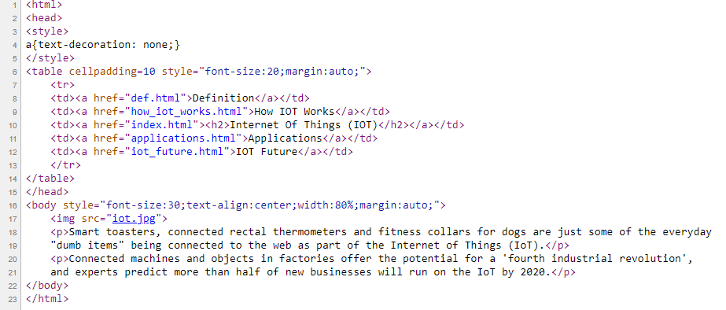

1. Definition page :

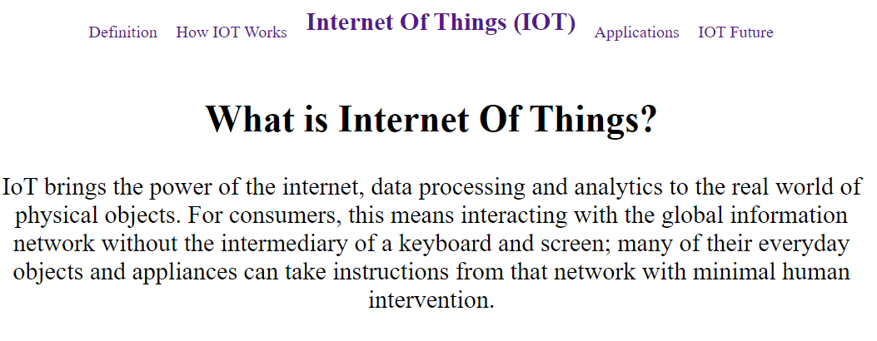

Source code :

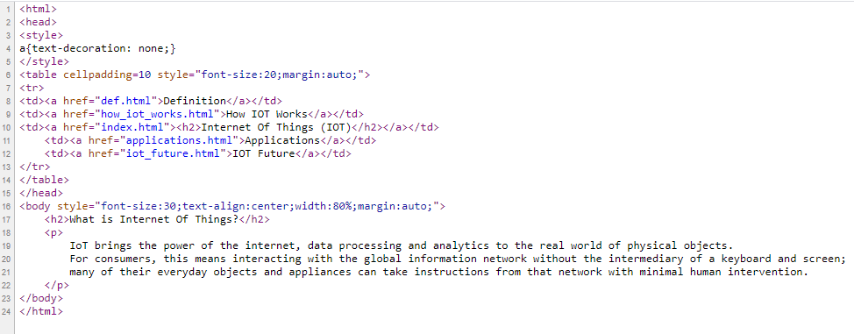

1. IOT Future page :

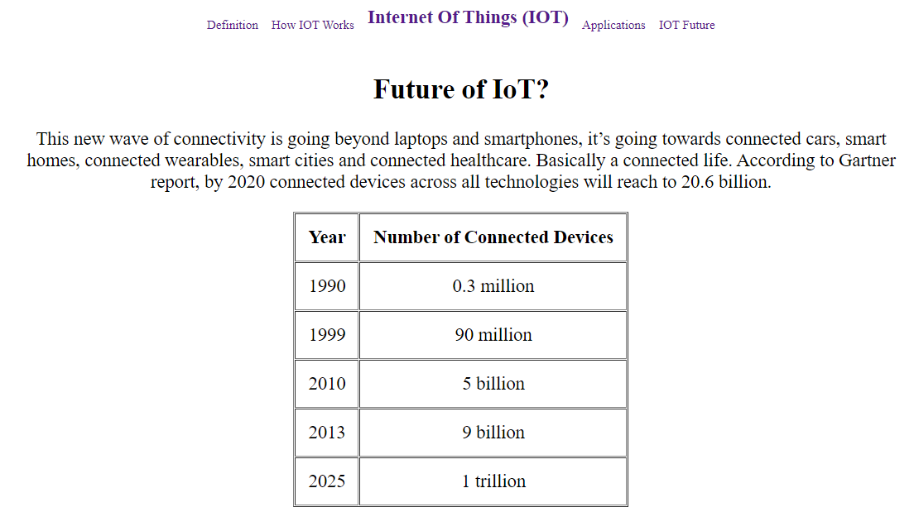

Source code :

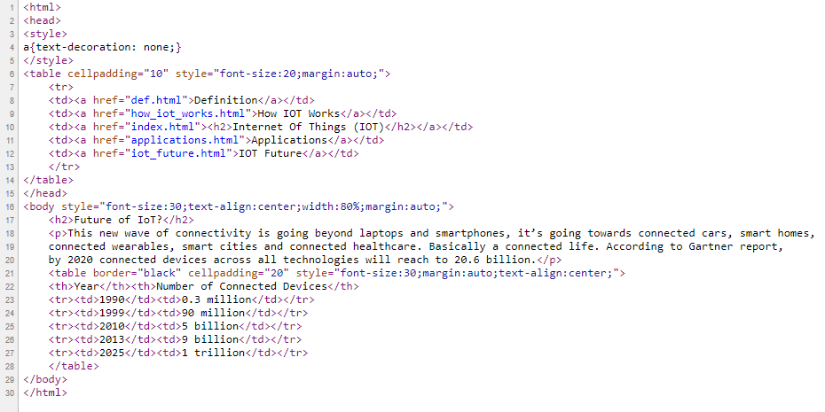

# Results and discussion

Just as the internet at large affects a broad spectrum of users, so does the IoT. Depending on the scale of connectivity and the number of devices involved, the IoT can have significant and specific applications, be they for a single user or for an entire city. Common applications of the IoT include the following.

**People and homes:**

People make direct use of IoT devices through technology that can be worn, such as smartwatches and fitness trackers, and devices that help make receiving and collecting information possible in real time. Applied to households, IoT devices can be used for a more connected, energy-efficient, and conveniently run home. Different aspects of a connected home can also be remotely accessed and controlled by home owners through a computer or a handheld smart device.  
**Automobiles:**

Sensors within a moving vehicle make it possible to collect real-time data about the vehicle and its surroundings. Autonomous vehicles use different sensors in combination with advanced control systems to assess their environments and consequently drive themselves.  
**Factories:**

With the application of IoT in factories, manufacturers can automate repetitive tasks as well as access information on any part of the entire manufacturing process. Information provided by sensors on factory machineries can help in devising ways to make the entire production line more efficient and less accident-prone.

**Businesses:**

On a larger scale, with the adoption of IoT technologies, businesses can be more cost-effective, efficient, and productive. For example, office buildings can be fitted with sensors that can monitor elevator traffic or overall energy consumption. Different industries naturally have different applications of the IoT: In the healthcare industry, IoT devices may be used to gain instant and accurate updates about the condition of patients, while in the retail industry, IoT devices may be deployed to help shoppers locate products and to monitor inventory.  
  
**Cities:**

 The combined uses of different IoT devices can cover urban and public areas. IoT devices can gather data from and affect its environment to help manage the various aspects of city governance, such as traffic control, resource management, and public safety.

# Conclusions

IoT has the potential to dramatically increase the availability of information, and is likely to transform companies and organizations in virtually every industry around the world. The number of different technologies required to support the deployment and further growth of the IoT places a premium on interoperability, and has resulted in widespread efforts to develop standards and technical specifications that support seamless communication between IoT devices and components. Collaboration between various standards development groups and consolidation of some current efforts will eventually result in greater clarity for IoT technology companies.