Network Traffic Analysis Report
Author
Mohamed Samir
Date
2/15/2026
Project Title
Network Traffic Analysis for Potential Security Threat Identification

1) Objective
The objective of this lab is to analyze network traffic in a controlled environment, identify potentially suspicious activities, document packet-level evidence, and provide practical mitigation recommendations.
The analysis focuses on SSH traffic over TCP port 22 between two lab machines.

2) Lab Environment
2.1 Network Setup
- Attacker Machine: Kali Linux
  - IP Address: 192.168.7.128
- Victim Machine: Metasploitable
  - IP Address: 192.168.7.129
- Capture Interface: eth0
- Network Range: 192.168.7.0/24 (lab context)
2.2 Tools Used
- Wireshark for packet capture and protocol analysis
- Linux Terminal (Kali) for generating test traffic (SSH connection)
2.3 Scope and Authorization
This activity was conducted in a controlled and authorized lab environment for educational and defensive cybersecurity analysis purposes.

3) Methodology
- Prepared two virtual machines in the same test network:
  - Kali as attacker simulation host
  - Metasploitable as target host
- Started packet capture on interface eth0 in Wireshark.
- Initiated an SSH connection from Kali to Metasploitable.
- Observed and verified TCP connection establishment (3-way handshake).
- Correlated terminal activity with packet-level evidence.
- Documented findings, indicators, risks, and mitigation actions.

4) Command Execution and Session Evidence
4.1 Executed Command
The following command was used on Kali to initiate SSH access to the victim machine:
ssh -oHostKeyAlgorithms=+ssh-rsa msfadmin@192.168.7.129
4.2 Observed Result
- Successful authentication to Metasploitable.
- Interactive shell session established.
- Terminal indicates remote login from 192.168.7.128.
- User context confirmed with:
pwd
Output showed:
/home/msfadmin
This confirms that remote shell access was successfully established over SSH.

5) Wireshark Traffic Analysis
5.1 Session Identification
Wireshark shows TCP communication between:
- Source: 192.168.7.128:59674
- Destination: 192.168.7.129:22
This mapping is consistent with SSH client-to-server behavior.
5.2 TCP 3-Way Handshake Evidence
The capture includes the full handshake sequence:
- SYN from attacker to victim
192.168.7.128:59674 → 192.168.7.129:22 [SYN]
- SYN, ACK from victim to attacker
192.168.7.129:22 → 192.168.7.128:59674 [SYN, ACK]
- ACK from attacker to victim
192.168.7.128:59674 → 192.168.7.129:22 [ACK]
This confirms successful TCP session establishment before encrypted SSH payload transfer.
5.3 Post-Handshake Traffic
Subsequent packets include SSHv2 Encrypted packet entries, indicating an active encrypted remote shell session.

6) Findings
Finding 1: Successful SSH Remote Access Session
- A full TCP handshake over port 22 was captured.
- SSH encrypted traffic followed handshake completion.
- Terminal confirms user logged in to remote host.
Interpretation:
This behavior is expected in this lab scenario, but similar traffic in production may indicate unauthorized administrative access if the source host is not approved.

7) Indicators of Compromise (IoCs) / Monitoring Indicators
- Source IP: 192.168.7.128
- Destination IP: 192.168.7.129
- Source Port: 59674 (ephemeral client port)
- Destination Port: 22 (SSH)
- Protocol: TCP / SSHv2
- Pattern: Interactive remote shell traffic after successful handshake
Note: In this lab, these are controlled indicators for demonstration. In real networks, context (asset ownership, identity, time, policy) determines whether activity is malicious.

8) Risk Assessment (Production Context)
If this same pattern appears in a real enterprise network without change control or authorization:
- Confidentiality Impact: High
Unauthorized shell access may expose sensitive data.
- Integrity Impact: Medium to High
Attackers may alter configurations or files.
- Availability Impact: Medium
Misuse could disrupt services or support persistence/lateral movement.
- Overall Severity: High (context-dependent)

9) Mitigation Recommendations
- Restrict SSH Access
  - Allow SSH only from trusted admin IP addresses.
  - Enforce firewall ingress/egress rules.
- Harden Authentication
  - Enforce key-based authentication.
  - Disable weak/legacy algorithms where possible.
  - Disable password login if operationally feasible.
- Access Control and Privilege Management
  - Disable direct root SSH login.
  - Apply least privilege to admin users.
- Monitoring and Alerting
  - Collect and centralize SSH authentication logs.
  - Alert on unusual source IPs, odd login times, and repeated failures/successes.
- Network Segmentation
  - Separate management interfaces from user/application segments.
  - Limit lateral movement paths.
- System Hardening and Patch Management
  - Keep systems updated.
  - Remove unnecessary exposed services.

10) Conclusion
This lab successfully demonstrated packet-level verification of an SSH remote session between 192.168.7.128 and 192.168.7.129.
Evidence from Wireshark (SYN, SYN-ACK, ACK + SSH encrypted packets) matched terminal proof of login activity, validating the analysis workflow.
While expected in this authorized simulation, the same traffic pattern in production environments must be continuously monitored and correlated with policy, identity, and asset criticality to detect unauthorized access.

11) Figures
- Figure 1: Wireshark overview showing traffic between lab hosts.
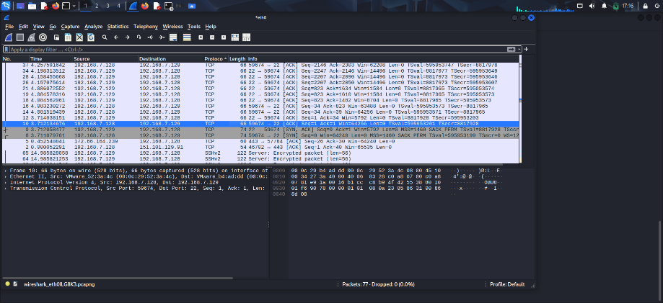
Figure 2: Terminal screenshot showing successful SSH login to Metasploitable.
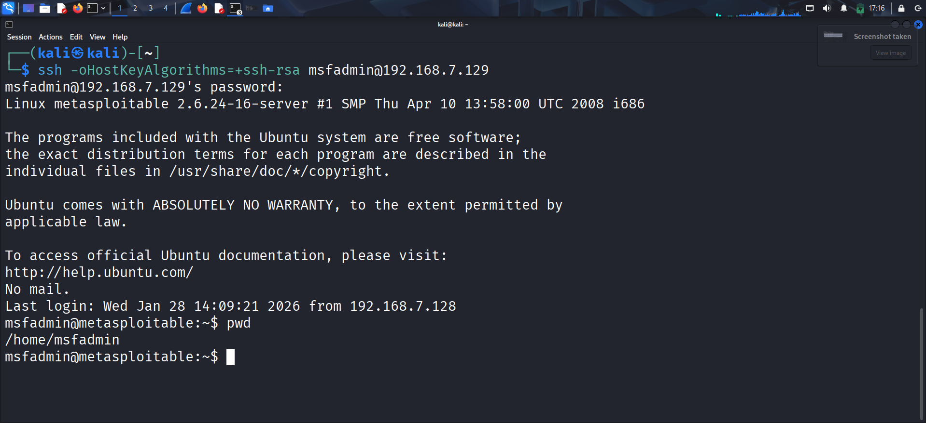
- Figure 3: TCP 3-way handshake (SYN / SYN-ACK / ACK) for SSH connection on port 22.

12) Appendix
12.1 Useful Wireshark Display Filters
ip.addr == 192.168.7.129 && tcp.port == 22
tcp.flags.syn == 1 && tcp.port == 22
ip.src == 192.168.7.128 && ip.dst == 192.168.7.129 && tcp.port == 22
12.2 Main Command Used
ssh -oHostKeyAlgorithms=+ssh-rsa msfadmin@192.168.7.129

