**Pattern Recognition**

**Assignment 3**

Nada Hazem Fahmy 3331

Mohamed Samy Aly 3311

Seif Eldin Samer Abdelwahab 3165

|  |  |  |  |  |  |
| --- | --- | --- | --- | --- | --- |
| ***accuracy*** | ***patience*** | ***Drop out*** | ***Batch size*** | ***epochs*** |  |
| 57.22% | 50 | 0.75 | 1024 | 200 | ***CNN*** |
| 64.93% | 50 | 0.5 | 1024 | 1000 | ***CNN2*** |
| 60% | 50 | 0.7 | 1024 | 1000 | ***CNN3*** |

***For CNN 2:***

Stopped after 190 epochs.

***For CNN 3:***

Stopped after 183 epochs.

**CNN 4:**

**Differentiated data:**

***Epochs = 1000***

***Patience = 100***

***Drop out = 0.7***

***Accuracy = 55.37 %*** *stopped after* ***326 epochs***

**CNN 5:**

**Integrated data:**

***Epochs = 1000***

***Patience = 50***

***Drop out = 0.5***

***Accuracy = 61.87 %***

|  |  |  |  |  |  |  |
| --- | --- | --- | --- | --- | --- | --- |
| **accuracy** | **Drop out** | **delta** | **Patience** | **Batch size** | **Epochs** |  |
| 60.31% | 0 | 0 | 50 | 1024 | 150 | **DNN 1** |
| 62.25% | 0.5 | - | - | - | - | **DNN 2** |
| 27.27% | 0.5 | - | - | - | 300 | **DNN 3** |
| 23.08% | 0.5 | - | - | - | 300 | **DNN 4** |
| 23.16% | 0.5 | - | - | - | 300 | **DNN 5** |

***DNN 1 data :*** *Combinations -> original and differentiated data*

***DNN 2 data*** *: Combinations -> original and differentiated data*

***DNN 3 data*** *: Combinations -> original and integrated data*

***DNN 4 data*** *: Combinations -> differentiated and integrated*

***DNN 5 data*** *: Combinations -> differentiated and integrated*

***For the DNN on original data we tried several combinations of hidden layers , using multiples of 5, multiples of 2 and both multiples of 5 and 2 and we found out that the best accuracy was obtained at 3 hidden layers of 128, 64 and 32 with overall accuracy***  59.43%

***Fully connected DNN(Original data)***

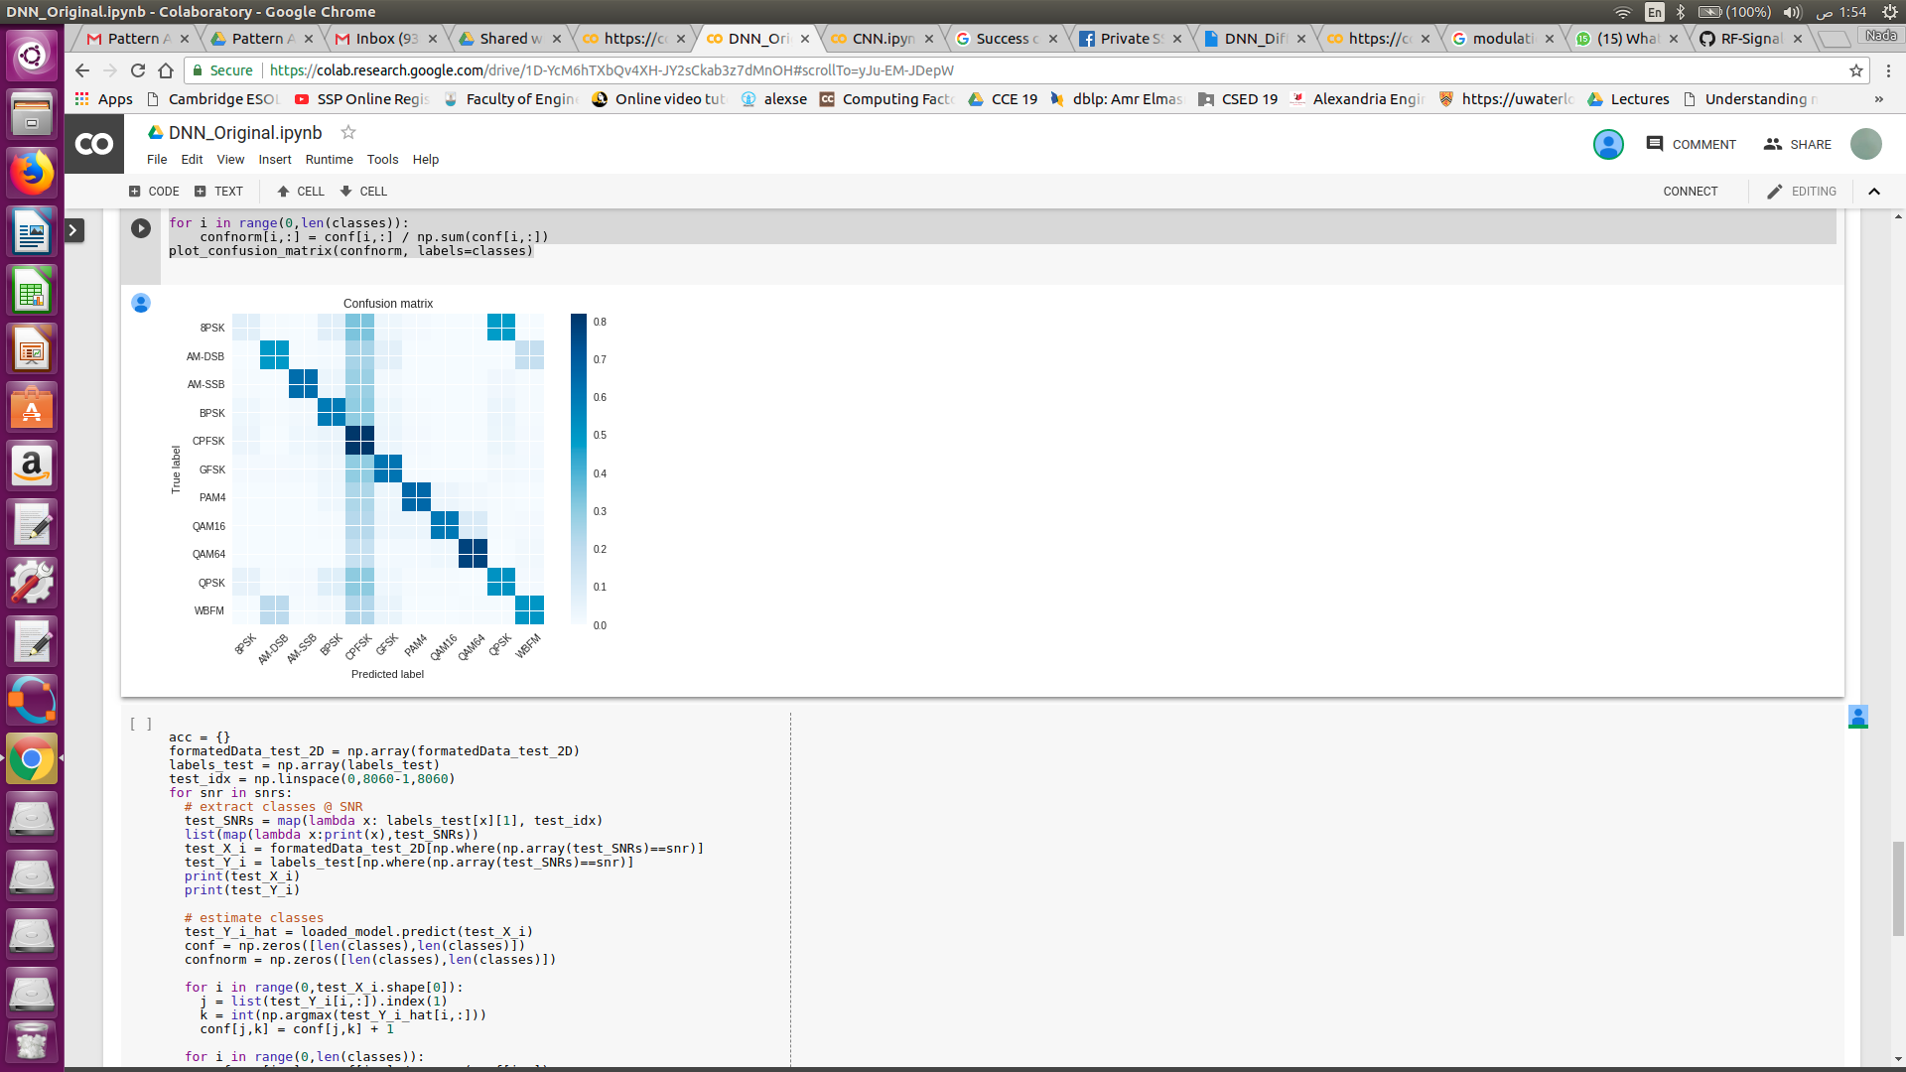

***confusing class is 8PSK***

Accuracy at SNR zero equals=0.7692307692307693

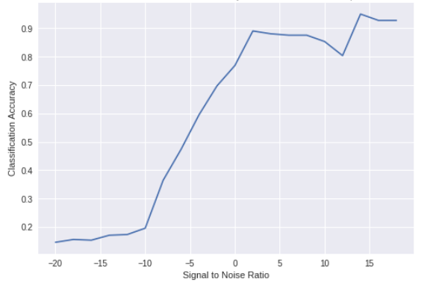

***Fully connected DNN(Original & differentiated data)***

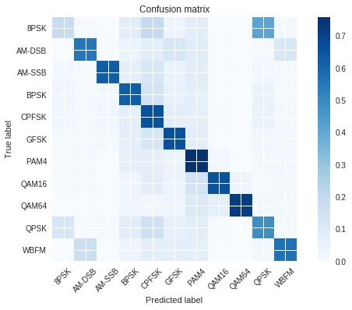

***:confusing class is also 8PSK inCNN***

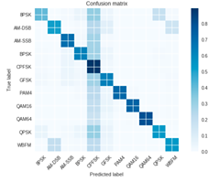

Accuracy at SNR zero = 0.8362282878411911

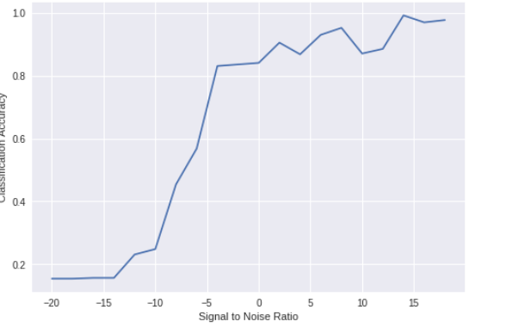

**Combined CNN:**

***CNN 1 : Original and differentiated data***

***Accuracy : 63.65 %***

***CNN 2: Original and Integrated data***

***Accuracy : 61.13 %***