**Networks Project**

**Reliable Data Transfer Protocols**

**Seif Eldin Samer - 3165**

**Mohamed Samy Aly - 3311**

**Report content:**

1- Introduction to the code

2- How to test

3- Testing Stop and Wait

4- Testing Selective Repeat

**1- Introduction to the code**

-The code is composed of 2 main Classes : Server and Client

**a- Server:**

The Server is run first to wait for any request from Clients.

The Server runs a new Thread for each running Client.

**b- Client:**

The Client is run after the server, many Clients could be run at the same time by the user.

**c- Server Thread:**

The Server Thread runs, for each Client calls, one of the implemented Protocols: Stop and wait or Selective repeat.

**d- Main:**

The Main class contains all variables to be changed like:

Window size, chunk size

**e- readFile:**

readFile is the class responsible for:

- reading file

- transforming data into packets

- calculating checksum

**f- Probability:**

This class calculates an array of size : ***sizeOfPackets*** + ***probabilityOfLoss***\****sizeOfPackets***

For example if I have 10 packets and 20% loss, it will create an array of 2 zeros and the rest are ones

The zeros should be placed in the first 10 places of the array and shuffled and the rest is ones.

[1,0,1,1,1,0,1,1,1,1,1,1]

Before Server sends, it checks first if the current index of this corruption array is 0 or 1 , if 1 : it will be sent

Else : dropped.

**g- Packet:**

The Packet class contains many fields :

-Data of packet

-Sequence number of packet

**2- How to test?**

Main class has final variable window to change ***window*** value,

And final variable ***probabilityPercent*** for the probability of loss in packets

And the ***fileName*** sent by client to server

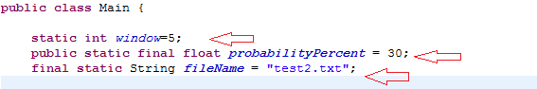

Run the Server first then run the Client.

The received data is printed in a file named "Received.txt".

**How to change the protocol:**

**Client:**

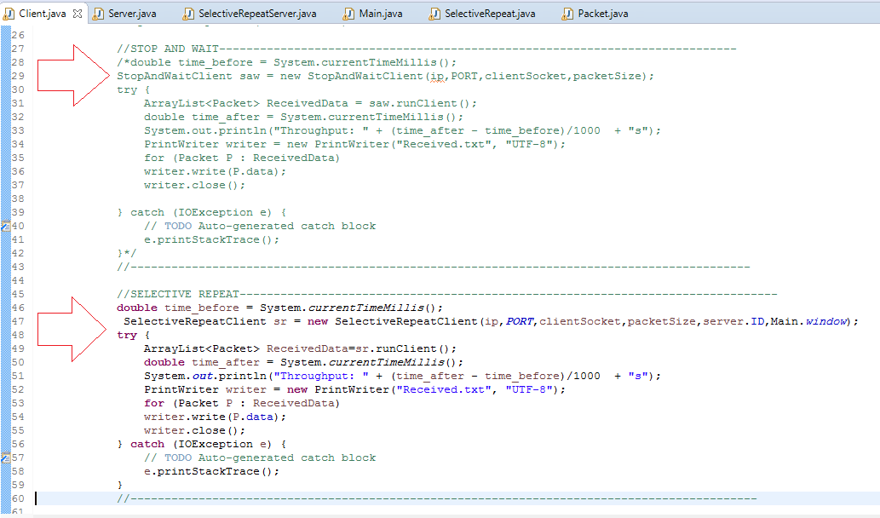

Remove the commented code around the protocol you want to run

Server:

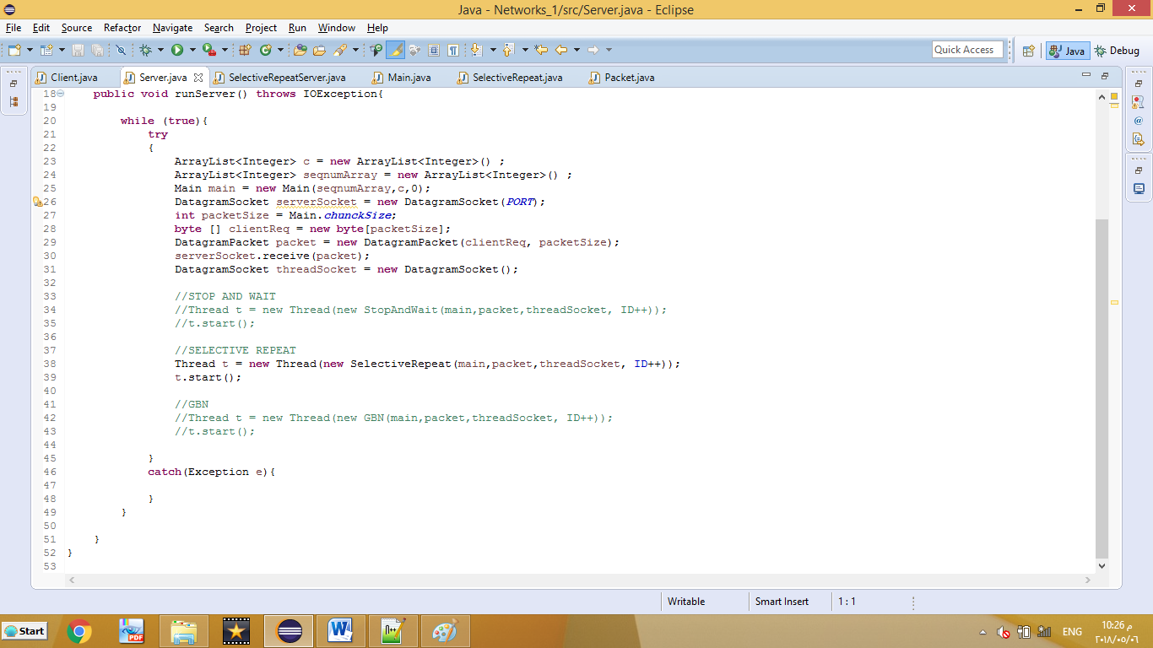

Same in Server