SkyGuard-X
AWS Anomaly Intelligence — Simple User Manual
Smart India Hackathon 2026 · Problem Statement SIH26073 (MoES / IMD) · Prototype v2 · 13 Sep 2026
SkyGuard-X watches Automatic Weather Station (AWS) data — temperature, pressure and humidity — and tells you, for every reading, whether it is normal, a sensor fault, a communication problem or a genuine weather event. For each alert it gives the cause, severity, confidence, a plain-English explanation, a corrected value and the maintenance action to take. This manual explains how to install it, use the website, upload your own data and read the results.

1. What you need
- A laptop with Windows 10/11, macOS or Linux (4 GB RAM is enough).
- Python 3.10 – 3.13 from python.org. On Windows tick “Add Python to PATH” during installation.
- The zip file skyguard_x_prototype_v2_2026-09-13.zip (about 28 MB).
- A web browser (Chrome, Edge or Firefox). No internet is needed after installation.

2. Install and start (5 minutes)
- Unzip the file. You get a folder named skyguard.
- Open a terminal inside that folder (Windows: type cmd in the folder’s address bar and press Enter; macOS: right-click the folder → “New Terminal at Folder”).
- Run the commands below for your system. The first install takes 2–5 minutes.
- When you see “Uvicorn running on http://0.0.0.0:8000”, open http://localhost:8000 in your browser.
Windows (Command Prompt / PowerShell):
python -m venv .venv
.venv\Scripts\activate
pip install -r requirements.txt
python run.py
macOS / Linux:
python3 -m venv .venv
source .venv/bin/activate
pip install -r requirements.txt
python run.py
To stop the server press Ctrl + C in the terminal. Next time you only need to activate the environment and run python run.py again.

3. The website — five tabs
The top-right buttons switch between the five pages. Everything runs on your laptop; nothing is uploaded to the internet.

3.1 Network — the big picture
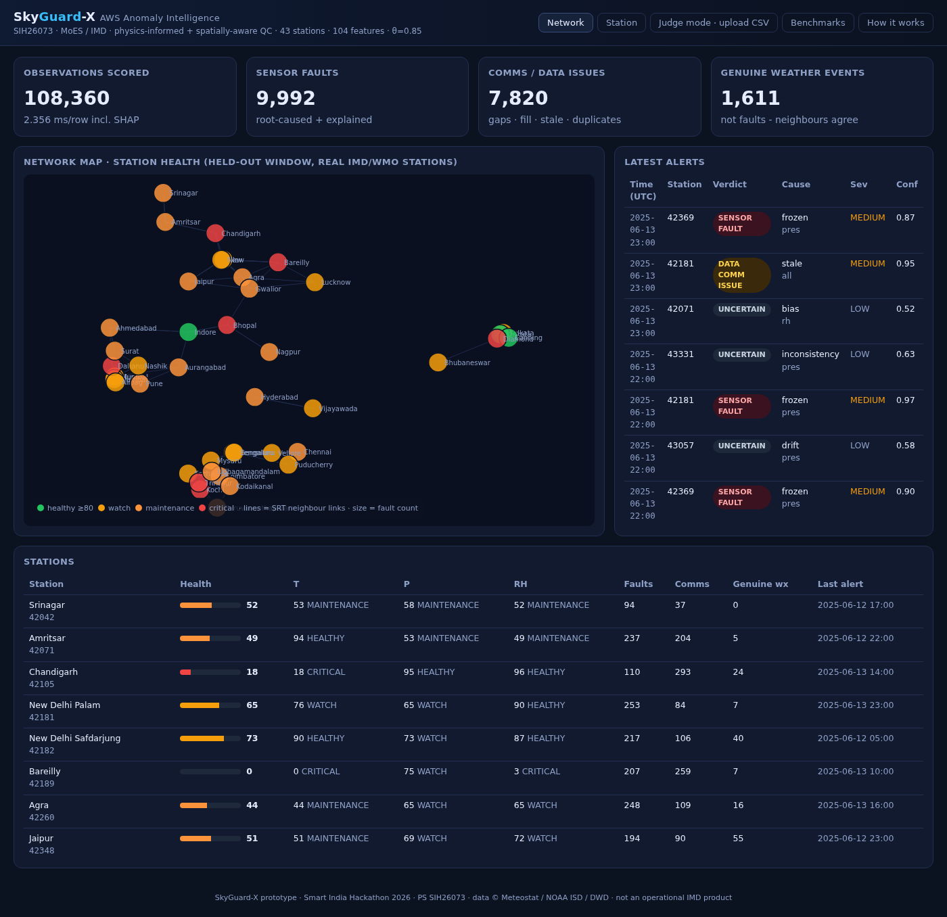
Network tab: KPIs, health map, latest alerts and the station table.
- Four KPI cards: readings scored, sensor faults found, communication/data issues, and genuine weather events (readings that looked strange but neighbours confirmed were real).
- Map: 43 real IMD/WMO stations. Colour = health (green healthy ≥ 80, yellow watch, orange maintenance, red critical). Dot size = number of faults. Lines join each station to the neighbours used for the spatial check. Click a dot to open that station.
- Latest alerts: the most recent problems across the whole network, with cause, severity and confidence.
- Stations table: health 0–100 for the station and for each sensor (T, P, RH), counts of faults, comms issues and genuine weather events, and the time of the last alert.

3.2 Station — replay one station
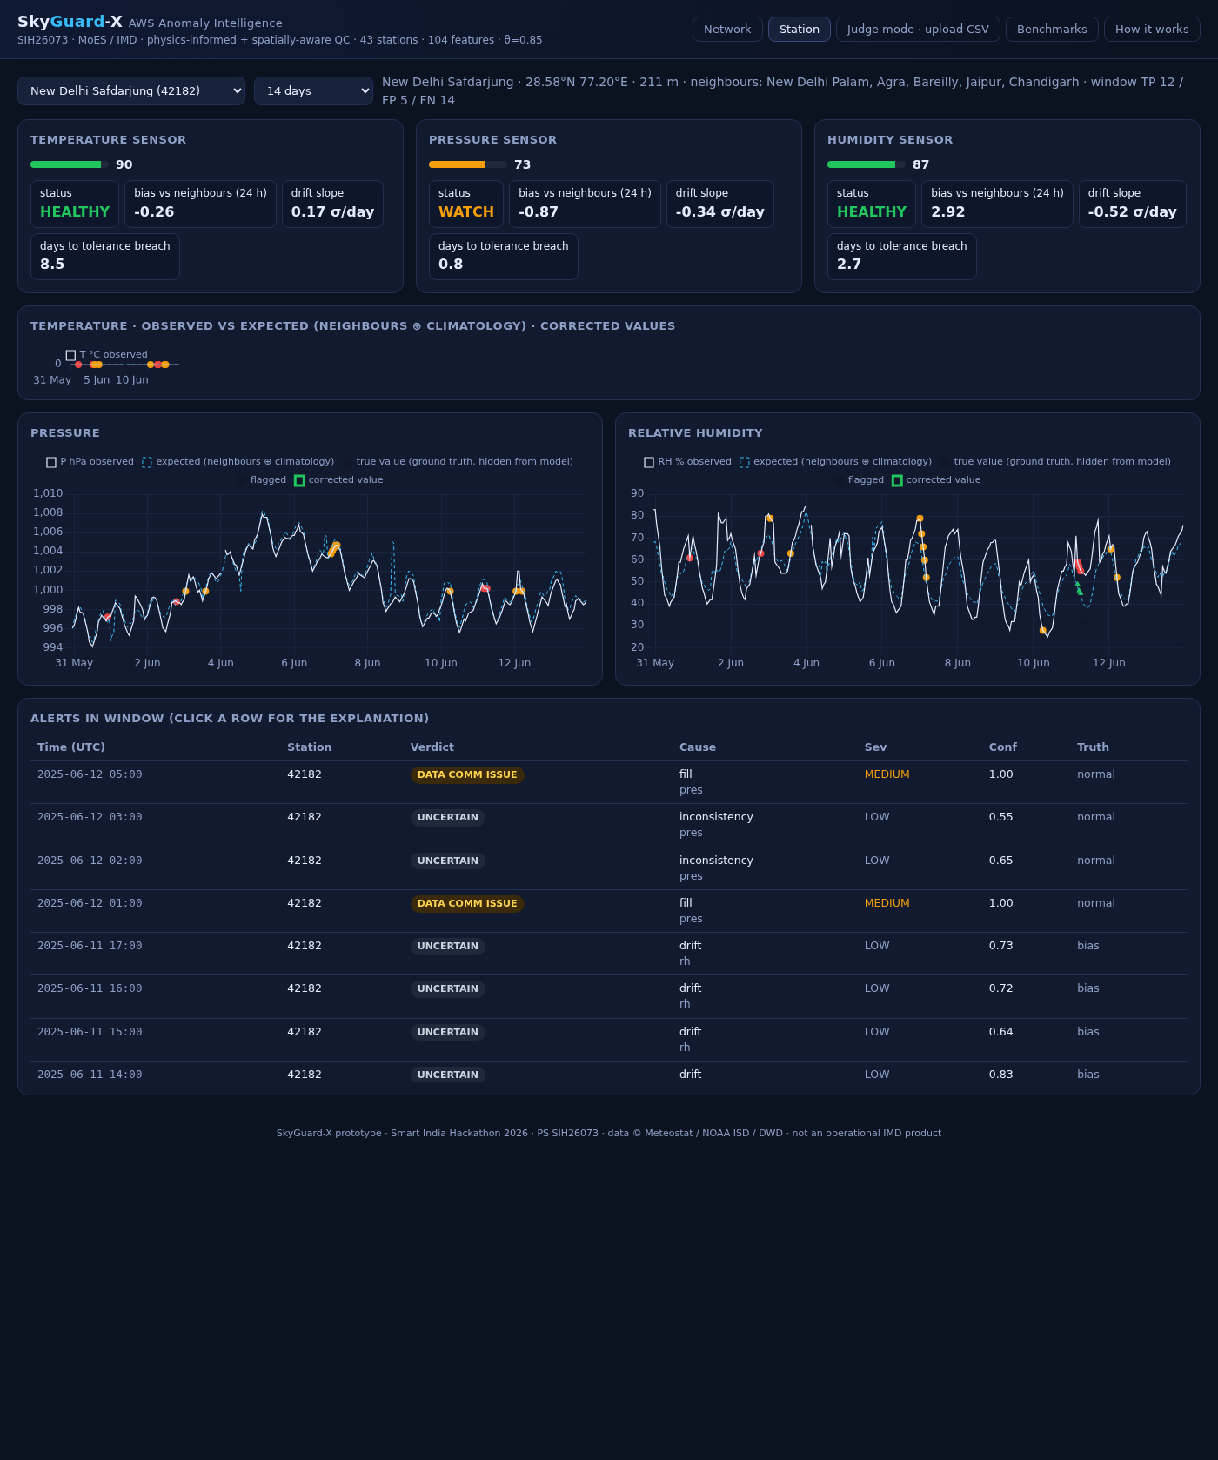
Station tab: observed vs expected values with flagged readings marked; click an alert row to see why.
- Choose a station from the drop-down and a window (7 / 14 / 30 / 60 days).
- Charts: solid line = what the sensor reported, dashed line = what SkyGuard-X expected (from climatology and neighbours), red dots = readings flagged as faulty.
- Health cards: current health of temperature, pressure and humidity sensors with status (HEALTHY / WATCH / MAINTENANCE / CRITICAL).
- Alerts in window: click any row to expand the plain-English explanation, the recommended action, the corrected value, the bias estimate and the top reasons (SHAP contributions) behind the decision.

3.3 Judge mode — upload your own CSV (the main demo)
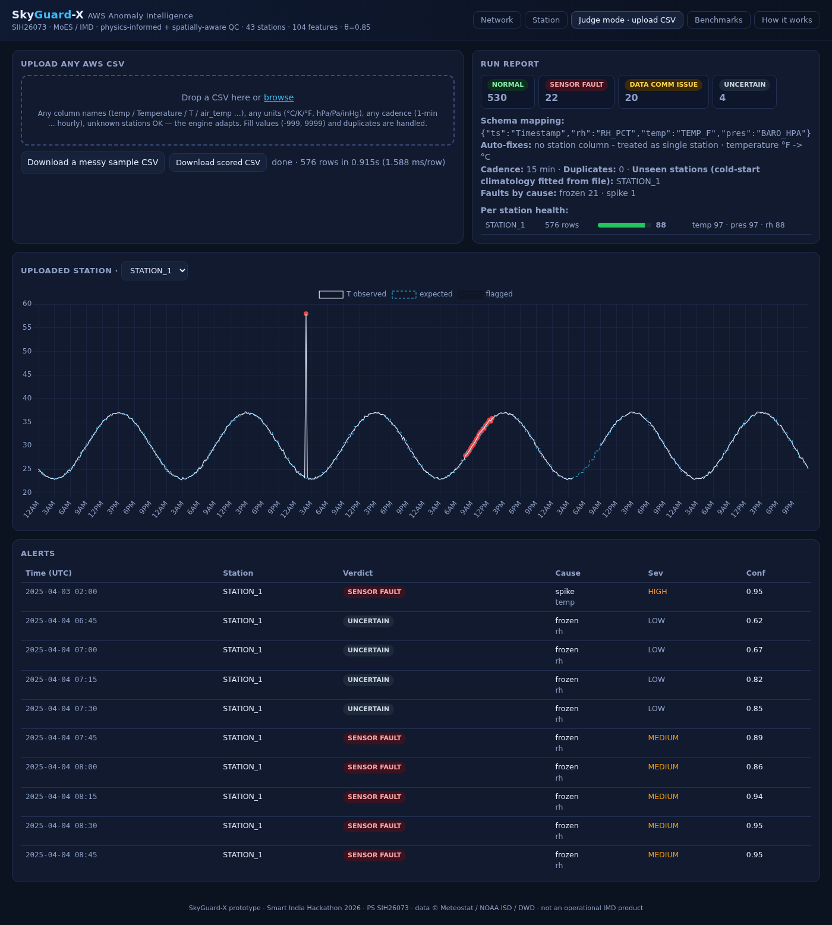
Judge mode: a messy 15-minute file with °F temperatures and semicolons — spike, frozen humidity and a 5-hour gap all found, zero false alarms.
This is where an evaluator tests the system on their own anomaly-injected data.
- Click “Judge mode · upload CSV”.
- Drag a file into the dashed box, or click browse. Accepted: .csv (comma, semicolon, tab or pipe separated), .tsv and .xlsx.
- Wait a few seconds. The status line shows rows scored and speed (about 1–3 ms per row).
- Read the Run report (right): verdict counts, how your columns were mapped, automatic fixes (units, timestamp format), detected cadence, unseen stations, faults by cause and per-station health.
- Scroll down: the chart shows your uploaded station (switch stations with the drop-down) and the Alerts table lists every flagged reading. Click a row for the explanation.
- Click “Download scored CSV” to get your file back with the verdict columns added (see section 5).
What your file needs:
- A timestamp column (any common format: 2025-04-03 02:00, 03/04/2025 02:00, ISO, or Unix epoch).
- Temperature, pressure and humidity columns — any names (temp / Temperature / T / air_temp / TEMP_F …) and any units (°C, K, °F; hPa, Pa, inHg; %). They are recognised and converted automatically.
- A station column is optional. Without it the file is treated as one station.
- Fill values (-999, 9999 …), duplicate timestamps, gaps and any cadence (1-minute to hourly) are handled.
- Don’t have a file? Click “Download a messy sample CSV” to get a test file with Kelvin, Pascals, day-first dates and sentinels, then upload it.
Tip: unknown stations work too — SkyGuard-X fits a climatology from the file itself (“cold start”), so it can be used on any AWS network, not just the 43 built-in stations.

3.4 Benchmarks — the numbers
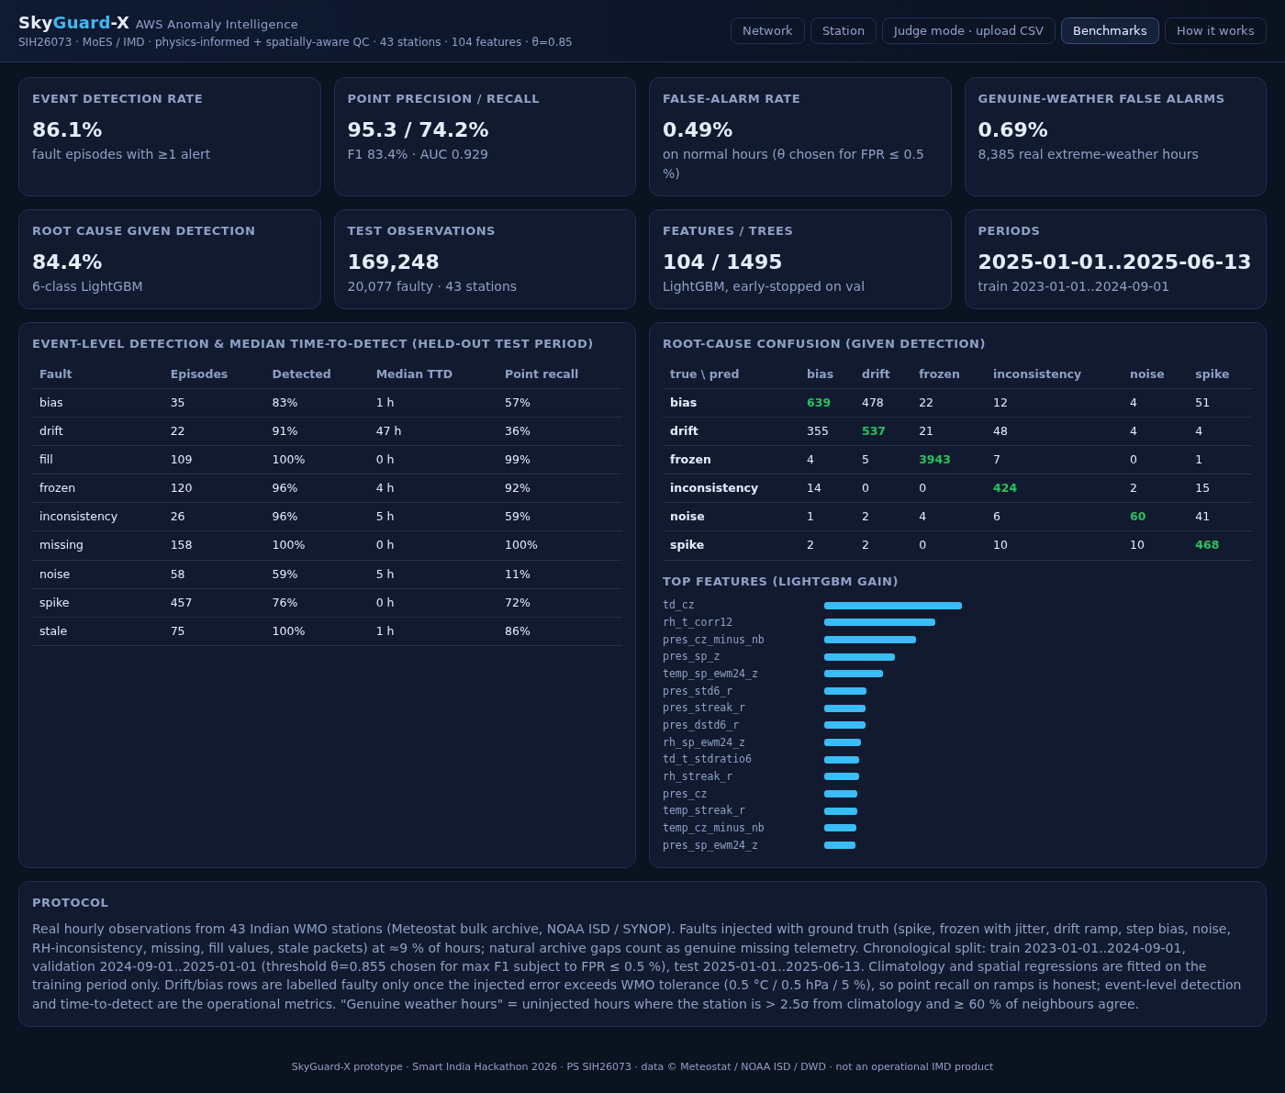
Benchmarks tab: honest, held-out results on 169,248 test hours with injected faults.
- Event detection rate, precision / recall, false-positive rate on normal hours and false-alarm rate on genuine extreme weather.
- A table per fault type (spike, frozen, drift, bias, noise, inconsistency, missing, fill, stale) with detection rate and time-to-detect.
- All numbers come from a chronological hold-out (2025) the model never saw during training — quote them as they are.

3.5 How it works
A one-page summary of the pipeline (Tier-1 deterministic QC → 98-feature context engine → LightGBM detector and root-cause → verdict layer → explanations) and what makes it different: real data, the Hubbard Spatial Regression Test, witness agreement for genuine weather, physics features, CUSUM drift tracking, cold start and the ESP32 edge tier.

4. Reading a result
Verdicts
Verdict | Meaning | What to do
SENSOR_FAULT | The instrument is wrong (spike, frozen, drift, bias, noise, T/RH inconsistency, out-of-range). | Follow the action shown; use the corrected value.
DATA_COMM_ISSUE | Telemetry problem: missing data, fill/sentinel values, stale repeated packets, duplicate timestamps. | Check power, modem/link, logger clock or firmware.
GENUINE_WEATHER_EVENT | Reading is unusual but neighbouring stations agree — real weather (thunderstorm, heat wave, cyclone). | No maintenance. Do not reject the data.
UNCERTAIN | Some evidence of a fault, below the alert threshold. | Watch; usually resolves to NORMAL or becomes a fault as it persists.
NORMAL | Nothing wrong. | —

Cause (root cause) and action
Cause | Typical sign | Recommended action shown by the system
spike | One-point jump that reverts | Transient – auto-reject reading, keep monitoring
frozen | Identical value for hours while others move | Sensor stuck – inspect element/connector; likely replacement
drift | Slow growing offset vs neighbours/climatology | Schedule recalibration
bias | Sudden constant offset | Verify against travelling standard; recalibrate
noise | Jittery readings | Check cable/shield & logger ADC
inconsistency | RH/T relationship broken (dew point > T) | Check RH element (wetting/contamination)
missing / fill / stale | Gaps, -999/9999 values, repeated packets | Check power, link, logger firmware or clock

Severity and confidence
- Severity LOW → MEDIUM → HIGH → CRITICAL, based on how far the reading is from what is expected (roughly >3σ, >5σ, >8σ).
- Confidence 0–1: the model’s probability that the reading is faulty (alerts are raised at ≥ 0.85; Tier-1 rule hits are 0.95–1.0).
- Corrected value the best estimate of the true reading, blended from neighbouring stations and the station’s own climatology.
- Bias estimate the current offset of the sensor (e.g. +3.1 °C), useful for recalibration.
- Health 0–100 per station and per sensor over the last 7 days: ≥80 HEALTHY, 60–79 WATCH, 40–59 MAINTENANCE, <40 CRITICAL.

5. Command line (batch scoring, no browser)
python -m skyguard --input yourfile.csv --output scored.csv
python -m skyguard --input yourfile.xlsx --output scored.csv --no-explain # faster, no SHAP text
The command prints a JSON run report and writes scored.csv with your original columns plus:
station_id, ts, temp, pres, rh, verdict, fault, sensor, severity, confidence, p_fault,
corrected, bias_estimate, temp_expected, pres_expected, rh_expected, explanation, action
Docker (optional, e.g. for Hugging Face Spaces):
docker build -t skyguard .
docker run -p 7860:7860 skyguard # then open http://localhost:7860

6. Suggested 3-minute demo
- Network tab – point at the map: “43 real IMD stations, colour is health, lines are the neighbour links used for the spatial test.”
- Click a red dot → Station tab – show the observed vs expected lines and click one alert to reveal the explanation, action and corrected value.
- Judge mode – upload the evaluator’s file (or the messy sample). Show that units and columns were auto-mapped, then the verdict chips and the alert list. Click the spike row: “58 °C, 87σ from climatology, no neighbour supports it → sensor fault, corrected to 23 °C”.
- Benchmarks tab – read the real numbers: 86 % of injected fault events detected, 0.49 % false positives on normal hours, 0.69 % false alarms on genuine extreme weather.
- Download the scored CSV and hand it over.

7. Troubleshooting
Problem | Fix
“python is not recognized” (Windows) | Use py instead of python, or reinstall Python with “Add to PATH” ticked.
pip install fails on lightgbm / shap | Use Python 3.11 or 3.12 (newest Python versions may not have wheels yet).
macOS: libomp.dylib not found | Run brew install libomp, then start again.
Port 8000 already in use | python -m uvicorn app.main:app --port 8080 and open http://localhost:8080
First page takes ~4 minutes to load | data/demo_scored.parquet was deleted; it is being rebuilt. Keep the file.
Upload says “Could not identify columns” | Make sure the file has a timestamp and three value columns; rename headers to temp / pres / rh if they are cryptic.
Upload says “file too large” | The demo server accepts up to 400,000 rows per upload; split larger files or use the command line.
Charts empty after upload | Timestamps could not be parsed — use a standard format such as 2025-04-03 02:00.

8. Known limits (be upfront)
- Small single-station offsets (below about 4 °C) are only caught after they persist for several hours; noise is the weakest class (≈59 % of events).
- Spatial checks need at least 2–3 neighbours within reach; a lone station relies on temporal, climatology and physics tests only.
- This is a hackathon prototype on public archive data, not an operational IMD product.

