1. Using vi write your CV in the file mycv. Your CV should include your name, age, school,

college, experience,…

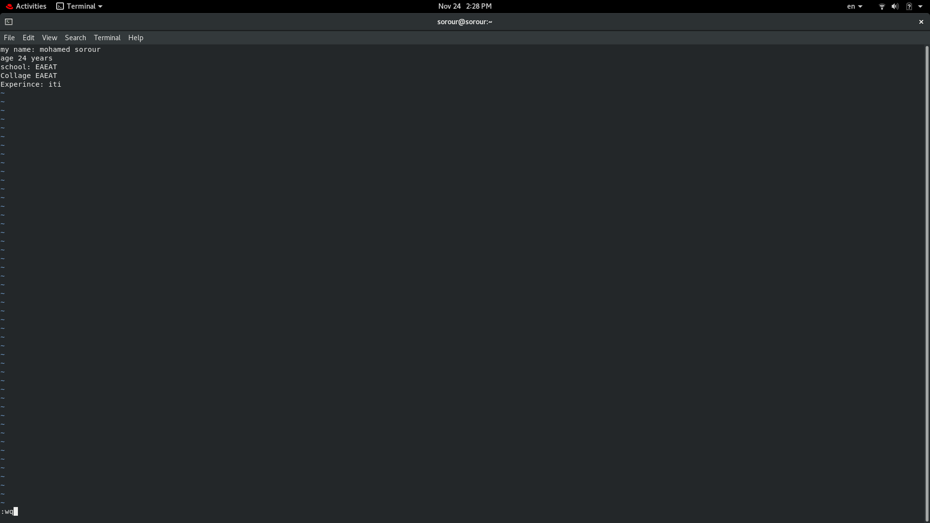

2. Open mycv file using vi command then: Without using arrows state how to:

a. Move the cursor down one line at time. → j

b. Move the cursor up one line at time. → k

c. Search for word age

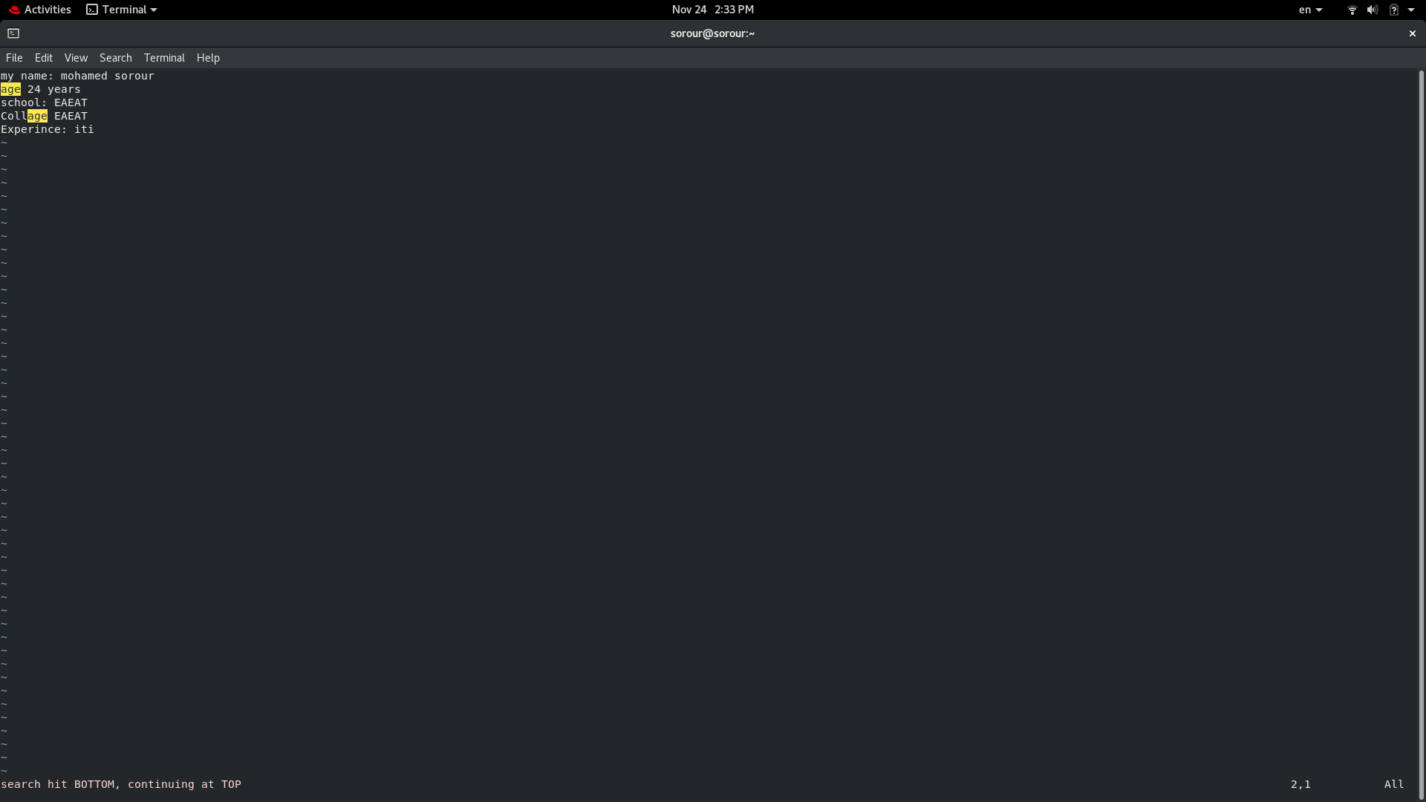

d. Step to line 5 (assuming that you are in line 1 and file is more than 5 lines).

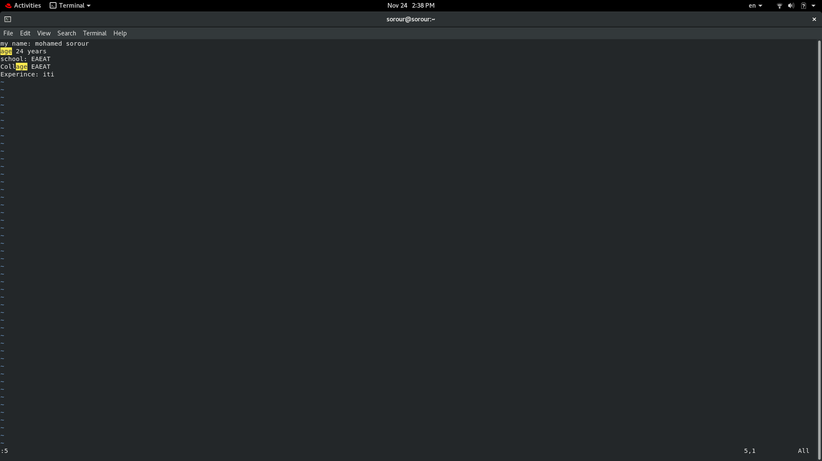

e. Delete the line you are on and line 5.

→ 1,5 del

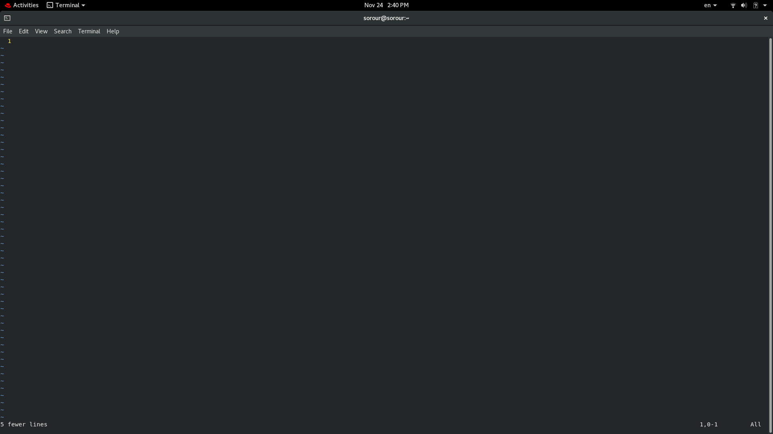

f. How to step to the end of line and change to writing mode in one-step. → A

3. List the available shells in your system.

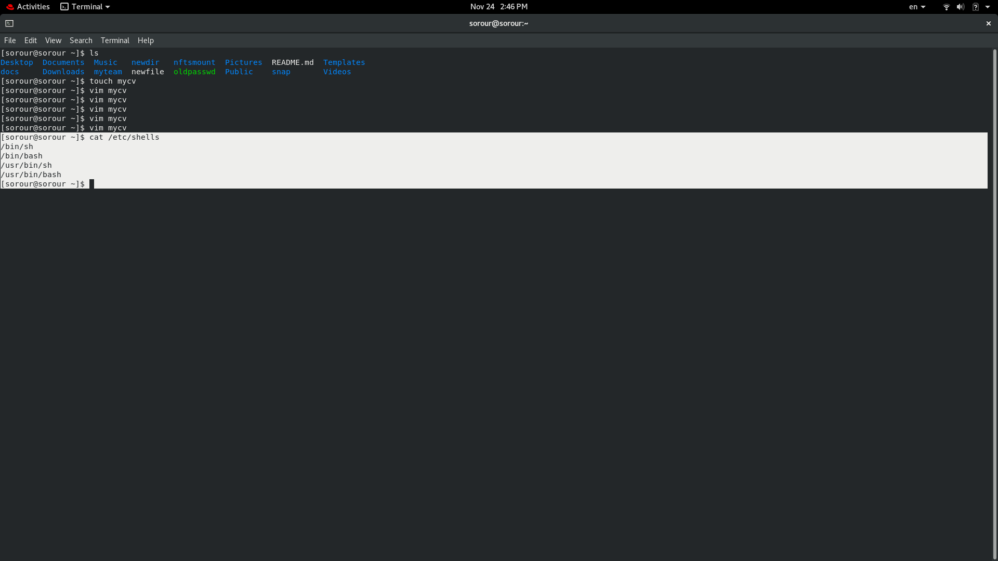

4. List the environment variables in your current shell.

→ printenv

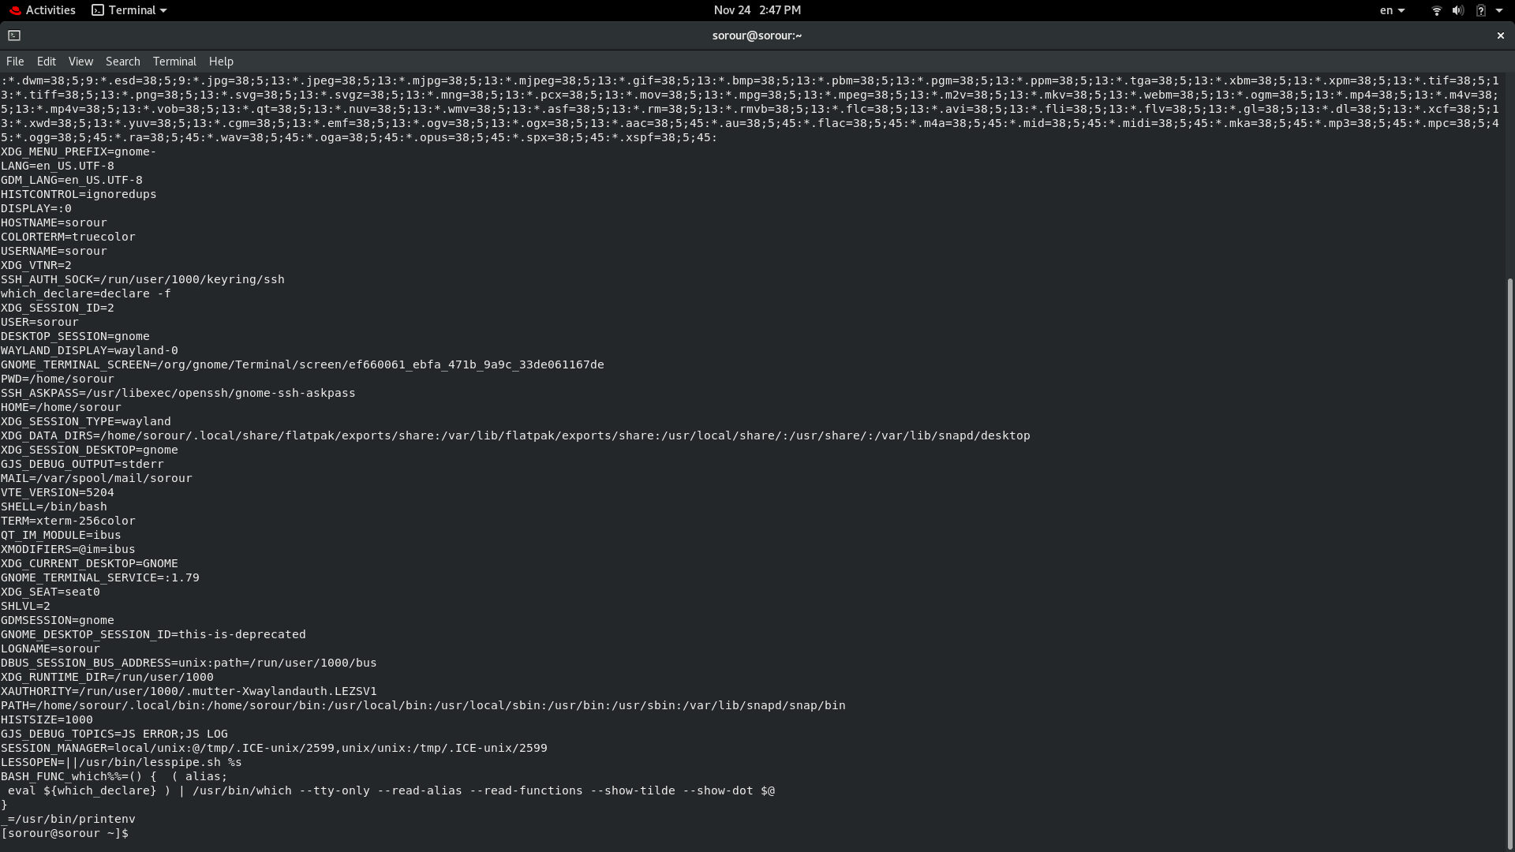

5. List all of the environment variables for the bash shell. → man bash

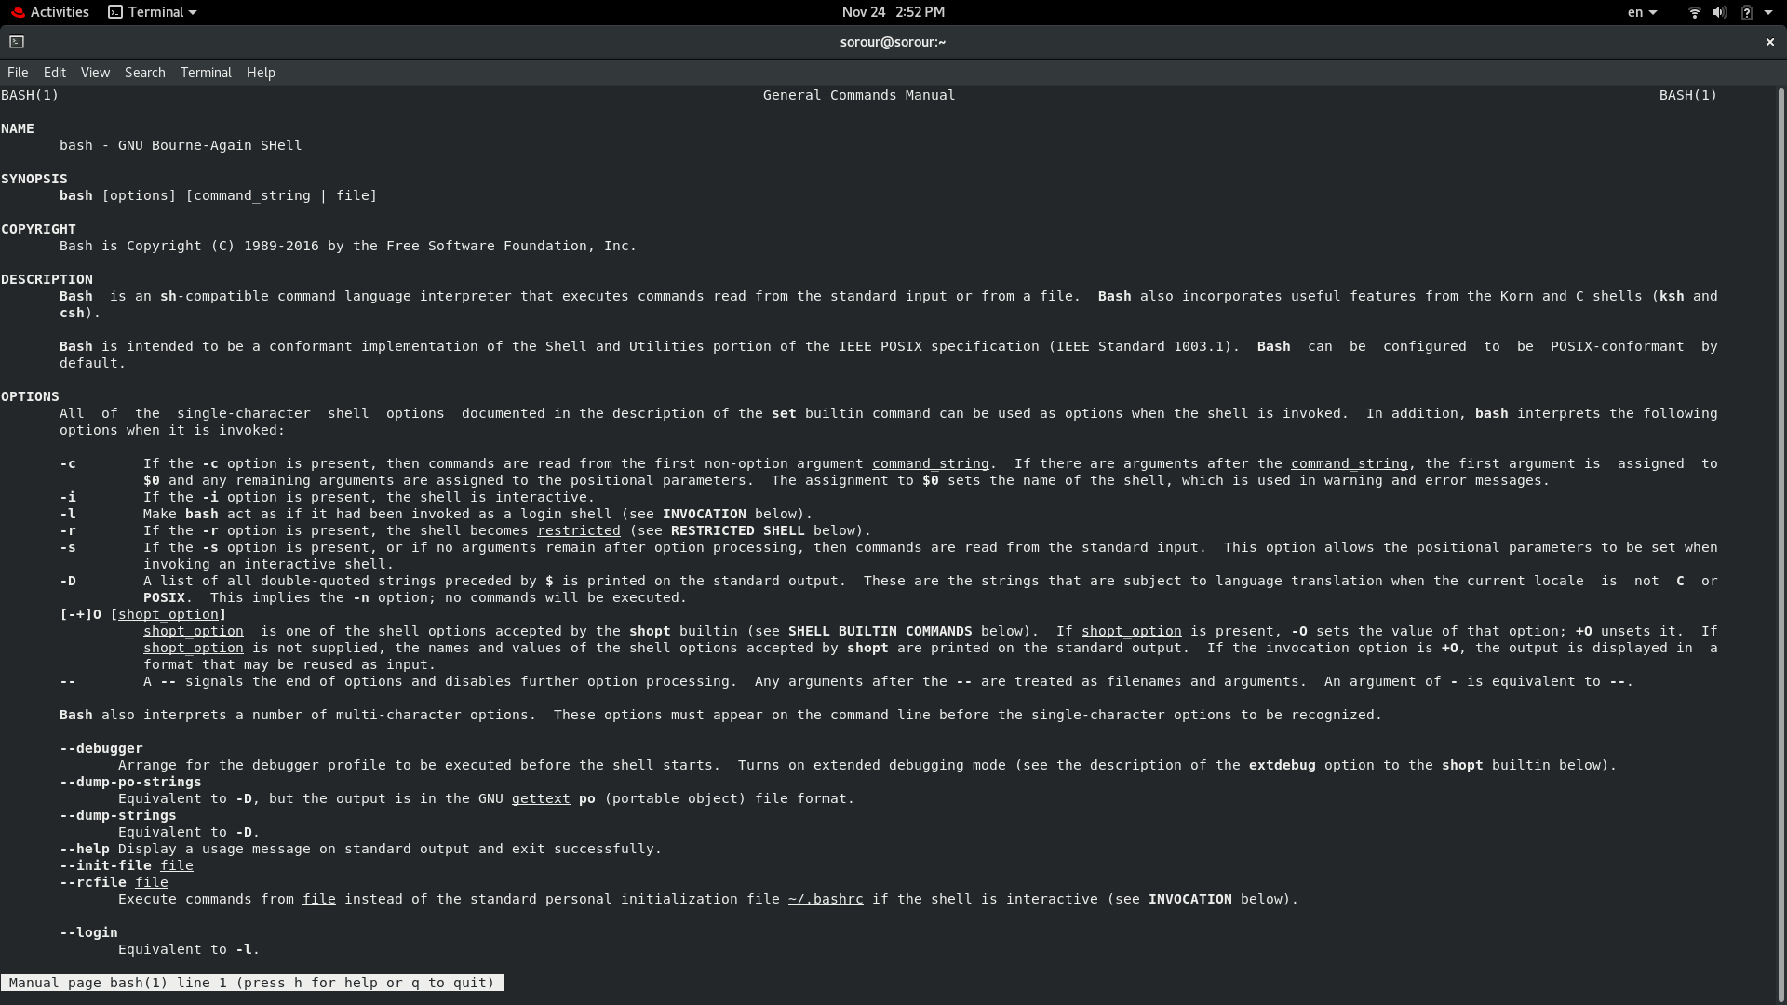

6. What are the commands that list the value of a specific variable?

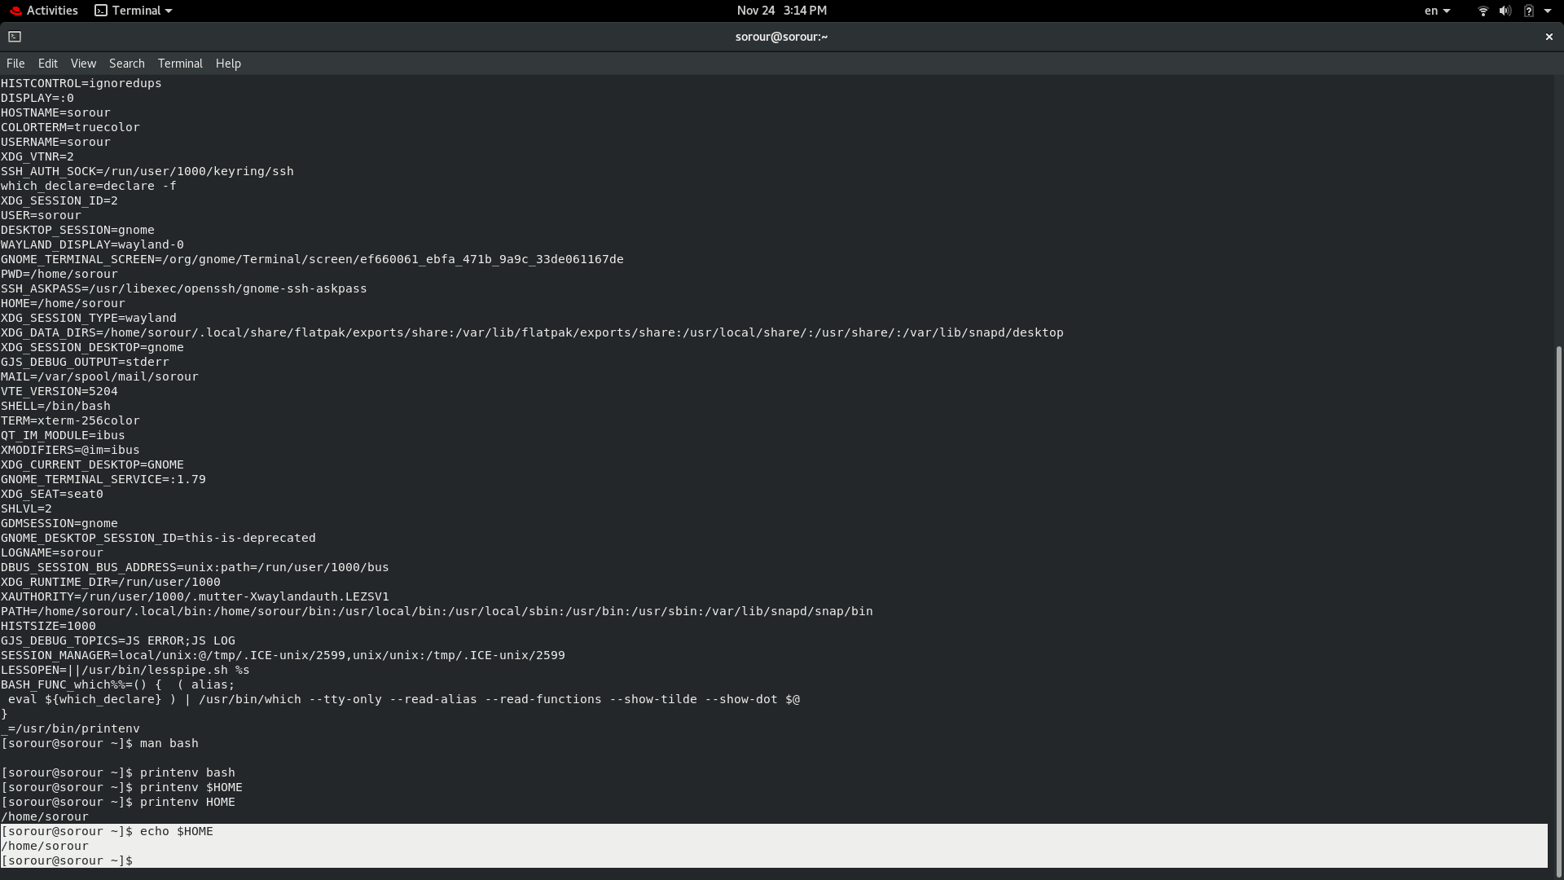

7. Display your current shell name.

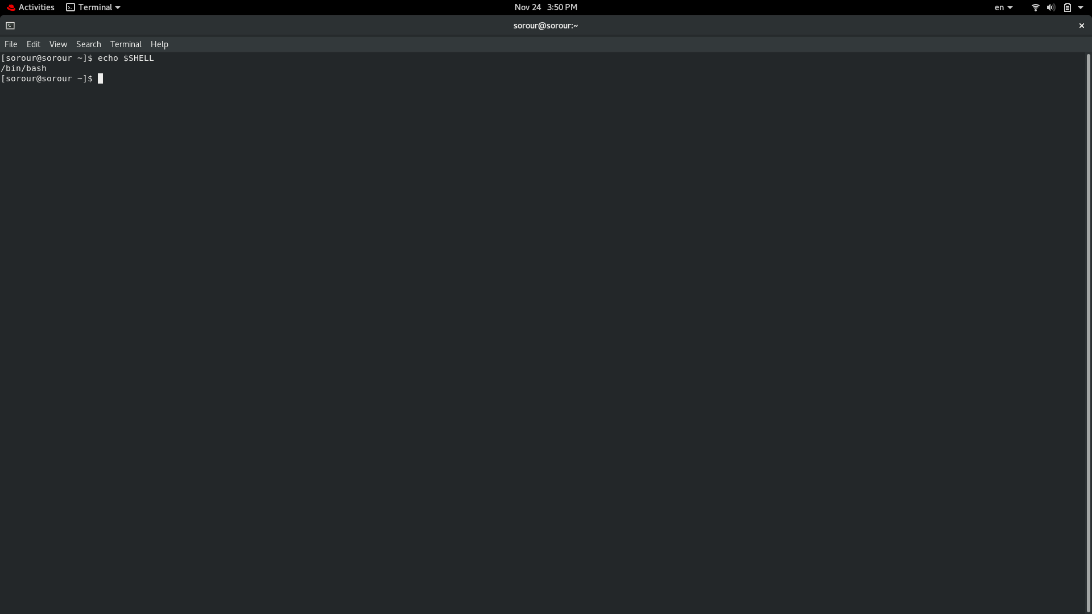

8. State the initialization files of: sh, ksh, bash.

.sh → shell script

ksh→ korn shell

bash→ bourne again shell

9. Edit in your profile to display date at login and change your prompt permanently.

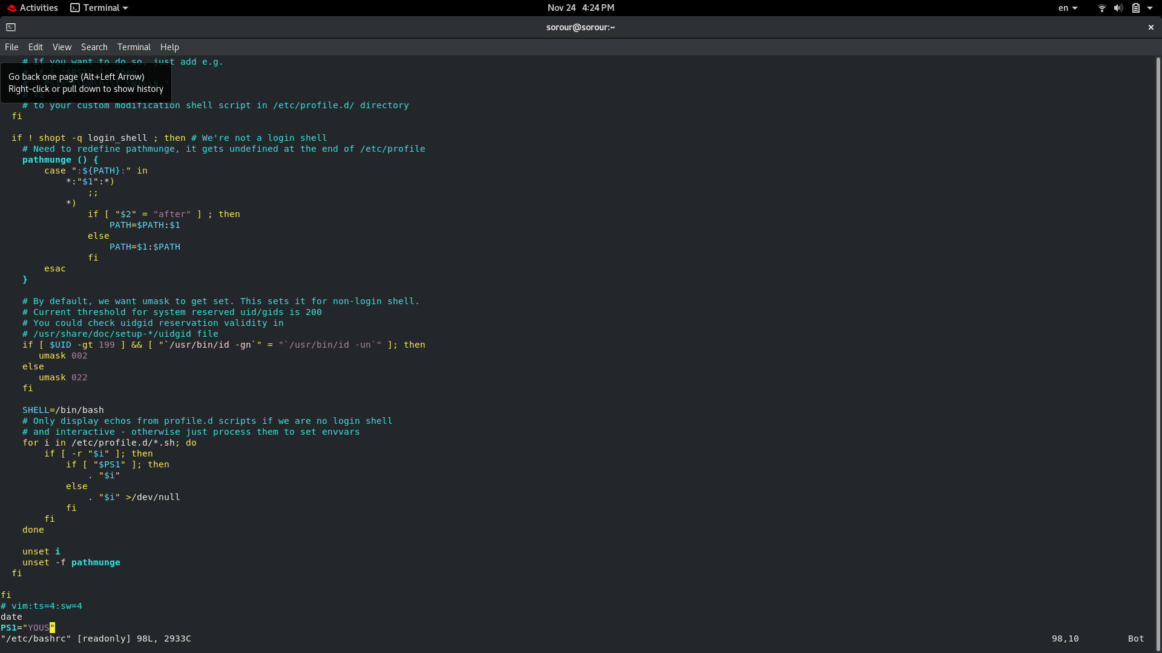

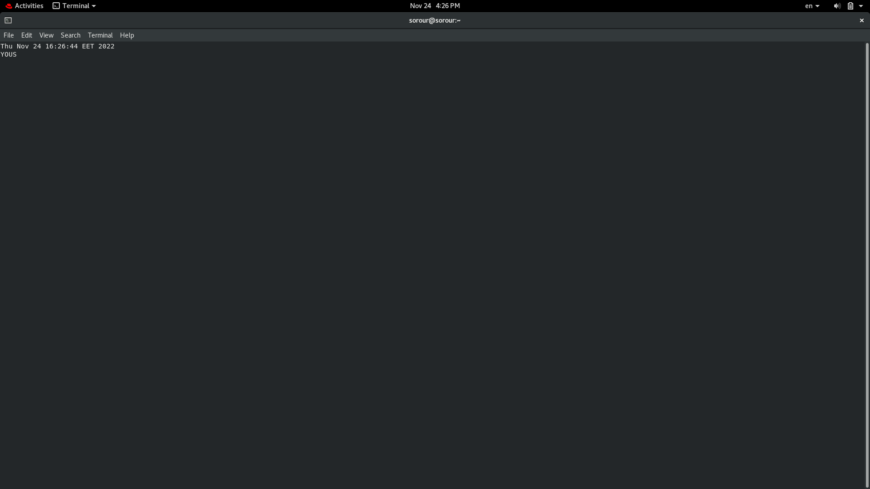

10.Execute the following command :

echo \ then press enter

What is the purpose of \ ? → to add an option e.g. \b

Notice the prompt ”>” what is that? and how can you change it from “>” to “:”. → by entering an option e.g. b

11.Create a Bash shell alias named ls for the “ls –l” command

