LAB2
1. Create a user account with the following attribute
• username: islam
• Fullname/comment: Islam Askar
• Password: islam

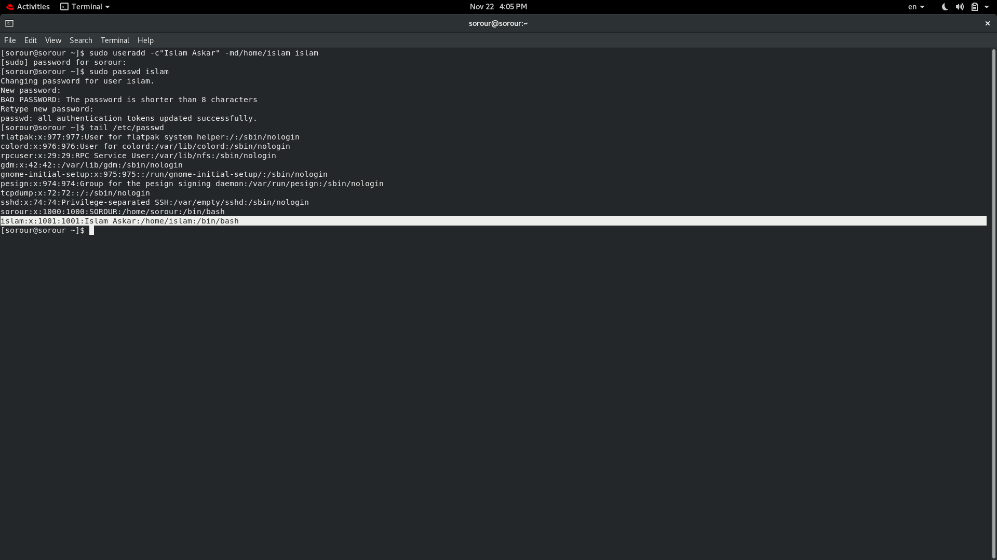

2.
Create a user account with the following attribute
• Username: baduser
• Full name/comment: Bad User
• Password: baduser
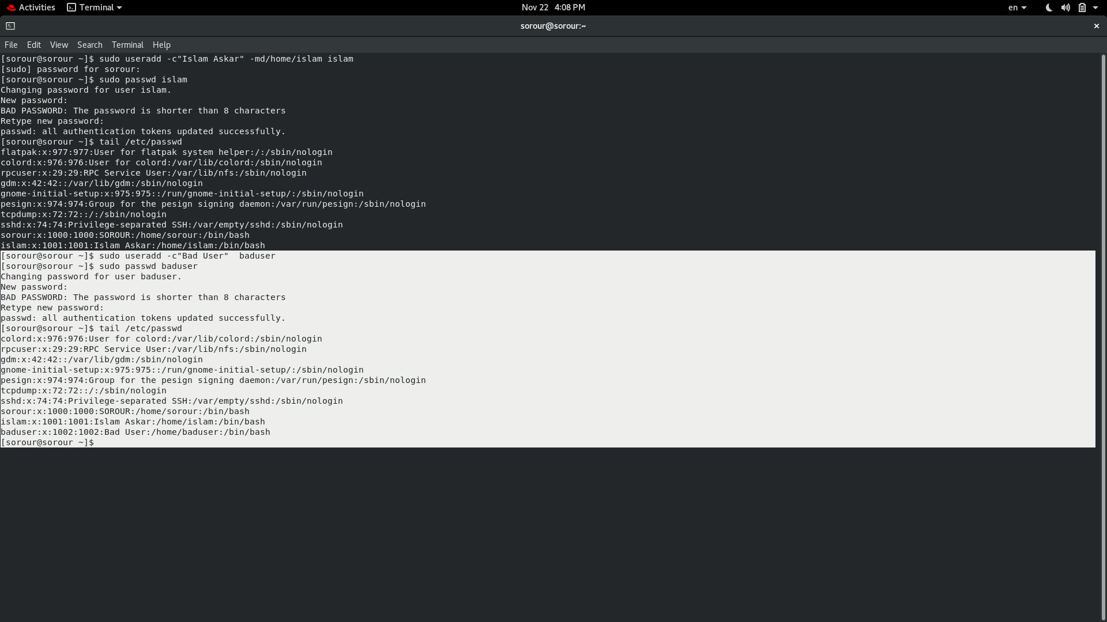
3.
Create a supplementary (Secondary) group called pgroup with group ID of 30000
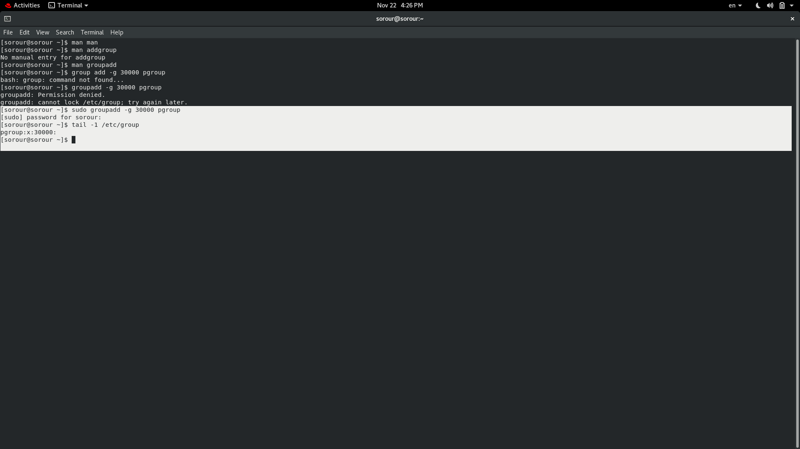
4.
Create a supplementary group called badgroup
5.
Add islam user to the pgroup group as a supplementary group
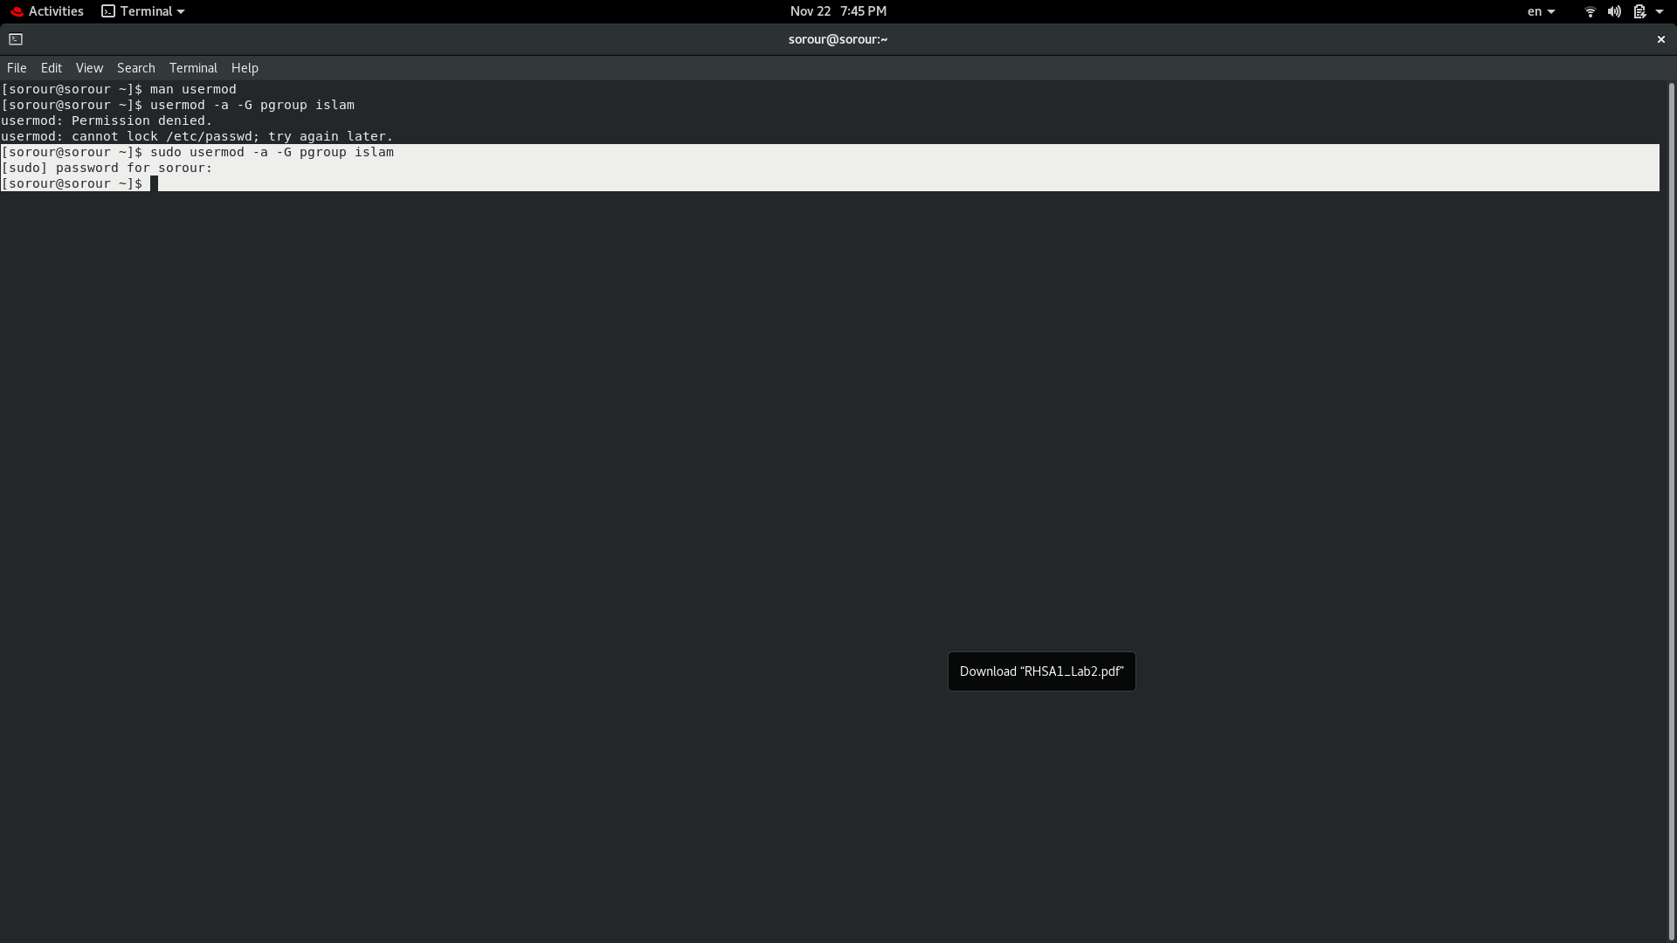

6.
Modify the password of islam's account to password
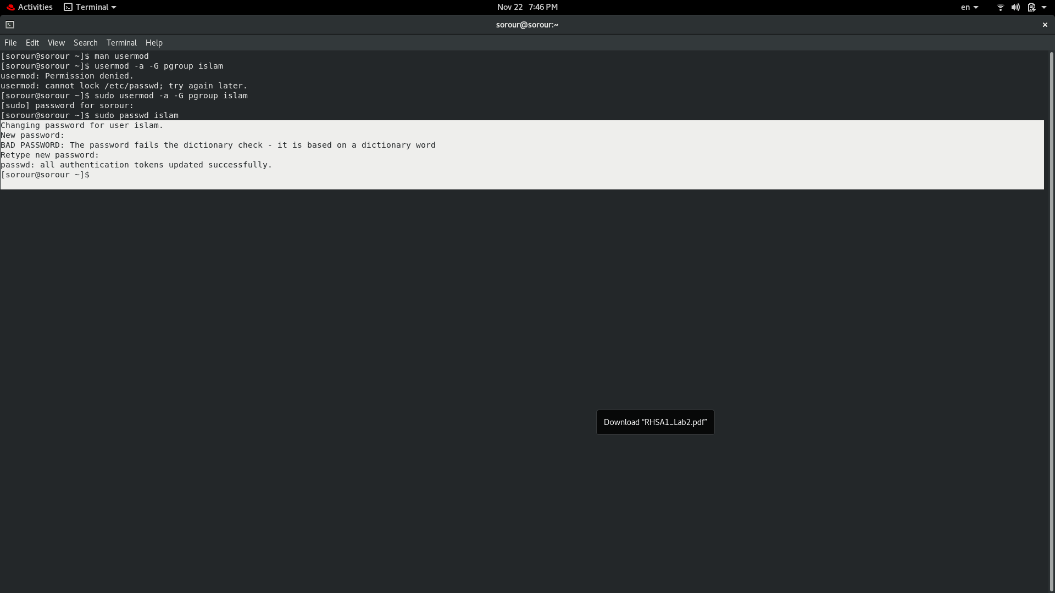
7.
Modify islam's account so the password expires after 30 days
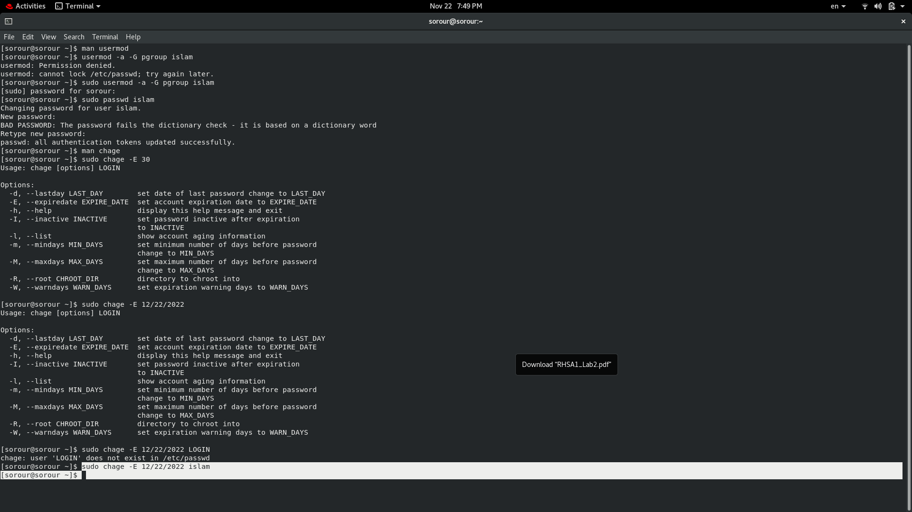
8.
Lock bad user account so he can't log in
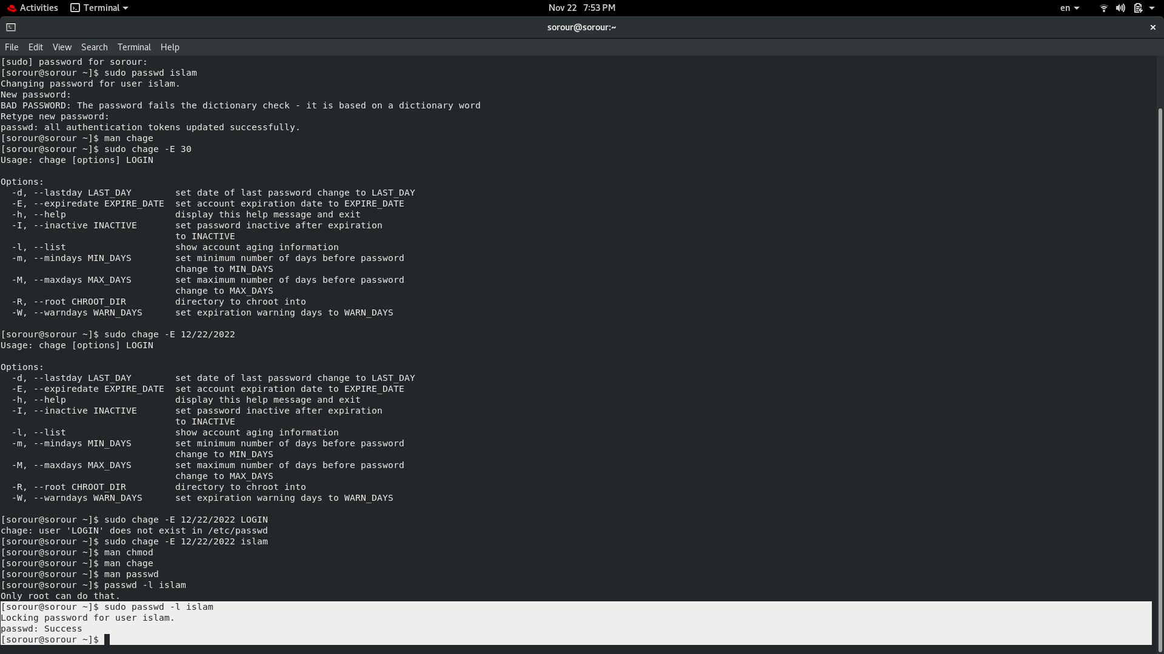

9.
Delete bad user account
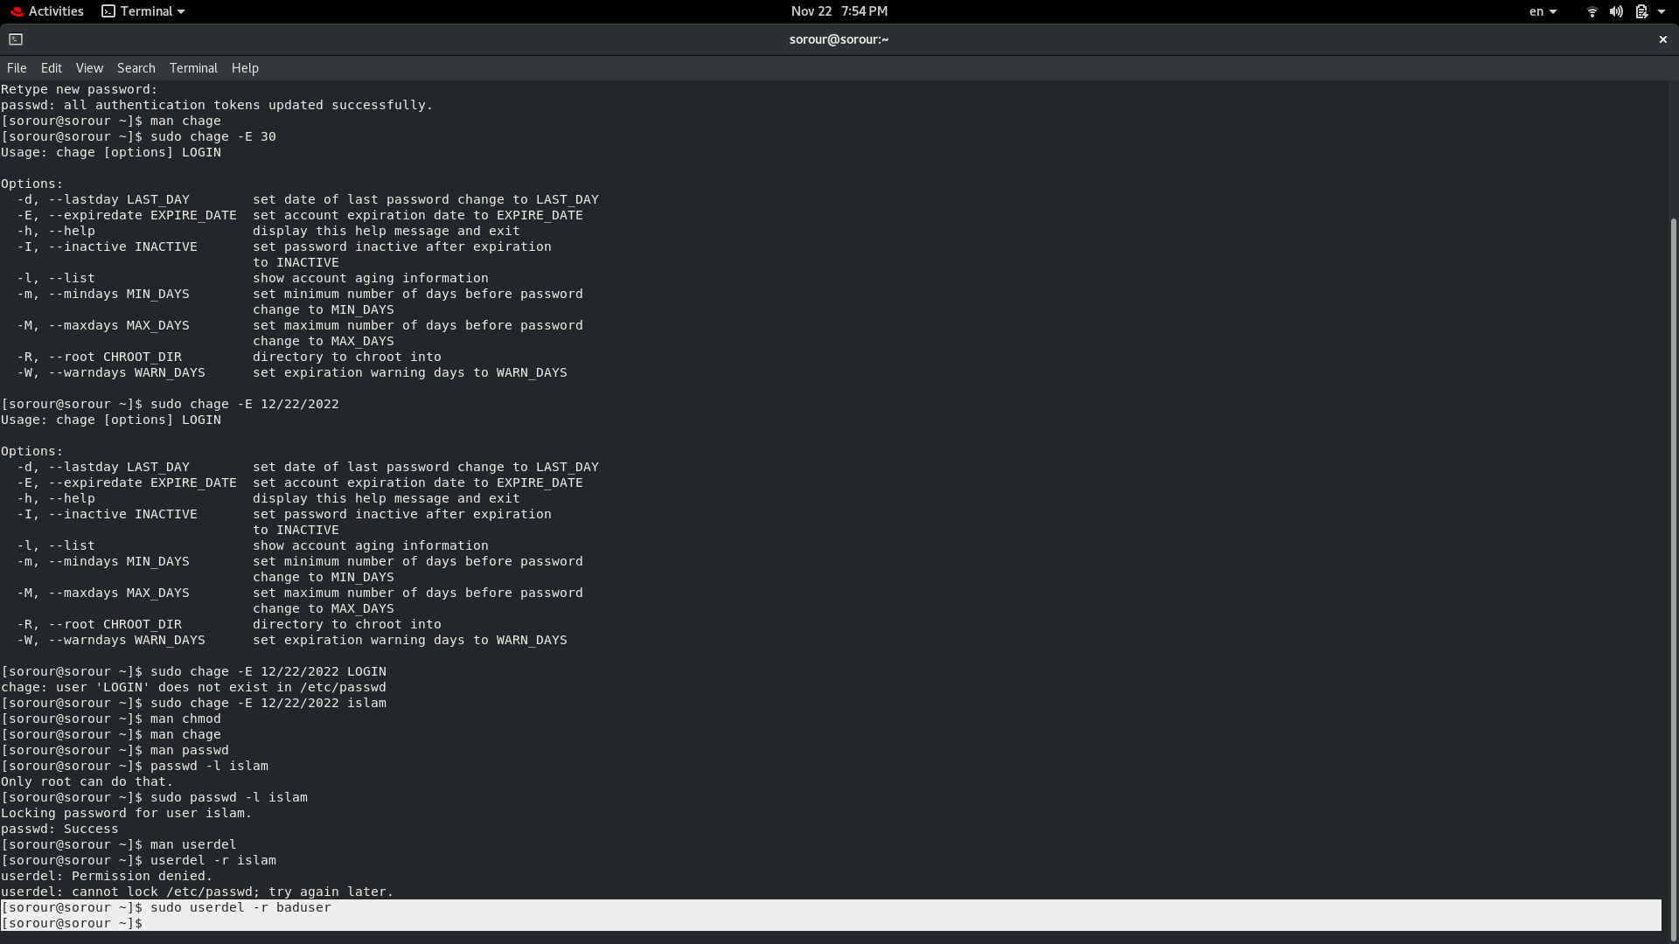

10. Delete the supplementary group called badgroup.
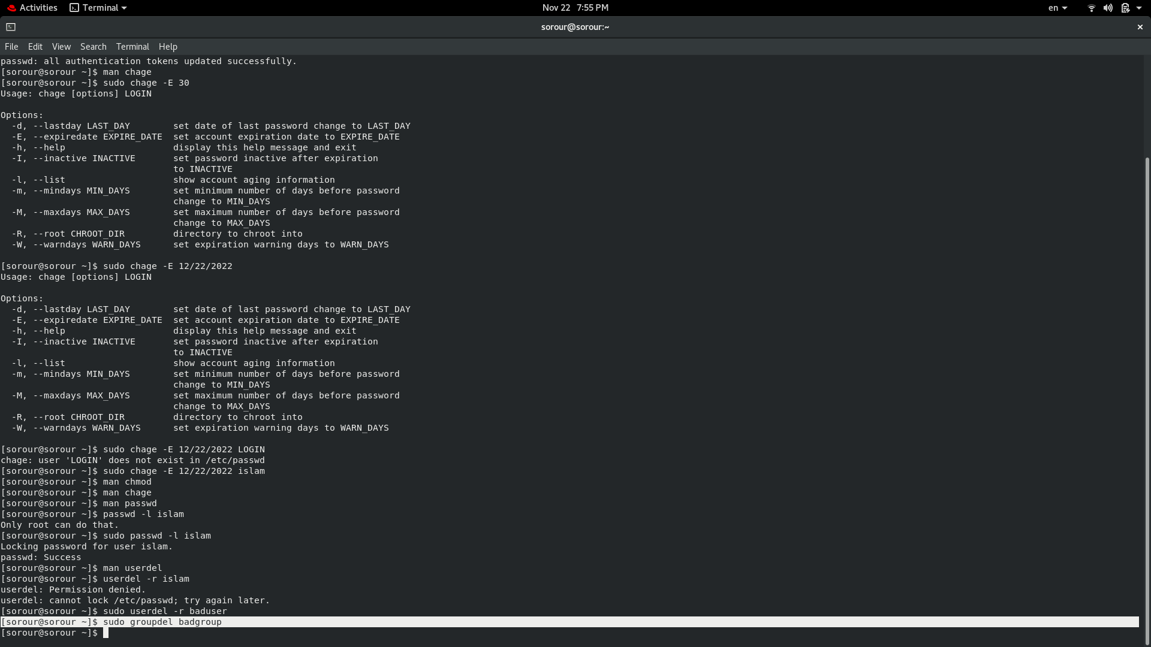
13. Create a folder called myteam in your home directory and change its permissions to
read only for the owner.
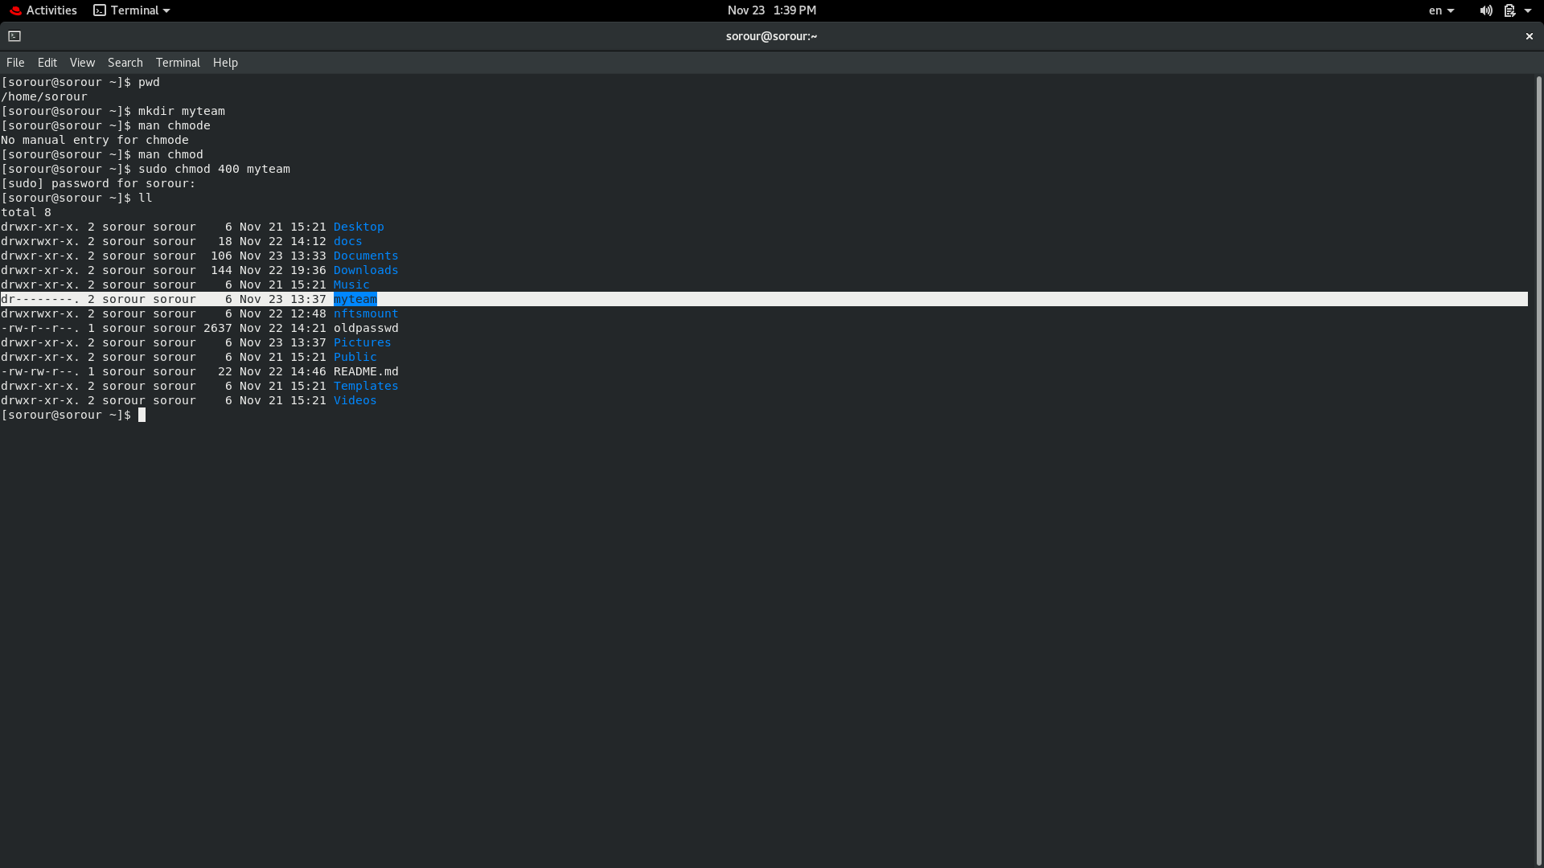
14. Log out and log in by another user
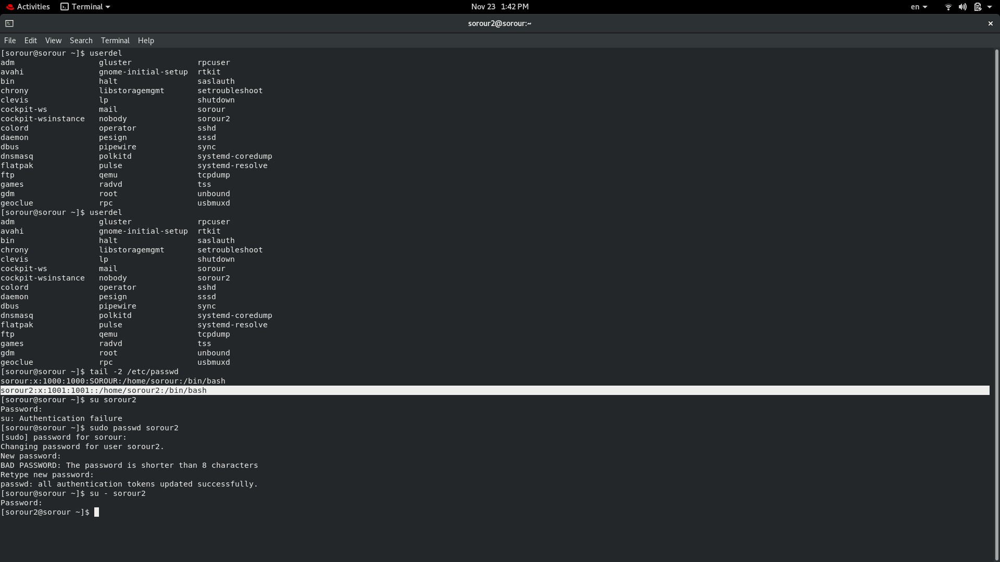
15. Try to access (by cd command) the folder (myteam)
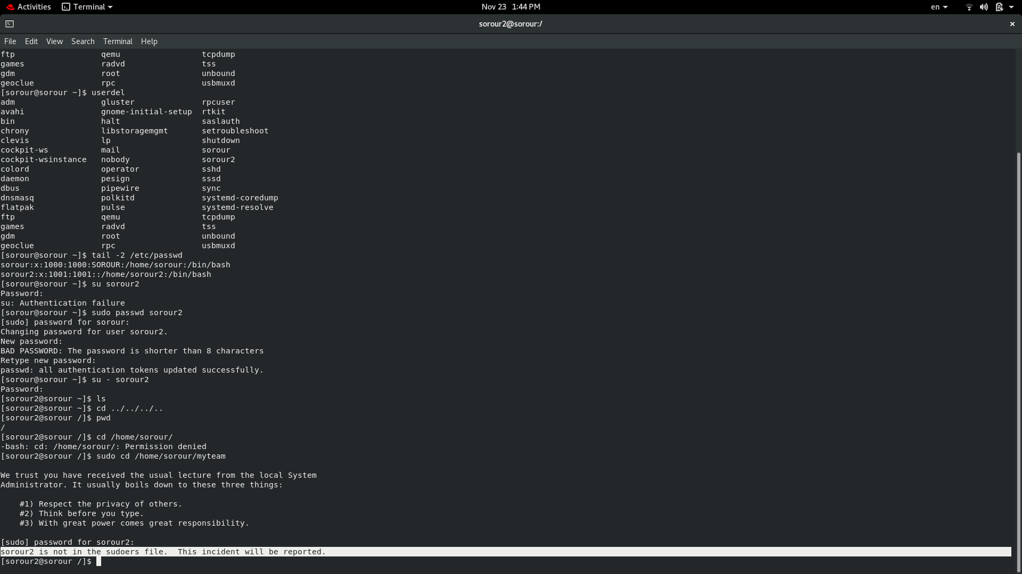
16. Using the command Line
Change the permissions of oldpasswd file to give owner read and write
permissions and for group write and execute and execute only for the others
(using chmod in 2 different ways)
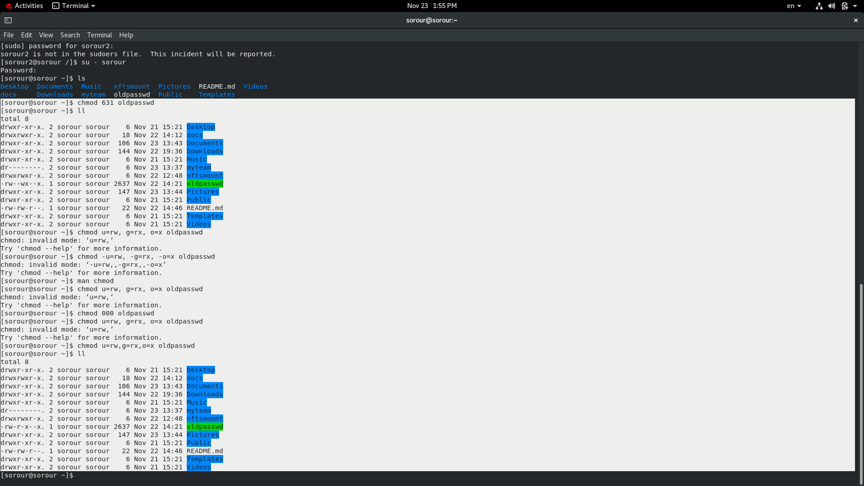
Change your default permissions to be as above.
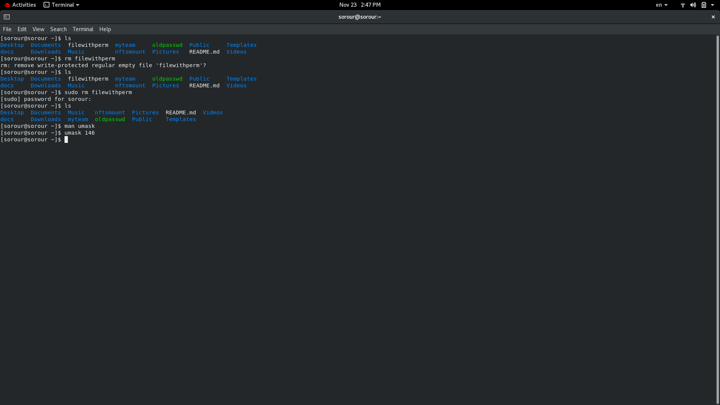

What is the maximum permission a file can have, by default when it is just
created? And what is that for directory.
File → 666 /RW
Folder → 777/ RWX
Change your default permissions to be no permission to everyone then create a
directory and a file to verify.
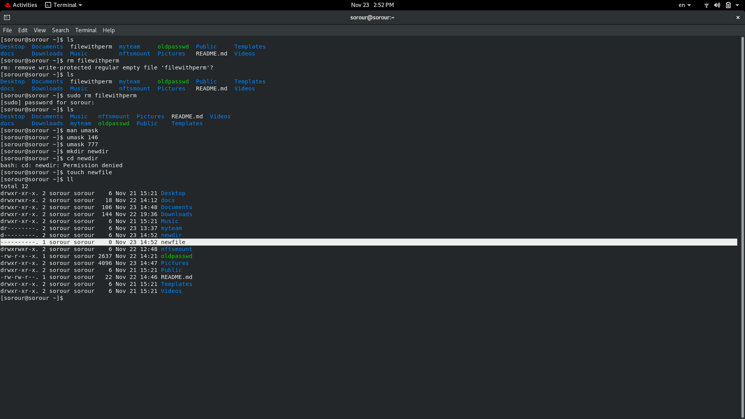
17.
What are the minimum permission needed for:
• Copy a directory (permission for source directory and permissions for target
parent directory)
permission for source directory → 041
permissions for target parent directory→ 021
• Copy a file (permission for source file and and permission for target parent
directory)
permission for source file → 400
permissions for target parent directory→ 021
• Delete a file
permission→ 021
• Change to a directory
permission→ 001
• List a directory content (ls command)
permission→ 401
• View a file content (more/cat command)
permission→ 400
• Modify a file content
permission→ 420
18. Create a file with permission 444. Try to edit in it and to remove it? Note what
happened.
Edit → read only:
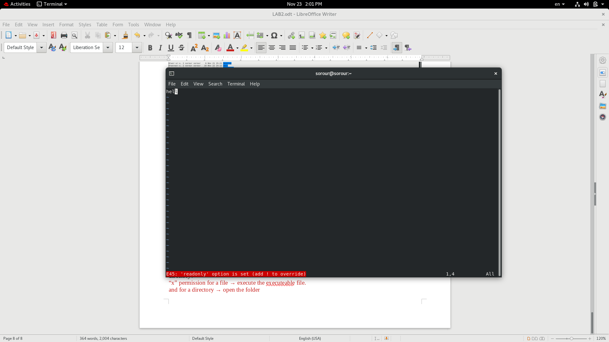
remove it→ it got removed only by sudo:
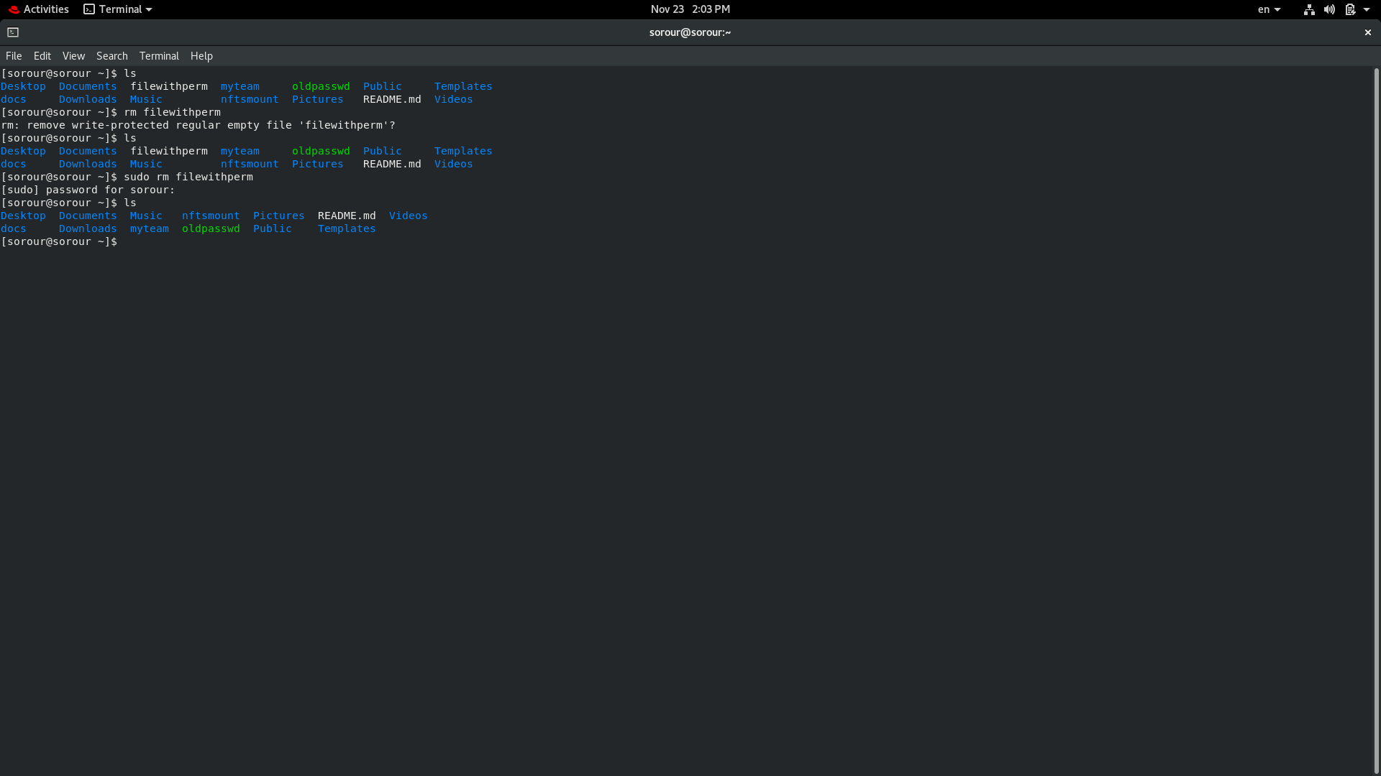
19. What is the difference between the “x” permission for a file and for a
directory?
“x” permission for a file → execute the executable file.
and for a directory → open the folder

