MOHAMED SOROUR – IoT- lab1:

1. Install CentOS /RHEL
done!
2. What is the difference between cat and more command?
Cat→ view all the file content
more→ view file content till certain percentage, then press enter to increase this percentage.
3. What is the difference between rm and rmdir using man?
Rm→ remove and empty directory files
rmdir→ remove empty directory
4. Create the following hierarchy under your home directory:
dir1 docs
dir11 dir12 mycv
file1
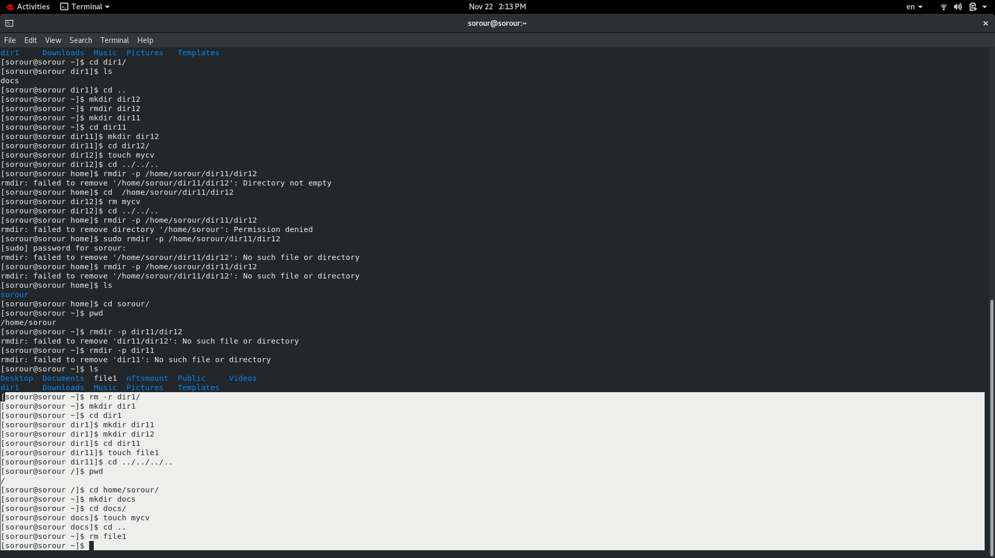
a. Remove dir11 in one-step. What did you notice? And how did you overcome that?I used rm- r to remove directory with files in it.
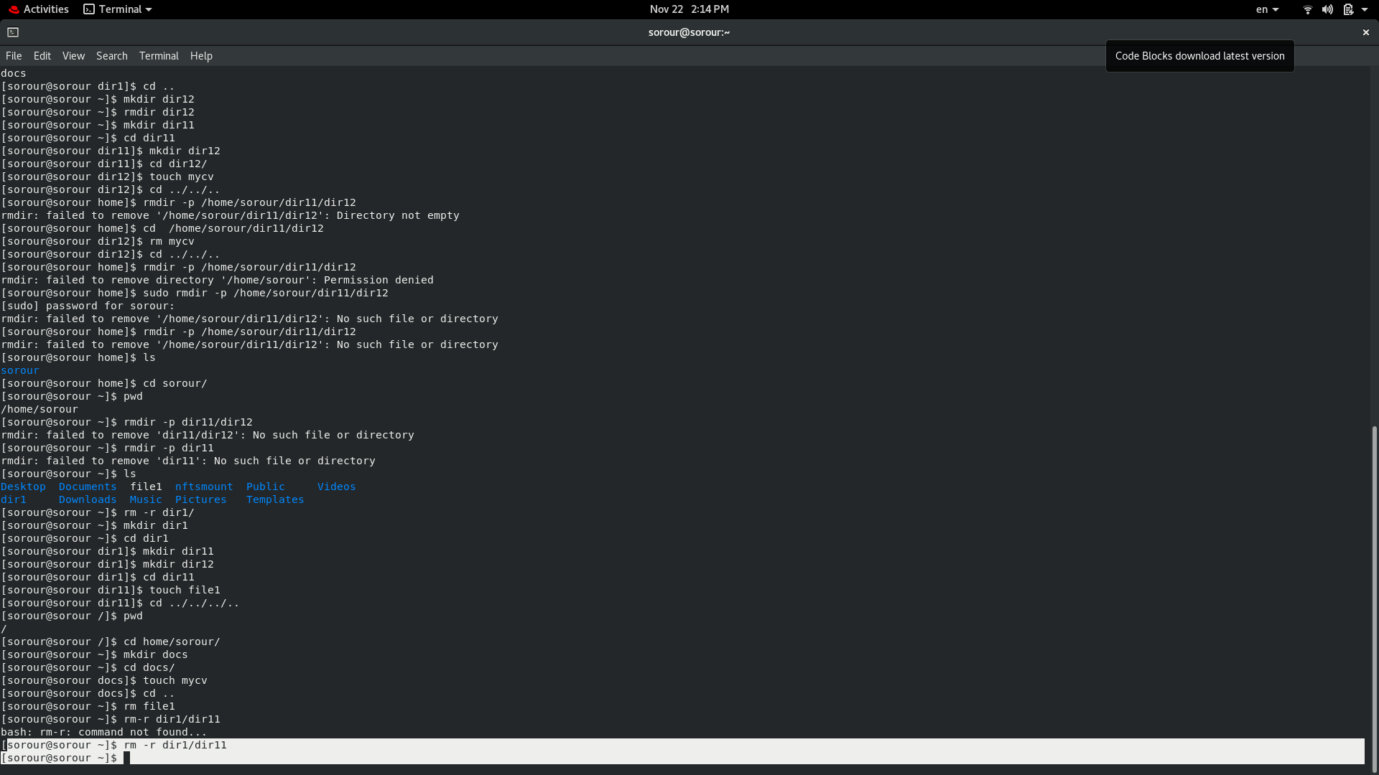
b. Then remove dir12 using rmdir –p command. State what happened to the hierarchy (Note: you are in your home directory).
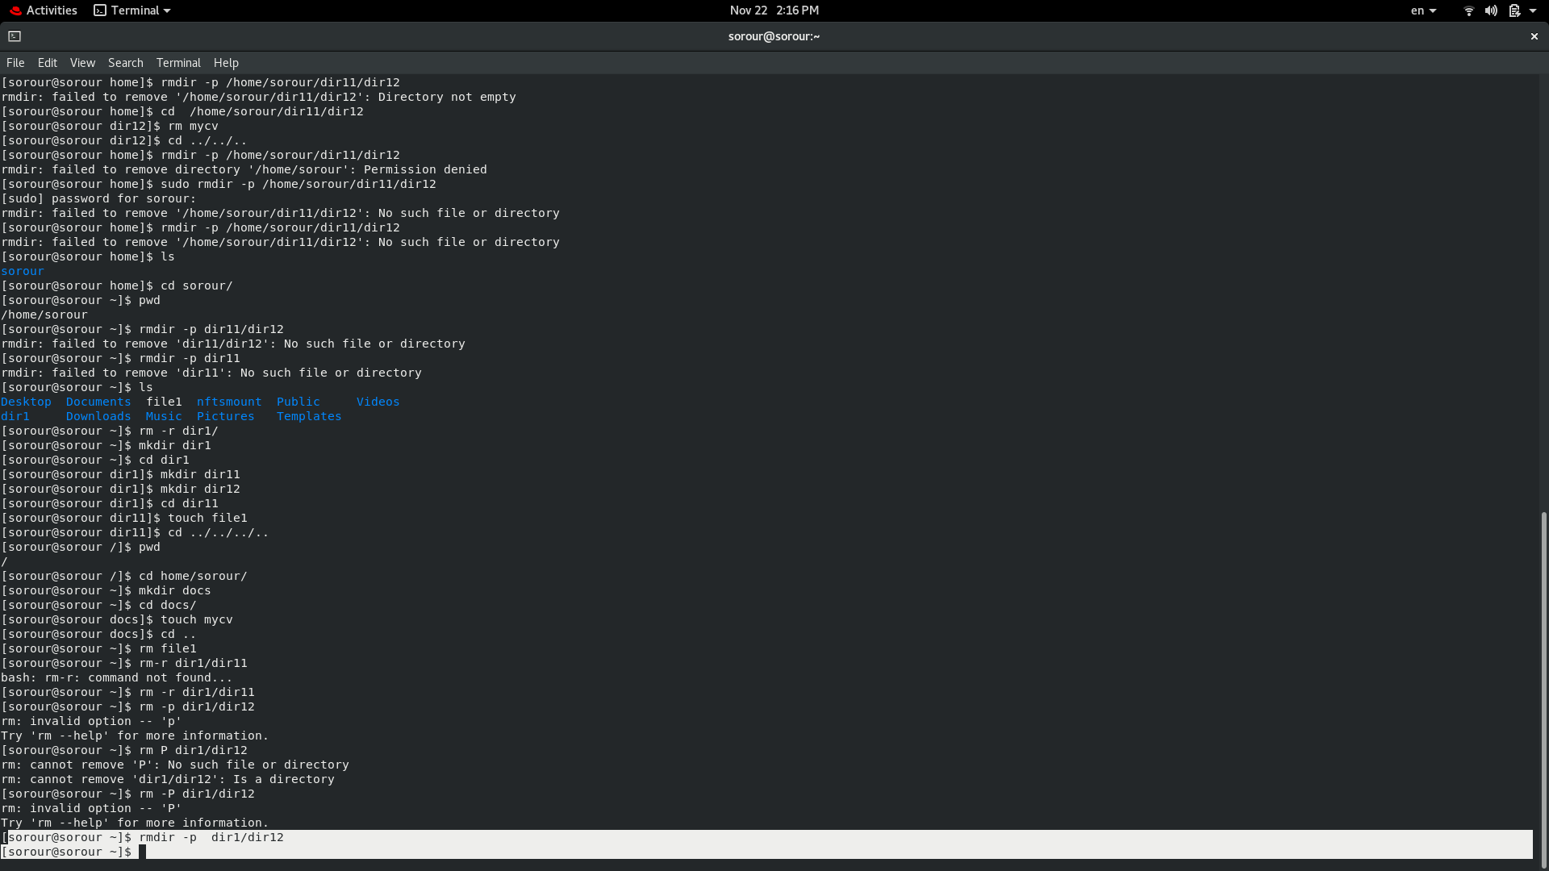
c. The output of the command pwd was /home/user. Write the absolute and relative path for the file mycv
relative path → docs/mycv
absolute path → home/sorour/docs/mycv

5. Copy the /etc/passwd file to your home directory making its name is mypasswd.
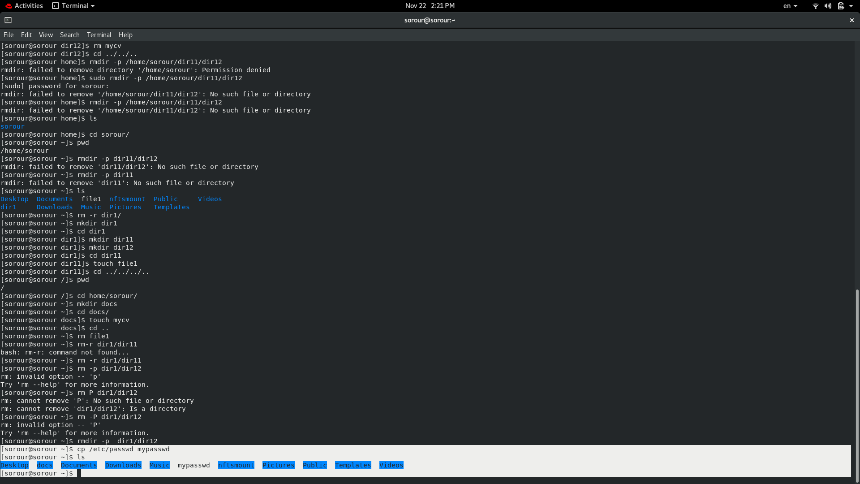
6. Rename this new file to be oldpasswd.
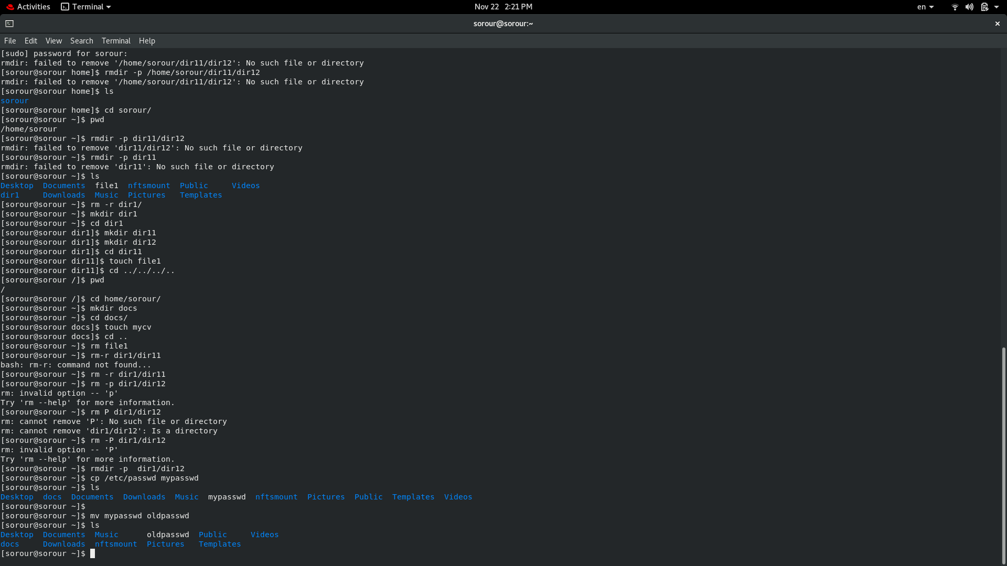
7. You are in /usr/bin, list four ways to go to your home directory
1-cd ../.. → cd home/sorour
2-cd ../.. → cd ~
3-cd /home/sorour
4- cd ~
8. List Linux commands in /usr/bin that start with letter w
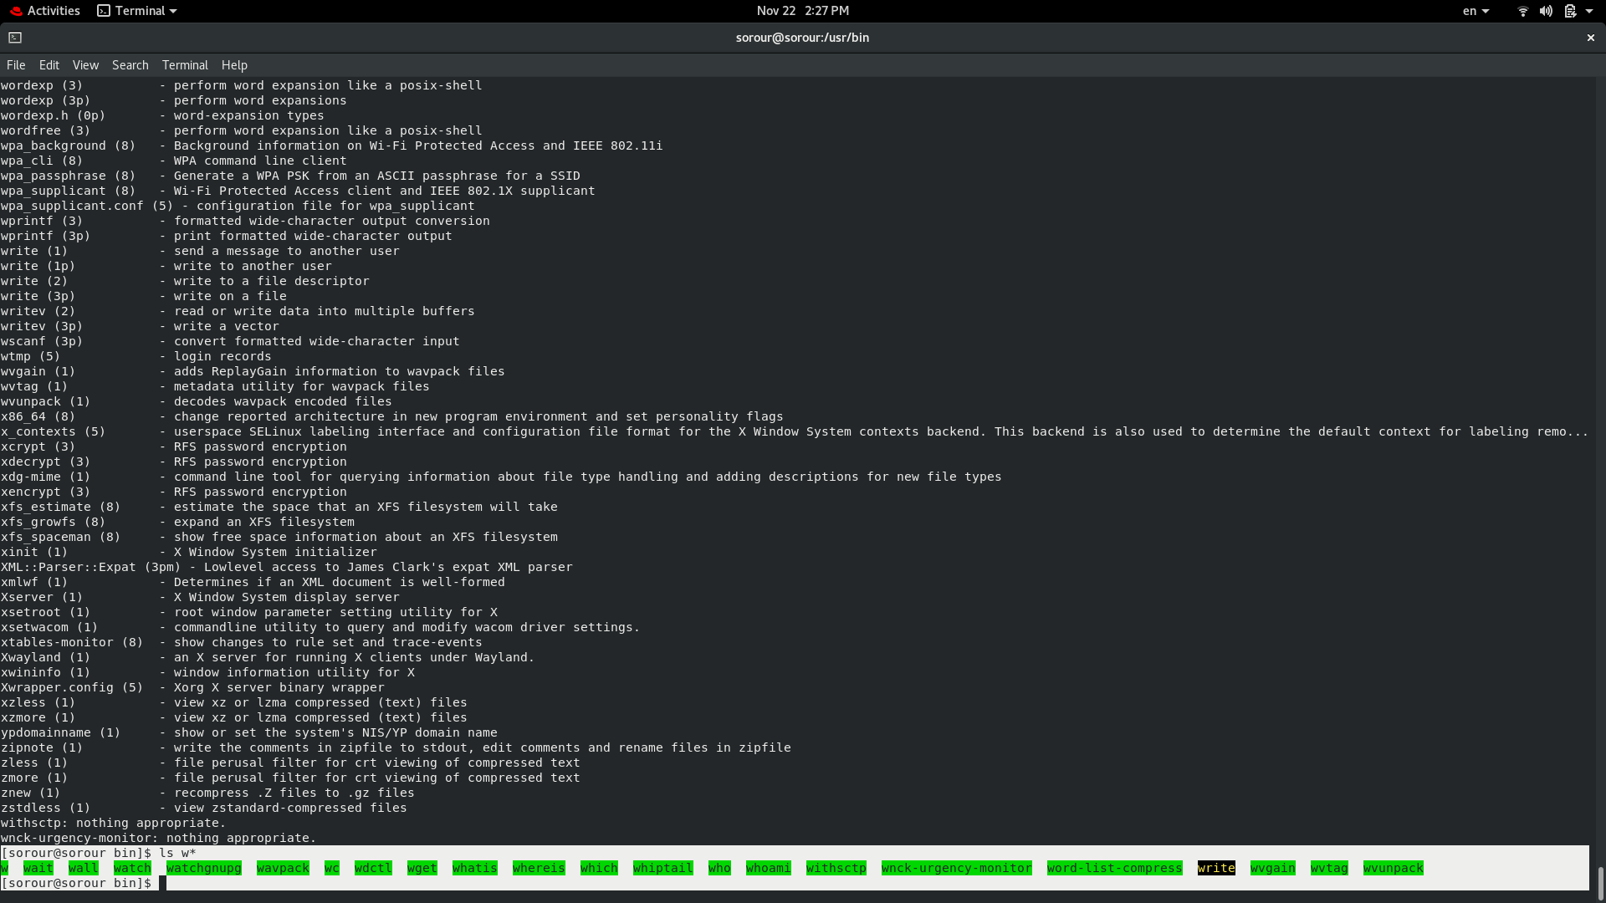
9. Display the first 4 lines of /etc/passwd
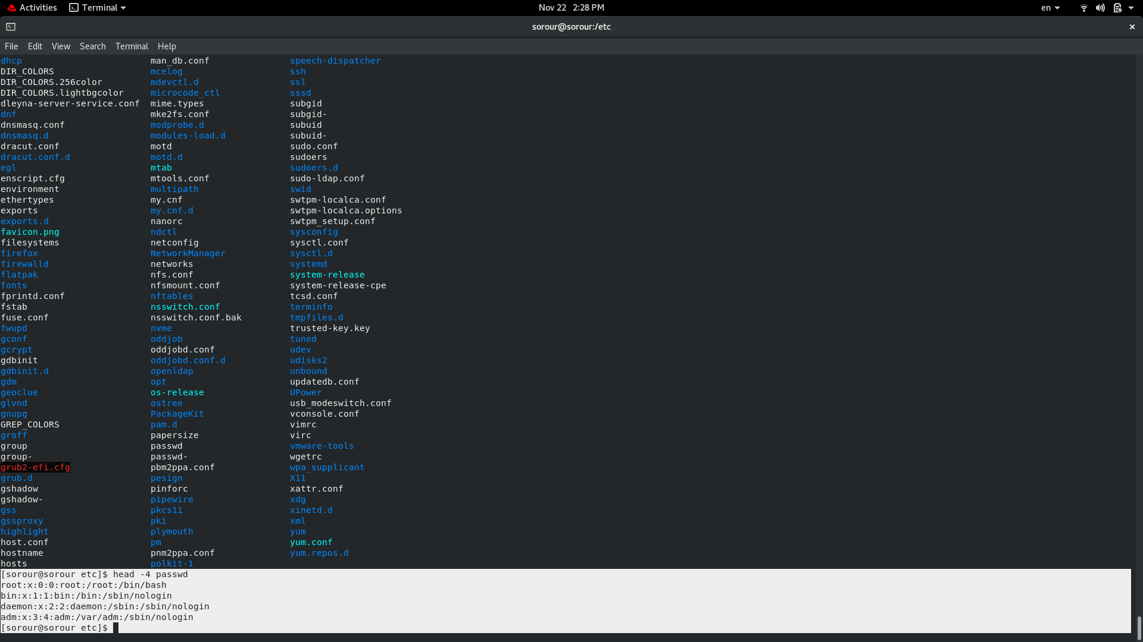
10.Display the last 7 lines of /etc/passwd
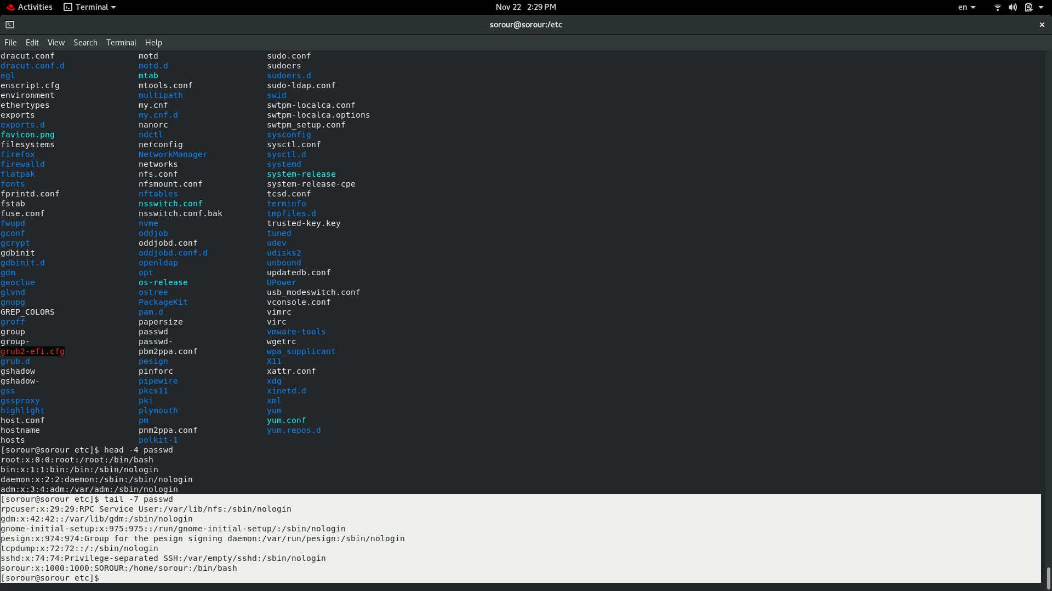
11.Display the man pages of passwd the command and the file sequentially in one command.

Man passed ; cat passwd
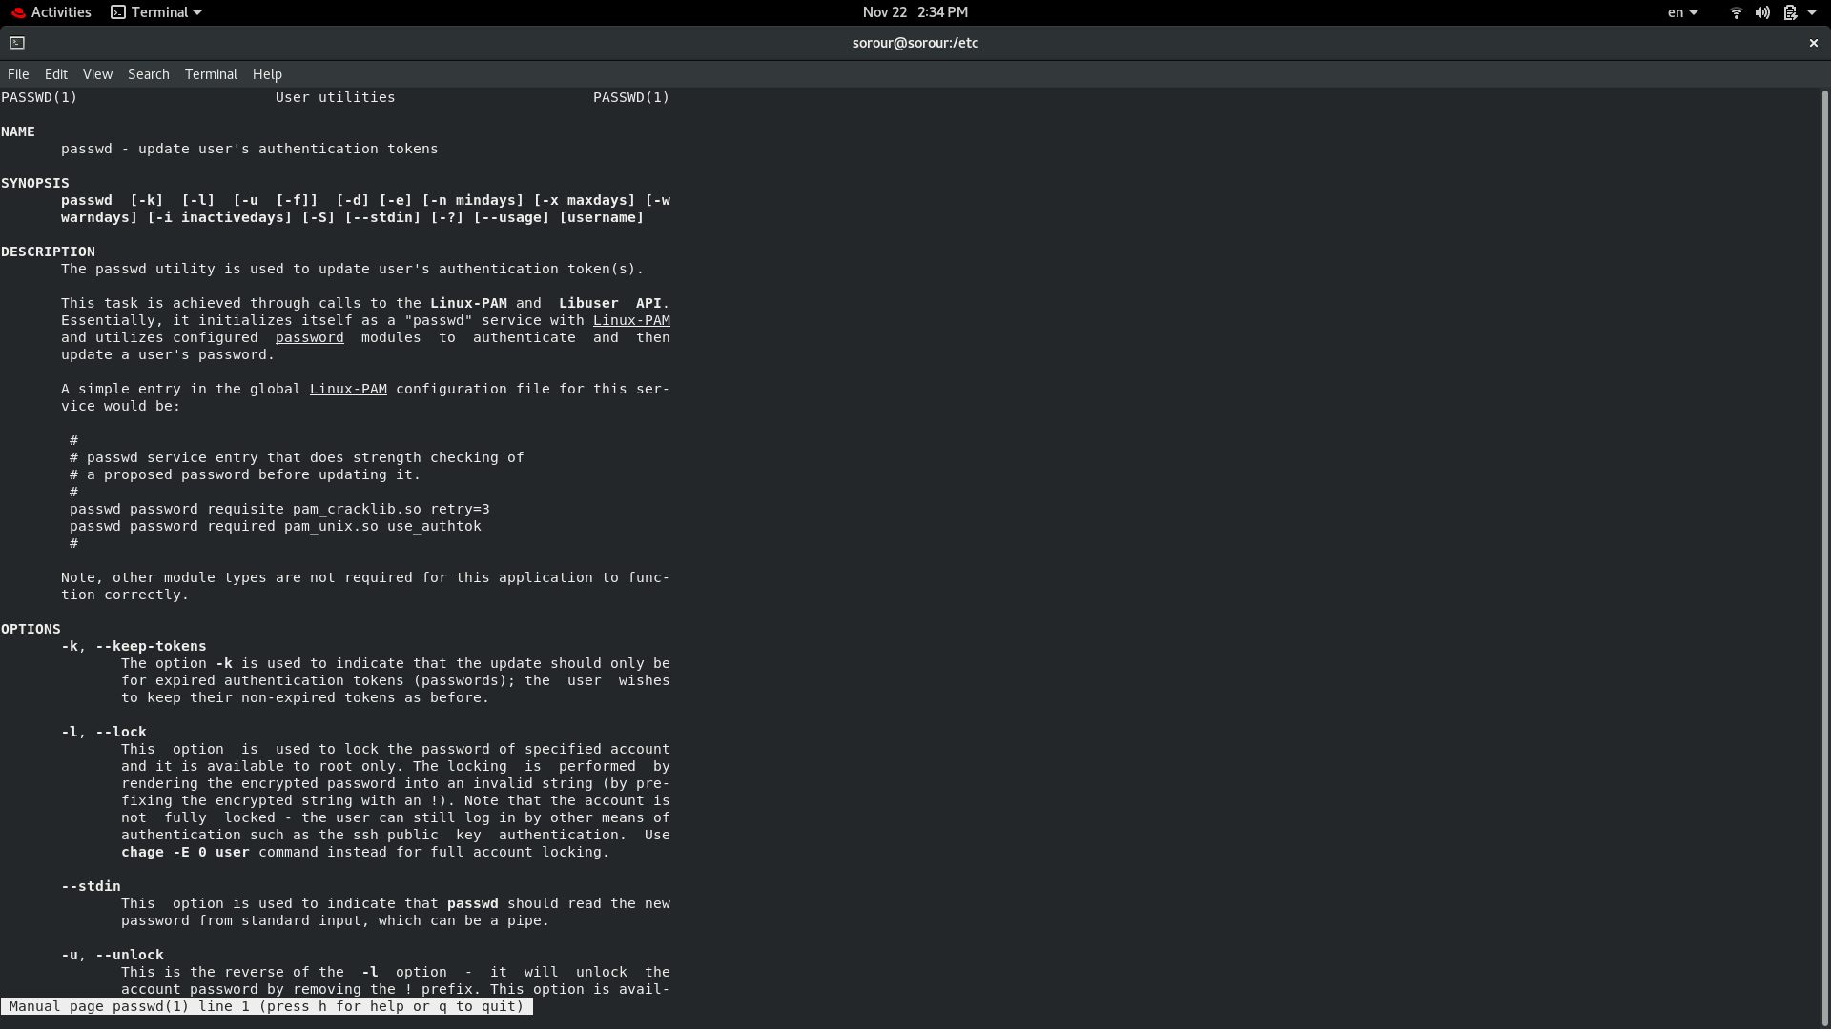

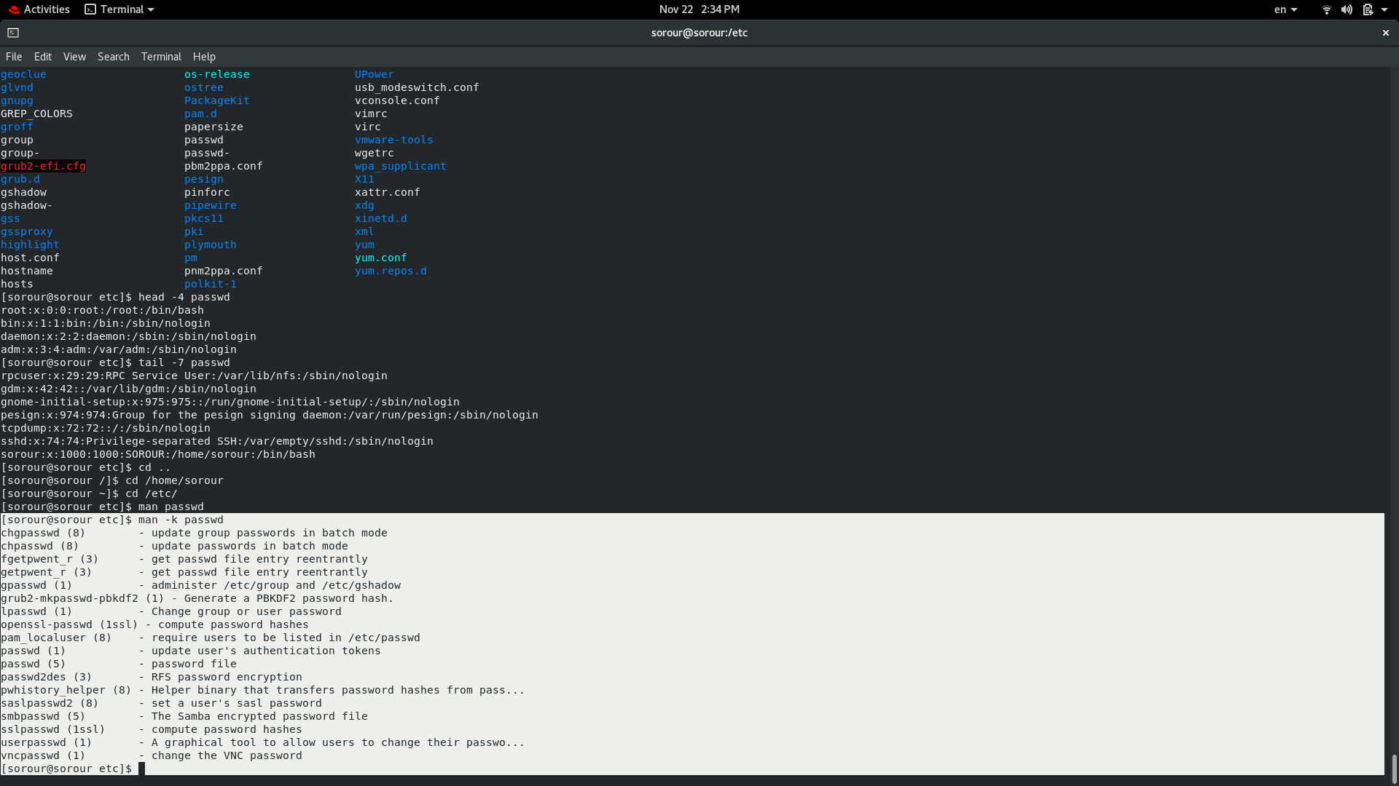
12.Display the man page of the passwd file.
13.Display a list of all the commands that contain the keyword passwd in their man page.

