RosettaCloud: Event-Driven Learning Platform Integration
A live more detailed, technical and interactive version of this Docs with high quality image and code snippets available: RosettaCloud Docs
Summary
RosettaCloud is a specialized event-driven technical learning platform designed to enhance existing Learning Management Systems (LMS) like OpenEdX. Rather than replacing core LMS functionality, RosettaCloud provides advanced hands-on lab environments, AI-powered assistance, and real-time feedback—seamlessly integrated with existing educational infrastructure.
The platform leverages Momento Cache and Topics services to create a scalable, real-time architecture where components communicate through events, ensuring a responsive and resilient educational experience that complements traditional LMS capabilities. 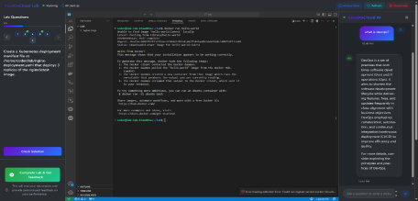Core Platform Architecture
RosettaCloud consists of three primary integrated systems, connected through an event driven architecture:
1. Interactive Lab Environment - Containerized environments for hands-on practice 2. AI-Powered Assistance - Real-time chatbot with context-aware responses 3. Personalized Feedback System - Event-driven feedback generation
These specialized components work alongside existing LMS functionality, creating a comprehensive educational ecosystem.
Event-Driven Architecture with Momento
The core of RosettaCloud is its event-driven architecture powered by Momento services: 1. Real-time Feedback: Immediate responses to user actions
2. System Decoupling: Independent components that communicate through events 3. Scalability: Efficient resource utilization during peak loads
4. Resilience: Fault tolerance through asynchronous communication Momento Cache Implementation
Momento Cache provides fast, distributed caching for ephemeral data: • Lab Session Tracking: Active lab environments mapped to user IDs • Question Caching: Parsed exercise metadata cached for rapid retrieval Momento Topics Implementation
Momento Topics enables real-time event broadcasting:
• Feedback System: Request-response cycle for personalized feedback • LMS Synchronization: Events that trigger updates to the core LMS (in planning) Integration with Existing Educational Ecosystems
RosettaCloud is architected as a complementary system that enhances established education platforms:
LMS Integration
RosettaCloud integrates with existing LMS platforms, which continue to manage: • User Management: Authentication, profiles, and roles
• Course Management: Content organization, curriculum design, and sequencing • Instructor Management: Teaching assignments and permissions • Enrollment: Student registration and access control
• Course Progress Tracking: Overall course completion and certification
RosettaCloud extends these systems with specialized technical education components:
• Interactive Lab Environments: Browser-based hands-on practice in isolated containers
• AI-Powered Assistance: Context-aware guidance through technical challenges • Real-time Exercise Verification: Automated checking of student solutions • Personalized Technical Feedback: AI-generated assessments of learner progress User Journey
The platform creates a seamless learning experience that connects core RosettaCloud functionality with LMS integration:
1. Authentication (currently it is auth using DynamoDB, but to be implemented using LMS) User → RosettaCloud Frontend → API Gateway → Authentication Service → DynamoDB
Users authenticate through RosettaCloud's authentication system, with user data stored in DynamoDB. This system is designed for future LMS integration through SSO mechanisms.
2. Lab Provisioning
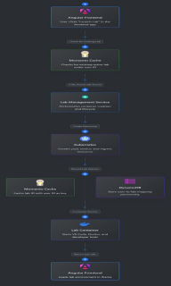
RosettaCloud Component → API Gateway → Lab Service → Momento Cache → Kubernetes
When a user selects a module, RosettaCloud checks Momento Cache for an existing lab session. If none exists, it creates Kubernetes resources, stores the lab ID in cach.
3. Lab Environment Access
Kubernetes → Lab Container → Code-Server → Angular Frontend (iframe)
The lab container initializes with developer tools, and the frontend embeds the environment in an iframe, allowing users to access their lab environment directly from the browser.
4. Exercise Completion
RosettaCloud supports two distinct question types, each with its own verification flow: Multiple Choice Questions (MCQ)
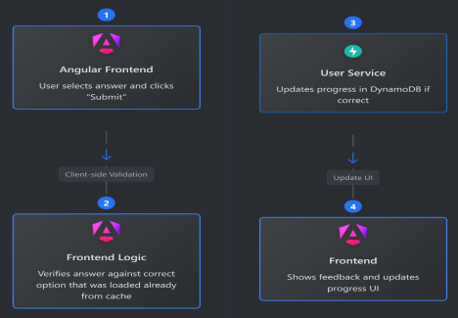Angular Frontend → Client-Side Validation → User Service → DynamoDB
MCQs are verified on the client side for instant feedback, with results persisted to RosettaCloud's storage.
Practical "Check" Questions
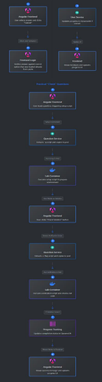
Angular Frontend → Question Service → Kubernetes → Lab Container → User Service → DynamoDB
Practical questions provide hands-on experience with real-world tools and require server side verification through execution of specialized scripts within the isolated lab container.
5. AI Assistance
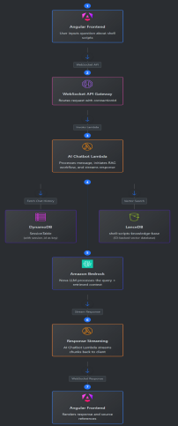
Angular Frontend → WebSocket API Gateway → AI Chatbot Lambda → Bedrock → Frontend
Students can ask questions through the integrated chatbot interface. The AI system uses Retrieval-Augmented Generation (RAG) to provide context-aware assistance based on course materials and technical documentation.
6. Feedback Request
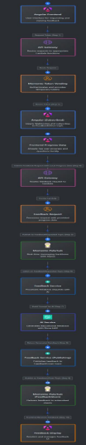
Angular Frontend → API Gateway → Feedback Request Lambda → Momento Topics → Frontend
Students can request personalized feedback on their progress. The AI-generated feedback is delivered in real-time via Momento Topics.
Key Features and Components
Interactive Lab Environment
• Containerized Tools: Code-Server with Docker-in-Docker capabilities • Resource Isolation: Each lab runs in separate Kubernetes namespace • Real-time Verification: Shell scripts with setup and check logic • Automatic Provisioning: On-demand creation from predefined templates AI-Powered Assistance
• Streaming Architecture: Real-time response chunks via WebSockets • Retrieval-Augmented Generation: Context from vector database • Educational Prompting: "Hint-first" approach encourages learning • Source Transparency: References to original documentation
Personalized Feedback System
• Secure Authentication: Short-lived, scoped Momento tokens • Asynchronous Processing: Non-blocking operation via topics • Real-Time Delivery: Immediate feedback delivery when ready • Comprehensive Assessment: Analysis of patterns across multiple exercises
Performance and Scalability
RosettaCloud's event-driven architecture provides exceptional performance characteristics:
Performance Advantages
• Lab Provisioning: New environments typically available within 1-2 seconds • Chatbot Responsiveness: Initial responses appear within 150ms • Feedback Generation: Comprehensive feedback delivered in under 2 seconds • Question Verification: Results available in under 500ms
• High Concurrency: System supports hundreds of simultaneous users
Scalability Benefits
1. Component Independence: Services scale individually based on demand 2. Resource Efficiency: Event-driven model minimizes idle resources
3. Peak Load Handling: Handles course launch periods without impacting performance
4. Caching Strategy: Momento Cache reduces database load
5. Asynchronous Processing: Background tasks don't block the learner experience Implementation Challenges and Solutions
Challenge 1: Resource Management
Solution: Implemented a robust event-driven lifecycle management system with Momento Cache for tracking active sessions and resource cleanup.
Challenge 2: Real-Time Communication
Solution: Combined WebSockets and Momento Topics to create a scalable, real-time communication system that efficiently handles thousands of concurrent connections.
Challenge 3: AI Response Latency
Solution: Implemented streaming responses via WebSockets, providing immediate feedback to users while chunking longer responses for perceived responsiveness.
Challenge 4: Stateless Architecture
Solution: Used Momento Cache and DynamoDB to maintain state across stateless Lambda functions, enabling horizontal scaling without synchronization issues.
Challenge 5: Environment Security
Solution: Created isolated container environments with strict resource limits and security boundaries, preventing cross-user contamination and resource abuse.
Educational Impact
Learning Effectiveness
• Immediate Feedback: Real-time verification results and AI assistance • Guided Discovery: "Hint-first" AI approach encourages critical thinking • Contextual Help: Documentation automatically retrieved and referenced
• Consistent Environments: Identical container environments eliminate setup issues • Comprehensive Review: Personalized feedback based on progress data Instructor Benefits
• Automated Verification: Immediate exercise validation without manual review • Progress Visibility: Real-time insight into student completion rates • Resource Efficiency: On-demand provisioning conserves computing resources • Scalable Support: AI assistance reduces repetitive questions
Future LMS Integration Capabilities
RosettaCloud is designed for seamless future integration with LMS platforms like OpenEdX:
User & Authentication Integration
• SSO Implementation: OpenID Connect/OAuth 2.0 for seamless authentication • Role-Based Access: Respect LMS permissions and course enrollments • Profile Synchronization: Maintain consistent user identity across systems Course & Content Integration
• LTI Compatibility: Support for Learning Tools Interoperability standard • Content Embedding: Labs embedded within course structure
• Content Sequencing: Honor prerequisites and course progression rules Grade & Progress Synchronization
• Grade Passback: LTI-compliant grade return to LMS gradebook
• Progress Tracking: Synchronize completion status across systems • Learning Analytics: Share detailed interaction data with LMS analytics
Deployment Architecture
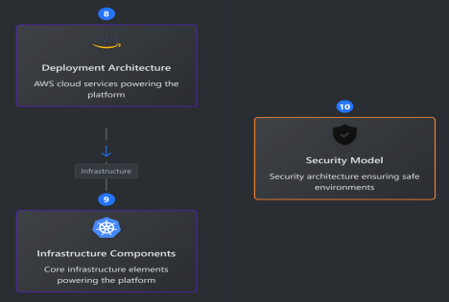
The integrated platform leverages AWS services and Momento for a seamless connection between systems:
AWS Services
• Amazon EKS: Hosts containerized lab environments (Currently we are using single EC2 to simulate it)
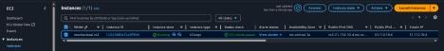• Lambda: Powers serverless components including chatbot and feedback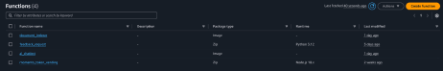
• API Gateway: Handles HTTP and WebSocket endpoints
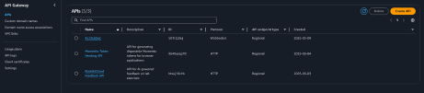• DynamoDB: Stores RosettaCloud-specific data
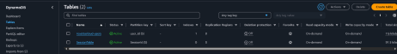• Amazon Bedrock: Provides AI capabilities for assistance and feedback 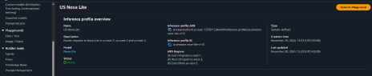Momento Services
• Momento Cache: Fast, distributed caching for ephemeral data
• Momento Topics: Real-time pub/sub messaging for event-driven communication
Conclusion
RosettaCloud demonstrates how event-driven architecture with Momento services can create a powerful technical education platform with the capability to integrate with traditional Learning Management Systems. The current implementation provides:
1. Hands-on Learning: Interactive environments for practical skill development 2. Intelligent Assistance: AI-powered guidance and feedback
3. Real-time Verification: Immediate validation of student solutions
4. Scalable Architecture: Event-driven design that handles educational workloads efficiently
The platform's architecture is specifically designed to enable future integration with LMS platforms, allowing RosettaCloud to complement existing educational technology investments while providing specialized technical education capabilities.
By focusing on these core strengths while building toward seamless LMS integration, RosettaCloud offers immediate value while positioning for a comprehensive educational ecosystem in the future.

