

**Faculty of engineering - Shoubra**

**Benha University**

**Research Article / Research Project / Literature Review**

in fulfillment of the requirements of

|  |  |
| --- | --- |
| **Department** | **Engineering Mathematics and Physics** |
| **Division** | **-----------------** |
| **Academic Year** | **2019-2020 Preparatory** |
| **Course name** | **computer** |
| **Course code** | **EMP023** |

**Title: -**

**……………Operating System……………**

By:

|  |  |  |  |
| --- | --- | --- | --- |
|  | Name | Edu mail | B.N |
| 1 | محمد طارق محمد النحاس | muhammed195823@feng.bu.edu.eg | 19 |

**Approved by:**

|  |  |
| --- | --- |
| Examiners committee | Signature |
|  |  |
|  |  |
|  |  |
|  |  |
|  |  |

**Research objectives**

1.Convenience: An OS makes a computer more convenient to use.

2.Efficiency: An OS allows the computer system resources to be used in an efficient manner.

3.Ability to evolve: An OS should be constructed in such a way as to permit the effective development, testing, and introduction of new system functions without interfering with service.

4. Making a computer system convenient to use i.e. hides details of Hardware resources from the programmer and provides him with a convenient interface of using computer system. It acts as an intermediary between hardware and software providing a high level interface to low level hardware and making it easier for the software to access the use of those resources.

5. Managing computer resources. This involves performing such tasks as keeping track of who is using which resource, granting resource requests, accounting for resource usage, and mediating conflicting requests from different programs and users.

**Abstract**

An operating system (OS) is system software that manages computer hardware, software resources, and provides common services for computer programs. Time-sharing operating systems schedule tasks for efficient use of the system and may also include accounting software for cost allocation of processor time, mass storage, printing, and other resources. For hardware functions such as input and output and memory allocation, the operating system acts as an intermediary between programs and the computer hardware,[1][2] although the application code is usually executed directly by the hardware and frequently makes system calls to an OS function or is interrupted by it. Operating systems are found on many devices that contain a computer – from cellular phones and video game consoles to web servers and supercomputers. The dominant desktop operating system is Microsoft Windows with a market share of around 82.74%. macOS by Apple Inc. is in second place (13.23%), and the varieties of Linux are collectively in third place (1.57%).[3] In the mobile sector (including smartphones and tablets), Android's share is up to 70% in the year 2017.[4] According to third quarter 2016 data, Android's share on smartphones is dominant with 87.5 percent with also a growth rate of 10.3 percent per year, followed by Apple's iOS with 12.1 percent with per year decrease in market share of 5.2 percent, while other operating systems amount to just 0.3 percent.[5] Linux distributions are dominant in the server and supercomputing sectors. Other specialized classes of operating systems, such as embedded and real-time systems, exist for many applications.

**Table of contents**

|  |  |
| --- | --- |
| **Subject / section** | **Page** |
| Introduction | **4** |
| Functions of Operating system, Types of Operating Systems  )Batch Operating System( | **5** |
| )Time-Sharing Operating Systems( | **6** |
| )Distributed Operating System( | **7** |
| Conclusions | **9** |
| References | **10** |

**List of Figures (If any)**

|  |  |  |
| --- | --- | --- |
| **Figure I.D** | **Description** | **Page** |
|  | Batch Operating System | **6** |
|  | Time-Sharing Operating Systems | **7** |
|  | Distributed Operating System | **8** |
|  |  |  |
|  |  |  |
|  |  |  |

**Introduction**

An operating system acts as an intermediary between the user of a computer and computer hardware. The purpose of an operating system is to provide an environment in which a user can execute programs in a convenient and efficient manner. An operating system is a software that manages the computer hardware. The hardware must provide appropriate mechanisms to ensure the correct operation of the computer system and to prevent user programs from interfering with the proper operation of the system. Operating System – Definition:

_An operating system is a program that controls the execution of application programs and acts as an interface between the user of a computer and the computer hardware.

_A more common definition is that the operating system is the one program running at all times on the computer (usually called the kernel), with all else being application programs.

_An operating system is concerned with the allocation of resources and services, such as memory, processors, devices, and information. The operating system correspondingly includes programs to manage these resources, such as a traffic controller, a scheduler, memory management module, I/O programs, and a file system.

**Literature Review**

Functions of Operating system – Operating system performs three functions:

1) Convenience: An OS makes a computer more convenient to use.

2) Efficiency: An OS allows the computer system resources to be used in an efficient manner.

3) Ability to Evolve: An OS should be constructed in such a way as to permit the effective development, testing and introduction of new system functions at the same time without interfering with service.

Types of Operating Systems

An Operating System performs all the basic tasks like managing file,process, and memory. Thus operating system acts as manager of all the resources, i.e. resource manager. Thus operating system becomes an interface between user and machine.Types of Operating Systems: Some of the widely used operating systems are as follows-

1. Batch Operating System –

This type of operating system does not interact with the computer directly. There is an operator which takes similar jobs having same requirement and group them into batches. It is the responsibility of operator to sort the jobs with similar needs.

Advantages of Batch Operating System:

_Multiple users can share the batch systems

_The idle time for batch system is very less

**Disadvantages of Batch Operating System:**

**_The computer operators should be well known with batch systems**

**_Batch systems are hard to debug**

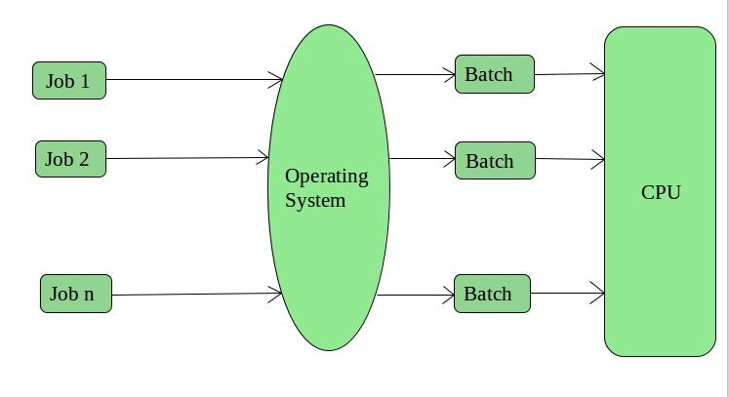

2. Time-Sharing Operating Systems –

Each task is given some time to execute, so that all the tasks work smoothly. Each user gets time of CPU as they use single system. These systems are also known as Multitasking Systems. The task can be from single user or from different users also. The time that each task gets to execute is called quantum. After this time interval is over OS switches over to next task.

Advantages of Time-Sharing OS:

_Each task gets an equal opportunity

_Less chances of duplication of software

Disadvantages of Time-Sharing OS:

_One must have to take care of security and integrity of user programs and data

_Data communication problem

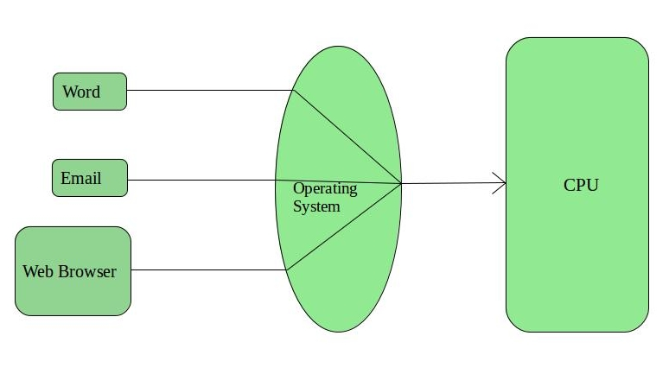

3. Distributed Operating System –

These types of operating system is a recent advancement in the world of computer technology and are being widely accepted all-over the world and, that too, with a great pace. Various autonomous interconnected computers communicate each other using a shared communication network. Independent systems possess their own memory unit and CPU. These are referred as loosely coupled systems or distributed systems. These system’s processors differ in size and function. The major benefit of working with these types of operating system is that it is always possible that one

user can access the files or software which are not actually present on his system but on some other system connected within this network i.e., remote access is enabled within the devices connected in that network.

Advantages of Distributed Operating System:

_Electronic mail increases the data exchange speed

_Since resources are being shared, computation is highly fast and durable

Disadvantages of Distributed Operating System:

_Failure of the main network will stop the entire communication

_To establish distributed systems the language which are used are not well defined yet

_These types of systems are not readily available as they are very expensive. Not only that the underlying software is highly complex and not understood well yet

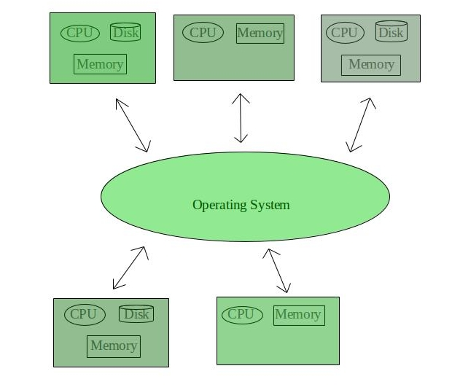

**Conclusions**

The operating system in its current form empowers users of all ages, as well as small, medium and large businesses – from children whose needs are only to play games and access the internet; to more specialised, productive and engineer/constructive areas of work: secretarial, household economies to large corporations (each member of staff) – in its use and functions, across a range of platforms/architectures, as never before. We now have a mass market, on a global scale, getting larger year by year. Its not a question any more, about the difficulties of computer technologies when it comes to buying or having an interest in this consumer product, but when will I be able to afford it. Computer OSs, currently, are based upon its visual aspects for users to handle and understand it; and indeed designers and developers have succeeded in this regard, for there will be no return to text-base interface/system. To understand, basically, the rudiments of the GUI system, requires very little preparatory reading of manual/user-guides, as it would have been with the text-base system; the graphical user interface allows intuitive interactions, and for this reason, more and more users cannot imagine anything else; it has become a de facto in the market place. To conclude, I do believe the computer is here to stay, and therefore it will require an OS, and has stated elsewhere in this report, the OS represent the persona of the computer; and for this reason, the computer and its persona will continue to evolve, as we evolve and our expectation grows; and by Gordon Moore's Law, bearing the silicon chip in mind, about every two years we can expect dramatic changes with an equal dramatic rein on cost.

**References**

1) "Desktop Operating System Market Share Worldwide | StatCounter Global Stats". StatCounter Global Stats. Retrieved 18 December 2017.

2) Dhotre, I.A. (2009). Operating Systems. Technical Publications. p. 1.

3) "w3schools.com OS Platform Statistics". Archived from the original on 5 August 2011. Retrieved 30 October 2011.

4) "Operating System Share by Groups for Sites in All Locations January 2009". Archived from the original on 6 July 2009. Retrieved 3 May 2010.