Experiment 5: UPTIME, DATE, MV Commands
Aim
To Execute and display the results for the following commands in Kali Linux Operating Systems: Uptime, Date, Mv.
Procedure
• Open Kali Linux
• Open terminal
• uptime command
- uptime -- press Enter.
- It displays the system running time, number of logged-in users, and system load averages.
• date command
- date -- press Enter.
- It displays the current system date and time.
• Creating a file for mv command
- mkdir EH5 -- press Enter.
- cd EH5 -- press Enter.
- touch old.txt -- press Enter.
• mv command
- mv old.txt new.txt -- press Enter.
- ls -- press Enter.
- It displays new.txt, confirming that the file has been renamed successfully.
Output: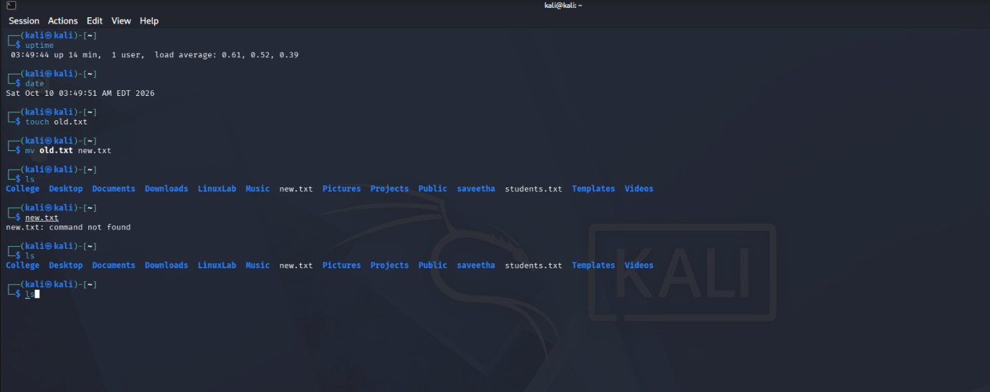
Result:Result: Thus, the uptime, date, and mv commands were executed successfully in Kali Linux Operating System, and their results were displayed.

