EXPERIMENT 7: EXECUTION OF CD, CP AND LS COMMANDS IN KALI LINUX

AIM:
To execute and display the results of the cd, cp, and ls commands in the Kali Linux operating system.
PROCEDURE:
1. CD Command (Change Directory)
The cd command is used to change the current working directory in Kali Linux.
Steps:
- Open the Kali Linux terminal.
- Type pwd to display the current working directory.
- Execute cd Documents to move to the Documents directory.
- Execute pwd to verify the current directory.
- Use cd .. to move to the parent directory.
Commands:
pwd
cd Documents
pwd
cd ..
2. CP Command (Copy Files)
The cp command is used to copy files from one location to another.
Steps:
- Open the Kali Linux terminal.
- Execute touch file1.txt to create a sample file.
- Execute cp file1.txt file2.txt to copy the file.
- Execute ls to verify that both files are present.
Commands:
touch file1.txt
cp file1.txt file2.txt
ls
3. LS Command (List Files and Directories)
The ls command is used to display the files and directories in the current working directory.
Steps:
- Open the Kali Linux terminal.
- Execute ls to list files and directories.
- Execute ls -l to display detailed information about files and directories.
- Execute ls -a to display all files, including hidden files.
Commands:
ls
ls -l
ls -a

Output: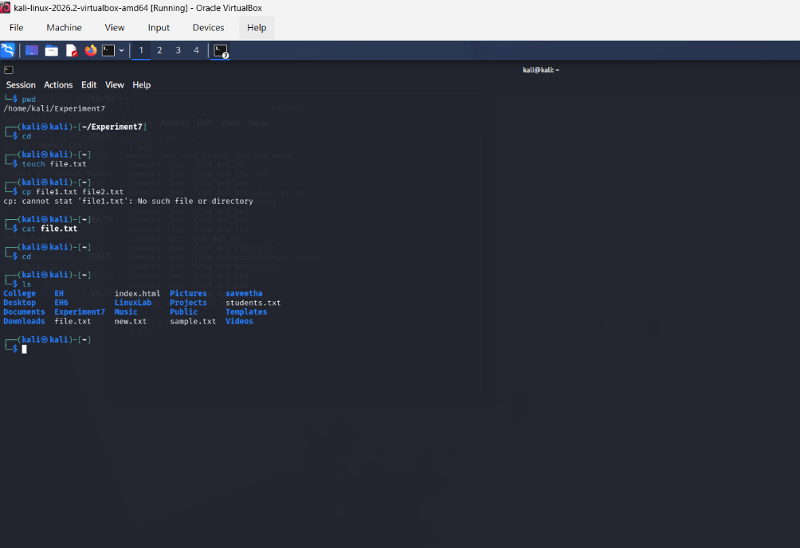

RESULT:
Thus, the cd, cp, and ls commands were successfully executed and studied in Kali Linux. The cd command was used to change directories, the cp command was used to copy files, and the ls command was used to list files and directories.

