CsharpDay09Assignment

PART01

Name: Mohamed Waleed Elkady
- Questions

1️)Why explicitly assign enum values?
To control exact numeric values for database storage, API communication, versioning, and avoiding accidental value shifts if new members are inserted.

2️)What if enum value exceeds underlying type range?
You get a compile-time error because the value cannot fit into the specified underlying type.

3️)Purpose of virtual with properties?
It allows derived classes to override and provide a new implementation.

4️)Why can’t you override a sealed member?
Because sealed prevents further modification in derived classes to protect the implementation.

5️)Static vs object members?
Static members belong to the class itself.
Object members belong to instances.

6️)Can you overload all operators?
No. Some operators like . , ?:, sizeof, typeof cannot be overloaded because they are language-defined behavior.

7️)When change enum underlying type?
When optimizing memory or matching external systems (e.g., network protocol using byte).

8️)Why can't static class have instance constructors?
Because static classes cannot be instantiated.

9️)Advantages of Enum.TryParse?
It prevents exceptions and safely handles invalid input.

10) Equals vs == in struct and class?
Struct: == not defined by default; Equals compares values.
Class: == compares references unless overloaded.

11)Why override ToString?
To provide meaningful readable output instead of type name.

12)Can generics be constrained?
Yes. Example:
where T : IComparable<T>

13)Generic method vs generic class?
Generic method applies type parameter only to method.
Generic class applies type parameter to entire class.

14)Why prefer generic swap?
Reduces duplication and works with any type.

15)Why override Equals in Department?
Ensures logical comparison (by Id) instead of reference comparison.

16)Why == not implemented by default for structs?
Because structs are value types and equality logic depends on developer intent, so C# avoids automatic operator generation.

PART02

1-Linkedin article: 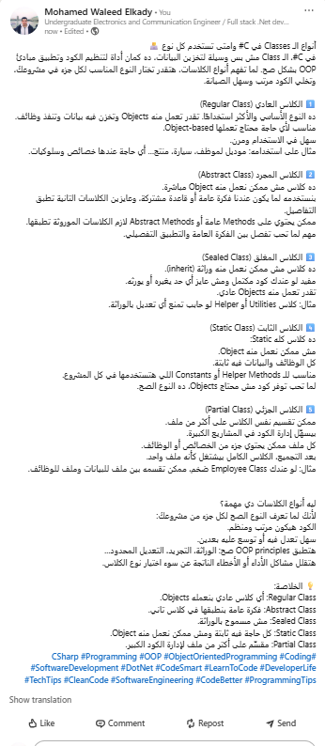

2- Generalization concept using Generics
Generalization is the idea of writing code that can work with many types instead of being limited to one specific type. In C#, generics are used to achieve generalization. They allow classes, methods, or interfaces to operate on any data type while maintaining type safety. This means you can write reusable and flexible code that works for integers, strings, or even custom classes, without duplicating logic for each type.
Key points:
- Reusable code for multiple types.
- Type-safe operations.
- Reduces duplication and increases flexibility.

3- Hierarchy design in real business
Hierarchy design is the practice of organizing classes and objects in a tree-like structure that represents real-world business relationships and roles. In C#, this is implemented through inheritance, abstract classes, and interfaces. The idea is to model general concepts as base classes (e.g., Employee) and specific roles as derived classes (e.g., Manager, Developer).
Key points:
- Base classes represent general concepts; derived classes represent specific roles.
- Reflects real business structures and responsibilities.
- Improves code clarity, maintainability, and reusability.

