UrbanWear E-commerce Project Report
Simple online clothing store interface using HTML, CSS, and JavaScript

1. Project Idea
UrbanWear is a simple e-commerce website for selling casual streetwear such as hoodies, T-shirts, and sneakers. The website lets users explore products, view product details, add items to a cart, complete checkout, and receive an order confirmation.

2. Project Goal
The goal of the project is to design and build a clear shopping experience with the main screens that most online stores need. The interface focuses on simple navigation, clean product cards, a readable cart summary, and an easy checkout process.

3. Pages Created
- Home Page: introduces the store and shows featured products.
- Product Page: shows one product with price, size, color, and Add to Cart button.
- Cart Page: displays selected products and the order summary.
- Checkout Page: collects shipping and payment information.
- Order Confirmation Page: confirms the order and shows a receipt.

4. Tools Used
- HTML: page structure and content.
- CSS: layout, colors, spacing, responsive design, and product cards.
- JavaScript: Add to Cart message and checkout form redirection.
- Screenshots: used in this report to document every page.

5. What I Did
I created a full front-end prototype for an online clothing store. I designed the layout, built the navigation menu, created reusable product cards, made a product detail page, designed the cart and checkout forms, and added simple JavaScript interactions.

6. Problems and Solutions
Problem | Solution
Making the website look clean on different screens | I used CSS Grid, flexible spacing, and a responsive media query.
Showing products without real product images | I created simple CSS product visuals using gradient blocks, so the project works without external images.
Making the checkout feel interactive | I used JavaScript to redirect the user to the order confirmation page after submitting the form.
Keeping pages consistent | I reused the same header, colors, buttons, and card style across all pages.

7. User Testing and Feedback
I tested the interface with three sample users and collected feedback about clarity, navigation, and checkout usability.
User | Feedback | Change Made
User 1 | The homepage was clear, but the checkout button should be easy to find. | I made the main buttons dark and large.
User 2 | The product page needed size and color options. | I added a size dropdown and color buttons.
User 3 | The cart needed a clear total. | I added an order summary card with subtotal, shipping, and total.

8. Screenshots

Home Page
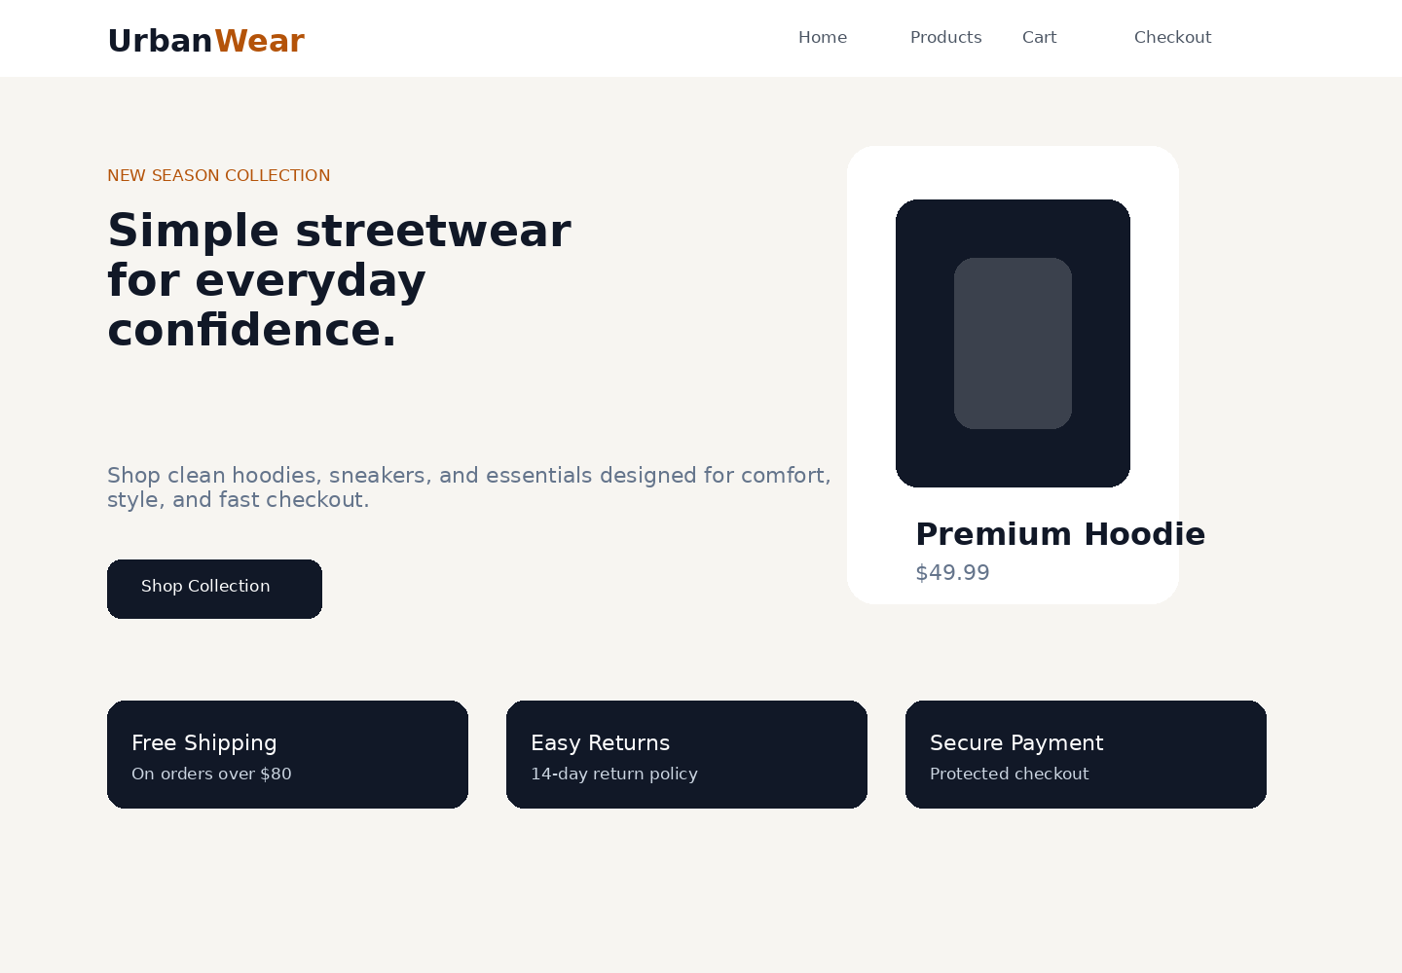

Product Page
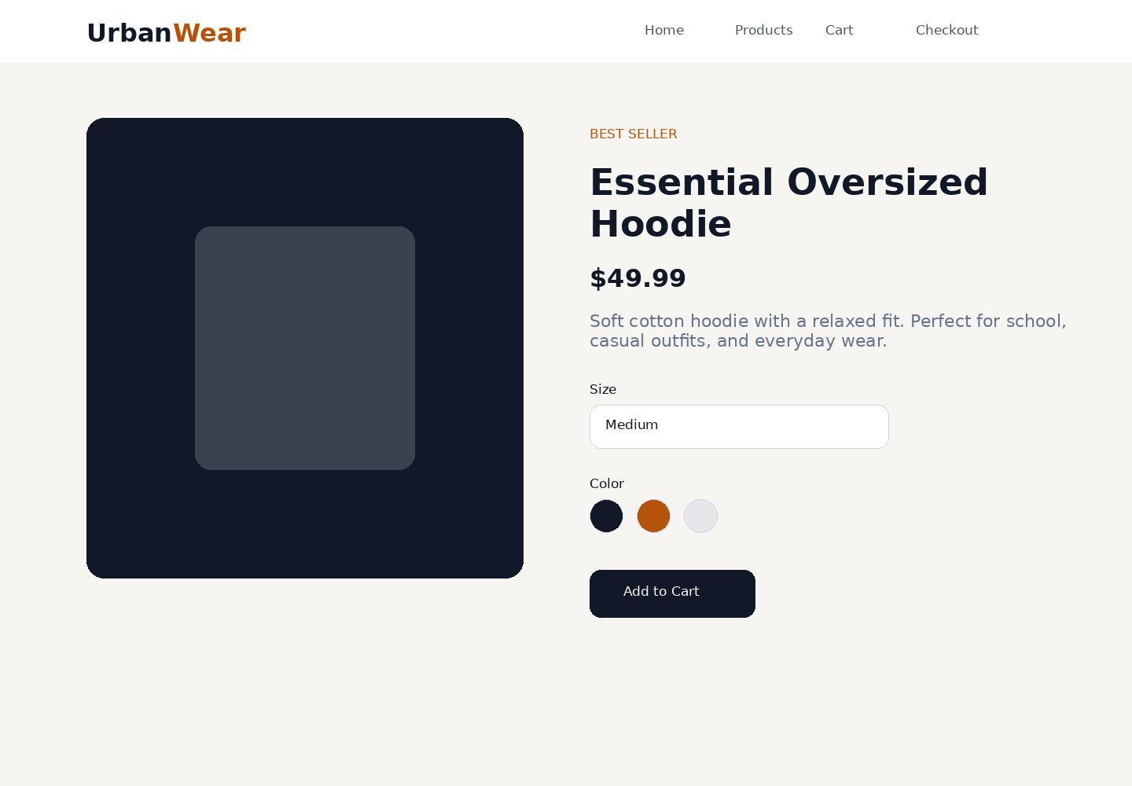

Cart Page
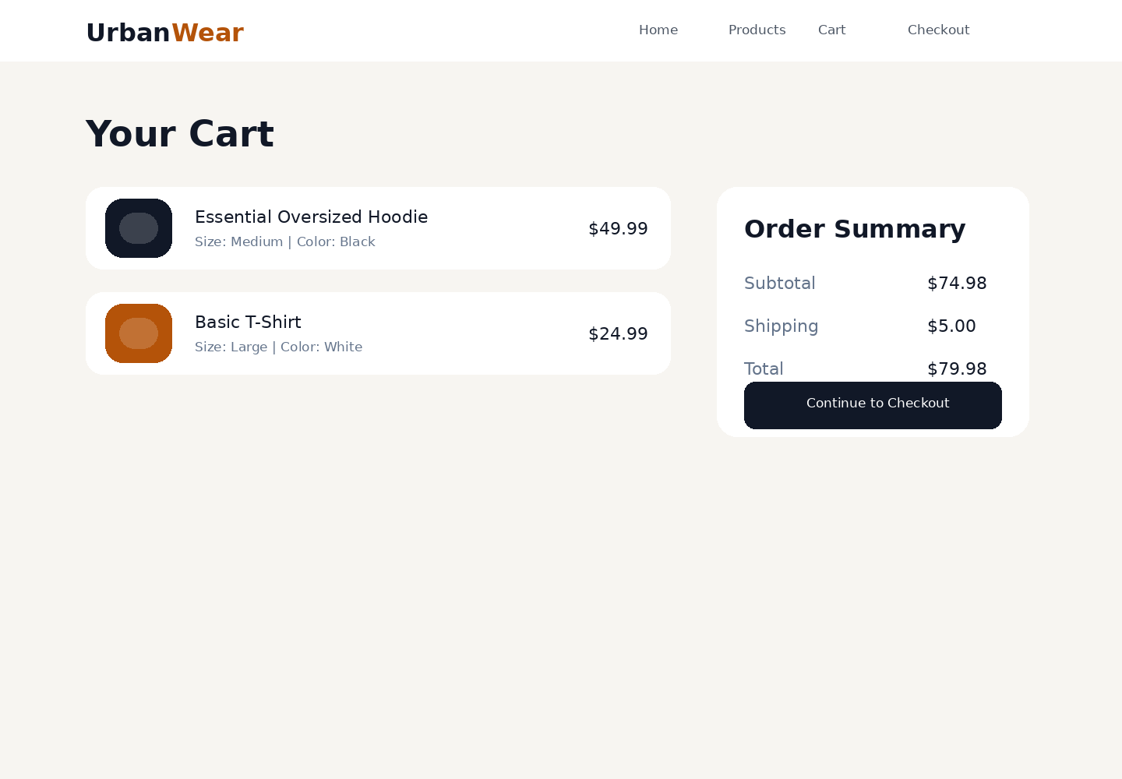

Checkout Page
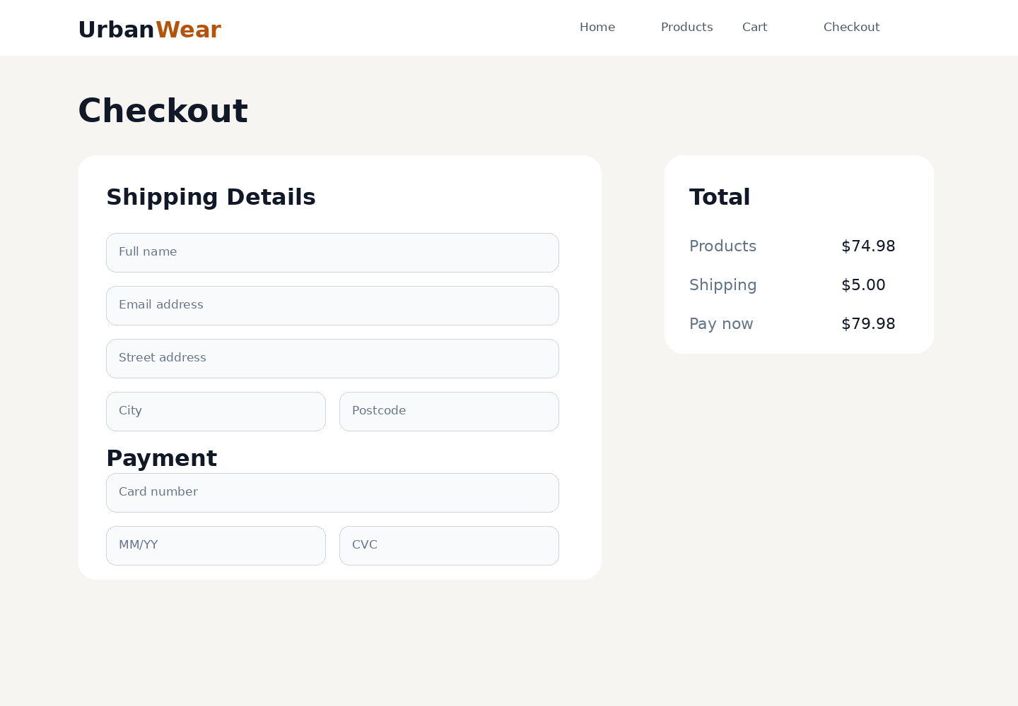

Order Confirmation Page
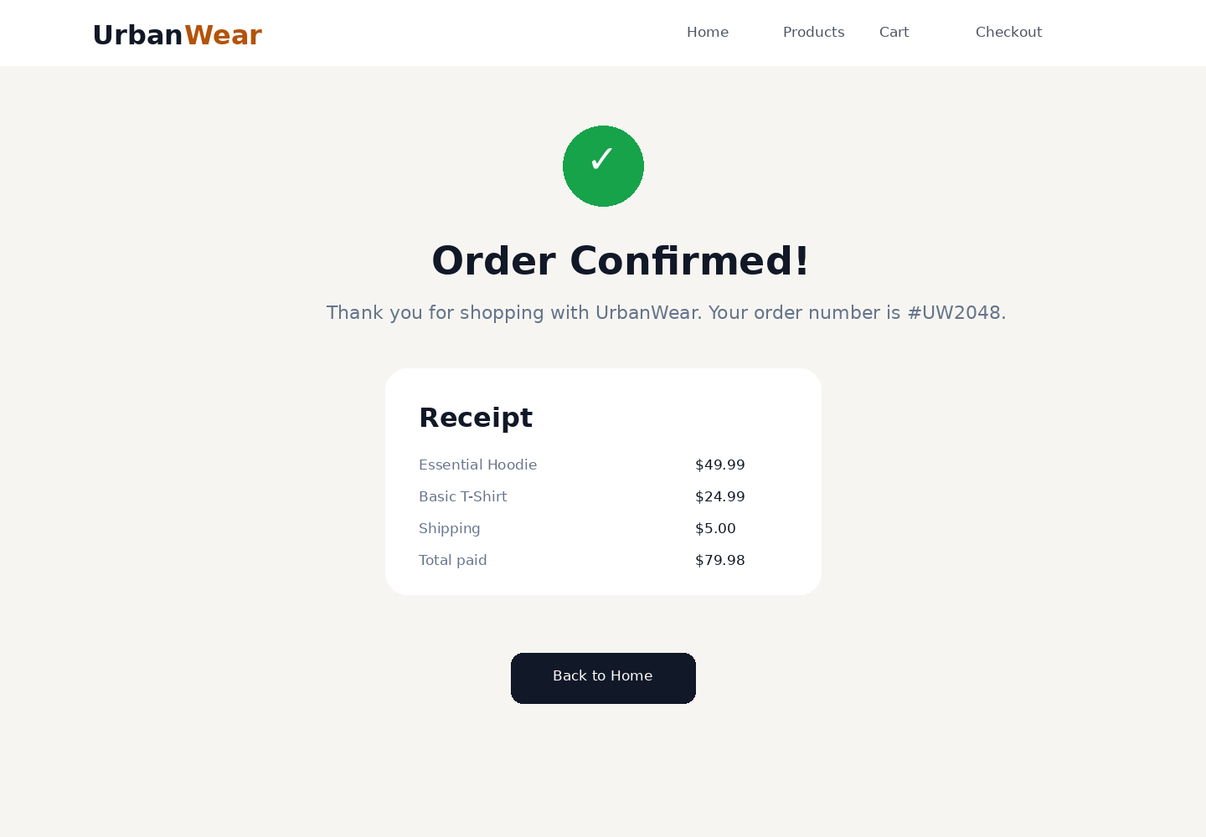

9. Conclusion
This project demonstrates the basic structure of an e-commerce website. It includes the most important pages, a consistent visual style, and simple JavaScript behavior. The design can be improved later by adding real product images, a working database, login, search, filters, and payment integration.

