AIE 425 Intelligent Recommender Systems, Fall Semester 24/25

Assignment #2: Significance weighting-based neighborhood CF

Student ID: A20000947

Full Name: Mohamed Yasser Saad Ahmed

Outcomes of section 3.1

The ratings has been normalized to a 1-5 rating scale.
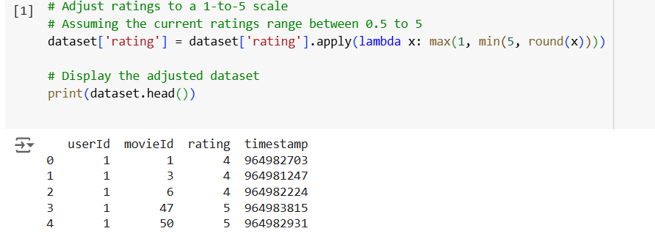
Then the total numbers of unique users and unique items has been counted, and also the total numbers of ratings.
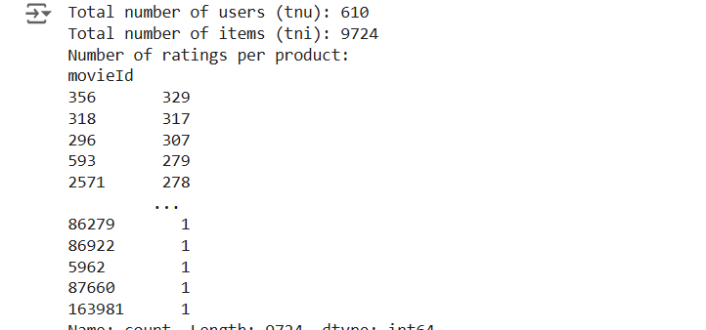

Afterwards the active users and target items has been picked based on the required criteria:
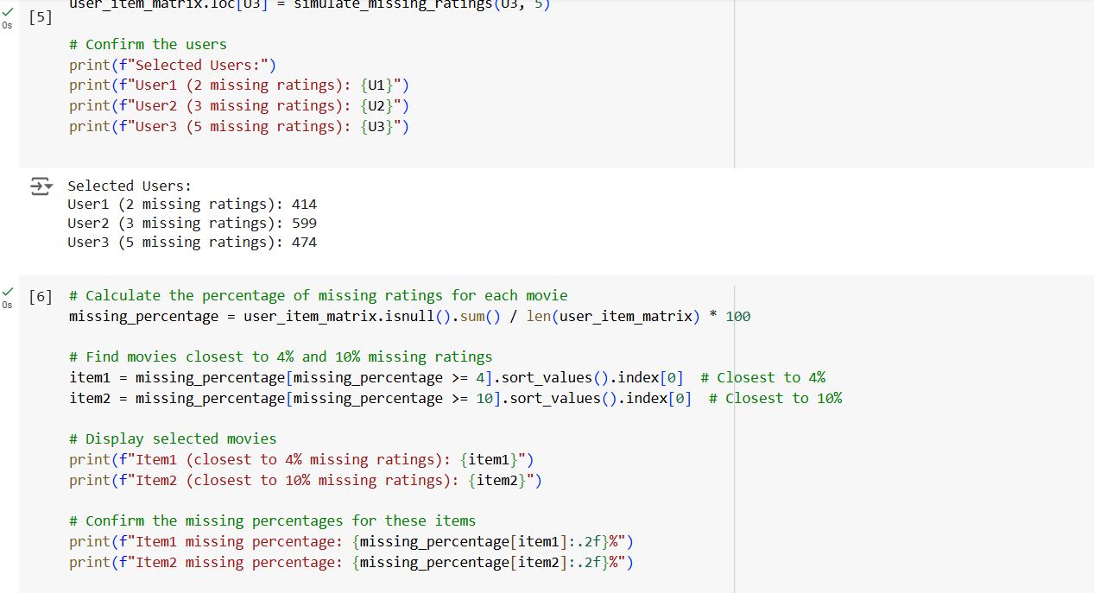
Then the numbers of users with common rated items has been counted and the also the number of co rated items:
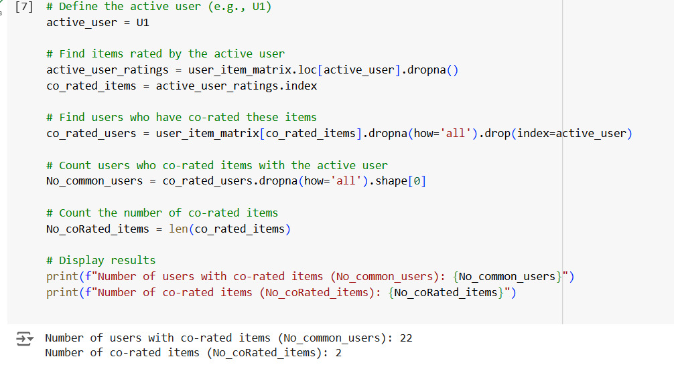

The quantity of ratings for the items has been visualized on a graph:

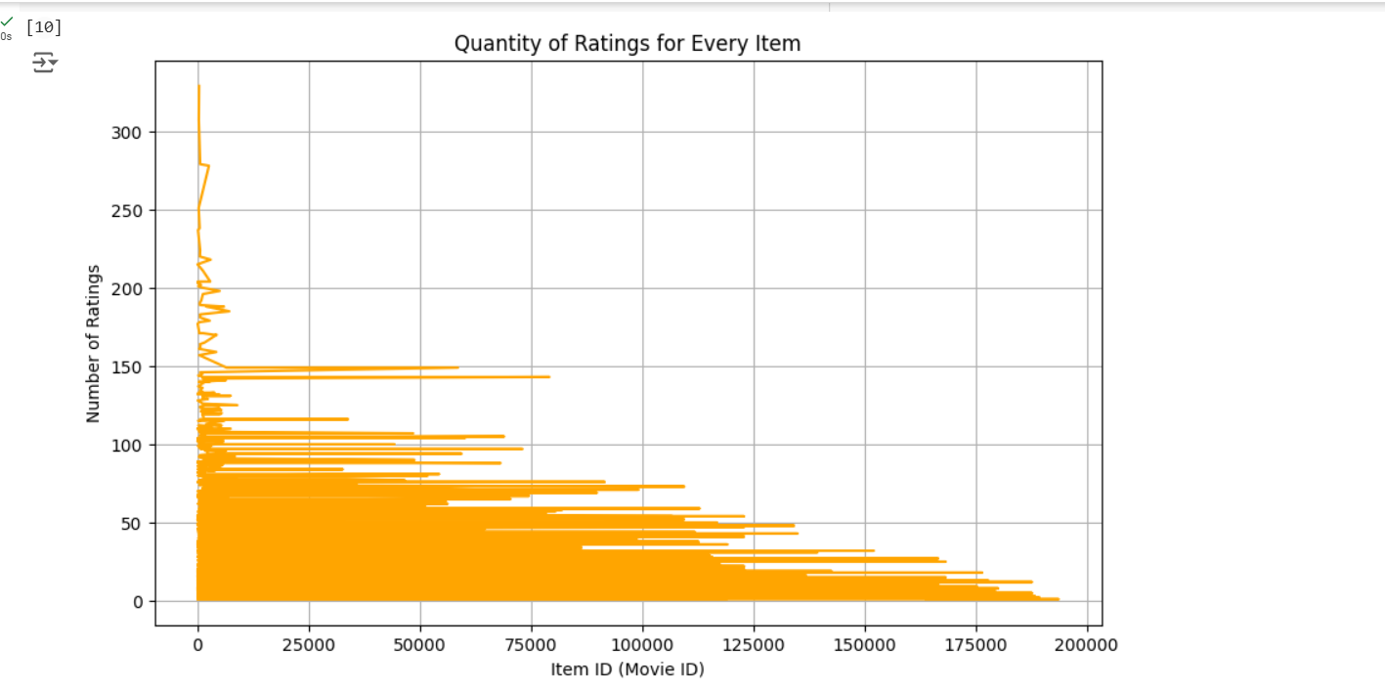
Summary of the comparison of Part 1 and 2

In both parts, the impact of the discount factor was easy to see, as the top 20% users close to the active users were different before and after applying the discount factore.

Before:
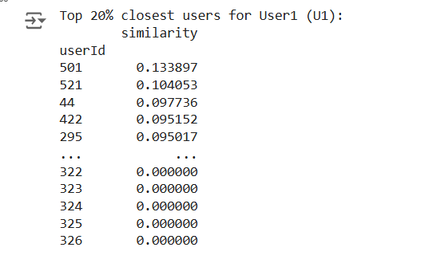
After:
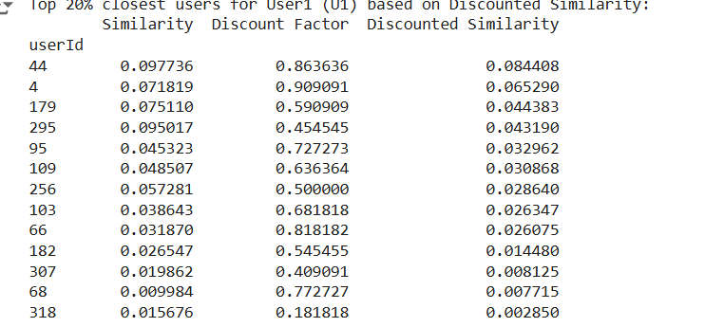

And as the top closest users were different, it is expected that the predicted ratings also should be different as following:
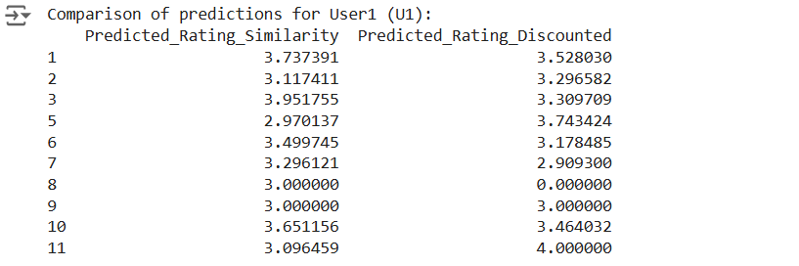
Now let’s see how this applies to the item-based CF after applying the discount factor and without applying it like we did on the user-based CF.

These were the top similar items to the target item based just on the similarity before applying the discount factor:
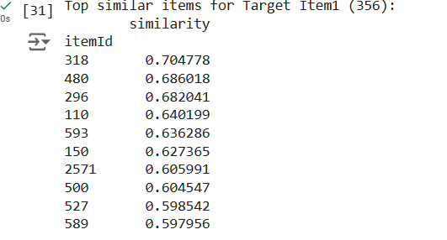
But after applying the discounted similarity the top similar items to the target items has been different as we see in the next figure:
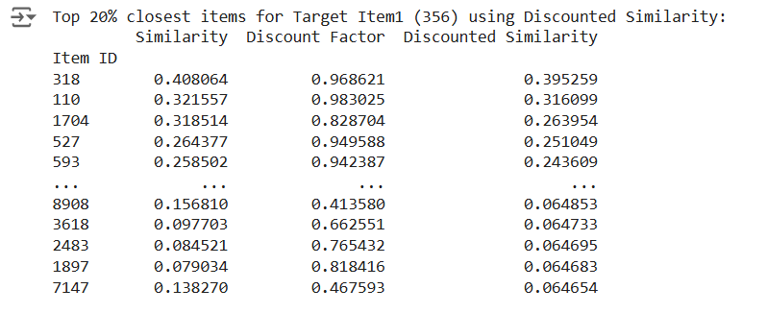
And these were the predicted missing ratings:
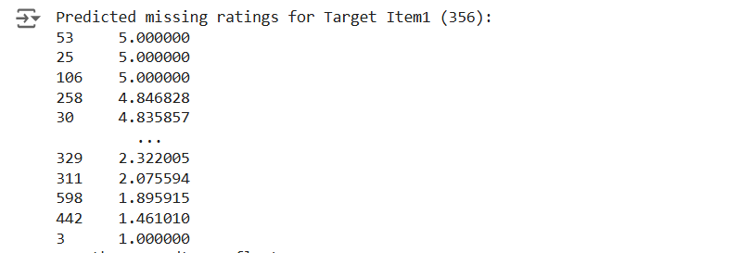
Conclusion:

The analysis successfully implemented user-based and item-based collaborative filtering algorithms using Cosine Similarity, Discounted Similarity (DS), and Pearson Correlation Coefficient (PCC). The study highlights the following findings:
- Impact of Significance Weighting:
  - Introducing Discount Factors (DF) reduces the influence of lower-ranked items in similarity computation. This adjustment ensures that predictions are more accurate by prioritizing significant relationships while suppressing less relevant contributions.
  - As seen in comparisons between predictions using raw similarity and discounted similarity, the DF improves recommendation precision.
- User-based vs. Item-based Methods:
  - User-based collaborative filtering tends to perform well when users share common preferences, while item-based filtering works better for sparse datasets with few user overlaps.
  - Pearson Correlation (PCC) performs effectively with mean-centering as it accounts for rating biases and scales across users.
- Predicted Ratings:
  - Predictions using top 20% items/users showed consistent improvements with the integration of DS. This demonstrates the importance of significance weighting in refining recommendations.
- Improvements:
  - Hybrid Methods: Combining user-based and item-based collaborative filtering can leverage both similarities for more robust predictions.
  - Matrix Factorization: Methods such as Singular Value Decomposition (SVD) can address sparsity issues and improve recommendation quality.
  - Context Awareness: Incorporating additional contextual data (e.g., timestamps, demographics) could further enhance predictions.

